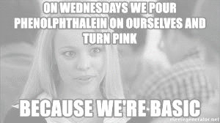
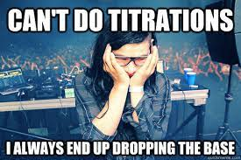
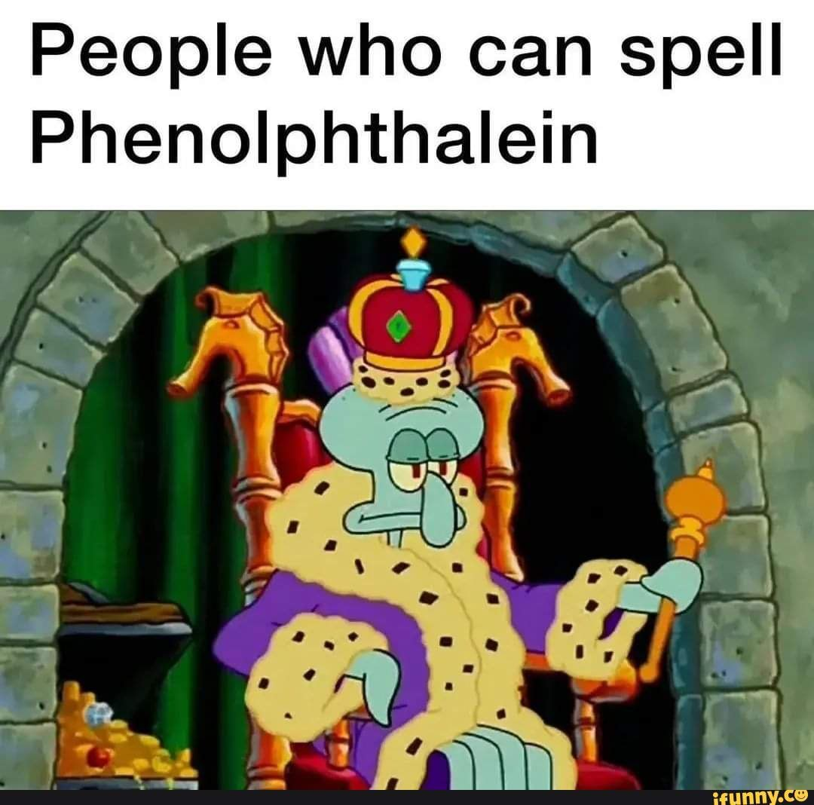
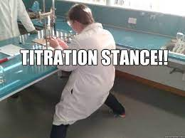
Identifying Acid, Bases, and Salts Think Tank Questions

- Find Table K in the Reference Tables. Which ion is common for all the acids listed?

- Common household acids include lemon juice, sour candy, and vinegar. What properties do these chemicals have in common?

- Find table L in the reference tables. Which ion is common for the first three bases listed?

- Common household bases include ammonia (floor cleaner), borax soap, and detergent. What properties do these chemicals have in common?

- And acid can be neutralized with a base and both substances will lose their properties. They react to form water and salt.
  - What is the formula for water?

  - What bonds does water have?

  - Table salt is one type of salt that can be formed. What is the formula of table salt?

  - What bonds does table salt have?

  - A common acid base reaction is provided below. Label the acid, base, and salt.
HCl + NaOH → NaCl + H₂O

  - Where do the atoms in water molecules come from in this reaction?

- label each as an acid base, salt, or water… if applicable (some chemicals will not be labeled).
HF NaCl CH₃OH H₂SO₄ Ca(OH)₂ CH₄

NH₄Br HCl Na₂SO₄ HNO₃ CH₃COOH NaOH

H₃PO₄ HOH CH₂(OH)₂ NH₄OH Ca(NO₃)₂ HC₂H₃O₂

- Draw ethanoic acid and circle which H⁺ ion is lost:

Identifying Acid, Bases, and Salts Check Your Understanding

1. Which formula represents a hydronium ion?
(1) H₃O⁺ (2) OH– (3) NH₄⁺ (4) HCO₃–

2. Which compound is an Arrhenius acid?
(1) H₂SO₄ (2) NaOH (3) KCl (4) NH₃

3. Which substance is an Arrhenius acid?
(1) Ba(OH)₂ (2) H₃PO₄ (3) CH₃COOCH₃ (4) NaCl

4. Which compound releases hydroxide ions in an aqueous solution?
(1) CH₃COOH (2) HCl (3) CH₃OH (4) KOH

5. The Arrhenius theory explains the behavior of
(1) acids and bases (3) alcohols
(2) isomers and isotopes (4) esters

6. Which two compounds are electrolytes?
(1) C₆H₁₂O₆ and CH₃CH₂OH (3) NaOH and HCl
(2) C₆H₁₂O₆ and HCl (4) NaOH and CH₃CHOH

7. Given the equation, which ion is X?
HCl(g) + H₂O(l)→X(aq) + Cl⁻(aq)
(1) hydroxide (3) hypochlorite
(2) hydronium (4) perchlorate

8. When one compound dissolves in water, the only positive ion produced in the solution is H₃O⁺(aq). This compound is classified as
(1) a salt (2) a hydrocarbon
(3) an Arrhenius acid (4) an Arrhenius base

9. An aqueous solution of lithium hydroxide contains hydroxide ions as the only negative ion in solution. Lithium hydroxide is classified as an
(1) aldehyde (3) Arrhenius acid
(2) alcohol (4) Arrhenius base

10. Which compound is an Arrhenius acid?
(1) H₂SO₄ (2) NaOH (3) KCl (4) NH₃
11. An Arrhenius base yields which ion as the only negative ion in an aqueous solution?
(1) hydride ion (3) hydronium ion
(2) hydrogen ion (4) hydroxide ion

12. Which two formulas represent Arrhenius acids?
(1) CH₃COOH and CH₃CH₂OH
(2) HC₂H₃O₂ and H₃PO₄
(3) KHCO₃ and KHSO₄
(4) NaSCN and Na₂S₂O₃

13. According to the Arrhenius theory, an acid is a substance that
(1) changes litmus from red to blue
(2) changes phenolphthalein to pink
(3) produces hydronium ions as the only
positive ions in an aqueous solution
(4) produces hydroxide ions as the only
negative ions in an aqueous solution

14. Which formula represents a hydronium ion?
(1) H₃O⁺ (2) OH– (3) NH₄⁺ (4) HCO₃–

15. Which substance is an Arrhenius acid?
(1) Mg(OH)₂ (2) H₂SO₄ (3) CH₃COOCH₃ (4) LiCl

16. Which compound releases OH⁻ ions in solution?
(1) CH₃COOH (2) HF (3) CH₃OH (4) LiOH

17. Which substance is an Arrhenius base?
(1) CH₃OH (2) LiOH (3) CH₃Cl (4) LiCl

18. The only positive ion found in H₂SO₄(aq) is the
(1) ammonium ion (3) hydronium ion
(2) hydroxide ion (4) sulfate ion

20. Which substance, when dissolved in water, forms a solution that conducts an electric current?
(1) C₂H₅OH (3) C₁₂H₂₂O₁₁
(2) C₆H₁₂O₆ (4) CH₃COOH
Strong or Weak, Concentrated or Dilute? Think Tank Questions

Directions: For each case, decide if the picture shows a weak or strong, and concentrated or dilute solution.

Acid: H+ ion: Anion A-:

 |  | W/S and C/D | Example
Case 1

Case 2

Case 3

Case 4

5. What does concentrated mean in terms of the amount of particles? _________________________________
6. What does dilute mean in terms of amount of particles?__________________________________________
7. What does strong mean in terms of ions? ______________________________________________________
8. What does weak mean in terms of ions? _______________________________________________________
Reactions Involving Acids & Bases Check Your Understanding

Neutralization Reactions: If equal mole amounts of acid and base are added together, the resulting solution is NEUTRAL! )

Acid + Base → Salt + Water

Example: HCl (aq) + NaOH (aq) → NaCl (aq) + H₂O (l)

Predict the products of and balance the following reactions:

___ HF (aq) + ___ LiOH (aq) → __________ (aq) + ___ HOH (l)

___ HNO₃ (aq) + ___ KOH (aq) → __________(aq) + ___ HOH (l)

___ HCl (aq) + ___ Ca(OH)₂ (aq) → __________(aq) + ___ HOH (l)

___ HClO₃ (aq) + ___ Mg(OH)₂ (aq) → __________(aq) + ___ HOH (l)

___ H₂CO₃ (aq) + ___ NaOH (aq) → __________(aq) + ___ HOH (l)

___ H₂SO₄ (aq) + ___ LiOH (aq) → __________ (aq) + ___ HOH (l)

___ H₂SO₃ (aq) + ___ Ca(OH)₂ (aq) → __________(aq) + ___ HOH (l)

___ H₃PO₃ (aq) + ___ KOH (aq) → __________(aq) + ___ HOH (l)

___ H₃PO₄ (aq) + ___ Ca(OH)₂ (aq) → __________(s) + ___ HOH (l)

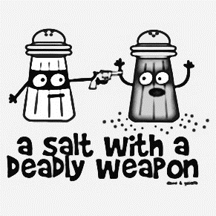
Neutralization reactions are a type of DOUBLE REPLACEMENT reaction
Reactions Involving Acids & Bases Think Tank Questions
Reactions of Acids with Metals (use Table J!) acid + more active metal 🡪 H₂(g) + salt

Any metal ABOVE H₂ in the table will react with acids to produce H₂ (g) and a salt.
Any metal below H₂ in the table will NOT react with an acid (only 3 metals do NOT react with acids: Cu, Au, Ag)
When metals react with acids, this is an example of a SINGLE REPLACEMENT reaction.

Predict the products of the following reactions:

Zn (s) + 2HCl (aq) → _______ + _________

Ag (s) + H₂SO₄ (aq) → _______ + _________

Ca (s) + H₂SO₄ (aq) → _______ + _________

Reactions Involving Acids & Bases Check Your Understanding
1. According to Reference Table J, which of these metals will react most readily with 1.0 M HCl to produce H₂(g)?
(1) Ca (2) K (3) Mg (4) Zn

2. Under standard conditions, which metal will react with 0.1 M HCl to liberate hydrogen gas?
(1) Ag (2) Au (3) Cu (4) Mg

3. Because tap water is slightly acidic, water pipes made of iron corrode over time, as shown by the balanced ionic equation below. Explain, in terms of chemical reactivity, why copper pipes are less likely to corrode than iron pipes.
2Fe(s) + 6H⁺(aq) 🡪 2Fe³⁺(aq) + 3H₂(g)

4. Many ancient cultural statues and buildings were made out of marble. Marble is a type of rock which contains the metal calcium in it. Explain, using Table J, why marble statues are damaged by acid rain.

5. During a laboratory activity, a student reacted a piece of zinc with 0.1 M HCl(aq).
(a) Complete the equation below by writing the formula of the missing products.

Zn + HCl 🡪 ________ + _________

(b) Identify one metal that does not react spontaneously with HCl(aq). _________

Acid Base Reactions Regents Questions

1. What are the products of a reaction between KOH(aq) and HCl(aq)?
(1) H₂ and KClO (3) H₂O and KCl
(2) KH and HClO (4) KOH and HCl

2. Which word equation represents a neutralization reaction?
(1) base + acid →salt + water
(2) base + salt →water + acid
(3) salt + acid →base + water
(4) salt + water →acid + base

3. Which compound could serve as a reactant in a neutralization reaction?
(1) NaCl (3) CH₃OH
(2) KOH (4) CH₃CHO

4. Which substance is always a product when an Arrhenius acid in an aqueous solution reacts with an Arrhenius base in an aqueous solution?
(1) HBr (3) KBr
(2) H₂O (4) KOH

5. Which reactants form the salt CaSO₄(s) in a neutralization reaction?
(1) H₂S(g) and Ca(ClO₄)₂(s)
(2) H₂SO₃(aq) and Ca(NO₃)₂(aq)
(3) H₂SO₄(aq) and Ca(OH)₂(aq)
(4) SO₂(g) and CaO(s)

6. Sulfuric acid, H₂SO₄(aq), can be used to neutralize barium hydroxide, Ba(OH)₂(aq). What is the formula for the salt produced by this neutralization?
(1) BaS (3) BaSO₃
(2) BaSO₂ (4) BaSO₄

7. Which chemical equation represents the reaction of an Arrhenius acid and an Arrhenius base?
(1) HC₂H₃O₂(aq) + NaOH(aq) 🡪 NaC₂H₃O₂(aq) + H₂O(l)
(2) C₃H₈(g) + 5 O₂(g) 🡪 3 CO₂(g) + 4 H₂O(l)
(3) Zn(s) + 2 HCl(aq) 🡪 ZnCl₂(aq) + H₂(g)
(4) BaCl₂(aq) + Na₂SO₄(aq) 🡪 BaSO₄(s) + 2 NaCl(aq)

When an acid dissolved it dissociates or ionizes (breaking up into two ions). The ions are separated due to the polarity of water, as shown below. Draw what happens to the other acid, base, and salt in water.
HCl(g) + H₂O(l) HCl(aq)

HNO₃(g) + H₂O(l) HNO₃(aq)

NaOH(s) + H₂O(l) NaOH(aq)

NaCl(s) + H₂O(l) NaCl(aq)

+
+
Cl⁻

-
H⁺

Explain why they are known as electrolytes when in solution but not when they are in solid or gas phases.
Bronsted Lowry Theory (Alternate Theory) Think Tank Questions

Acids are defined as proton (H⁺) donators. They donate protons to the base. Bases are defined as proton
acceptors. They accept protons from the acid.
HBr + NH₃ NH₄⁺ + Br⁻
According to Bronsted-Lowry theory, acid-base reactions involve a transfer of a proton. Above, the acid on
the left, ___________, transfers (donates) a proton (H⁺) and becomes a base on the right, __________.
The donating acid and the base it becomes are called conjugate acid - base pairs. The base on the left, __________, accepts a proton (H⁺) and becomes an acid on the right, _________. This is also a conjugate pair.
HF_{(aq)} + H₂O _{(l)} H₃O⁺_{(aq)} + F⁻_{(aq)} (1)
HI_{(aq)} + NH_{3(aq)} NH₄⁺_{(aq)} + I⁻_{(aq)} (2)
NH₄⁺_{(aq)} + OH⁻_{(aq)} NH_{3(aq)} + H₂O _{(l)} (3)
H₂SO_{4(aq)} + H₂O _{(l)} HSO₄⁻_{(aq)} + H₃O⁺_{(aq)} (4)

- In the reactions above, list the acids in the reactants and explain what they all have in common.

- In the reactions, list the bases in the first half of the equation and explain what they all have in common.

- If you reverse the equations, list the new acids and bases.
Acids: Bases:

- Now you can see, that each acid on the left hand side produces a corresponding base on the right hand side. The base is called the conjugate base. Similarly, a base on the right hand side will produce a conjugate acid. These pairs are known as conjugate acid-base pairs. List the conjugate acid-base pairs for equations (1) and (2).

5. Write the acid-base reaction for NH₃ reacting with HClO₂ and identify the acid, the base, the conjugate acid and the conjugate base.

Bronsted Lowry Theory (Alternate Theory) Check Your Understanding

- One acid-base theory defines a base as an
(1) H⁺ donor (2) H donor (3) H⁺ acceptor (4) H acceptor

- One alternate acid-base theory states that an acid is a(n)
(1) H⁺ donor (2) OH⁻ donor (3) H⁺ acceptor (4) OH⁻ acceptor

- According to one acid-base theory, a water molecule acts as an acid when the water molecule
(1) accepts an H+ (2) accepts an OH– (3) donates an H+ (4) donates an OH–

- Given the equation representing a reaction at equilibrium:
NH₃(g) + H₂O(l) 🡨🡪 NH₄⁺(aq) + OH–(aq)
The H⁺ acceptor for the forward reaction is
(1) H₂O (l) (2) NH₄⁺ (aq) (3) NH₃ (g) (4) OH– (aq)

- Which formula represents a hydronium ion?
(1) H₃O⁺ (2) OH– (3) NH₄⁺ (4) HCO₃–

- Given the balanced equation representing a reaction:
NH₃(g) + H₂O (l) 🡨🡪 NH₄⁺(aq) + OH–(aq)
According to one acid-base theory, the NH₃(g) molecules act as
(1) an acid because they accept H⁺ ions
(2) an acid because they donate H⁺ ions
(3) a base because they accept H⁺ ions
(4) a base because they donate H⁺ ions

- Which statement describes an alternate theory of acids and bases?
(1) Acids and bases are both H⁺ acceptors.
(2) Acids and bases are both H⁺donors.
(3) Acids are H⁺ acceptors, and bases are H⁺ donors.
(4) Acids are H⁺ donors, and bases are H⁺ acceptors.

- Which substance, when dissolved in water, forms a solution that conducts an electric current?
(1) C₂H₅OH (2) C₁₂H₂₂O₁₁ (3) C₆H₁₂O₆ (4) CH₃COOH

Honors pH Activity

Directions: Test each solution’s pH and record. Determine the hydronium concentration. Using the equation [H₃O⁺][OH⁻] = 1.0x10⁻¹⁴, determine the hydroxide concentration and pOH.
Solution | pH | [H₃O⁺] | pOH⁺ | [OH⁻] | pH + pOH | Compare [H₃O⁺] and [OH⁻] | A/B/N?
- Describe the relationship between the H⁺ and pH.

- Describe the relationship between OH⁻ and pOH.

- Define the relationship between pH and pOH.

- Define the relationship between the concentration of hydroxide and hydrogen ions.

- If the pH of solution A is 4 and the pH of solution B is 2, how much more concentrated is A than B?

- If solution C has a concentration of 1.00x10⁻⁵ hydronium ions and solution B has a concentration of 1.00x10⁻¹² hydroxide ions, which is more acidic?

The pH Scale Think Tank Questions
The pH scale is a measure of the H⁺ or H₃O⁺ concentration in a solution. “pH” stands for “potential to ATTRACT Hydrogen ions” “potential to ATTRACT Hydrogen ions. The pH scale is logarithmic, which means that a change of one pH unit will change the concentration of H⁺ by a factor of 10.

1. What is the relationship between pH value and hydrogen ion concentration?

2. Which substance is 10000 times more acidic than seawater?

3. What substance is 100 times more basic than lemon juice?

3. Complete the table below using the grid above:

 | Hydronium Ion Concentration (M) | pH | Acid or Base?
Stomach fluids
Lemon Juice
Tomato Juice
Milk
Blood
Seawater
Milk of Magnesia
Aqueous Ammonia
Bleach
5. Find the pH of the following solutions and determine if its acidic or basic:
Acid Concentration | pH | Acid or Base? (or neutral ☺)
[H₃O⁺] = 1x10⁻²
[H₃O⁺] = 1x10⁻⁷
[H₃O⁺] = 1x10⁻¹⁰
[H⁺] = 1x10⁻¹¹
[H⁺] = 1x10⁻⁵
[H₃O⁺] = 0.0010
[H₃O⁺] = 0.0000010
[H⁺] = 0.0000000010

pH Check Your Understanding

Recall the following:
      - increasing or decreasing the pH by 1 changes the [H⁺] by a factor of 10¹ (10 times, ten-fold)
      - increasing or decreasing the pH by 2 changes the [H⁺] by a factor of 10² (100 times, hundred-fold)
      - increasing or decreasing the pH by 3 changes the [H⁺] by a factor of 10³ (1000, thousand-fold)

- Describe what happens to the concentration of hydrogen ions in a solution if the pH is changed from 7 to 5.

- Describe what is happening to the concentration of hydrogen ions in a solution if the pH is changed from 5 to 8.

- Complete the table below:
pH Change | [H₃O⁺] increase or decrease? | [OH⁻] increase or decrease? | Does the solution become more acidic or basic? | By a factor of…
6 to 8
8 to 5
3 to 7
11 to 9
14 to 13
4 to 8

4. Which of these pH numbers indicates the highest
level of acidity?
(1) 5 (2) 10 (3) 8 (4) 12

5. Which change in pH represents a hundredfold increase in the concentration of hydronium ions in a solution?
(1) pH 1 to pH 2 (3) pH 2 to pH 1
(2) pH 1 to pH 3 (4) pH 3 to pH 1

6. The pH of a solution changes from 4 to 3 when the hydrogen ion concentration in the solution is
(1) decreased by a factor of 100
(2) decreased by a factor of 10
(3) increased by a factor of 100
(4) increased by a factor of 10

7. Solution A has a pH of three and solution Z has a pH of six How many times greater is the hydronium ion concentration in solution A than the hydronium ion concentration in solution Z?
(1) 100 (2) 3 (3) 2 (4) 1000

8. What is the pH of a solution that has a hydronium ion concentration 100 times greater than a solution with a pH of 4?
(1) 5 (2) 3 (3) 2 (4) 6

Honors Acid Base Practice

- The equation for the auto-ionization of water can be written as: H₂O + H₂O ⇐⇒ H₃O⁺ + OH–
At room temperature, [H₃O⁺][OH⁻] = 1 ⋅ 10^{–14}. Calculate the concentration of the ions and explain why the pH of water is 7.

- Suppose the [H₃O⁺] were increased to 1.0 ⋅ 10^{–3} M by the addition of acid. Calculate the [OH–] in solution.

- Suppose the [OH–] were increased to 2.5 ⋅ 10^{–3} M by the addition of base. Calculate the [H₃O⁺].

- Determine the pH of the solutions in Q2 and Q3. Determine the pOH of these solutions.

- The hydrogen ion concentration of several foods was measured with the following results. Bananas have a [H₃O⁺] of 2.5 ⋅ 10^{–5} M. Pickles have a [OH–] of 8.3 ⋅ 10⁻¹¹ M and milk has a pH of 6.4. List the foods in order from most basic to most acidic.

- The pH of a solution is 3.8. Calculate the [H⁺], [OH–] and pOH.

- The pH of the blood plasma is regulated between a very narrow range (7.35 - 7.45). One of the equilibrium systems that helps to manage this is: 2 H₂O + CO₂ ⇐⇒ 2 H₂CO₃ ⇐⇒ H₃O⁺ + HCO₃– A person whose blood pH gets too low tends to hyperventilate, blowing off CO₂ gas in the process. Explain how the loss of CO₂ can raise the blood pH.

- The pH of cider vinegar is approximately 5, whereas the pH of a freshly opened can of Coca-Cola is approximately 2.5. How many times greater is the [H₃O⁺] in the Coke than [H₃O⁺] in the vinegar?

- After a while, an open can of a carbonated soft drink goes flat according to the equilibrium reaction 2 H₂O + CO₂ ⇐⇒ 2 H₂CO₃ ⇐⇒ H₃O⁺ + HCO₃– . How would this change the pH of the beverage if at all? Explain.

Indicators Check Your Understanding
How to use Table M:
If the pH is below the first number, the solution will be the first color listed
If the pH is above the second number, the solution will be the second color listed
If the pH is between the numbers, the solution will be a mix of the two colors

Table M

Ex: If you add bromothymol blue… to a solution with a pH of 8, it will be blue
to a solution with a pH of 6, it will be green
to a solution with a pH of 4, it will be yellow

1. Which indicator, when added to a solution, changes color from yellow to blue as the pH of the solution is changed from 5.5 to 8.0?
(1) bromocresol green
(2) bromothymol blue
(3) litmus
(4) methyl orange
2. Which indicator would best distinguish between a solution with a pH of 3.5 and another with a pH of 5.5?
(1) bromothymol blue (3) litmus
(2) bromocresol green (4) thymol blue
3. In which solution will bromocresol green appear blue?
(1) 1 M NaCl (3) 1 M NH₃
(2) 1 M H₂CO₃ (4) 1 M CH₃COOH
4. In which solution will the thymol blue indicator appear blue?
(1) 0.1 M CH₃COOH (3) 0.1 M KOH
(2) 0.1 M HCl (4) 0.1 M H₂SO₄
5. What is the color of the indicator methyl orange in a solution that has a pH of 2?
(1) blue (3) yellow
(2) orange (4) red
6. In a solution with a pH of 3, what color is bromocresol green?
(1) yellow (3) green
(2) blue (4) red
7. At what pH will bromothymol blue be yellow and bromocresol green be blue?
(1) 10.5 (2) 5.7 (3) 7.0

8. A student used blue litmus paper and phenolphthalein paper as indicators to test the pH of distilled water and five aqueous household solutions. Then the student used a pH meter to measure the pH of the distilled water and each solution. The results of the student’s work are recorded in the table below.
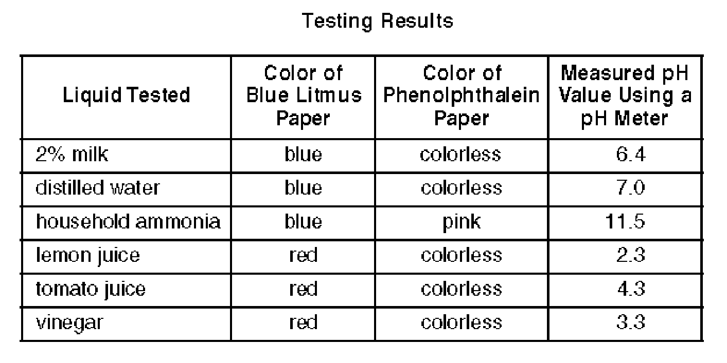
- Identify the liquid tested that has the lowest hydronium ion concentration.

- Explain, in terms of the pH range for color change on Reference Table M, why litmus is not appropriate to differentiate the acidity levels of tomato juice and vinegar.

- Based on the measured pH values, identify the liquid tested that is 10 times more acidic than vinegar.
Titrations Think Tank Questions

Titrations are procedures used to determine the concentration (M) of an acid or a base. You combine together an acid and a base knowing the volume of each and the concentration of only one of them.
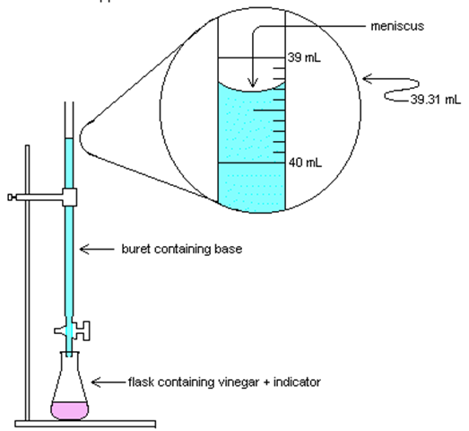
What number would be at the top of the buret?

Read the volume of the base in the buret.

If the buret holds 50mL, how much base is actually in the buret?

If a student started at 2.0mL and released base until it was at the level shown, how much bases was added?

Why is it not necessary to subtract all your volumes from 50mL?

buret containing BASE

Using the equation on Reference Table T, you can solve for either the molarity/concentration (M) or a volume added (V).
M_{A} V_{A} = M_{B} V_{B}
M_{A}= molarity of H⁺ V_{A} = volume of acid

M_{B} = molarity of OH– V_{B} = volume of base

1. A 25.0-milliliter sample of HNO₃ (aq) is neutralized by 32.1 milliliters of 0.150 M KOH (aq). What is the concentration of the acid?

2. How many milliliters of 0.200 M NaOH are needed to neutralize 100. mL of 0.100 M HCl?

3. In a titration, 20.0 milliliters of 0.15 M HCl(aq) is exactly neutralized by 18.0 milliliters of KOH(aq).
- Complete the equation below for the neutralization reaction by writing the formula of each product.

KOH(aq) + HCl(aq) → _________ + _________

- Compare the number of moles of H⁺(aq) ions to the number of moles of OH– (aq) ions in the
titration mixture when the HCl(aq) is exactly neutralized by the KOH(aq).

- Determine the concentration of the KOH(aq).

- What is the new pH of the solution?

- In a laboratory activity, 0.500 mole of NaOH(s) is completely dissolved in distilled water to form 400. milliliters of NaOH(aq). This solution is then used to titrate a solution of HNO₃(aq).

- Identify the negative ion produced when the NaOH(s) is dissolved in distilled water.

- Calculate the molarity of the NaOH(aq). Your response must include both a correct numerical setup and the calculated result.

- If 26.4 milliliters of the NaOH solution is needed to exactly neutralize 44.0 milliliters of the HNO₃ solution, what is the molarity of the HNO₃ solution?

- Complete the equation below representing this titration reaction by writing the formulas of the products.

Neutralization Particle Diagrams

Draw the various stages of a neutralization reaction between nitric acid and lithium hydroxide.

- Initial Anhydrous Acid and Base
Anhydrous Acid | Anhydrous Base

- Acids and Base in Aqueous solution
Aqueous Acid | Aqueous Base

- Acid and Base mixed together initially and after a few minutes of stirring
Initial | Final

- After the evaporation of water from the mixture
Anhydrous Product

Neutralization by Titration Check Your Understanding

H₃PO₄ + H₂O 🡪 3H₃O⁺ + PO₄⁻³ H₂SO₄ + H₂O 🡪 2H₃O⁺ + SO₄⁻²
What happens when an acid has two or more hydrogen atoms? Do they just lose one? Strong acids completely ionize leaving no hydrogen atoms in the anion or conjugate base. This means we need to amend our titration formula for these special acids to include all the acidic ions that come off.

Ca(OH)₂ + H₂O 🡪 2OH⁻ + Ca⁺² Mg(OH)₂ + H₂O 🡪 2OH⁻ + Mg⁺²
Similarly, what happens when a base has two or more hydroxide ions? Do they just lose one? Strong bases completely ionize leaving no hydroxide ions in the cation. This means we need to amend our titration formula for these special bases to include all the basic ions that come off.

The M_{a}V_{a} = M_{b}V_{b} formula will have coefficients in front of the M corresponding to the number of H⁺ or OH⁻ in the acid and base formula.

Example: If 35.0mL of 3.00M H₃PO₄ is neutralized by 50.0mL of Ca(OH)₂, what is the molarity of the base?
M_{a}V_{a} = M_{b}V_{b} becomes 3 M_{a} V_{a} = 2 M_{b} V_{b}
3(3)(35) = 2(x)(50)
x = 3.15M

1. If 65.0mL of 1.50M H₃PO₄ is neutralized by 25.0mL of Ca(OH)₂, what is the molarity of the base?

2. If 15.0mL of 3.50M H₂SO₄ is neutralized by 25.0mL of Mg(OH)₂, what is the molarity of the base?

3. If 150.0mL of 4.50M HNO₃ is neutralized by 3.00M Mg(OH)₂, what is the volume of the base added?

4. If 25.5mL H₃PO₄ is neutralized by 50.0mL of 2.00M LiOH, what is the molarity of the acid?

5. If 35.0mL of H₂CO₃ is neutralized by 50.0mL of 1.50M KOH, what is the molarity of the acid?

6. If 6.00M HI is neutralized by 50.0mL of 4.50M RbOH, what is the volume of the acid added?
Titration Regents Questions

1. What are the products of a reaction between LiOH(aq) and HCl(aq)?
(1) H₂ and LiClO (2) H₂O and LiCl
(3) LiH and HClO (4) LiOH and HCl

2. Which word equation represents a neutralization reaction?
(1) salt + acid →base + water
(2) base + salt →water + acid
(3) base + acid →salt + water
(4) salt + water →acid + base

3. Which compound could serve as a reactant in a neutralization reaction?
(1) HCl (3) CH₃OH
(2) HOH (4) H₂O

4. Which substance is always a product when an Arrhenius acid in an aqueous solution reacts with an Arrhenius base in an aqueous solution?
(1) HF (3) KBr
(2) H₂O (4) LiOH

5. Which reactants form the salt MgSO₄(s) in a neutralization reaction?
(1) H₂S(g) and Mg(ClO₄)₂(s)
(2) H₂SO₃(aq) and Mg(NO₃)₂(aq)
(3) H₂SO₄(aq) and Mg(OH)₂(aq)
(4) SO₂(g) and MgO(s)

6. Sulfuric acid, H₂SO₄(aq), can be used to neutralize barium hydroxide, Ca(OH)₂(aq). What is the formula for the salt produced by this neutralization?
(1) CaS (3) CaSO₃
(2) CaSO₂ (4) CaSO₄

7. Which chemical equation represents the reaction of an Arrhenius acid and an Arrhenius base?
(1) HCl + NaOH🡪 NaCl + H₂O
(2) C₃H₈+ 5 O₂ 🡪3 CO₂ + 4 H₂O
(3) Zn + 2 HCl🡪 ZnCl₂ + H₂
(4) Ba(OH)₂ + Na₂SO₄ 🡪 BaSO₄ + 2 NaOH

8. Which volume of 0.10 M NaOH(aq) exactly neutralizes 15.0 milliliters of 0.20 M HNO₃(aq)?
(1) 1.5 mL (3) 3.0 mL
(2) 7.5 mL (4) 30. mL

9. In which laboratory process could a student use 0.10 M NaOH(aq) to determine the concentration of an aqueous solution of HBr?
(1) chromatography
(2) decomposition of the solute
(3) evaporation of the solvent
(4) titration

10. The data collected from a laboratory titration are used to calculate the
(1) rate of a chemical reaction
(2) heat of a chemical reaction
(3) concentration of a solution
(4) boiling point of a solution

11. Which volume of 0.10 M NaOH(aq) exactly neutralizes 15.0 milliliters of 0.020 M HNO₃(aq)?
(1) 1.5 mL (3) 3.0 mL
(2) 7.5 mL (4) 30. mL

12. What volume of 0.120 M HNO₃(aq) is needed to completely neutralize 150.0 milliliters of 0.100 M NaOH(aq)?
(1) 62.5 mL (3) 180. mL
(2) 125 mL (4) 360. mL

13. A 25.0-milliliter sample of HNO₃(aq) is neutralized by 32.1 milliliters of 0.150 M KOH(aq). What is the molarity of the HNO₃(aq)?

14. A 25.0 mL sample of 5.00 M HCl is required to neutralize 34.5 mL of NaOH solution, what is the concentration of the NaOH solution?

15. A total of 50.0 mL of 0.50 M KOH solution completely neutralizes 125 mL of hydrobromic acid solution (HBr). Calculate the concentration of the HBr solution.

16. What volume of 0.10 M NaOH(aq) exactly neutralizes 15.0 milliliters of 0.20 M HNO₃(aq)?

17. What volume of 0.05 M HI is required to neutralize 50 ml of 0.01 M NaOH solution?

18. What volume of 0.500 M HNO₃(aq) must completely react to neutralize 100.0 milliliters of 0.100 M KOH(aq)?

19. In a titration, 15.65 milliliters of a KOH(aq) solution exactly neutralized 10.00 milliliters of a 1.22 M HCl(aq) solution.
- Write the balanced equation for the titration reaction.

(b) Show a correct numerical setup for calculating the molarity of the KOH(aq) solution.

20. In performing a titration, a student adds three drops of phenolphthalein to a flask containing 25.00 milliliters of HCl(aq). Using a buret, the student slowly adds 0.150 M NaOH(aq) to the flask until one drop causes the indicator to turn light pink. The student determines that a total volume of 20.20 milliliters of NaOH(aq) was used in this titration.
(a) The concentration of the NaOH(aq) used in the titration is expressed to what number of SF?

(b) Calculate the molarity of the HCl(aq) used in this titration. Your response must include both a correct numerical setup and the calculated result.

Regents Review
 | Key Idea Question | Justify your answer  with an explanation or calculation. | Confidence Level  None Moderate Fully
1 | Which of the following is not an electrolyte?  - CH₃COOH c. C₂H₅OH  - NaOH d. LiCl |  | Pre-discussion:  Post discussion:
2 | In the reaction, water acts as the  NH₃ + H₂O ↔ NH₄⁺ + OH⁻  - Acid because it donates H⁺  - Base because it donates H⁺  - Acid because it accepts H⁺  - Base because it accepts H⁺ |  | Pre-discussion:  Post discussion:
3 | Which of the following represents a 100x increase in H₃O⁺ concentration?  - pH 3🡪 5 c. pH 6🡪2  - pH 8🡪 11 d. pH 9🡪7 |  | Pre-discussion:  Post discussion:
4 | Which metal will not react with acids?  - Cu c. Li  - Zn d. Mg |  | Pre-discussion:  Post discussion:
5 | Which ion is represented by X?  H₂O + HI 🡪 I⁻ + X  - Hydronium c. hydrogen  - Hydroxide d. iodide |  | Pre-discussion:  Post discussion:
6 | Complete the neutralization reaction:  __H₂SO₄ +__ LiOH 🡪 _______ + __HOH |  | Pre-discussion:  Post discussion:
7 | Calculate the Molarity of 50.0mL HCl neutralized by 100.0mL of 2.0M NaOH. |  | Pre-discussion:  Post discussion:
8 | Which is the best indicator for determining the difference between a strong acid with a pH of 2.0 and a weak acid with a pH of 5.0? |  | Pre-discussion:  Post discussion:
9 | Explain what happens to the hydroxide and hydrogen ion concentration as lemon juice (citric acid) is added to iced tea (neutral). |  | Pre-discussion:  Post discussion:
10 | Sketch a representation of how HCl is oriented around the water molecule as it dissolves and explain why HCl is classified as an electrolyte only in the aqueous phase. |  | Pre-discussion:  Post discussion:
Common Sense Chemistry Review
Pretty basic stuff. 🡨 Acid what you did there

- Identify the ingredients in the following common household chemicals as acids, bases, salts, or neither:
  - Aspirin HOOCC₆H₄OOCCH₃
  - Glass cleaner NH₄OH
  - Ethanol C₂H₅OH
  - Bleach ClO-
  - Baking Soda NaHCO₃
  - Deodorant Al(OH)₃

- A farmer tests his soil with pH paper and finds the value to be 5.5, which could explain why his crops are dying.
  - Is the soil acidic, basic, or neutral?

  - Identify a substance that could be added to the soil that would make the soil more suitable for farming (more neutral).

  - The farmer adds lime to the soil on the east side of his farm and re-tests the pH. The pH rises to 8.5, which further weakens his plants. Has the hydronium concentration increased or decreased, and by what factor has it changed?

  - The farmer calls in a specialist to help with his dying plants. First the specialist quick tests the soil with a few indicators. Identify the color changes expected for each indicator on the east and west side of his farm: East West
    - Methyl orange ____________________ _____________________
    - Bromothymol blue ____________________ _____________________
    - phenolphthalein ____________________ _____________________
    - litmus ____________________ _____________________
    - thymol blue ____________________ _____________________
    - bromocrescol green ____________________ _____________________

  - The specialist wants to determine the exact concentration of acid or base in the original soil in order to determine how to treat it effectively.
    - What is the technique the specialist may use to determine the molarity of the soil?

    - The specialist obtains a 150.0mL sample of soil and neutralizes the soil with 1.0M Ca(OH)₂. The process requires 75.0mL of Ca(OH)₂.
      - How does the specialist know when to end the process when the soil was neutralized?

      - Calculate the concentration of the acid or base present in the original soil.

