Name: ____________________________________ Analysis of Food Dye in Gatorade

Purpose: We will be creating our own spectrophotometers! The optimal wavelength of light will be identified for a dye solution (depending on your team). Then, dilutions of dye will be used to create a Beer’s Law graph of concentration vs absorbance. The data will be used to find the concentration of an unknown solution of Gatorade.

Materials: 7 uM Dyes Blue1, Red 40, Yellow 5, Water, Red paper, Blue paper, Green paper, Gatorade (strawberry, lime, glacier freeze (G2 works best)), Smartphone and color app (colorimeter app), cuvettes, Graduated cylinders, Chemwipes, gloves.

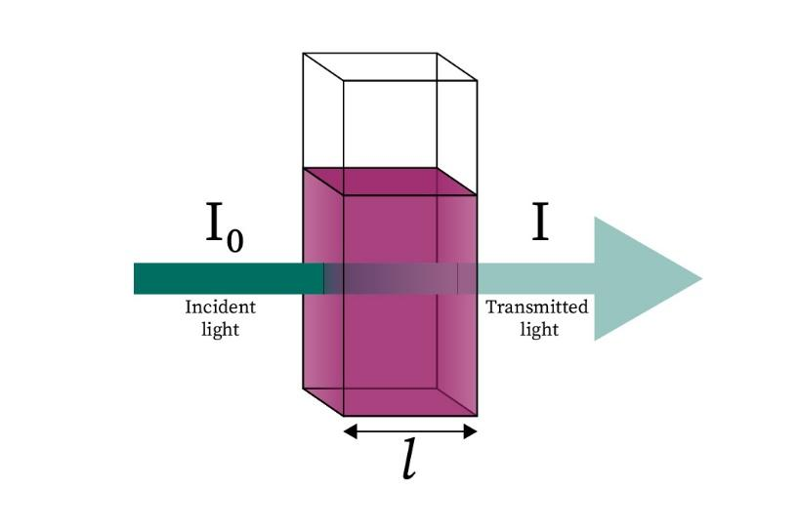
Background Information: Light absorption occurs when the contents of the solution takes up the energy of a photon of light, which reduces the transmission of the light as it passes through the sample. The lux number that is recorded for each sample in our experiment is directly proportional to the transmittance. The following information will help you obtain the absorbance value of your samples.
Incident light (I₀) = lux number of water (blank sample)
Transmitted light (I) = lux number of solution
Transmittance (T) = (I) / (I₀)

Absorbance (A) is the opposite of transmittance (T) and states how much of the light the sample absorbed:
A = – log (T) or A = -log (I) / (I₀) and A =εbC

Pre-Lab Questions:
- The reason we see color is because everything around us absorbs different wavelengths of light. The color wheel can help us keep track of what colors are being absorbed. Observe the color wheel and the graph below.
  - At what wavelength is the color red most absorbed?

  - If you are using red dye, what color light should be used to measure transmittance?

  - At what wavelength is the color blue most absorbed?

  - If you are using blue dye, what color light should be used to measure transmittance?

  - At what wavelength is the color yellow most absorbed?

  - If you are using yellow dye, what color light should be used to measure transmittance?

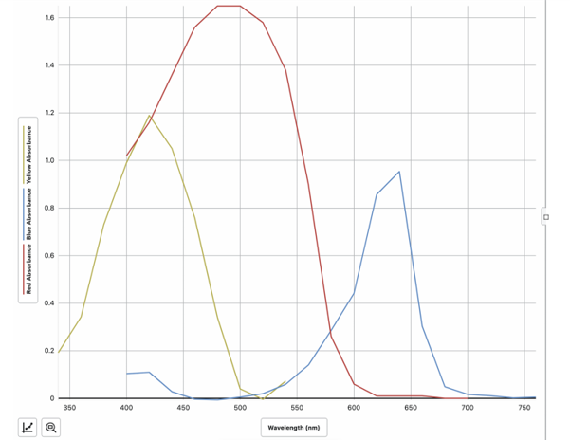
Peaks in order: Yellow, Red, Blue
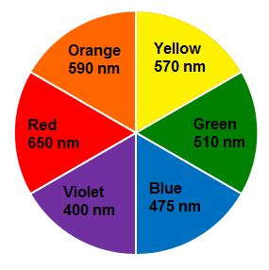

- The length of the sample container must remain constant for all samples.
  - What value does that represent in the Beer’s law equation?

  - Why should this remain constant?

- Why do we need to measure the transmittance (lux) of pure water?

- The containers must be wiped off each time you take a measurement? What error may be induced if the containers have fingerprints on them?

- What if you mix the wrong amounts of dye and water together? Is there a way to fix your work?

Procedure and Notes:
- Build a “spectrophotometer” using paper (red, blue, or green), and a cuvette.
  - Identify your assigned dye color and what construction paper you will need (see pre-lab questions about color above).
  - Set up construction paper chosen
- Download a free color app on your smartphone (in materials section).
- Measure 3.0mL of your dye in a graduated cylinder. Add to the cuvette.
- Make the “view finder” shoot through the solution towards the color paper.
- Obtain the lux (l) color value (for the color that matches your paper) for 3.0mL of the original dye concentration (7.00uM).
- Obtain the lux (l) color value for 3.0mL pure water (0.00uM).
- Obtain the lux (l) color value for the gatorade solution matching your dye.
- To create diluted solutions and measure their values:
  - Obtain 5mL of your dye solution and mix completely with 5.0mL of water (for a total of 10.0mL of diluted solution). Shake to mix with gloves on.
  - Measure about 3.0mL of the dilute solution and add it to the cuvette.
  - Measure the lux(l) color value for the dilute solution and record.
  - Discard the 3.0mL from the cuvette.
  - There should be 7.0mL of dye solution remaining in the first cylinder. Remove and discard 2.0mL
  - Add 5.0 mL of water to the 5.00mL of dye.
  - Calculate the new Molarity of your solution.
  - Measure the lux(l) color value for the dilute solution and record.
  - Repeat steps d-g until you have at least two measurements past the gatorade value. Remember to rinse the cuvettes and dry the outsides each time to obtain more accurate results.
Suggestions: Secure all aparati. Movement of the box, paper, and phone can skew results. Maintain roles:
- Technician: Assembles and maintains equipment such as paper and phone placement.
- Data analyst: Observes and records values from the phone app.
- Diluter(s): Measures dye and water, mixes with gloves on.

Data and Analysis:
- What color was used as the background in your spectrophotometer? Explain your choice below.

- I used the color app to get R (red), B (blue), or G (green) (Circle one)

- Show the calculation of the M₁V₁ = M₂V₂ for the first dilution.

- Show the calculation of the M₁V₁ = M₂V₂ for the second dilution.

- Use particle diagrams to show the “serial dilution” of the dye over time. The size of the box is the same to show the total 10mL solution of the dye in water. The dye is the circles and the water is the background.
Original Dye solution 7μM | First dilution ___μM | Second dilution ___μM | Third dilution ___μM
- Use your data and calculations to fill in the table below.
Concentration of Dye (μM) | R (red), B (blue), or G (green) color app values | Calculated Absorbance
7.00
0.00
Gatorade ? uM
- Show a sample calculation for Absorbance: A = -log (I / I₀) for the second absorbance value. The I₀ is the color app value for Pure Water and the I is the color app value for the Dye Solutions. Show one calculation but then record all calculations answers in the data table.

- Show the calculation for Absorbance: A = -log (I / I₀) for the gatorade value.

- Create the Beer’s Law Graphs with the Concentration (uM) vs. Calculated absorbance values. Upload an image of the graph with your lab.
- Using your graph, what is the concentration of dye in your Gatorade?
- Why might someone want to know how much artificial food dye is in their drinks?

