Bertillion Measurement Lab
Background: Alphonse Bertillon invented “athropometrics”, a method with which to identify people based upon their individual measurements. His theory was that each person is highly individual. Therefore, no one else would possess another person’s exact measurements. This system was initially accepted and used by various law enforcement agencies throughout the U.S. Bertillon cards were printed reflecting these measurements, and oddly enough, a fingerprint. Bertillon chose the following parts of the body for his measurements. The choice between using the left or right sides was arbitrary. Although the theory suggested that it would succeed, there were instances where it would fail. Anthropometrics relied on the recorder being exact in his measurements. If the recorder was tired or inattentive, the measurements could fail to identify a person. Suspects who were drunk, ill, or uncooperative would also result in inaccurate measurements.
Data:
Body Area | Measurements/Observations
Body height
Outstretched reach of both arms
“wingspan”
Trunk Height
Width of Head
Length of Right Ear
Width of Right Ear
Length of Left Foot
Length of Left Middle Finger
Length of Left Little Finger
Length of Left Forearm
Hair color
Eye Color

Questions:
- What problems can you foresee with this measurement system?

- Does anyone in your group have similar measurements?

The West Brothers
In 1903, a prisoner by the name of Will West was sentenced to incarceration at the US Penitentiary at Leavenworth, Kansas. During his in-processing, the records clerk obtained Will West’s Bertillon measurements and photograph. Will West denied ever being incarcerated at the facility. The records clerk doubted this information and referenced his Bertillon measurements into the system, retrieving the Bertillion card for a William West. Will West continued to deny that the William West card was his. Subsequent investigation discovered the William West was already incarcerated in the facility as of September 9, 1901. By examining the photographs, one can see the failure of the Bertillon system. Compare the Bertillon measurements. In particular, keeping in the mind the various factors that would affect the measurements. This failure strengthened the science of fingerprints as the normally accepted method of personal identification. Recent opinions suggest that Will and William West were related, therefore the closeness in measurements.
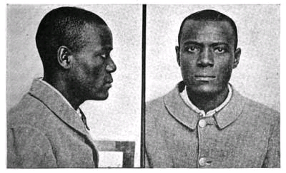
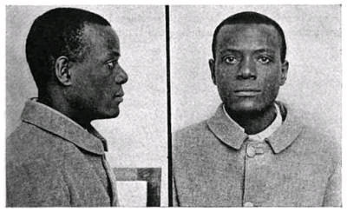
William West
Will West
Measurement | Will West | William West
Height | 178.5 | 177.5
Reach | 187.0 | 188.0
Trunk | 91.2 | 91.3
Head Width | 19.7 | 19.8
Head Length | 15.8 | 15.9
Length of right ear | 14.8 | 14.8
Width of right ear | 6.6 | 6.5
Length of left foot | 28.2 | 27.5
Length of left middle finger | 12.3 | 12.2
Length of the left little finger | 9.7 | 9.6
Length of the left forearm | unavailable | 50.3

