Lab: Bite Marks
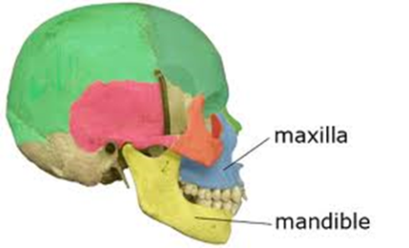
Background: Forensic odontology is an established branch of forensic science in which the principles of dental science are applied to legal matters. Forensic odontologists frequently assist investigators in identifying human remains, particularly in mass disaster situations like the New York City World Trade Center disaster in 2001. While their work in identifying unknown victims is perhaps most well-known, forensic odontologists also use their expertise to analyze bite mark evidence on victims or inanimate objects present at crime scenes. The theory underlying forensic odontology is that no two mouths are alike; an individual’s dentition —the type, number, and arrangement of teeth—is believed to be unique. This makes a bite mark a valuable piece of evidence. A forensic odontologist can use teeth impressions left in foods like apples, cheese, chocolate, and even chewing gum to link a suspect to a victim or crime scene. When saliva is present in the impression, the potential for DNA analysis exists. Even when this is not possible, a dental impression alone can provide crucial information about the person who left it behind.

Part 1: Making Bite Plates
- Obtain a Styrofoam plate from your instructor.
- Place the plate in your mouth. Make sure it is placed back far enough to sit between your back molars.
- Bite down firmly on the plate. Do not chew on the Styrofoam or bite completely through the plates. Remember that all you are trying to do is get an impression of your teeth!
- Remove the plate and wipe off any residual saliva with a paper towel. Immediately discard the paper towel. Wash your hands with soap and water to avoid spreading bacteria.
- Complete Table 1.
Data Table 1
Jaw | Width (cm) | Depth (cm) | Unique Characteristics
Maxillae
Mandible

Part 2: Investigating a crime scene.
- Obtain two transparency sheets. Label both with your name in the upper right hand corner. In the upper left hand corner, label one as upper and the other as lower.
- Examine the crime scene bite mark on the Styrofoam plate.
- Fill in the top two rows of data table 2 for the crime scene bite mark.
- Next place the transparency sheet labeled upper over the upper impressions.
- With a permanent marker, outline the pattern made by each of the upper teeth. Be careful to trace each tooth individually.
- Repeat the process for the lower teeth.
- Open the bag with the bite impressions from the four suspects.
- Fill in data table 2 for each suspect.
- Next lay your transparencies over the impression and determine what suspect committed the crime.
- Compare your results with your forensic team (group).

Data Table 2
 | Jaw | Width (cm) | Depth (cm) | Unique Characteristics
Crime Scene | Maxillae
 | Mandible
Suspect 1 | Maxillae
 | Mandible
Suspect 2 | Maxillae
 | Mandible
Suspect 3 | Maxillae
 | Mandible
Suspect 4 | Maxillae
 | Mandible

Questions:
  - What suspect do you think committed the crime based upon the bite mark evidence? Explain.

  - Imagine you are the defense attorney for the suspect. What arguments could you use to damage the credibility of the evidence presented by the forensic odontologist regarding the dental impression comparison?

  - In most cases, a dental impression found in a food item at a crime scene does not show a full complement of teeth. What other types of evidence might a forensic scientist look for to provide additional information about the person who left the impression?

