The Quantum Mechanical Model and Electron Configurations

Model 1: Bohr model diagrams and QMM Electron Configurations for the first 20 elements

Element | Electron Configuration | Valence Electrons
H | 1s¹ | 1
He | 1s² | 2
Li | 1s² 2s¹ | 1
Be | 1s² 2s² | 2
B | 1s² 2s² 2p¹ | 3
C | 1s² 2s² 2p² | 4
N | 1s² 2s² 2p³ | 5
O | 1s² 2s² 2p⁴ | 6
F | 1s² 2s² 2p⁵ | 7
Ne | 1s² 2s² 2p⁶ | 8
Na | 1s² 2s² 2p⁶ 3s¹ | 1
Mg | 1s² 2s² 2p⁶ 3s² | 2
Al | 1s² 2s² 2p⁶ 3s² 3p¹ | 3
Si | 1s² 2s² 2p⁶ 3s² 3p² | 4
P | 1s² 2s² 2p⁶ 3s² 3p³ | 5
S | 1s² 2s² 2p⁶ 3s² 3p⁴ | 6
Cl | 1s² 2s² 2p⁶ 3s² 3p⁵ | 7
Ar | 1s² 2s² 2p⁶ 3s² 3p⁶ | 8
K | 1s² 2s² 2p⁶ 3s² 3p⁶ 4s¹ | 1
Ca | 1s² 2s² 2p⁶ 3s² 3p⁶ 4s² | 2
Electron configurations are a way of expressing the number of electrons present in each orbital of an atom. The orbital represents the space within an atom where the probability of finding an electron is high.

- Observe the Hydrogen Bohr diagram and QMM electron configuration. Considering the atomic number of hydrogen, how many total electrons must be represented in both representations? ____

- Observe the Helium Bohr diagram and electron configuration.
  - How many total electrons must be represented in both representations? ____
  - How many energy levels does helium have? ____
  - What might the coefficient 1 represent in the electron configuration for hydrogen and helium?

- Observe the Lithium Bohr diagram and electron configuration.
  - How many electrons must be represented in both representations?____
  - How many energy levels does lithium have? ____
  - What might the coefficients 1 and 2 represent in the electron configuration for lithium?

  - What might the superscripts ² and ¹ represent in the electron configuration for lithium?

  - Which part of the electron configuration represents the valence electrons for lithium?

- Observe all the Bohr diagrams and electron configurations given for the first 20 elements.
  - How many electrons fill the first Bohr level for any atom? ____
  - Why does every electron configuration start with 1s? What does it correlate to on the Bohr diagrams?

  - Observe all “s” orbitals. How many total electrons does any s orbital hold? ____
  - Observe all “p” orbitals. How many total electrons does any p orbital hold? ____
  - How many electrons can fit in the second energy level of any Bohr diagram? ____
  - If you add the number of electrons that fill the 2s with the number that fill 2p, how many electrons fill the second energy level in electron configurations? ____
  - How do the number of electrons present in the third level of the Bohr diagrams provided compare to the number of electrons that fill the 3rd level in the electron configurations?

  - If you add all of the superscripts of a given electron configuration, what does the total represent? Provide an example to explain your answer.

Model 2: Orbital shapes

The pictures below show a magnified representation of the electron orbitals of atoms. The white parts of the pictures represent where electrons are most probably located.
1s
2s | 2px | 2py | 2pz
3s | 3px | 3py | 3pz

- Observe the 1s and 2s orbitals. Describe the general shape of s orbitals.

- Observe the p orbitals.
  - Describe the general shape of p orbitals.

  - All of the images have a small black dot in the center, a place where electrons will never be. What does a small center dot represent in the atom?

- Recall from Model 1,
  - How many electrons fill any s orbital? ____
  - Using your knowledge of charge attraction and repulsion, propose a reason why an s orbital cannot hold more electrons than we see in the electron configurations.

  - How many electrons fill the entire p sublevel for any atom? _____
  - If there are 3 types of p orbitals, one in the x plane, one in the y plane, and one in the z plane, as shown in Model 2, how many electrons fill each p orbital? ____
The Pauli Exclusion Principle states that no two electrons may have the same “quantum numbers” which are a way to describe where the electrons are found inside the atom. Therefore, within one orbital, the electrons must rotate in opposite directions, which can also reduce their repulsive forces.
- Explain how the Pauli Exclusion Principle confirms or goes against your answers in the previous question.

Model 3: Orbital Notations
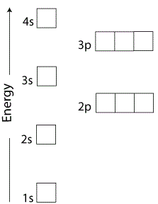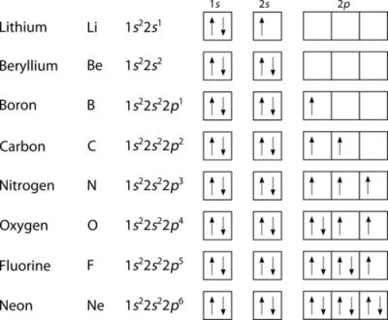
Orbital notations are used to show the energy and rotation of electrons within orbitals of the atom. Each box represents one of the spherical s orbitals or one of the lobe like p orbitals. Arrows are used to show the direction of the electron spin: up arrows are clockwise rotating electrons and down arrows are counterclockwise rotating electrons. Although the orbitals have different amounts of energy as depicted in the first diagram, the orbitals may be shown in one row for simplicity.
- Using the diagram on the left of Model 3, which orbital has electrons with the least energy? ____
- Propose a reason why the orbital you chose in the previous question has the lowest energy.

- Compare the two diagrams of Model 3. In what order are the electron configurations written compared to orbital notations?

- Using the diagram to the right in Model 3,
  - How many electrons fill each box/orbital? ____
  - Does any box have two electrons with the same spin? ____
  - What do you notice about the order in which electrons are filled in the p orbitals?

Hund’s Rule states that the lowest energy (and therefore more stable) electron configuration is one with the maximum number of unpaired electrons with the same spin.
- Based on the diagrams above and Hund’s Rule, explain why the following orbital notations are not valid and propose a correction:
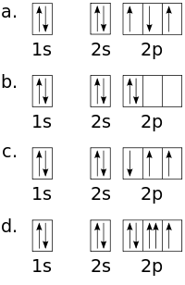

- Using the electron configurations given in model 1, draw the orbital notation for:
  - Sodium

  - Aluminum

  - Phosphorous

  - Calcium

Model 4: d orbitals

Recall that the third energy level of an atom can hold up to 18 electrons. So far, we have identified the 3s electrons and the 3p electrons which total 8 electrons and then moved on to the 4s orbital. The third energy level actually has an additional set of five 3d orbitals. The 3d orbtals fill with electrons after the 4s, although the 4s is still considered the valence orbital.
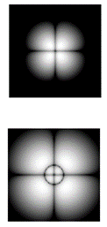
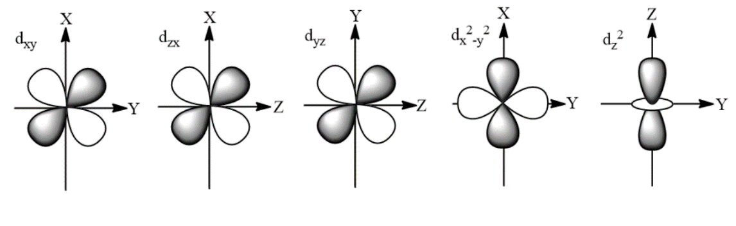

- Describe the shape of the d orbitals.

- If 2 electrons of opposite spin fill any orbital and there are five types of d orbitals, how many total electrons does the 3d sublevel hold? ____

Model 5: Aufbau Principle

The Aufbau Principle states that electrons are placed in the lowest energy orbitals availiable to create ground state electron configurations. Below, each line represents an orbital in which two electrons can spin in opposite directions.

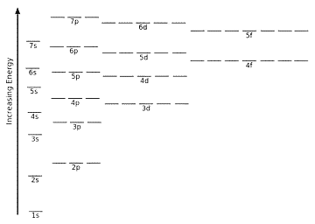

- According to Model 5,
  - How many orbitals does any p sublevel contain? ____
  - How many orbitals does any d sublevel contain? ____
  - Notice there are also f orbitals on the diagram corresponding to very high energy levels only. How many orbitals does any f sublevel contain? ____
  - Which sublevel has the lower energy, 4s or 3d? ____
  - Which sublevel has the higher energy, 5p or 6s? ____
- Identify the Bohr electron configuration (2-8-18-32…) for the calcium atom.
  - Previous to this quantum mechanical model, could you explain why calcium has two valence electrons?

  - Using the quantum mechanical model, why does calcium have two valence electrons?

Model 6: Relating to the Periodic Table

Many people feel they need to memorize the order in which sublevels are filled with electrons, and due to the non-intuitive nature of d and f orbital filling it may seem difficult. The diagram below shows a periodic table of elements in which the symbol is replaced by the electron configuration of the last electron added according to the Aufbau Principle. You may choose to have your normal periodic table out during this section.

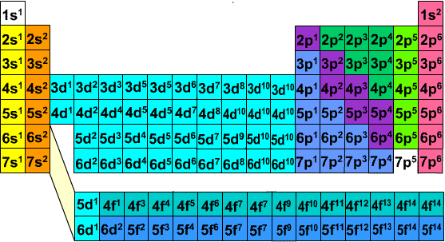

- What do all elements in period 2 have in common and what does that pattern represent?

- What do all elements in groups 1 and 2 have in common and what does that pattern represent?

- What do all elements in groups 13-18 have in common and what does that pattern represent?

- Which orbital do transition metals fill last? ____
- Read the electron configurations in Atomic Number order and compare it to the order we fill orbital in Model 5. Explain any relationships you observe.

- Identify the Bohr electron configuration for Scandium.
  - According to the Bohr model, how many valence electrons does scandium have? ____
  - According to the quantum mechanical model, which orbital represents the valence electrons of scandium? ____
  - Why do most transition metals have 1-2 valence electrons? (Which orbital represents the valence?)

Model 7: Short Cuts
To make writing long electron configurations shorter, a noble gas short cut can be used.
Element | Electron Configuration | Noble Gas Short cut
Li | 1s² 2s¹ | [He] 2s¹
Be | 1s² 2s² | [He] 2s²
B | 1s² 2s² 2p¹ | [He] 2s² 2p¹
C | 1s² 2s² 2p² | [He] 2s² 2p²
N | 1s² 2s² 2p³ | [He] 2s² 2p³
O | 1s² 2s² 2p⁴ | [He] 2s² 2p⁴
F | 1s² 2s² 2p⁵ | [He] 2s² 2p⁵
Ne | 1s² 2s² 2p⁶ | [He] 2s² 2p⁶
Na | 1s² 2s² 2p⁶ 3s¹ | [Ne] 3s¹
Mg | 1s² 2s² 2p⁶ 3s² | [Ne] 3s²
Al | 1s² 2s² 2p⁶ 3s² 3p¹ | [Ne] 3s² 3p¹
Si | 1s² 2s² 2p⁶ 3s² 3p² | [Ne] 3s² 3p²
P | 1s² 2s² 2p⁶ 3s² 3p³ | [Ne] 3s² 3p³
S | 1s² 2s² 2p⁶ 3s² 3p⁴ | [Ne] 3s² 3p⁴
Cl | 1s² 2s² 2p⁶ 3s² 3p⁵ | [Ne] 3s² 3p⁵
Ar | 1s² 2s² 2p⁶ 3s² 3p⁶ | [Ne] 3s² 3p⁶
K | 1s² 2s² 2p⁶ 3s² 3p⁶ 4s¹ | [Ar] 4s¹
Ca | 1s² 2s² 2p⁶ 3s² 3p⁶ 4s² | [Ar]4s²

- Compare the full electron configuration to the noble gas configuration and create a rule that can be used to write a shorter electron configuration.

- Use your rule to write the full and short electron configuration for:

  - Gallium: __________________________ __________________________

  - Titanium: __________________________ __________________________

  - Selenium: __________________________ __________________________

- Draw the valence orbital notation for chlorine.

Model 8: Ions

Recall that cations are formed when an atom loses valence electrons and anions are formed when an atom gains electrons to the valence. Below is a list of Period 7 atoms that form cations with their corresponding electron configurations.
Element | Electron Configuration
 | Atom | +1 ion | +2 ion | +3 ion
Potassium | [Ar] 4s¹ | 1s² 2s² 2p⁶ 3s² 3p⁶
Calcium | [Ar] 4s² |  | 1s² 2s² 2p⁶ 3s² 3p⁶
Scandium | [Ar] 4s² 3d¹ |  |  | 1s² 2s² 2p⁶ 3s² 3p⁶
Titanium | [Ar] 4s² 3d² |  | 1s² 2s² 2p⁶ 3s² 3p⁶ 3d² | 1s² 2s² 2p⁶ 3s² 3p⁶3d¹
Vanadium | [Ar] 4s² 3d³ |  | 1s² 2s² 2p⁶ 3s² 3p⁶ 3d³ | 1s² 2s² 2p⁶ 3s² 3p⁶3d²
Chromium | [Ar] 4s² 3d⁴ |  | 1s² 2s² 2p⁶ 3s² 3p⁶ 3d⁴ | 1s² 2s² 2p⁶ 3s² 3p⁶ 3d³
Manganese | [Ar] 4s² 3d⁵ |  | 1s² 2s² 2p⁶ 3s² 3p⁶ 3d⁵ | 1s² 2s² 2p⁶ 3s² 3p⁶ 3d⁴
Iron | [Ar] 4s² 3d⁶ |  | 1s² 2s² 2p⁶ 3s² 3p⁶ 3d⁶ | 1s² 2s² 2p⁶ 3s² 3p⁶ 3d⁵
Cobalt | [Ar] 4s² 3d⁷ |  | 1s² 2s² 2p⁶ 3s² 3p⁶ 3d⁷ | 1s² 2s² 2p⁶ 3s² 3p⁶ 3d⁶
Nickel | [Ar] 4s² 3d⁸ |  | 1s² 2s² 2p⁶ 3s² 3p⁶ 3d⁸ | 1s² 2s² 2p⁶ 3s² 3p⁶ 3d⁷
Copper | [Ar] 4s² 3d⁹ | 1s² 2s² 2p⁶ 3s² 3p⁶ | 1s² 2s² 2p⁶ 3s² 3p⁶ 3d⁹
Zinc | [Ar] 4s² 3d¹⁰ | 1s² 2s² 2p⁶ 3s² 3p⁶

- From which orbital is the first electron removed for any atom in Model 8? ____
- Propose a reason that explains why potassium only forms a +1 ion and calcium only forms a +2 ion.

- From which orbital do the transition metals lose their third electron? ____
- Propose a reason that explains why Zinc only forms a +2 ion.

- Write the electron configuration for the following additional ions:
  - Ti⁺⁴

  - V⁺⁵

  - Cr⁺⁶

  - Mn⁺⁴

  - Mn⁺⁷

