Name: ________________________________________ Esterification
Background Information: Esters account for the fragrant odors in many fruits. Unfortunately, when produced in laboratories, esters can have a very chemical odor and some students will not be able to identify the odor as easily as others. Esters are synthesized by heating an organic acid in an alcohol solution containing a small amount of acid as a catalyst.
Guiding Question: How are esters synthesized and what are their physical properties?

Pre-Lab Questions:
- Identify and compare the functional group present in organic acids, alcohols and esters.

- For each ester synthesized, predict the name and structure of the ester formed and complete the structural formula of the acids and alcohols used to form them. Put it in the data table.

Materials: assorted acids, assorted alcohols, 18M H₂SO₄, ice, hot plate, beaker, test tube, test tube rack, test tube holder, cylinders, dropper bottle, and thermometer.

Procedure: Record all observations and any measurements taken throughout the experiment!
- Set up a water bath in a large beaker on a hot plate. Keep the temperature between 60 and 70C.
- Measure 1.0 mL of the assigned acid in a graduated cylinder. Add it to a test tube.
- Measure 1.0 mL of the assigned alcohol in a graduated cylinder. Add it to the test tube of acid.
- Your teacher will add 4 drops of concentrated sulfuric acid to the acid and alcohol mixture.
- Heat for 10 minutes or until two layers of liquid form.
- Turn off the hot plate, cool the test tubes, and then place them in an ice water bath.
- Add 5mL or more of distilled water to each ester to bring the ester up to the surface of the test tube.
- Waft the odor and record what familiar fruit, flower or vegetable it resembles. Waft all esters.

Alcohol | Acid | Ester | Ester Name | Odor
Ethanol  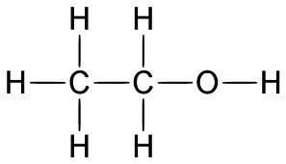 | Ethanoic acid  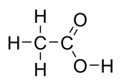 | 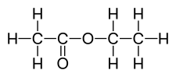 | Ethyl  ethanoate
Propanol | Ethanoic Acid
Butanol | Ethanoic Acid
Pentanol | Ethanoic Acid
Ethanol | Salicyclic Acid  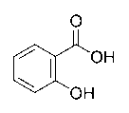
Ethanol | Benzoic Acid  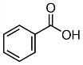
Propanol | Benzoic Acid  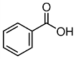

Post lab Question: Based on the results of this lab, predict the name of the product formed when octanol reacts with heptanoic acid. Draw the structures of this reaction.

