Forensic Entomology Lab

Objective: Use entomological evidence to determine the post-mortem interval (time of death) for each of the 5 cases.

PART 1:
- Examine the entomological in the evidence bag for each case. Be careful to work with the evidence from one case at a time.
- Measure the maggot and pupae evidence to determine the life stages and species found at the scene. Using the life history chart and ecological information (Tables 1-3) answer the questions for each investigation.

PART 2:
- Obtain the entomological evidence from crime scene 5 located in the petri dish.
- Remove 1 insect using tweezers and place them in the alcohol to kill/preserve them.
- Measure the length of the insect and record in Data table A.
- Using the information provided to you, determine the approximate post-mortem interval (time of death) based on the fact that this larvae is from a Blow Fly.
- Discard the dead insects in the garbage but leave the live samples in the petri dish.

Data Table A
Length of larvae
Time since death

Table 1: Common insects found to determine time of death
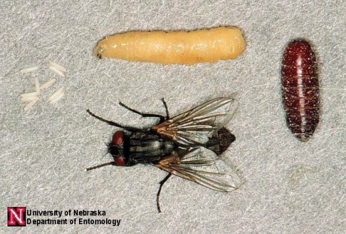  House Fly Live Stages (eggs, larva, pupa, adult) | 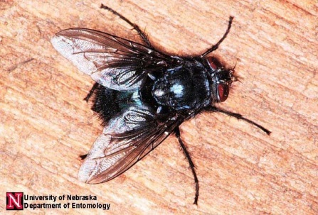  Blow Fly
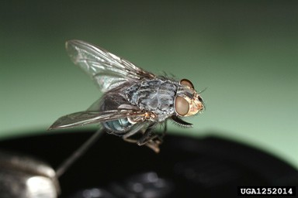 | 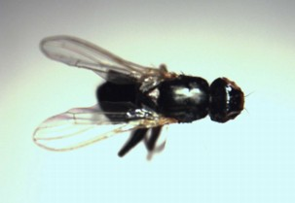
Flesh Fly | Skipper Fly

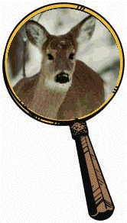
INVESTIGATION #1
Police Report: The body of a female deer was found behind a fence along a busy two-lane road on the edge of the city limits of Charlotte. Animal Control was called and reported no apparent wounds on the body. It was not hunting season.
Weather Report: Daytime temperatures have been fairly consistent for the past three weeks, ranging from 70 to 74º F.

Questions:
- Approximately how long has this animal been dead?

Insect | Length | Estimated Time Since Death
House fly (Blue)
Blow Fly (Yellow)
Fresh Fly (White)
Skipper fly (Pink)
Pupae (Brown)

Final answer to days since death: _________________
- Why are maggots of different ages found in the body?

- Other than temperature, what abiotic (external to the corpse) conditions would you want to obtain from the weather station to help you to be more confident of your time of death estimation?

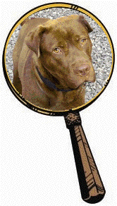

INVESTIGATION #2

Police Report: The body of a large pit bull terrier was found inside a walk-in basement at a home in Cary. Maggots were found concentrated in the head and region behind the shoulder. The windows were closed, although the open curtains allowed sunlight to enter, and the air conditioner was set at 72º F.

Weather Report: Daytime temperatures have been variable over the past three weeks, ranging from 75 to 94º F. Skies have been sunny.

Questions:
- Approximately how long has this animal been dead?

Insect | Length | Estimated Time Since Death
House fly (Blue)
Blow Fly (Yellow)
Fresh Fly (White)
Skipper fly (Pink)
Pupae (Brown)

Final answer to days since death: _________________
- What effect, if any, do the outside temperatures have on your estimation of time of death?

- How does the fact that the windows were closed relate to the populations of flies you observed in and around the corpse? (Is there something different about this population than the population in Investigation #1?) How do you explain the absence of the blow fly, Calliphora vomitoria?

- Do you suspect foul play? Explain.

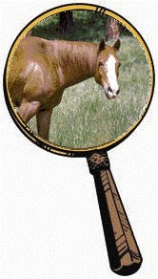
INVESTIGATION #3

Police Report: The body of a young male horse was found in a pasture in a small town near Wilmington. The autopsy from the vet school reveals that the cardiac glycoside, oleandrin (similar to digitalis, a powerful heart stimulant), was present in the body. Oleandrin is found in the oleander plant. Oleander is a common ornamental shrub in this area, but none grows within 200 feet of the pasture.

Weather Report: Daytime temperatures have been unusually warm over the past three weeks, ranging from 84 to 86º F.

Questions:
- Approximately how long has this animal been dead?

Insect | Length | Estimated Time Since Death
House fly (Blue)
Blow Fly (Yellow)
Fresh Fly (White)
Skipper fly (Pink)
Pupae (Brown)

Final answer to days since death: _________________
- What effect, if any, does oleandrin have on your estimation of time of death? Explain how you used this information in calculating the postmortem interval.

- What effect, if any, does temperature have on your estimation of time of death? Explain how you used this information in determining the postmortem interval.

- Does the location of the body, coupled with the insects recovered from it, suggest foul play, or can you tell from the information given? Explain.

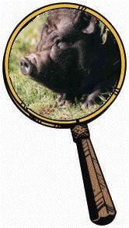
INVESTIGATION #4

Police Report: The body of a large pot-bellied pig was found in a dense stand of evergreen trees far from any urban area in Buncombe County. Hairs around the pig’s neck were worn away in a band pattern.

Weather Report: Daytime temperatures have been average over the past three weeks, ranging from 70 to 73º F. Temperatures in the woods would be approximately 5 degrees cooler due to the lack of sun in the shady environment.

Questions:
- Approximately how long has this animal been dead?
Insect | Length | Estimated Time Since Death
House fly (Blue)
Blow Fly (Yellow)
Fresh Fly (White)
Skipper fly (Pink)
Pupae (Brown)

Final answer to days since death: _________________
- What effect, if any, does temperature have on your estimation of time of death?

- Does the location of the body, coupled with the insects recovered from it, suggest foul play, or can you tell from the information given? Explain.

Table 2: Life History of Flies. The development of body length (in millimeters) of some fly species during their metamorphosis at 72o F (L = Larvae, P = Pupae, A = Adult Fly).
 | Species
Days after Death | (Blue)  Musca domestica House fly | (Yellow)  Calliphora vomitoria Blow fly | (White)  Sarcophaga carnaria Flesh fly | (Pink)  Piophila nigriceps Skipper fly
1 |  | Egg | L 9-11
2 | Egg | L 9-11 | L 12-16
3 | Egg | L 9-11 | L 17-20
4 | L 6 | L 12-16 | L 21-25
5 | L 6 | L 12-16 | L 26-30 | Egg
6 | L 7-11 | L 17-20 | L 31-35 | Egg
7 | L 12-16 | L 17-20 | L 36-40 | L 3
8 | L 17-20 | L 21-25 | L 41-44 | L 3
9 | L 21-25 | L 21-25 | L 44-46 | L 4-6
10 | L 26-30 | L 26-30 | L 44-46 | L 7-9
11 | L 31-35 | L 26-30 | P 38-40 | L 10-13
12 | P 26-29 | L 31-35 | P 38-40 | L 14-16
13 | P 26-29 | L 31-35 | P 38-40 | P 13-15
14 | P 26-29 | P 31-34 | P 38-40 | P 13-15
15 | P 26-29 | P 31-34 | P 38-40 | P 13-15
16 | P 26-29 | P 31-34 | P 38-40 | P 13-15
17 | P 26-29 | P 31-34 | P 38-40 | P 13-15
18 | A 30-32 | P 31-34 | P 38-40 | P 13-15
19 |  | P 31-34 | A 42-45 | A 16-18
20 |  | P 31-34
21 |  | A 36-38

Table 3: Ecological information for certain species of flies.
 |  | Musca domestica House fly | Calliphora vomitoria Blow fly | Sarcophaga carnaria Flesh fly | Piophila nigriceps Skipper fly
Temperature (oF) | 55o | delayed 4 | delayed 4.5 | delayed 4 | delayed 3
 | 65o | delayed 4 | delayed 3 | delayed 2 | delayed 1
 | 80o | accelerated 1 | accelerated 2 | accelerated 1.5 | accelerated 1
 | 85o | accelerated 3 | accelerated 4 | accelerated 3 | accelerated 2
Ecological Traits | Habitat  Lighting Drugs | urban and rural  full to partial sun no effect | urban and rural  partial sun to shady  sensitive to effects | urban and rural  prefers sunny  no effect | urban  prefers sunny  no effect

