Forensic Paper Chromatography
Introduction:
Chromatography is used to separate mixtures of substances into their components. All forms of chromatography work on the same principle.
They all have a stationary phase (the paper) and a mobile phase (the liquid solvent). The mobile phase flows through the stationary phase and carries the components (ink) of the mixture with it. Different components travel at different rates.
Paper chromatography can be used to help solve crimes involving notes. The ink from the note can be extracted with methanol. The ink can then be spotted onto paper and separated by chromatography. Each dye will have a specific retardation factor, or R_{f} value.

R_{f} = distance from origin to spot_______
distance from origin to solvent front

Purpose:
The purpose of this experiment is to use paper chromatography to determine which pen was used in a crime.

Materials:

Developing chambers
Chromatography paper
Pens
Water
Small vials
Methanol
Droppers
Pulled capillary tubes
Ransom note
Rulers
Scissors
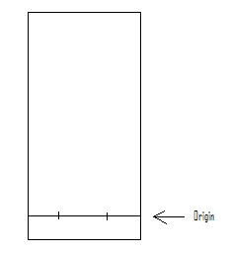

Safety:
Always wear safety glasses in the lab.

Procedure:
1. Obtain 3 pieces of chromatography paper. About 1 cm from the bottom, draw a straight line across each paper with a pencil. This line is called the origin.

2. For suspect #1 pen, place a small dot from the pen at the origin in the center of 1 piece of chromatography paper. Repeat for the other two suspects on separate pieces of chromatography paper.
3. Fill each test tube with 0.5 cm of ethanol.
4. Carefully insert one chromatography paper into each of the developing chambers, spotted end down. Also, be certain that the sides of the paper do not touch the developing chamber.
8. Allow the developing chamber to remain undisturbed until a good separation is obtained or until the solvent front is near the top of the paper. In a good separation, the colors are separated and the solvent is clearly above the top color. Do not let the solvent run off the paper.
9. Remove the chromatogram.
10. Mark the solvent front with a pencil.
11. Calculate the Rf values (Rf = distance solute moved/distance solvent moved).

Data/Calculations:

Suspect 1 Suspect 2 Suspect 3 Forged Check
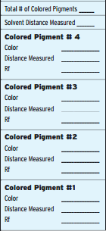
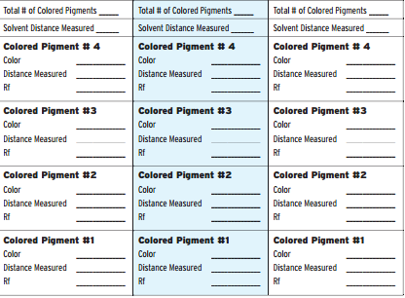

Analyis: Match the suspect chromatograms to the chromatogram from the evidence bag and determine which suspect forged the check.

Suspect # ______________

