Unit 1: Observation, Inference, Perception, Crime Scene Procedures, 4th Amendment
Introduction to Forensic Science Notes

Forensic Science: The application of scientific knowledge and methodology to legal problems and criminal investigations

Types of Science used in Forensics:

- Chemistry
- Biology
- Firearms
- Document Examination
- Photography
- Toxicology and Drug Analysis
- Technology
- Fingerprints

Forensic Scientist Job Description:
- Process and document crime scenes
- Collect and preserve evidence
- Analyze and compare evidence in laboratory
- Reconstruction of data (form the “best theory” of events in the case)
- Testify as an expert witness
- Scientific research
- Training others in forensic science

Types of Forensics
- Computer Forensics: Computers for fraud and the pursuit of other crimes has increased to dramatic proportions. Specialists deal with computer crime. Computer crime is not only about fraud. Computer crimes also deal with pornography, child sex abuse and the sale of black market goods online.
- Forensic Accounting: A forensic accountant will seek to trace any financial discrepancies within a company's accounts and use so-called 'paper trails' or 'audit trail’
- Forensic Archaeology: Archaeology and anthropology are the study of historic human remains and the objects, buildings and other artifacts associated with them.
- Forensic Dentistry: Forensic Dentistry is the area of forensic medicine concerned with the examination of teeth, especially in the cases of victims who cannot be identified.
- Forensic Entomology: Entomology is the study of insects. Forensic entomologists use insects to provide more information about crimes.
- Forensic Graphology: Forensic Graphology is the study of handwriting especially that found in ransom notes, poison pen letters or blackmail demands.
- Forensic Medicine: If a body is found in a field with no visible signs of injury forensic medicine seeks to answer the questions; how did the body get there, how did the person die.
- Forensic Pathology: Forensic pathology involves discovering the cause of death, especially in cases where it is sudden or the police suspect that it has not occurred by natural causes.
- Forensic Psychology: Forensic psychology is the forensic study of the mind and the ways in which the mind works, especially in the instances of violent crime.
- Forensic Toxicology: Forensic toxicology deals with the investigation of toxic substances, environmental chemicals or poisonous products. If you have ever been asked to take a drug test for work or you know someone who has, then you are already familiar with one of the applications of forensic toxicology. The toxicology part refers to the methods used to study these substances. Forensic toxicology is actually a bit of a mix of many other scientific disciplines such as chemistry, pathology and biochemistry. It also shares ties with some of the environmental sciences.
Degree Requirements:
- B.S. in science (preferred to be in biology, chemistry or forensic science)
- Some schools specialize in a forensic science B.S. degree (ex. John Jay College of Criminal Justice)
Skills Needed:
- Good observation skills – use 5 senses
- Analytical skills – ability to identify problem, organize info, draw conclusions
- Deductive reasoning – using logical steps to draw a conclusion based on facts or evidence

Are Forensic Scientists part of the police department?
- Varies by County and State (some lab are independent labs some are part of the police department)
- The forensics lab must be accredited to hold up in court

Four Major Federal Crime Laboratories:
- FBI Federal Bureau of Investigation, largest crime lab in the world
- DEA Drug Enforcement Administration, analyzes drugs seized
- ATF Bureau of Alcohol Tabaco and Firearms, analyzes alcoholic beverages, weapons, explosives
- USPIS U.S. Postal Inspection Service, crimes involving the postal service

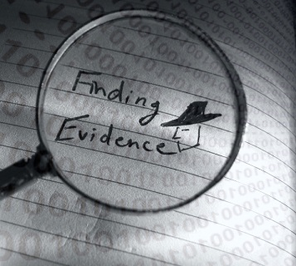
Perception Notes

How are observations made? We use our senses: Sight, Taste, Hearing, Smell, Touch. But these observations can be flawed! Given the unreliable nature of eyewitness testimony, summarize the importance of forensic evidence rather than eyewitness accounts in criminal proceedings on your conclusion sheet.

Body language: Some indicators to look for:
- Watch the eyes
- Look for fidgeting
- Look for covering the mouth or touching the face
- Observe for a dry mouth
- Pay attention to gestures
- Crossing arms or legs
- Body pointed away from you or avoiding eye contact

The Modern polygraph was invented by James Larson in 1921. Polygraph’s work by attempting to detect unconscious changes in the body such as increased heart rate, blood pressure, breathing rate and changes in skin such as sweating. The admissibility of polygraph results in court is on a case by case basis. Voice detectors were invented in the 1970’s to detect changes in stress of the voice.

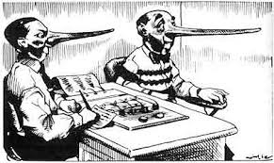
Crime Procedures Notes
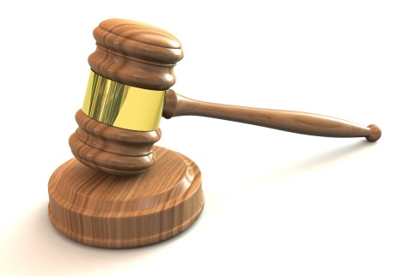
- Investigation:
  - Crime scene documented and searched for evidence
  - Information is gathered for prosecutor
  - Determine if there is enough evidence for probable cause
    - Probable Cause – reason for making a search
- Arrest Warrant Issued
  - No warrant needed if an officer was present
  - 95% of all arrests occur without a warrant.
- During Arrest
  - Suspect is read Miranda rights
  - Suspect is “booked”- fingerprinted and photographed
  - Suspect is presumed innocent
- Within 72 hours:
  - Non Jury Hearing
  - Prosecution presents case
  - Accused can cross examine and provide favorable evidence
- Judge:
  - Assures defendant has a lawyer and understands the charge
  - If it is a Misdemeanor, the court may accept a plea
  - For Felonies the judge sets preliminary hearing to decide if there is probable cause if the defendant pleads:
    - Guilty: Sentencing date
    - Not Guilty: Trial date
The Burden of Proof
- The burden of proof is on the prosecution
- 50% of persons arrested are convicted
- 25% of those arrested are sentenced to 1 or more years in prison
- 90% of cases are plea bargained
The Legal System
- Civil Law- Deals with the relationships between individuals
Ex. Contracts, marriage, divorce, wills property
- Criminal Law – Deals with offenses against an individual
- Misdemeanor: minor crime theft, minor assault & battery, Small amounts of drugs
- Felony: Rape, Murder, Armed robbery, Serious assaults, Dealing drugs, Fraud, Auto theft, Forgery

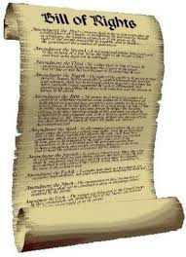
The “Bill of Rights”
The “Bill of Rights” gives individuals the right to:
- presumed innocence until proven guilty.
- not to be searched unreasonably.
- not to be arrested without probable cause.
- “reasonable” search and seizure of personal property.
- refuse self-incrimination.
- fair questioning by police.
- protection from physical harm throughout the justice process.
- to an attorney.
- trial by jury.
- be made aware of charges.
- cross-examine prosecution witnesses.
- not be tried again for the same crime.
- guard against cruel and unusual punishment.
- due process.
- speedy trial.
- excessive bail and fines.
- equal treatment regardless of race, gender, religion, country of origin and other personal attributes.

Miranda Rights
Your “Miranda Rights” are named after a U.S. Supreme court case Miranda v. Arizona S384 US 436 (1966). The police must advise suspects of their "Miranda Rights" - their right to remain silent, their right to an attorney, and the right to an appointed attorney if they are unable to afford counsel - prior to conducting a custodial interrogation. If a suspect is not in police custody (i.e., "under arrest"), the police do not have to warn him of his rights.

Miranda v. Arizona:In 1963, Ernesto Miranda, a 23 year old mentally challenged man was arrested for stealing $8.00 from a bank in Phoenix, Arizona. After 2 hours of questioning, not only did he confess to stealing the money, but he confessed to the kidnapping and rape of an 18 year old woman 11 days earlier. He was never told that he did not have to speak or that he was allowed to have a lawyer present.

Outcome of the Case: At the trial, Miranda’s lawyer tried to get the confession thrown out, but it was denied. In 1966, the case went to the Supreme Court. The Supreme Court ruled that Miranda’s confession was inadmissible and could not be used as evidence because he was not advised of his rights.

The 4th Amendment Notes

The fourth is an amendment to the United States Constitution and part of the Bill of Rights. It prohibits unreasonable searches and seizures and requires any warrant to be judicially sanctioned and supported by probable cause.

Types of Searches:
- looking around a house or apartment
- looking into an automobile
- wire taps
- taking blood/saliva
- looking through binoculars or telescopes
- x-rays
- looking through pockets and hand bags
- dog sniffing

Legal Warrantless Searches:
- Searches after an arrest
- Consent searches
- Plain view
- Stop and frisk
- Hot pursuit
- Automobile
- Inventory
- Border and airport searches
- Exigent circumstances

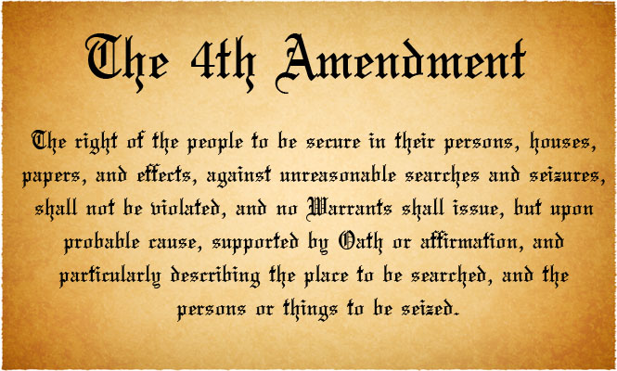

What is a Criminal?
1. When you think of a criminal, what comes to mind?

- Draw your criminal. Be as detailed as possible (don't worry if you are not a good artist).

- Analyzing your drawing, do you see any characteristics about your criminal that can be viewed as a stereotype? How could this affect an eyewitness account?

- Now without looking it up, what are some types of physical evidence that can be used to help solve crimes? Write them down.

- Check your list with this one below. Circle the evidence you missed.
Drugs and toxic substances | Resins, plastics | Fingerprints
Paints | Explosive residues | Hair
Gunshot residues | Serial numbers | Tissues
Firearms and ammunition | Documents | Pollen
Impressions (shoe prints, bite marks…) | Fibers | Wood material
Petroleum products | Glass | Bones
Rubber material | Body fluids | Tool marks

- This is a test of your observational skills. Look at the picture for 3 minutes. Then answer the questions without looking back at the picture.
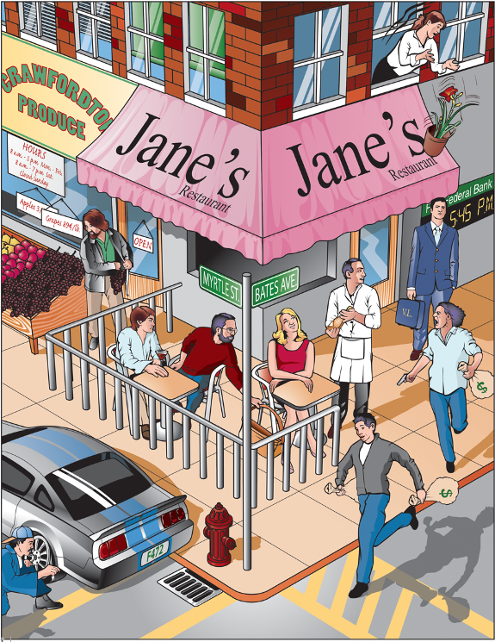

  - What time was it by the bank’s clock?
  - What day of the week was it?
  - What was the name of the outdoor café?
  - On what street was the entrance to the restaurant?
  - How many thieves are staging the holdup?
  - Were they armed?
  - How many bags of loot were they carrying?
  - Was the thief in the street wearing a hat?
  - How many people, besides you and the holdup men, were at the robbery?
  - What were the initials of the man in the business suit?
  - What immediate danger was he in?
  - Was the onlooker from the second floor a man or a woman?
  - What store was next to the café?
  - What was the shopper stealing?
  - What was the license number of the car parked in front of the store?
  - How do you know the car was illegally parked?
  - What part of the car was being vandalized?
  - What type of hat is the person wearing who is vandalizing the car?
  - What offense was in progress against the female diner?
  - What was the cost of the grapes?

The Trouble with Eyewitness Identification Testimony in Criminal Cases
Greg Hurley, Knowledge and Information Services Analyst, National Center for State Courts
Research has found that eyewitness-identification testimony can be very unreliable. Law enforcement and the courts should follow the recommendations of social scientists when using and assessing eyewitness techniques, such as lineups, in criminal cases.
Social scientists have demonstrated through studies since the 1960s that there was significant reason to be concerned about the accuracy of the eyewitness-identification testimony used in criminal trials. Although witnesses can often be very confident that their memory is accurate when identifying a suspect, the malleable nature of human memory and visual perception makes eyewitness testimony one of the most unreliable forms of evidence.
Courts took very little notice of the problems associated with eyewitness identification until DNA evidence began to be used to exonerate criminal defendants, in some cases decades after they were convicted. In irrefutable cases of wrongful conviction, people both within and outside of the judiciary began to question the factors that led to each wrongful conviction. It became clear that the predominate cause was inaccurate eyewitness identification.
In 2014 the National Academy of Sciences (NAS) released a report, Identifying the Culprit: Assessing Eyewitness Identification. It was a very comprehensive review of studies that defined the nature of the problem and suggested solutions that can be employed to mitigate the impact. The report made it clear that this is a very complex problem, rooted in human psychology, which impacted police and courtroom practices. Following the NAS report, there have been a number of published articles further addressing the psychological underpinnings of the problem, police practices, and possible judicial solutions.
In 2016 Professor Keith A. Findley published “Implementing the Lessons from Wrongful Convictions: An Empirical Analysis of the Eyewitness Identification Reform Issues” (Missouri Law Review, vol. 81). Professor Findley’s article was important because he synthesized the prior work in this area and presented it in a comprehensible way for the legal community. He also addressed the mechanisms some state judiciaries have used to mitigate the problem.
It should be noted that the most critical reforms in the area of eyewitness identification will need to come from the law-enforcement community. However, the court plays an important role as the gatekeeper of evidence that can be used against a defendant.
In using lineups for purposes of eyewitness identification, the literature recommends the following reforms, as defined by Professor Findley:
- Only One Suspect per Procedure
- Proper Selection of “Fillers”
- Unbiased Witness Instructions
- Double-Blind Administration
- Prompt Recording of Confidence Statements
- Sequential Presentation
- Limit the Use of Show-ups
It is suggested that only one suspect be included in a lineup, even if there are multiple suspects. Lineups are designed to be a test of memory, and including more than one suspect increases the chance that a defendant is selected by mere guesswork. This recommendation is equally applicable to paper lineups, in which the witness is shown photographs, and more traditional lineups of actual people. The “fillers” that are included in the lineup should be of the same race and age range and generally fit the description of the perpetrator. The actual suspect should not stand out due to some physical characteristic from the fillers. The instructions given to the witness should include a statement that the perpetrator may not be present in the lineup. This is critically important because research has demonstrated that this instruction decreases misidentifications. Ideally, the instructions would be standardized, with the same instructions read to every witness before a lineup.
Humans can subtly and unconsciously communicate information. This may be by eye movement, gesture, or other body movement. For this reason, the administration of lineups should be “double blind,” meaning that neither the witness nor the officer administering the lineup know which person is the suspect in the case. This eliminates any possible “contamination” of the lineup. When witnesses select the individual they believe is the culprit, their degree of confidence should be contemporaneously recorded. This is important because studies have shown that witnesses’ confidence in their selections can increase over time. Changes in the confidence level may later be a critical issue for the trier of fact when considering the credibility of an eyewitness’s identification.
A disadvantage of a traditional lineup, or a lineup of pictures when all the pictures are presented at once, is that a witness may compare people and select the person that most approximates what they remember. Although the literature is divided on this issue, most reports and studies suggest a sequential lineup may be more reliable. In a sequential lineup, people or pictures are shown to a witness one at a time. This causes the witness to focus exclusively on the person or picture presented, rather than engage in comparison.
The worst form of a lineup is the “show-up.” Show-ups are typically used in the field and are done shortly after a crime was committed. Law enforcement will cause a witness to view a single suspect who has often been located in the vicinity of the crime. The suspect is most frequently in handcuffs and may be showing other signs of distress, e.g., sweating. Obviously, these circumstances create a highly suggestive situation in which the risk of a misidentification dramatically increases. Although there may be some situations when police do not have probable cause to make an arrest and this may be the only viable investigatory mechanism they have, this practice should not otherwise be used.
Courts have historically taken the position that the credibility of witnesses is the province of juries. However, some state judiciaries have taken action to decrease the risk of misidentifications. For example, both New Jersey and Massachusetts have created new statewide jury instructions that give jurors guidance regarding the problems associated with eyewitness identifications and how they can better assess the credibility of that testimony. The New Jersey Courts also created Rule 3:11 (Rules Governing the Courts of the State of New Jersey), “Record of Out of Court Identification Procedure.” The rule requires that a law-enforcement officer must make a contemporaneous record of a lineup procedure, and the rule specifies what must be included in the record. If a law-enforcement officer fails to comply with the requirements of the rule, the results of the lineup are inadmissible. This is an excellent example of a judiciary using its evidentiary gatekeeping function to cause necessary change in law-enforcement procedures.
To protect the public from wrongful convictions based on an eyewitness misidentification, it is important that both law enforcement and the courts take notice of recent developments on the issue in the social sciences. The courts must be aware of the malleable nature of human memory and the lineup practices used by law enforcement in the jurisdiction. Although they are downstream of the primary problem, the courts have the power and duty to properly instruct jurors, the ability to refuse to admit evidence that does not meet a fundamental level of trustworthiness, and the ability to work with justice system partners to improve the criminal justice system.

Questions:
- Are eyewitness-identifications reliable? Why or why not?

- How many suspects should be included in a lineup?

- What does it mean when they say the administration of lineups should be “double blind?"

- What type of lineup (all at one or sequential) is best and why?
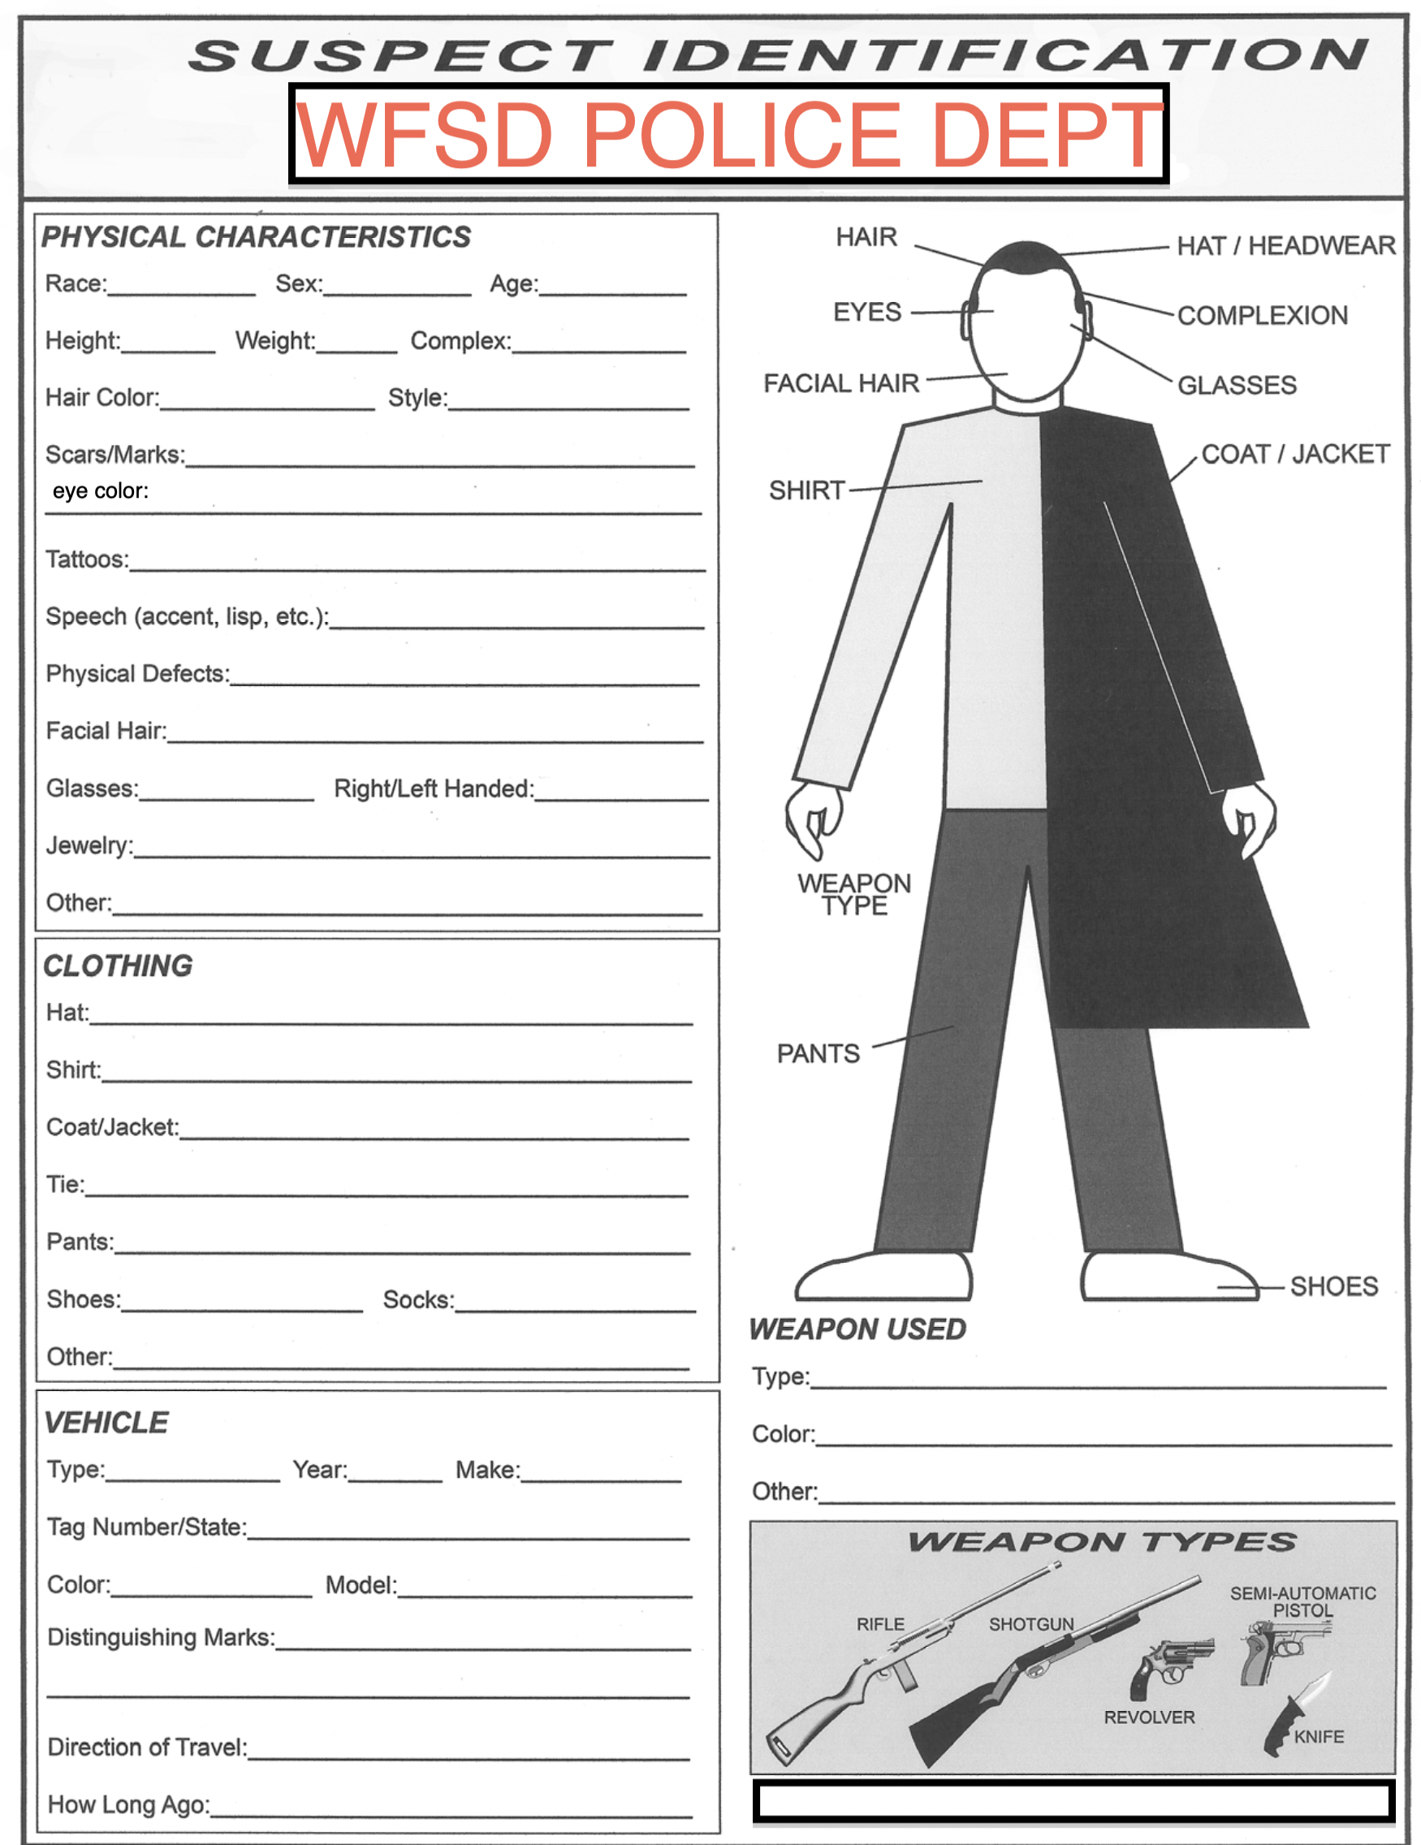
4th Amendment Rights in School Part 1
Objective: You will examine a case involving a students' 4th Amendment rights.
Procedure: Read the court case and answer the questions that follow.
What Happened in State Court?
The State of New Jersey brought delinquency charges against T.L.O. in Juvenile Court. T.L.O. argued that the vice-principal violated her Fourth Amendment rights to be free from unreasonable searches and seizures by government officials because the vice-principal had no reason to believe a crime had been committed and had no search warrant. The Juvenile Court agreed that a vice-principal was a government official and that Fourth Amendment protections applied to searches by school officials but found that the vice-principal's search of her purse was reasonable. The New Jersey Supreme Court reversed the Juvenile Court and found that once the vice principal had found the cigarettes in T.L.O.'s purse, the search should have ended and there should have been no further exploration of the purse.
Appellant's (State of New Jersey) argument: The vice-principal's search of the purse was reasonable because a teacher had told the vice-principal that T.L.O. had been smoking. Thus, the vice-principal had reasonable cause to suspect a school rule had been broken. When the vice-principal was searching for the cigarettes, the drug-related evidence was in plain view. Plain view is an exception to the warrant requirement of the 4th Amendment.
Respondent's (T.L.O.) argument: The vice-principal had no probable cause to believe that T.L.O. had committed a crime when he searched her purse. Possession of and use of cigarettes (at that time) were not crimes. Belief that a school rule has been broken is not grounds for a warrantless search. Furthermore, even if the vice principal had the right to search T.L.O.’s purse for cigarettes that the search should have ended when the cigarettes were found.
Food for thought: If the Court should find that the vice-principal's search of T.L.O.'s purse was reasonable, does this open the door to school administrators randomly searching students' lockers, desks and belongings?
*T.L.O. is the initials of the juvenile in this case. Since the person involved in the case is a minor, her name may not be used in order to protect her privacy.

Background:
In a New Jersey high school, a teacher found two girls smoking in the bathroom and took them to the principal's office. One girl admitted to smoking but the other, known as T.L.O., denied it. The principal demanded to see the girl's purse and found evidence that she was also selling marijuana at school. T.L.O. was taken to the police station where she admitted to selling marijuana. Based on her confession and the evidence in her purse, the state of New Jersey brought charges against her. In a juvenile court, T.L.O. argued that her Fourth Amendment rights against unreasonable searches and seizures had been violated. The court sided with the school, and T.L.O. took her case to the New Jersey Supreme Court, which later found that the search was unreasonable and the evidence could not be used. The state of New Jersey appealed the decision to the United States Supreme Court.

Decision:
In 1985, the Supreme Court, by a 6-3 margin, ruled that New Jersey and the school had met a "reasonableness" standard for conducting such searches at school. The high court said school administrators don't need to have a search warrant or probable cause before conducting a search because students have a reduced expectation of privacy when in school.

Conclusion Questions:
- Who is right? The students or the or the principal?

- If the principal does not find anything, does this mean he violated the students' Fourth Amendment rights? Explain.

- Did the principal need a reason to search their lockers? Cite specific evidence from the reading.

4th Amendment Rights in School Part 2

Objective: Do students have the same rights on school premises as they do outside of school?
Setting: School hallway in front of Kristen's and Chris's lockers.
Principal: Kristen and Chris, please open your lockers. It has been reported to the office that you brought a knife to school. You know it is against the law to have weapons in school.
Mark: I do not have a knife in my locker. I will not open this locker without you getting a search warrant.
Elaine: I also do not have knives in my locker. Unless you have a search warrant, you have no right to search my locker.
Principal: I have here the combinations to both of your lockers. If you will not open the lockers for me, I will open them on my own.
Mark: If you find anything, you cannot use it against me to punish me.
Elaine: Don't you know anything about the Fourth Amendment? You can't just search anywhere that you want. This is my private locker.

Procedure: Read the following case then answer the questions that follow

New Jersey v. T.L.O.*
Facts of the Case: On March 7, 1980, a teacher at Piscataway High School in New Jersey found two girls smoking in a restroom. Since this was a violation of school rules, the teacher took the two students to the principal's office. The assistant vice-principal questioned the two girls separately. One student admitted that she had been smoking. However, T.L.O. denied that she had been smoking in the restroom and claimed she did not smoke at all. The assistant vice principal then asked to see T.L.O.'s purse. When he opened the purse he found a pack of cigarettes and also noticed a package of rolling papers which the vice-principal knew were associated with marijuana use. He then searched the purse more thoroughly and found a small quantity of marijuana, a pipe, several empty plastic bags, a substantial amount of money, a card that appeared to be a list of students who owed T.L.O. money, and two letters that implicated T.L.O. in the distribution and sale of marijuana, a crime under New Jersey law.

What Happened in State Court: The State of New Jersey brought delinquency charges against T.L.O. in Juvenile Court. T.L.O. argued that the vice-principal violated her Fourth Amendment rights to be free from unreasonable searches and seizures by government officials because the vice-principal had no reason to believe a crime had been committed and had no search warrant. The Juvenile Court agreed that a vice-principal was a government official and that Fourth Amendment protections applied to searches by school officials, but found that the vice-principal's search of her purse was reasonable. The New Jersey Supreme Court reversed the Juvenile Court and found that once the vice-principal had found the cigarettes in T.L.O.'s purse, the search should have ended and there should have been no further exploration of the purse.
Appellant’s (State of New Jersey) argument: The vice-principal's search of the purse was reasonable because a teacher had told the vice-principal that T.L.O. had been smoking. Thus, the vice-principal had reasonable cause to suspect a school rule had been broken. When the vice-principal was searching for the cigarettes, the drug-related evidence was in plain view. Plain view is an exception to the warrant requirement of the 4th Amendment.
Respondent’s (T.L.O.) argument: The vice-principal had no probable cause to believe that T.L.O. had committed a crime when he searched her purse. Possession of and use of cigarettes (at that time) were not crimes. Belief that a school rule has been broken is not grounds for a warrantless search. Furthermore, even if the vice-principal had the right to search T.L.O.'s purse for cigarettes that the search should have ended when the cigarettes were found.
Food for thought: If the Court should find that the vice-principal's search of T.L.O.'s purse was reasonable, does this open the door to school administrators randomly searching students' lockers, desks and belongings?
*T.L.O. is the initials of the juvenile in this case. Since the person involved in the case is a minor, her name may not be used in order to protect her privacy.

1. Who is right, Elain, Mark or the principal?

2. If the principal does not find anything, does this mean she violated Elain and Mark’s Fourth Amendment rights? Explain.

3. Did the principal need a reason to search their lockers? Cite specific evidence from the reading.

4th Amendment Rights in School Part 3

Objective: Do schools have the right to drug test student athletes?
It's My Body
Setting: High School classroom during a meeting for winter sports
Characters: Girls' basketball coach—Champ,
Boys' basketball coach--Coach Winner,
Players--Jack and Jill

Coach Champ: All of you players need to know that at any time we can require you to
give us a urine sample.
Jack: No way! That is an invasion of our privacy.
Coach Winner: The United States Supreme Court says we can do it and we will.
Jill: Why are you doing this?
Coach Champ: To test for drug use among the athletes.
Jack: I didn't think we had a drug problem in this school
Coach Winner: We don't, but we are going to test so we can keep drugs out.
Jill: I don't think the United States Supreme Court allows you to do that.
Coach Champ: The school lawyers, Joanie Cochran and Mark Clark, say we can legally do this.
Jack: Those two got their law degrees by correspondence courses.

1. Who's right, the coaches or the students?

2. List the necessary criteria for allowing the urine testing.

6 Major Exceptions to the Warrant Requirement

Procedure: Please read each case and decide if any of the evidence is admissible. Please number each case 1 - 6 and state what the evidence is and whether or not it is admissible in court.

1. Search Incident to Lawful Arrest
A search incident to lawful arrest does not require issuance of a warrant. In other words, if someone is lawfully arrested, the police may search her person and any area surrounding the person that is within reach (within his or her “wingspan”). See Chimel v. California, 395 U.S. 752 (1969). The rationale is that the search is permissible as a protective measure.

EXAMPLE: John is arrested for driving while intoxicated after being pulled over for running a red light. A search of his car reveals 8 bags of heroin in the glove compartment and an illegal handgun in the trunk. Which if any of the evidence is admissible?

2. Plain View Exception
No warrant is required to seize evidence in plain view if the police are legitimately in the location from which the evidence can be viewed. For example, an officer cannot illegally enter a suspect’s back yard and then use the plain view exception to seize an illegally kept alligator living in the pool. But, if on the premises to serve a warrant duly issued to search for marijuana plants, the alligator, if in plain view, can rightly (though by no means easily) be seized.

EXAMPLE: The police are called to Donald’s house by neighbors who see him beating up his wife, Victoria. After properly entering the house (without a search warrant – see emergency exception below), police notice Donald’s prized gun collection hanging on the wall. Fortunately for the officers, the guns are not loaded. Unfortunately for Donald, many of them are illegal and Donald is arrested for battery as well as for the illegal guns, which are seized. Which if any of the evidence is admissible?

3. Consent
If consent is given by a person reasonably believed by an officer to have authority to give such consent, no warrant is required for a search or seizure. So, if a suspect’s "significant other" provides police with a key to the suspect’s apartment, and police reasonably believe that she lives there, the search will not violate suspect’s Fourth Amendment rights even if she did not live there and even if she, in fact, lacked authority to consent, . See Illinois v. Rodriguez, 497 U.S. 177 (1990).

EXAMPLE: Officer Warren knocks on a murder suspect’s door. the door is answered by the suspect’s 6 year old child, Timmy. The officer asks Timmy “Is it okay if I come in and talk to your Dad? He’s expecting me.” And then walks into the apartment. He then sees the suspect, Roland, sitting on the sofa oiling his illegal Tommy-gun, the suspected murder weapon. He arrests Roland for possession of the gun and seizes the evidence. Which if any of the evidence is admissible?

4. Stop & Frisk
Police may stop a suspect so long as there is a reasonable suspicion of a criminal act. The evidence necessary for “reasonable suspicion” here is something beyond mere suspicion, but is less than the level required for probable cause. If there is reason to believe that the person may be armed and dangerous, the police can also frisk the suspect. See Terry v. Ohio, 392 U.S. 1 (1968).

EXAMPLE: Officer P. Harker’s peers often joke that he has something akin to a “spidey-sense” which tells him when folks are up to no good. While enjoying a cup of coffee at his favorite donut shop, Officer Harker’s neck hairs stand up straight. He immediately goes outside where he sees Ivan walking down the street, carrying a small duffel bag. He orders Ivan to stop and drop the bag. When the bag falls, Officer Harker hears the clanging of metal against metal. He then frisks Ivan and discovers a hidden pistol in Ivan's pocket. He then searches the duffel bag and discovers ammunition and several illegal hunting knives. Which if any of the evidence is admissible?

5. Automobile Exception
Because vehicles are obviously highly mobile, a warrant is not required to search vehicles if police have probable cause to believe the vehicle contains evidence of a crime, the instrumentalities of crime, contraband, or the fruits of a crime. Although commonly referred to as the “automobile exception,” this rule applies to any vehicle, including boats. While in some ways, it is quite a broad exception, this rule limits the ability to search those areas which might contain evidence of the type suspected to be present. In other words, if police suspect that the occupant of a boat is smuggling people across the border, searching a small tackle box on board would not be permissible. However, if they were looking for drugs, they could search the tackle box. The rationale is that, if an officer has to take the time to obtain a warrant, the vehicle might be out of reach before the warrant can be issued and executed. See Carroll v. United States, 267 US. 132 (1925).

EXAMPLE: Officer Demidum has reason to believe that an abandoned car on the corner contains illegal drugs in the trunk. The car is missing all four wheels and is up on cinder blocks, and the engine was stolen long ago. Assuming that the automobile exception applies, Officer Demidum uses a crowbar to force open the still-working lock on the trunk. There, he finds 10 kilos of cocaine. Rushing back to the station house to show off the evidence to his Captain, Officer Demidum runs into Judge Sosad. Judge Sosad says “You should have called me first. Which if any of the evidence is admissible?

6. Emergencies/Hot Pursuit
The rationale here is similar to the automobile exception. Evidence that can be easily moved, destroyed or otherwise made to disappear before a warrant can be issued may be seized without a warrant. Furthermore, if a suspect enters private property while being pursued by officers, no warrant is required to enter that property in order to continue pursuit, even if the suspect is in no way connected with the property owner.

EXAMPLE: While running from police, Fred enters Joe’s garage and the police follow Fred in. (They are not required to give up pursuit until such time as they can obtain a search warrant for the premises.) While in Joe's garage, police notice illegal drugs in plain view. Which if any of the evidence is admissible?

Taking the DNA of Arrestees:
Protecting the Public or Violating the 4th Amendment?

An arrestee is a person arrested for a crime and who has not yet been convicted for that offense. Currently, 21 states have passed legislation to make it legal for law enforcement to swipe an arrestee's inner cheek for DNA. The DNA is processed and its profile is entered into the state's CODIS DNA database (SDIS) to see if the person has a criminal record and if it can be linked to any previous unsolved crimes by matching it to "unknown forensic samples" in the DNA database.
The 21 states that presently allow this are: Alabama, Alaska, Arizona, Arkansas, California, Colorado, Florida, Indiana, Kansas, Louisiana, Maryland, Michigan, Minnesota, Missouri, New Mexico, North Dakota, South Carolina, South Dakota, Tennessee, Texas Vermont and Virginia.
In these states and the others that have not yet passed similar legislation, the legality and ethics of taking DNA from arrestees continues to be debated.
Argument For Taking DNA From Arrestees
Criminals tend to be repeat offenders and numerous studies that have documented that the taking of arrestee's DNA helps to reduce and avoid crime, especially homicides and rapes. For example, in a recent Indiana Study each conviction of an offender prevented an average of seven to eight future crimes. And according to an article published in the Michigan Law Review in 1991 (Vol. 89, 1991), "Bright Lines, Dark Deeds: Counting Convictions Under the Armed Career Criminal Act," by James E. Hooper, 70% of American crime is committed by just 6% of its criminals.
4th Amendment Concerns
Critics also argue that the taking of DNA from arrestees is in violation of the 4th Amendment. The 4th Amendment of the U.S. Constitution guards against unreasonable searches and seizures. People on both sides of the issues, whether they are civil libertarians or supporters of DNA arrestee laws, have strong opinions about what the 4th Amendment actually protects.
"The right of the people to be secure in their persons, houses, papers, and effects, against unreasonable searches and seizures, shall not be violated, and no Warrants shall issue, but upon probable cause, supported by Oath or affirmation, and particularly describing the place to be searched, and the persons or things to be seized."
Civil libertarians argue that DNA from arrestees violates their 4th Amendment rights because it constitutes an unreasonable search and seizure. Proponents of DNA arrestee laws focus on the "probable cause" phrase in the Amendment. They claim that an arrestee's DNA can be taken because it is "probable cause" that caused them to be arrested in the first place. In recent years, as more and more states have passed legislation to take DNA of arrestees, some arrestees have challenged these laws on 4th Amendment grounds.
Charles Raines was indicted in Montgomery County, Maryland on charges of first degree rape, second degree rape and robbery. In August 2003, he filed suit. Raines claimed that the taking of his DNA was in violation of his 4th Amendment Rights. On January 29, 2004, the Circuit Court for Montgomery County granted the appellee's motion to suppress physical evidence because it found that the Maryland DNA Collection Act (Md. Code (2003), Â§ 2-501 et. seq., of the Public Safety Article), was in violation of the Fourth Amendment. But on August 26, 2004, the appellate court overturned the lower court and ruled that the DNA Collection Act does not violate the Fourth Amendment. The court's opinion included: "The DNA profile thus serves the purpose of increasing the efficiency and accuracy in identifying individuals within a certain class of convicted criminals. The purpose is akin to that of a fingerprint". State v. Raines 857 A.2d 19, 33 (Md. 2004).
Similarly, on September 14, 2007, the Virginia Supreme Court, ruled in Anderson v. Commonwealth, that an arrestee's DNA sample, "is analogous to the taking of a suspect's fingerprints upon arrest and was not an unlawful search under the Fourth Amendment." Anderson had his DNA taken upon his arrest in 2003 on unrelated charges of rape and sodomy. When his DNA profile was passed through the DNA Database it produced a "cold hit" to a woman that was raped, sodomized, and robbed in 1991.
And on January 20, 2007, the Supreme Court of New Jersey handed down a decision, supporting the taking of DNA of an arrestee in State v. O'Hagen, 914 A.2d 267, 280 (N.J. 2007). In this case the defendant entered a guilty plea in the Superior Court to third-degree possession of a controlled substance (heroin) and his sentence included the requirement of submitting to DNA testing. The defendant challenged this requirement and the challenge made its way to the state's Supreme Court. The Supreme Court held that: (1) New Jersey's DNA Database and Databank Act of 1994 does not violate federal and state constitutional rights to be free from unreasonable searches, and (2) the Act does not violate equal protections under federal and state constitutions.
Explain whether you are for or against taking DNA from arrestees. Support your answer and be prepared to defend your decision.

Should Arrestee's DNA Be Kept?
Another issue that is raised among civil libertarians is if an arrestees' DNA profile does not match any previous unsolved crime and the arrestee is not convicted or the case against him is thrown out, should his DNA be kept in the database? In fact, in some states the DNA sample is automatically destroyed and the DNA profile is removed from the database (e.g. Virginia). Other states handle this differently. For example, the law passed in Colorado permits the collection of DNA at booking, but samples may not be uploaded into the DNA database until there are charges. Also, the law requires the resulting DNA profile to be removed from the database if the person is not charged with a felony, the charges are dismissed, or if the person is found not guilty of the felony charge.
Other states require that the arrestee must petition the court to have their DNA profile destroyed and removed from the database (e.g. California). In some states, the DNA profile of the arrestee, will be catalogued and stored in the DNA Database indefinitely. The assumption being that, that certain arrestees may commit more crimes in the future and they can then be identified faster before more people are victimized.

Explain whether or not you feel that if DNA is taken from an arrestee should be kept in a database. Support your answer and be prepared to defend your decision.

