Unit 4: Impressions

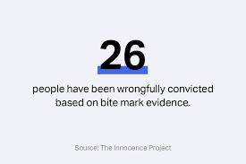
Impressions
Impressions are created when one object is pressed against another material with enough force to leave an impression or imprint of the object. Examples of Impressions:

- Bite Marks: Individual evidence if the Forensic Odontology investigator has the right tools and the mark is full. Investigators can analyze bite mark for the following individual evidence:
  - Characteristics of the teeth (position, evidence of dental work, wear patterns, etc.)
  - Saliva or blood (DNA)
  - Approximate age of biter
  - When the bite occurred
  - If the person played an instrument, has teeth that are chipped
- Impressions of the teeth can be created using overlays.
- Humans have 32 teeth if they have their “Wisdom” teeth and 28 if they don’t (age at which they appear – can come in up until you are 25!)

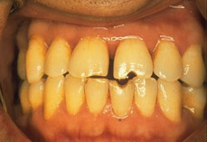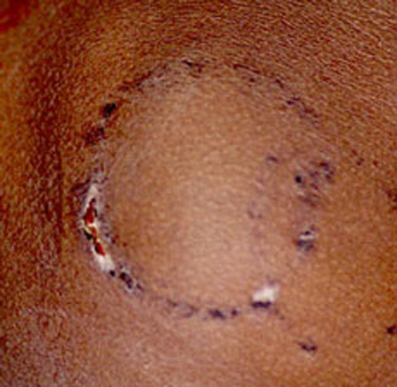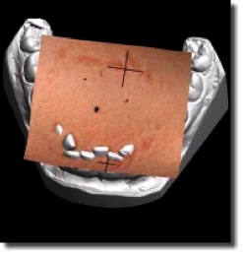

- Shoe Impressions: Investigators can analyze a shoe print to determine it’s…
  - Class Evidence: Type and brand of shoe, manufacturer, model and size, approximate height of wearer.
  - Individual characteristics: such as wear patterns and specific damages or defects
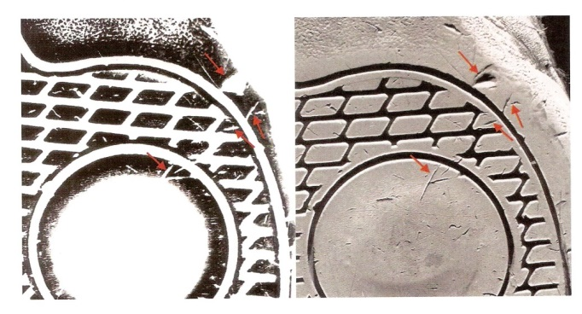
- How to obtain shoeprints?
    - Photograph
    - Dusting (2-D print)
    - Casting (3-D print)

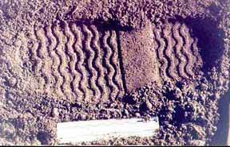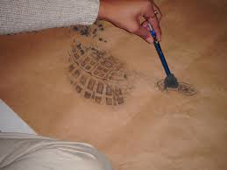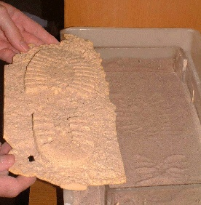

- Tire Impressions: Investigators can analyze a tire mark to determine it’s…
  - Class Evidence: Type and brand of tire
  - Individual characteristics: such as wear patterns and specific damages or defects
- Tires are made of semi-hard rubber. The treads create a pattern of rubber on tire which usually wears down as the tire is used. The softer surface (usually) the better the impression (snow, soil)

