Unit 5: Hair
Hair Evidence

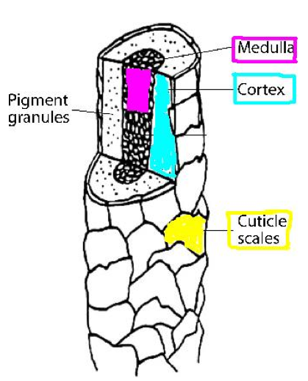
Hair is the most frequently found piece of trace evidence.
Hair is usually class evidence unless:
- If DNA in root is found it is individual evidence. This is not common.
- Sometimes mtDNA testing can be done (still class evidence but more narrowed). This mtDNA can be linked to the maternal side.

From hair one can determine:
- Human vs animal?
- Race (sometimes)
- Location of hair on body (head, leg...)
- Was hair was forcibly removed ?
- Was hair treated with chemicals?
- Were drugs/ toxins ingested?

Things hair can’t determine:
- Age (except infant hair)
- Gender (unless DNA in root)

Hair Structure:
Cuticle:
- The cuticle is the outside covering made of overlapping scales.
- Scales point down towards tip (older part) of hair.
- 3 Basic Patterns of Cuticle:
  - Coronal: Scales stacked like paper (Non human…. Ex. Bat Hair)
  - Spinous: Scales shaped like petals (Non human…. Ex. Rabbit Hair)
  - Imbricate: Scales flattened and close together (Human hair has imbricate structure)
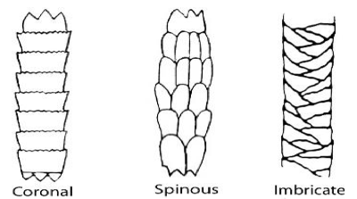

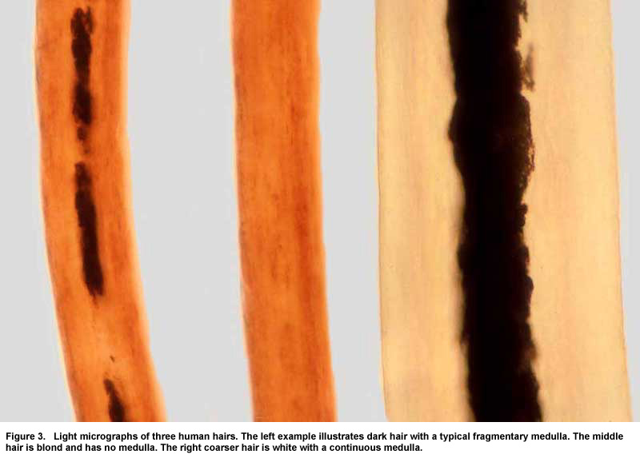
Medulla:
- Interrupted: Medulla is seen as individual cells or fragments in repeating intervals.
- Absent: no medulla visible
- Continuous: Formed as a solid center line.
- Fragmented: few parts visible
- The medullary Index is the ratio of diameter of medulla to the overall diameter of the hair
  - Humans < 1/3
  - Animal > 1/2

Loose Hair Structure:
- Naturally Shed Hair: rounded
- Forcible Removal of Hair: bent or pointed
- Burned Hair: black and bent

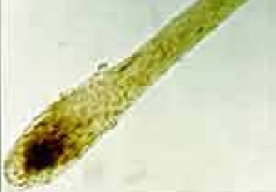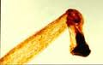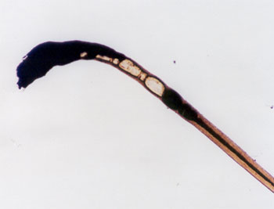

Toxicology
- Hair grows approximately 0.5 inches (1.3cm) per month.
- Various sections of hair are tested to determine if toxins are in the system and when they were ingested (based on the length of the hair).
- Any hair can be tested.

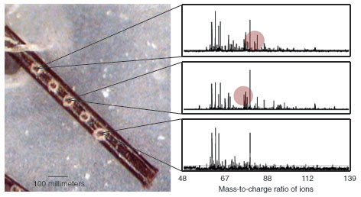

Observation of the Medulla Activity
Procedure:
- Observe the prepared hair slides at each station and quickly sketch the hair below.
- Then determine the type of medulla present.
- Determine the Medullary Index (<1/3 or > 1/2)
- Lastly, determine if the hair is animal or human
Hair# 3
Hair# 2
Hair# 1

Medulla:____________________ Medulla:____________________ Medulla:____________________
M.I. ____________________ M.I. ____________________ M.I. ____________________
A or H: _____________________ A or H: ____________________ A or H: _____________________

Hair# 5
Hair# 4
Hair# 6

Medulla:____________________ Medulla:____________________ Medulla:____________________
M.I. ____________________ M.I. ____________________ M.I. ____________________
A or H: _____________________ A or H: _____________________ A or H: _____________________

Observation of the Cuticle Activity
Procedure:
- Have someone in your group remove a hair from their head.
- Obtain a microscope slide.
- Place a small amount of clear nail polish on the slide and place the hair in it (leave some hair sticking out of the polish so you can remove the hair later)
- Let the polish dry for 5 minutes then carefully remove hair from the slide.
- Place the hair on the microscope and observe the cuticle pattern.
- Sketch the cuticle pattern below labeling the type of pattern observed.

Toxicology & Hair Removal
1. A convicted felon on parole for drugs was subject to a court ordered drug test to ensure they refrains from drug use while on parole. The individual was released form prison 4 months ago. Based up on the hair toxicology results did they violate the court order?

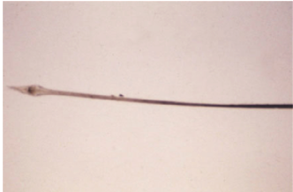

2. The following hair was found at a potential crime scene. Does this hair indicate a possible crime?
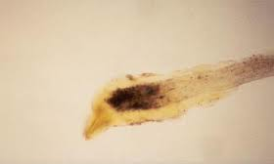

- The body of a woman was found in the woods. Some hair fibers found on the body were sent to the crime lab for analysis. The ends of the hair attached to the body were gray, but the tips of the hair showed that it had been dyed. The distance from the root of the hair to the beginning of the dyed area measured 8 mm. Investigators determined that the victim’s hair had last been dyed on August 1, 2004. Approximately what date did the woman die? Explain your answer.

- A woman with long hair is a suspect in a burglary case. At the crime scene, several long hairs were found attached to a broken lock of the safe. The police obtain a warrant and request a sample of 25 to 50 hairs from this woman. They tell the woman it is important that they pull the hairs from her head rather than to merely cut the hairs. The police suspect that the woman was stealing to help support a drug habit.

- Why is it important that the police pull the hairs from her head rather than cut her hair?

- Why is it necessary to obtain 25 to 50 hairs from this woman?

- The woman denies that she is currently taking drugs and states that she stopped using drugs a year ago. Explain how the police can determine if the woman has been off drugs for over one year.

- Suppose the hairs of the woman match the hairs found at the crime scene. Why does this not necessarily prove that she was the guilty party?

