Unit 6: Fingerprints
Fingerprinting Notes

Vocabulary:
- Dactylogram: Another fancy word for a print made by a finger.
- Latent Print: Prints found at the crime scene.
- Minutiae: Points on a fingerprint where ridges change shape. These are used to identify and characterize fingerprints. Researchers should find as many minutiae on a latent print as they can.

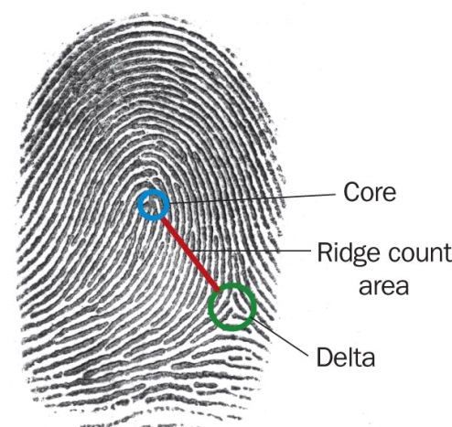
Every individual has their own set of fingerprints, making fingerprints individual evidence. Fingerprints are the most common piece of trace evidence found at a crime scene. Two things a forensic examiners looks for on a fingerprint are the presence of a core and deltas. The core is the center of a loop or whorl. A triangular region located near a loop is called a delta. Some of the ridge patterns near the delta will rise above and some will fall below this triangular region. Sometimes the center of the delta may appear as a small island. A ridge count is another characteristic used to distinguish one fingerprint from another. To take a ridge count, an imaginary line is drawn from the center of the core to the edge of the delta. In the figure to the right, the red line shows the area used in the ridge count from the delta to the core area.

3 Basis Types of Fingerprints
(And the percent of people who have them)
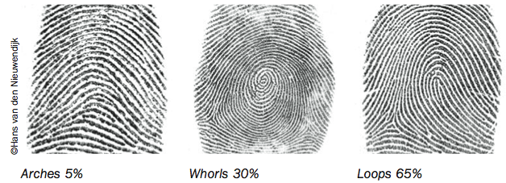

Types of Arches: Arches are the simplest type of fingerprints that are formed by ridges that enter on one side of the print and exit on the other. No deltas are present.
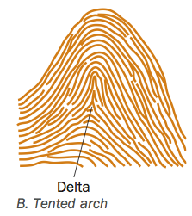
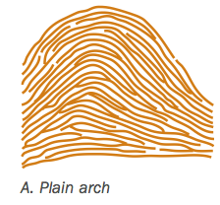

Types of Whorls: Whorls have at least one ridge that makes (or tends to make) a complete circuit. They also have at least two deltas. If a print has more than two deltas, it is most likely an accidental.
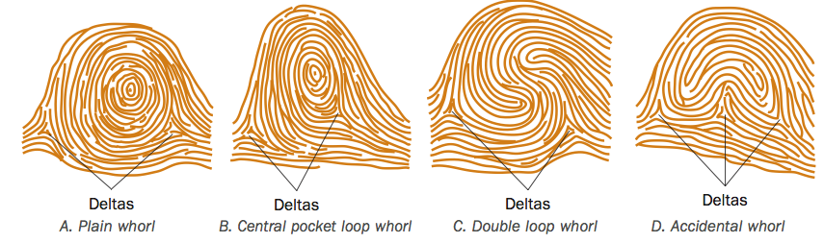

Types of Loops: Loops must have one delta and one or more ridges that enter and leave on the same side. These patterns are named for their positions related to the radius and ulna bones.
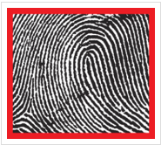
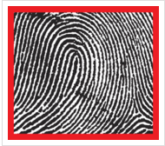

L- Ulnar Loop L- Radial Loop
R- RadialLoop R-Ulnar Loop

Ridge Characteristics: Minutiae Patterns

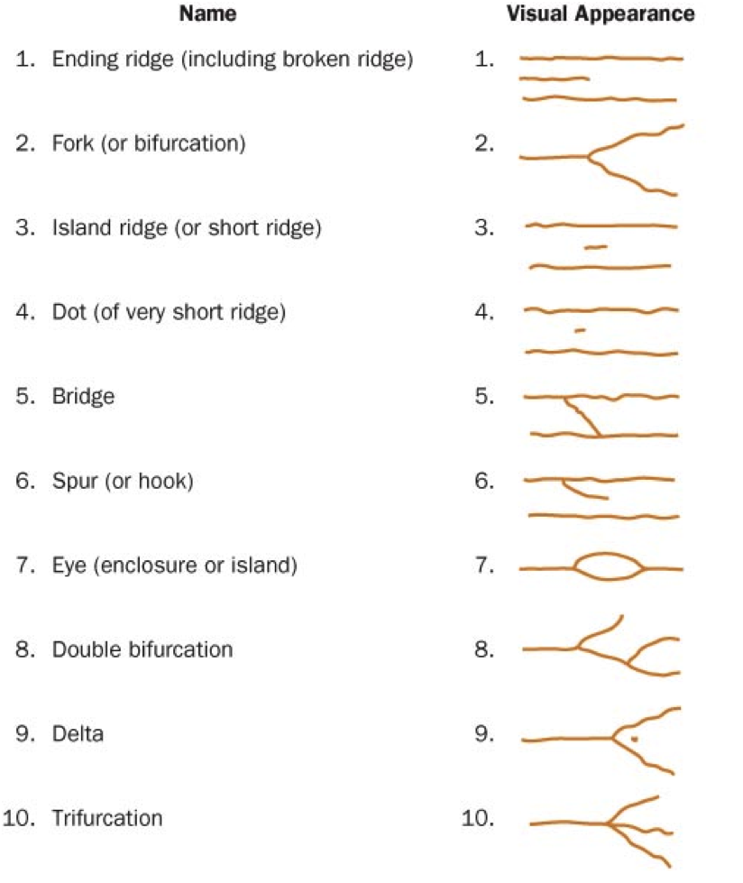

Lifting Prints
- Dusting: A brush is used to dust powder above a print. The brush must have very soft bristles as to not move the print. Camel hair is usually used.
- Super Glue Fuming: Lift prints off hard nonporous surfaces such as glass and plastic.
- Iodine Fuming: For lifting prints of paper.
AFIS
The Integrated Automated Fingerprint Identification System, or IAFIS, is a national fingerprint and criminal history system that responds to requests 24 hours a day, 365 days a year to help our local, state, and federal partners—and our own investigators—solve and prevent crime and catch criminals and terrorists. IAFIS provides automated fingerprint search capabilities, latent search capability, electronic image storage, and electronic exchange of fingerprints and responses.
What is included in IAFIS: Not only fingerprints, but corresponding criminal histories; mug shots; scars and tattoo photos; physical characteristics like height, weight, and hair and eye color; and aliases. The system also includes civil fingerprints, mostly of individuals who have served or are serving in the U.S. military or have been or are employed by the federal government. The fingerprints and criminal history information are submitted voluntarily by state, local, and federal law enforcement agencies.
How big it is: IAFIS is the largest criminal fingerprint database in the world, housing the fingerprints and criminal histories for more than 70 million subjects in the criminal master file, along with more than 34 million civil prints. Included in our criminal database are fingerprints from 73,000 known and suspected terrorists processed by the U.S. or by international law enforcement agencies who work with us.
How fast it works: The average response time for an electronic criminal fingerprint submission is about 27 minutes, while electronic civil submissions are processed within an hour and 12 minutes. IAFIS processed more than 61 million ten-print submissions during Fiscal Year 2010.
When it started: IAFIS was launched on July 28, 1999. Prior to this time, the processing of ten-print fingerprint submissions was largely a manual, labor-intensive process, taking weeks or months to process a single submission. The FBI has been the national repository for fingerprints and related criminal history data since 1924, when more than 800,000 fingerprint records from the National Bureau of Criminal Identification and Leavenworth Penitentiary were consolidated with Bureau files. The first use of computers to search fingerprint files took place in October 1980.
What’s new: While IAFIS has been an effective system, criminal and terrorist threats have evolved over the past decade. Today’s environment demands faster and more advanced identification capabilities. The Next Generation Identification program, or NGI, represents a quantum leap in fingerprint identification that will help us in solving investigations, preventing crime, and apprehending criminals and terrorists.
NGI—which delivers an incremental replacement of IAFIS—provides automated fingerprint and latent search capabilities, electronic image storage, and electronic exchange of fingerprints to more than 18,000 law enforcement agencies and other authorized criminal justice partners 24 hours a day, 365 days a year. Upon completion, NGI will have the ability to process fingerprint transactions more effectively and accurately. With the delivery of NGI Increment 4 in the summer of 2014, NGI will effectively replace IAFIS.

Fingerprint Identification Activity
Objectives: By the end of this activity, you will be able to:
1. Describe and identify different types of fingerprint minutiae.
2. Identify different minutiae patterns found in fingerprints.
Procedure:
- Study the picture below. It shows fingerprints obtained from a suspect and a crime scene (mirror). Notice how the investigator has labeled the points of comparison with the same letter on the rolled ink print and the latent print from mirror. Use the chart of characteristics in your text to identify the specific characteristics.

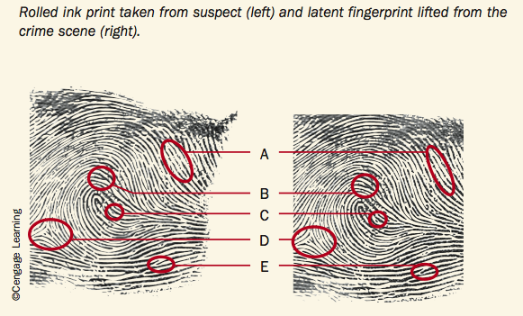
A: _________________________________________
B: _________________________________________
C: _________________________________________
D: _________________________________________
E: _________________________________________
Fingerprint Matching Activity
1. Match the latent crime scene print to one of the suspect’s fingerprints.
2. Justify your match by identifying the fingerprint pattern along with 6 fingerprint minutiae found in both the crime scene print and the suspect’s fingerprint.
3. Circle the common minutiae points on both the crime scene print and the suspect’s fingerprint.
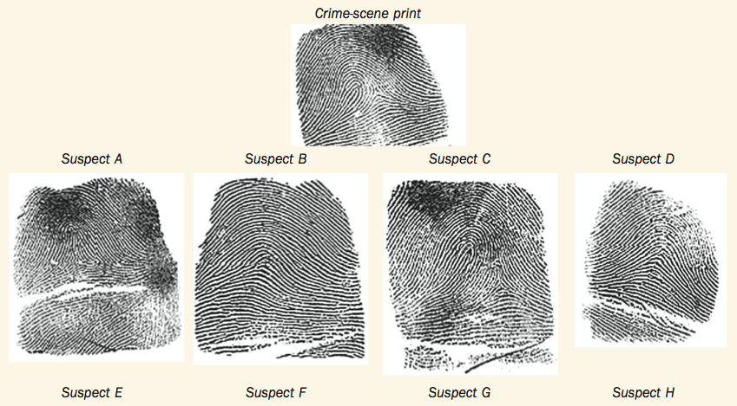
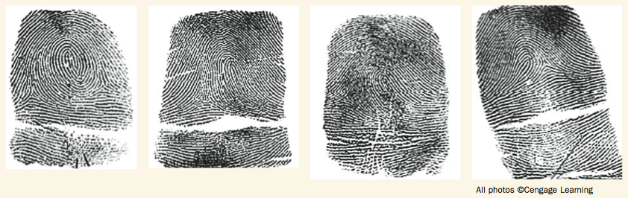

Fingerprint ID Card
1. R Thumb | 2. R Index | 3. R. Middle |  | 4. R. Ring | 5. R. Little
6. L Thumb | 7. L Index | 8. L. Middle |  | 9. L. Ring | 10. L. Little
Left Four Fingers Taken Simultaneously |  | L. Thumb | R. Thumb | Right Four Fingers Taken Simultaneously
Classification: Plain Arch, Tented Arch, Radial Loop, Ulnar Loop, Plain Whorl, Central Pocket Whorl, Double Loop Whorl, Accidental Whorl
R. Thumb ________________________________ L. Thumb _________________________________
R. Index _______________________________. L. Index _________________________________
R. Middle _______________________________. L. Middle ________________________________
R. Ring _________________________________. L. Ring __________________________________
R. Little ________________________________ L. Little _________________________________
Identifying Minutiae

Procedure:
- Identify the type (class) of print shown below _________________________________________
- Name the type of minutiae shown in 1-15.

- ________________________ 2. ________________________
3. ________________________ 4. ________________________
5. ________________________ 6. ________________________
- ________________________ 8. ________________________
9. ________________________ 10. _______________________
11. _______________________ 12. _______________________
- _______________________ 14. _______________________
15. _______________________

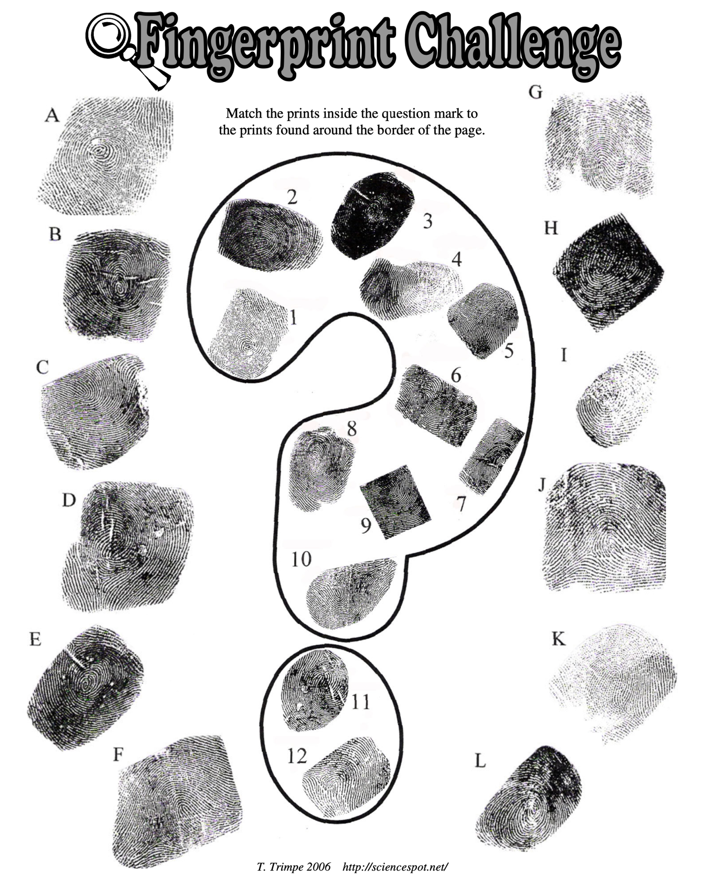

Lifting Techniques
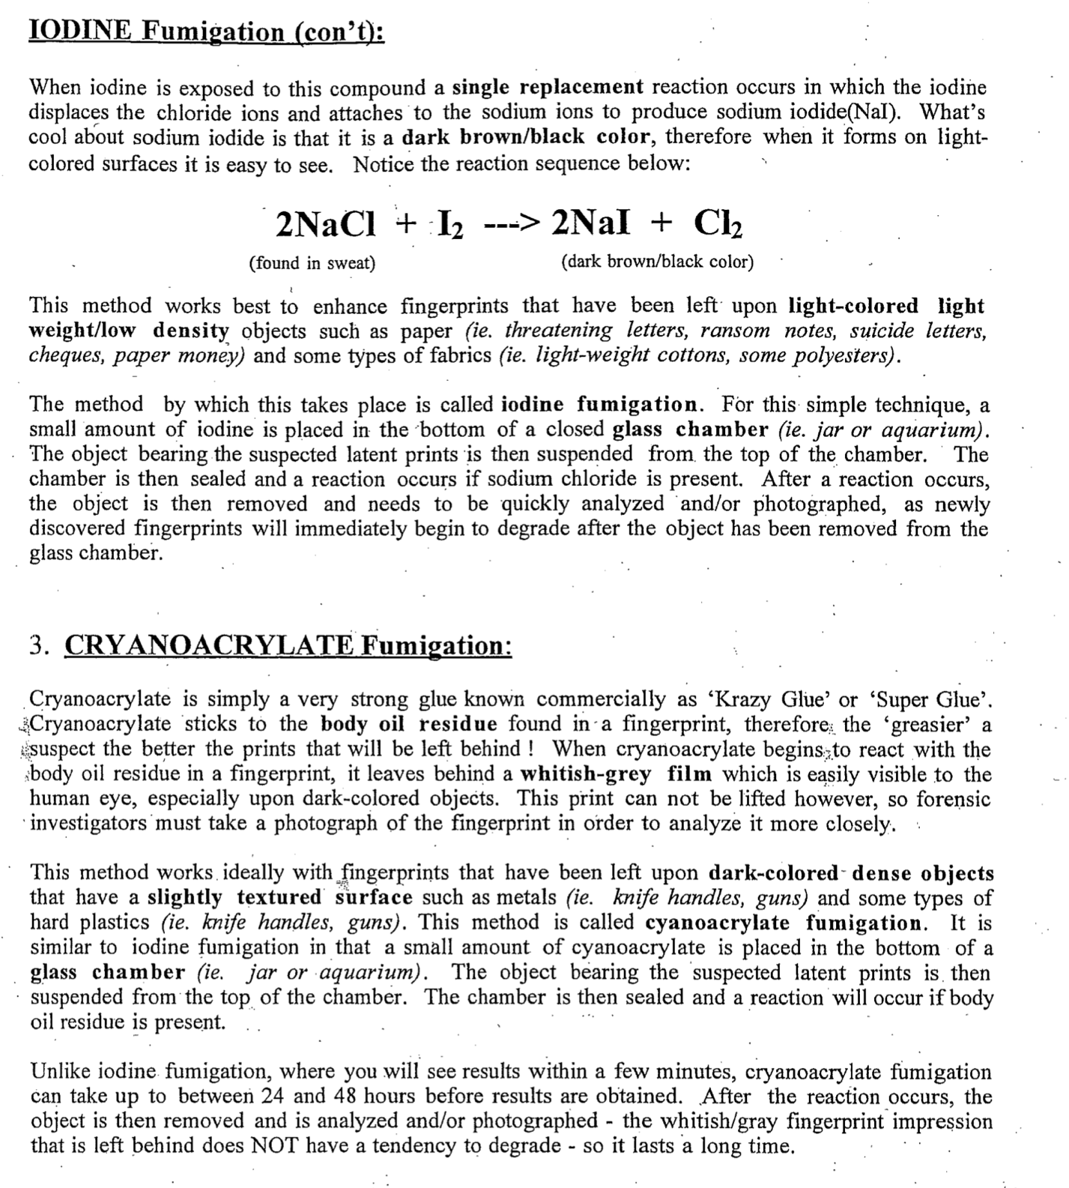
Questions:
- What determines the type of method a forensic expert would use when enhancing latent fingerprints?

- What are the three common methods of latent fingerprint Enhancement?

- What are most lifting powders made of?

- Why must you wear a mask when using a lifting powder?

- What makes the lifting powder brushes so special?

- Why is the powder highly attracted to the oily fingerprint residue and not the surrounding surfaces?

- Iodine is a negatively-charged anion. What positively charged cation is it attracted to in sweat?

- When does a single replacement reaction occur?

- On what type of objects does iodine fumigation work best? 10. What is another name for cryanoacrylate?

- What type of objects does this method work best on?

- What must a forensic scientist do with these prints as they cannot be lifted?

- Compare reaction times between iodine fumigation and cryanoacrylate fumigation
Dusting and Lifting Prints

Procedure:
- Make a thumbprint on the table by placing your thumb on the top if the table and pressing down firmly.
- Dip the brush in the power and lightly dust the area where you left the print. Too much dust and force may smudge the print.
- Once the print is visible, remove excess powered by lightly blowing the dusts away. Try not to inhale the dust between inhaling and exhaling.
- Use 5-6 inches of tape to cover the whole print. Use a clean finger to slide over the tape and smooth he tape’s surface. Force out all air bubbles.
- Gently pull up the tape and place it in a box below. Make sure tape is secure.
- Observe the print under the magnifying glass and point to 10 ridge characteristics.
- Repeat for each member of the group.
Name:  Finger:  Print Classification: | Name:  Finger:  Print Classification:
Name:  Finger:  Print Classification: | Name:  Finger:  Print Classification:
Review
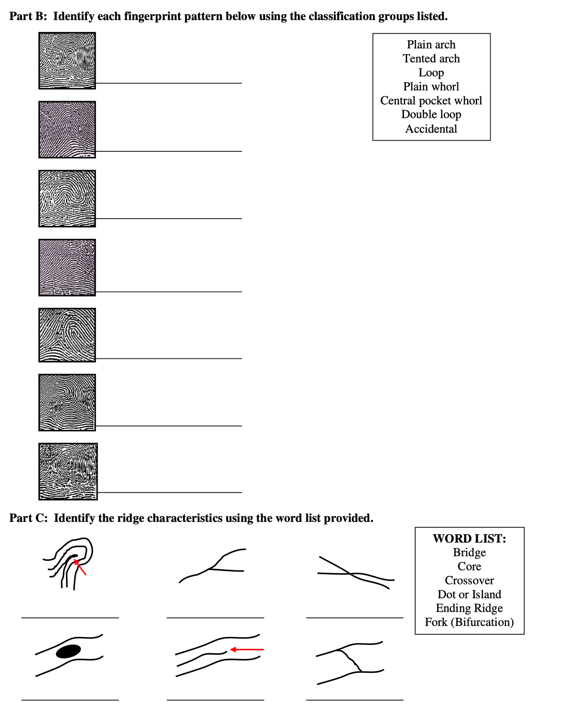
Fingerprinting the Dead
Unless a corpse is severely deteriorated, fingerprints can be obtained and matched against known missing persons and national fingerprint databases. Fingerprints often lead to quick and absolute identifications. Saline sometimes is injected into the tips of the fingers, causing the pads to swell and potentially reveal the friction ridges. Alternatively, skin over the pads of the fingers can be carefully sliced away, viewed under a microscope, and even photographed for matching purposes. Fingerprints can even be obtained from mummified bodies in some circumstances. The finger pads of such corpses are shriveled and have the texture of old leather, but soaking them in water or glycerin may swell them enough for fingerprints to be obtained. Fingerprints are taken after all trace evidence, particularly fingernail clippings or crapings, has been obtained, because small bits of evidentiary material can be lost merely by prying open the hand to take the fingerprints.
The Lady in the Concrete
On December 19, 1987, the skeletal remains of a middle-aged woman were discovered in the foundations of a residential building in Los Angeles. Examination of the bones revealed that she had died of multiple stab wounds. The upper part of her body had been buried in poured concrete, which, as it flowed over her, had left a clear cast of her head and torso. The victim’s arms were crossed over her body and had left visible cavities in the concrete where her hands had been. Parts of the concrete were particularly smooth in texture, and it seemed possible that identifiable prints could be obtained from it. Operatives of the police Latent Print Division carefully poured a silicone-rubber mix into the mold of each hand and obtained sufficient ridge detail from the fingers and palm. Piraino had previously made an application for employment, at which time her fingerprints had been taken, and she was positively identified from these. The casts also dramatically revealed cuts and stab wounds on the hands and fingers, caused as Piraino attempted to defend herself from her attacker.

Glove Prints
Many criminals, knowing how easily their fingerprints can give them away, wear gloves while committing a crime – but this can frequently prove a valueless precaution. In one classic case (first case), a burglar wore a pair of latex gloves while breaking into a post office in Manchester, England. He stripped them off as he left, however, and carelessly discarded them. Turning the gloves inside out, the police fingerprint expert was able to obtain a perfect set of prints from the inner surface. In another case, a burglar took a new pair of gloves with him to the scene of the crime, then threw away the manufacturer’s paper band that had surrounded them – leaving behind a good set of his prints on the paper. In the 1960’s Gerald Lambourne began to study the identification of prints from gloves. After more than ten years of research, Lambourne was able to show in court that a glove print could be positively identified. In January 1971, a man was arrested on suspicion of trying to break into premises in Pimlico, London, and a glove print was found on a newly broken window. He examined the lifted print: “I was satisfied that it had been made by a left-hand glove. The texture of the print indicated a glove with a suede finish, the surface of which had been damaged.” The suspect was in possession of a pair of sheepskin gloves with a suede finish, and surface damage on the left-hand glove exactly matched the print. Although the prisoner pleaded guilty at trial, Lambourne was permitted to explain his evidence to the court. It might be thought that domestic rubber gloves, which are produced in the hundreds of thousands by an identical manufacturing process, would reveal no signs of individuality. Lambourne, however, secured the cooperation of a manufacturer and examined a large batch. As he successfully showed: “Such gloves are made, inside out, on porcelain formers. The grip pattern is indented in the former. This is dipped in a tank containing latex which adheres to it...Slight uneven adhesion of the latex can mutilate what should be a regular pattern. Air bubbles can occur in the pattern area when the former is dipped into the latex, or a piece of latex from a pervious glove can contaminate a portion of the pattern. All of these factors can be detected in a glove print. The user of such gloves would not be aware of these slight variations, which are only revealed under magnification.” The results of Lambourne’s findings are now employed by police forces and forensic institutions all over the world.
Questions:
1. Under what circumstances can fingerprints not be taken from the dead?

2. What are the two methods fingerprint examiners use to take prints from the dead?

3. Why are fingerprints generally taken last in the examination process?

4. How were the fingerprints taken from victim?

5. Would examiners have gotten the same results if the victim was buried in just soil?

6. In the first case, how was the criminal caught?

7. What was Lambourne’s contribution to fingerprint identification?

8. How was the criminal in the Pimlico, London case caught?
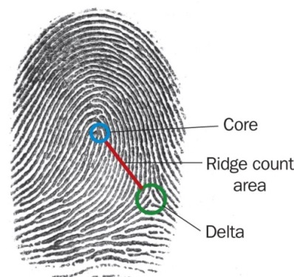
Fingerprint Review

- What is a Dactylogram?

- Explain the 3 ways to pick up “latent prints” at a crime scene. What materials will you need?

- Describe the difference between the core, ridge and delta when describing a print.

- Label each of the prints below at loop, whorl or arch and explain.

- Which of the prints above is the most common? The least?

- Draw the difference between a plain and a tented arch.

- Explain how you can tell is a whorl is plain or central pocket.

- Draw a double loop and an accidental whorl.
- How can you tell if a loop is ulna or radial?

- Name the following minutiae:

- How many minutiae points does a police officer need to identify a suspect?

- Describe the utilization of AFIS.

- What does AFIS stand for?

- What departments use AFIS?

- How many prints are in AFIS?

