Unit 7: Blood

Blood and Blood Spatter

Composition of Blood
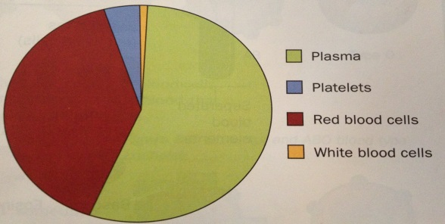
- Plasma – liquid portion of blood
- Platelets – helps blood to clot
- Red Blood Cells – Carries Oxygen, contains hemoglobin (makes blood red)
- White Blood Cells – fight disease, contains DNA*

Because many people in the world share the same blood type, this type of blood evidence is considered to be class evidence. It is biological and circumstantial.

Blood Type Test
The name of the blood is generated by which antibodies are on the red blood cell. Antibodies are in the plasma of the blood, opposite of the blood type.

The blood can also have the Rh protein (named after the Rhesus monkey) and therefore named Rh+ or Rh-
Blood Type | Antigen on Red Blood Cells | Antibodies in Plasma
A | A | B
B | B | A
AB | A and B | None
O | None | A and B

Blood Type  Blood is tested with antiserums to determine the blood type. If the blood serum clumps the blood, it can tell you about the blood type. | Can Receive | Can Donate
A | O, A | A, AB
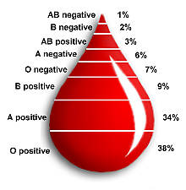  B | O, B | B, AB
AB | O, AB, A. B | AB
O | O | O, A, B, AB

Different regions have different percentages of people with these blood types. The diagram above shows the world population percentages.
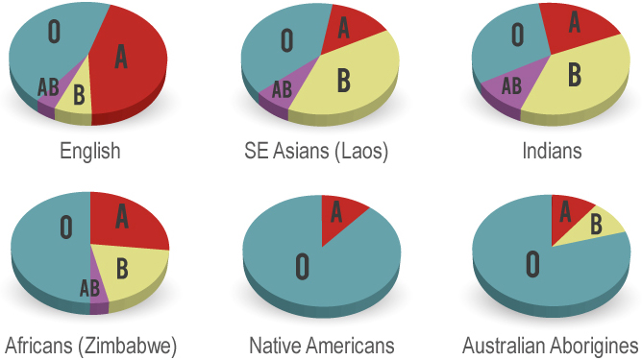

Blood Identification
Steps to Identify an Unknown Stain at the Scene
- Confirm the stain is blood
  - Kastle-Meyer color test: Mix phenolphthalein and peroxide; reacts with blood to cause a deep pink color. Positive tests for all blood, cauliflower, and broccoli.
  - Leukomalachite test: Reacts with blood to cause a green color. Positive test for all blood.
  - Luminol test: Reacts with blood to produce light. Positive tests for all blood, starch, horseradish, and bleach.
- Confirm the blood is human
  - ELISA Test (Enzyme Linked Immunosorbent Assay): Blood is injected into a rabbit to produce antibodies. Antibodies are isolated and stored. When a sample of human blood is mixed with these anti-human antibodies a positive reaction occurs and the presence of human blood is confirmed. Only a small sample is needed.
- Determine blood type/DNA testing
- Use blood spatter analysis to help reconstruct the crime (BPA)
Parent Drop

Spines

Blood Spatter (Bloodstain Pattern Analysis (BPA)): The examination of the shapes, locations, and distribution patterns of bloodstains in order to provide an interpretation of the physical events which gave rise to their origin…

Key Words:
- Spatter – Bloodstains created from the application of force to the area where the blood originated.
- Origin/Source – The place from where the blood spatter came from or originated.
- Angle of Impact– The angle at which a blood droplet strikes a surface.
- Parent Drop– The droplet from which a satellite spatter originates.
- Satellite Spatters– Small drops of blood that break of from the parent spatter when the blood droplet hits a surface.
- Spines – The pointed edges of a stain that radiate out from the spatter; can help determine the direction from which the blood traveled.

Factors affecting Shape of Blood Droplet
- Size of the droplet
- Angle of the impact
- Velocity at which blood droplet left its origin height
- Bloodstains can occur on any surfaces such as carpet, wood, tile, wallpaper, clothing, etc.
  - Texture of surface:
    - On a clean glass or plastic, droplet will have smooth outside edges
    - On a rough surface, droplet will produce scalloping on the edges

Type of Blood Stains:
- Passive: Marks formed by gravity, like drops or blood pools.
- Projected: Patterns that occur when a force is applied to the source of the blood. Includes low, medium, or high impact spatters, cast-off, arterial spurting, expiratory blood blown out of the nose, mouth, or wound.
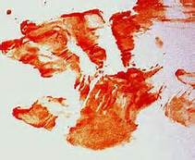
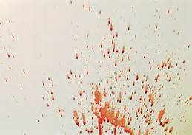
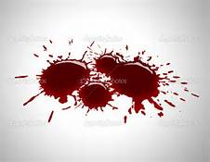
- Transfer: These patterns are created when a wet, bloody object comes in contact with a target surface; may be used to identify an object or body part. A wipe pattern is created from an object moving through a bloodstain, while a swipe pattern is created from an object leaving a bloodstain.

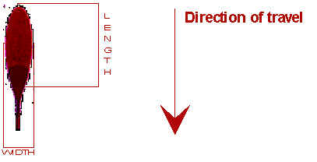
Examination of Directionality: Direction drop of blood traveled in space from its point of origin

Lines of Convergence: The location of the source of blood can be determined if there are at least two drops of blood spatter. Done by drawing a line down the long axis of the blood spatter and noting where the lines intersect
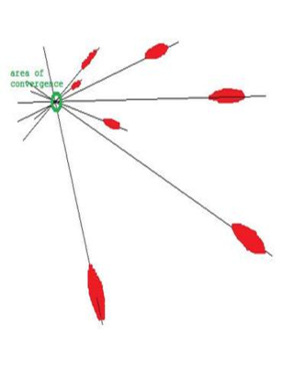

What can an investigator learn from the analysis of a blood spatter?
- Distance between target surface and origin of blood
- Type and velocity of weapon
- Number of blows
- Handedness of assailant (right or left-handed)
- Position and movements of the victim and assailant during and after the attack
- Which wounds were inflicted first
- Type of injuries
- How long ago the crime was committed
- Whether death was immediate or delayed

Blood is a Mixture
What makes blood red?
Your blood contains cells called erythrocytes or red blood cells (RBCs). Red blood cells are packed full of a protein molecule called hemoglobin. The heme in the hemoglobin is red in color. Each molecule of hemoglobin contains four iron atoms. The iron atoms in the hemoglobin molecules bind to oxygen molecules.This is how your body transports oxygen from your lungs to all the cells of your body. Each RBC contains millions of hemoglobin molecules, and each drop of blood contains millions of RBCs.
More than Red Blood Cells
But there is a lot more to blood than RBCs.There are two other types of cells in blood, white blood cells (leukocytes or WBCs) and platelets (thrombocytes). Red blood cells outnumber WBCs 1,000:1. White blood cells are an important part of our immune or defense system. They fight infection from bacteria and viruses. Platelets are responsible for creating a clot to stop bleeding from a wound. The RBCs, WBCs and platelets float around in pale yellow liquid called plasma. Plasma is more than just water. It contains important proteins, hormones and salts. Red blood cells live for only four months. Therefore, your bone marrow is always at work producing new blood cells. As you heard in the video, your bone marrow makes 4-5 billion RBCs every hour! Red blood cells make up 40-45 percent of your blood volume.
What causes anemia?
In order to make hemoglobin, you need to eat enough protein, iron and certain vitamins. Causes of anemia include an iron-poor diet or chronic disease.
Sometimes the cause of anemia is that the bone marrow is not producing enough RBCs.This can be caused by the effects of cancer treatment, radiation, toxins or kidney failure as well as by iron deficiency. Healthy kidneys produce a hormone called erythropoietin. This hormone stimulates the bone marrow to produce RBCs.
Anemia can also be caused by a loss of blood.Women who have very heavy menstrual periods or people who have lost significant blood due to an injury or surgery can become anemic.
How can people with low numbers of red blood cells recover?
If an injury or surgery has caused a loss of blood, a transfusion will correct the problem immediately. A common treatment for mild anemia is to take supplemental iron in the form of pills or infusions. Chronic anemia is treated by identifying and eliminating its cause. A blood transfusion can bring relief to patients while they are waiting for a proper diagnosis. Depending on the underlying cause of anemia, other treatments may correct the problem so that no further transfusions are necessary.
Can donating blood cause the donor to become anemic?
The answer is usually no. Before donating blood, a person’s hematocrit is measured. Only those with healthy hematocrit levels can donate blood.The red blood cells lost in a blood donation are quickly replaced in a healthy person in about four to six weeks.

Questions
- Why is it important to get enough iron in your diet?

- Without oxygen, our cells. Cannot work. Which of the following might be an explanation why someone feels weak?
  - They do not have enough hemoglobin
  - They do not have enough red blood cells
  - Either a or b would cause someone to feel tired and weak
- What type of blood cell far out numbers the others in the blood?

- If you fell and scraped your knee, describe what each type of blood cell would be doing at the site of injury.

- What are two ways someone can become anemic?

- What are two treatments for anemia?

- Which treatment would work best to help someone who has been in a car accident and lost a lot of blood?

- What would you tell someone who’s not sure if they can give blood because they think they might be anemic?

Human vs Animal Blood
Red blood cells in humans differ from those of many animals in that they do not have nuclei. Most animals, besides mammals, have nuclei in their mature red blood cells. Mature mammalian red blood cells lose their nucleus and organelles in order to carry more hemoglobin, and they do not need to use any oxygen themselves.
Animals with an open circulatory system have hemolymph, a fluid combining blood and interstitial fluid, rather than blood, and it contains only one type of cell, hemocytes. Phagocytic cells ingest foreign particles and pathogens and serve in signaling within the body. Animals with hemolymph use hemocyanin instead of hemoglobin to transport oxygen The vast majority of animals, and certainly all larger animals have red blood similar to our own. There are popular misconceptions about the color of animal’s blood that a lot of them have different colored blood to us. In reality this is only a very small portion of all the animals in the world, and most have red blood. They have hemoglobin in their blood, just as humans do, which contains iron, which gives it its red coloration. While all mammals and larger animals have red blood, there are a few animals, mainly amphibians and lizards that have greenish blood as well. This is because their blood contains bile making them poisonous to most predators. Whether this is a way of avoiding predators or simply an easier way to expel waste that gets built up in the body isn’t known.
There is also a popular misconception that animals’ and human’s blood can be blue until it makes contact with the air, where upon it becomes red. There is some slight truth to this however. Some animals such as crabs and lobsters use copper rather than iron as the main component of their blood cells. This gives their blood a blue color as their cells contain hemocyanin rather than hemoglobin as ours do.
Because copper isn’t very efficient at binding with oxygen in the blood. The blood of crabs and lobsters usually has a faint shade, rather than the rich shade of red that our blood has. This is because it contains less oxygen. Lobsters in particular have poor oxygen absorption, and may have almost gray blood in some cases. Human blood by contrast as with most mammals is very oxygen rich. We expend a lot of energy moving and keeping warm, and so use up more oxygen.
Smaller creatures such as insects van have a multitude of different colors as their blood color. Things such as beetles or caterpillars for example often have yellow colored blood. This is because they use a different system for binding oxygen to humans and larger animals. Where we use hemoglobin and iron to bind and absorb oxygen, they tend to use Hemolymph. This isn’t strictly the same as blood but serves much the same purpose, and contains all the chemicals that they need to breathe and survive. In some insects such as this their blood isn’t even pumped around their body, rather it is free moving and moves as their bodies move. They can usually breathe through their skin all over the surface of their bodies, thus, ensuring that enough oxygen still passes through to all their organs.
1. What is one major difference between human blood and the blood of most other animals?

2. Why is human blood red?

3. What types of animals have blue blood? Why?
Human blood under the microscope​: The red blood cells do not have a nucleus. Label the red and white blood cells
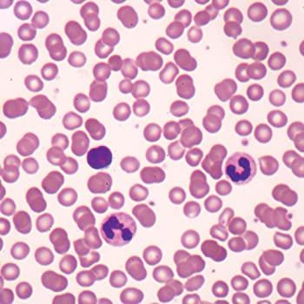

Animal (non-vertebrate) blood under the microscope: ​The red blood cells have a nucleus​. Label the red and white blood cells
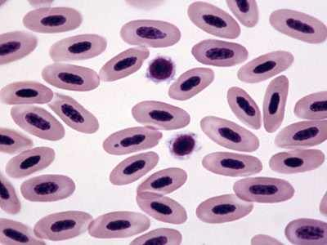

Crime Scene:
A red stain found at a crime scene was found to be blood using a presumptive test. The blood was sent to the lab to determine if it was animal or human. The blood slide is shown below. Is the blood obtained from the crime scene from a human? Explain why or why not.
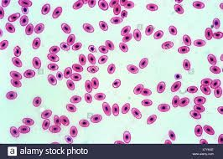

Animal Versus Human Blood Classification

Procedure: Look at samples of animal and human blood under the microscope. Sketch what you see in the labeled circle.
Animal Human

Questions:
- What are some similarities between the blood types?

- What are the differences between the blood types?

- If you were an investigator with an unknown blood sample, what specific characteristics would you look for to determine if the blood was human?

Blood Pattern Analysis
Blood pattern analysis plays an important role in the reconstruction of many crime scenes. For example, when a prominent Cincinnati physician appeared to be the victim of an apparent suicide, the spatter pattern on his hand and on the couch on which he lay told a story of murder instead. The various types of bloodstains indicate how the blood was projected from the body via several factors:
- Type of injuries
- The order in which the wounds were received
- Whose blood is present
- The type of weapon that caused the injuries
- Whether the victim was in motion or lying still when the injury was inflicted
- Whether the victim was moved after the injury was inflicted
- How far the blood drops fell before hitting the surface where they were found.
Blood may be dripped out, sprayed from an artery, oozed out through a large wound, or flung off a weapon raised to strike another blow. In the 1930s, Scottish pathologist John Glaister classified blood splashes into six distinct types:
- Drops on a horizontal surface
- Splashes, from blood flying through the air and hitting a surface at an angle
- Pools around the body, which can show if it's been dragged
- Spurts from a major artery or vein
- Smears left by movement of a bleeding person
Trails, either in form of smears when a bleeding body is dragged, or in droplets when it is carried. (Trails also form when a person is wounded and walks away but leaves blood along the way.) Any of these can be traced back to their converging point by considering such factors as the surface on which it fell, the angle it hit, and the distance it traveled. Brian Kennedy, a sergeant with the Sacramento County Sheriff's Department in California, is an expert in crime scene reconstruction, specializing since 1984 in bloodstain pattern analysis. For more than a decade, he has been teaching this technique to other forensic investigators and he believes that gaining insight from bloodstain patterns can strengthen interrogation strategies and provide juries with a clear visual format. According to the basic teaching texts, the shape of a blood drop can reveal a lot about the conditions in which it fell. Given the many variations in what can happen at a crime scene, the experts don't necessarily all agree, but a flexible rule of thumb with a generally smooth and non-porous surface might be the following:
- If blood falls a short distance--around twelve inches—at a 45-degree angle, the marks tend to be circular.
- If blood drops fall several feet straight down, the edges may become crenellated, and the farther the distance from the source to the surface, the more pronounced the crenellation.
- A height of six feet or more can produce small spurts that radiate out from the main drop.
- If there are many drops less than an eighth of an inch across, with no larger drop, then it may be concluded that the blood spatter probably resulted from an impact.
- If the source was in motion when the blood leaked or spurted, or if the drops flew through the air and hit an angled surface, the drops generally look like stretched-out exclamation marks. The end of the stain that has the smallest size blob indicates the direction in which the source was moving.
"All classifications of bloodstain patterns help in the reconstruction of the events," Kennedy points out. "Spatter patterns give the nature of the force and positioning of the victim when shot or bludgeoned. Castoff patterns reveal the positioning and the possible size of the assailant. One also gets an indication of the size of the instrument swung and whether the swinger is left- or right-handed. Transfer patterns and hemorrhage or drip patterns give the direction of movement after blood is shed and can give an indication of timeframes. Arterial spurting can give the position, movement and seriousness of the injury, while 'shadows'---the absence of blood where one would expect to find it--- suggest movement or removal of objects and changes to the scene."
A case in England in 1984 shows the importance of blood pattern analysis. A village womanizer named Graham Backhouse was found injured in his home with slashes across his face and chest. A neighbor with whom he'd had a dispute lay dead nearby, shot by Backhouse, who claimed the man had attacked him. However, the blood patterns showed that Backhouse had been standing still or moving slowly when he was wounded, rather than being in the sort of struggle he described. In that case, the blood would have been flung against surfaces to produce the elliptical pattern. Also, there was no blood from Backhouse on his gun or near the victim. The conclusion was that he shot his victim and then self-inflicted his wounds. In another case on which Kennedy worked, People vs. Pallermo in San Joaquin County, the defendant claimed the female victim had accidentally shot herself. "However, the bloodstain pattern analysis and computer models showed the defendant's rendition to have been an impossibility, and it placed the shooter across the room with the victim crawling into the corner to get away from the threat of the gun. The jury found the defendant guilty of second degree murder." This was one of the central issues in the most prominent case of the past decade in which blood analysis was a primary feature: the O. J. Simpson investigation.
QUESTIONS
- List all factors which indicate how blood was projected from the body.

- List all six distinct types of blood splashes.

- What are the 5 flexible rules of thumb for blood on a smooth, non-porous surface?

- In your opinion, how important is blood-spatter analysis in crime scene reconstruction? Cite an
example from the article.
- With so much blood spatter at the OJ Simpson crime scene, why do you think the evidence
was largely overlooked? Explain.

Blood Trails, DNA and O.J.

Since 1985, with Alec Jeffrey's discovery of the uniqueness of portions of the DNA structure of certain genes, investigations involving blood have taken an entirely new turn. While the ultimate goal of the analysis of proteins and enzymes was to individualize blood, that's pretty much established with DNA technology. Within a year of the discovery, DNA typing was being put to the test in criminal cases. It not only cleared one man who had confessed to a crime, but also led to the conviction of the actual killer in the same crime. DNA can narrow down suspects in a hurry, but it's not foolproof. It can be challenged in court on the basis of sloppy evidence collection and the corruption of samples during testing. That was the tactic that O. J. Simpson's defense team used to win for him an acquittal in his double murder trial. Just how did they manage to accomplish this? To trace their strategy, let's look at the case. On the night of July 12, 1994, Nicole Brown Simpson and Ronald Goldman were slaughtered outside her Brentwood, California home. Nicole was the former wife of football celebrity O. J. Simpson, and he was called in from out of town for questioning. Going to his home on the night of the murder, detectives had noted a bloodstain on the door of his white Ford Bronco and a trail of blood leading up to the house. That was suspicious enough to start asking questions. When Simpson returned to Los Angeles, investigators noticed a cut on a finger of his left hand. He told several conflicting stories about how he had gotten it, which boxed him in later when blood at the crime scene indicated that the killer had been cut on his left hand and had trailed blood outside the gates. That hardly seemed coincidental. Then when several droplets of blood at the scene failed to show a match with either of the victim's blood types, Simpson's blood was drawn for testing (after the droplets had already been collected). Comparison between his DNA and that of the blood at the scene showed strong similarities. The tests indicated that the drops had three factors in common with Simpson's blood and only one person in 57 billion could produce an equivalent match. In addition, the blood was found near footprints made by a rare and expensive type of shoe-shoes that O. J. wore and that proved to be his size. Next to the bodies was a bloodstained black leather glove that bore traces of fiber from Goldman's jeans. The glove's mate, stained with blood that matched Simpson's, was found on his property. There were also traces of the blood of both victims lifted from inside Simpson's car and house, along with blood that contained his DNA. In fact, his blood and Goldman's were found together on the car's console. Forensic serologists at the California Department of Justice, along with a private contractor, did the DNA testing. Then other evidence emerged, such as the testimony of the limousine driver who came to pick Simpson up for the ride to the airport: On the night of the murder, while he waited for Simpson, he had seen a black man cross the driveway and go into the house. Then Simpson claimed that the driver had been unable to get him on the intercom because he had "overslept." So then who was the black man who had entered the house? When arraigned, Simpson pleaded Not Guilty and hired a defense team of celebrity lawyers. Barry Scheck and Peter Neufeld from New York were the DNA experts, renowned for their work on the Innocence Project, which used DNA analysis to defend the falsely accused. Scheck felt confident that they could produce challenges before the jury that would both educate and persuade them. Page 1 of 13 The reliability of this evidence came to be called the "DNA Wars," and three different crime labs performed the analysis. All three determined that the DNA in the drops of blood at the scene matched Simpson's. It was a 1 in 170 million match, using one type of analysis known as RFLP, and 1 in 240 million match using the PCR test. Nevertheless, criminologist Dr. Henry Lee testified that there appeared to be something wrong with the way the blood was packaged, leading the defense to propose that the multiple samples had been switched. They also claimed that the blood had been severely degraded by being stored in a lab truck, but the prosecution's DNA expert, Harlan Levy, said that the degradation would not have been sufficient to prevent accurate DNA analysis. He also pointed out that control samples were used that would have shown any such contamination, but Scheck suggested that the control samples had been mishandled by the lab-all five of them---and the jury bought it. The evidence was damning, but the defense team managed to refocus the jury's attention on the corruption in the Los Angeles Police Department. They then disputed the good reputation of the forensics labs, insisting that the evidence had been carelessly handled. Deliberating less than four hours, the jury freed Simpson with a Not Guilty verdict. They simply failed to understand how damning the DNA evidence really was and how ill fitting was the defense's logic about certain aspects of the blood at the crime scene. Nevertheless, it can certainly be the case that what appears to be overwhelming blood analysis evidence still fails to tell the whole story.

- What caused investigators to consider O.J. a suspect and to start asking questions?

- What was the first link between the crime and O.J. Simpson?

- When comparing O.J.’s DNA and the blood at the scene of the crime, what were the odds of a match between them?

- What was the link between the blood evidence and O.J.’s shoes?

- What was the role of the black leather glove in the investigation?

- Why was it very suspicious that both of the victims’ blood was found in O.J.’s car?

- What was concluded from the DNA tests of O.J.’s blood?

- What was wrong with the blood evidence that was obtained by the investigators?

- Do you think that if this case was tried this year, the verdict would be the same based upon the same evidence? Why or why not?

