Name: ____________________________________ Glue Lab
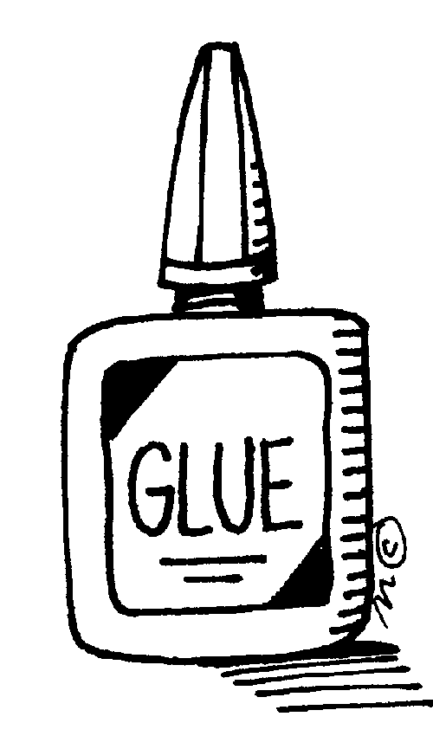
Introduction: Animal glue is an adhesive that is created by prolonged boiling of animal connective tissue. These protein colloid glues are formed through hydrolysis of the collagen from skins, bones, tendons, and other tissues, similar to gelatin. These proteins form a molecular bond with the glued object. Stereotypically, the animal in question is a horse, and horses that are put down are often said to have been "sent to the glue factory." However, other animals are also used, including rabbits and fish. Animal glue has existed since ancient times, although its usage was not widespread. There is evidence that the Neanderthals used glues in their paints to guard their works from moisture, and some horse tooth glues can be dated back nearly 6000 years, but no written records from these times can prove that they were fully or extensively utilized. The first known written procedures of making animal glue were written about 2000 BC. Between 1500–1000 BC, it was used for wood furnishings and mural paintings, found even on the caskets of Egyptian Pharaohs. Evidence is in the form of stone carvings depicting glue preparation and use, primarily utilized for the pharaoh’s tomb’s furniture. Egyptian records tell that animal glue would be made by melting it over a fire and then applied with a brush. Greeks and Romans later used animal and fish glue to develop veneering and marquetry, the bonding of thin sections or layers of wood. Animal glue, known as taurokolla in Greek and gluten taurinum in Latin, were made from the skins of bulls in antiquity. Broken pottery might also be repaired with the use of animal glues, filling the cracks to hide imperfections. About 906–618 BC, China utilized fish, ox, and stag horns to produce adhesives and binders for pigments. Animal glues were employed as binders in paint media during the Tang Dynasty. Records indicate that one of the essential components of lampblack ink was proteinaceous glue. Ox glue and stag-horn glues bound particles of pigments together, acting as a preservative by forming a film over the surface as the ink dried. The Chinese, such as Kao Gong Ji, also researched glue for medicinal purposes.
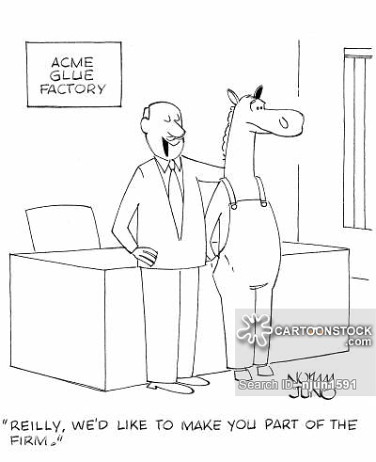
Today, animal glues are sparsely industrialized, but still used for making and restoring objects, paintings, illuminated parchment manuscripts, and other artifacts. Gelatin, a form of animal glue, is found in many contemporary products, such as gelatin desserts, marshmallows, and pharmaceutical capsules, and is used to reinforce sinew wrappings, wood, leather, bark, and paper. The main ingredient in the glue we will make is milk. Milk is 87% water, 4.8% carbohydrate, 4% fat, 3.5 % protein, and 0.7% minerals. The carbohydrate is mostly the dissaccharide sugar, lactose. The fat is in the form of globules that reflect light and give milk some of its whiteness. Some vitamins are dissolved in the fat. The proteins are complete, meaning they have all essential amino acids. The most abundant protein is casein. The precipitation takes place when the milk becomes acidic, near pH 4.6. Some glues do not use animals and are called “chemical glues.” Although there are many ingredients used to make chemical glue, most formulas contain something called polymers. A polymer is a large molecule that often is described as being a long molecular strand, much like spaghetti. Some polymers are naturally "sticky" depending on how they are made. Others require certain ingredients called tackifiers to make them sticky. One of our many challenges is to be sure we have exactly the right balance of polymers and tackifiers to create glue that is sticky and strong. As long as the glue remains inside the bottle away from air it will remain fluid. Glue hardens when there is a loss of water from the formula. Exposure to the atmosphere will cause the water to evaporate and make the glue harden. That's why it is important to keep the cap on the glue bottle closed to prevent hardening or drying out.
When you spread adhesive, such as chemical glue, it wets the surface you apply it to. Lots of very weak electrostatic forces between the glue molecules and the molecules in the surface (called van der Waals forces) hold the two things together. For adhesives to work well like this, they have to spread thinly and wet the surfaces very well. There's no actual chemical bond between the glue and the surface it's sticking to, just a huge number of tiny attractive forces. The glue molecules stick to the surface molecules like millions of microscopic magnets. In some cases, adhesives can make much stronger chemical bonds with the materials they touch. For example, if you use certain glues on certain plastics, the glue and the plastic actually merge together to form a very strong chemical bond—they effectively form a new chemical compound at the join. That process is called chemisorption.

Purpose: To create glue from common household products, explaining bonding and IMF. Then make crafts ☺
Pre-Lab Questions:
- Animal glue is not only used as an adhesive. Provide another use for animal glue.

- Not all glues are animal based. What is another category of glues?

- How come glue sticks to most surfaces but doesn’t stick to the bottle or harden inside the bottle?

- Animal glue can form covalent bonds to the surface of the objects you are gluing. Other glues form intermolecular forces between the glue and the surfaces. Which glue would be stronger?

Materials: skim milk, cylinder, beaker, stirring rod, hotplate, filter paper, flask, funnel, baking soda, craft supplies.
Procedure:
- Measure 62.5 mL of skim milk using a cylinder and add to a beaker.
- Measure 12.0 mL of vinegar using a cylinder and add to the beaker of milk (an acidic solution).
- Gently heat milk mixture on a hot plate while stirring constantly with a stirring rod until small lumps form.
- Remove the beaker of milk mixture form the heat and continue to stir as lumps form, until no more form.
- Allow the lumps to settle to the bottom of the beaker for 2-3 minutes.
- Filter the solid (curds) from the liquid (whey) using a funnel, flask, and filter paper.
- Gently press the filter paper around the curds to squeeze the excess liquid out.
- Return the solid to the beaker.
- Add 10 ml of water to the curds and stir.
- Add ½ teaspoon of baking soda to neutralize the vinegar; bubbles should appear. Add baking soda until almost no bubbles appear.
- Attempt to glue to small pieces of construction paper together. Write your name on the paper and place on the window sill to dry overnight.
Data: Record all measurements with units and write observations:

Questions:
- “Little Miss Muffet sat on a tuffet eating her curds and whey.” Explain what curds and whey are.

- You may have eaten curds and whey before: cottage cheese. Normally “rennin” is added to the skim milk to separate the milk proteins into curd and whey separately. Why was vinegar and heat added to the milk we used?

- Explain in terms of solubility why filter paper can be used to separate the curd and whey.

