Handwriting Analysis Activity

Match each of the handwriting samples on the left with one of those on the right.
Use the 12 handwriting characteristics to help in your comparison.

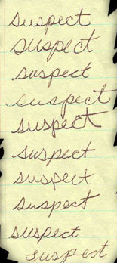
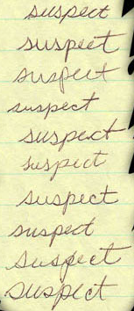
1_____
2_____
3_____
4_____
5_____
6_____
7_____
8_____
9_____
10_____

a
b
c
d
e
f
g
h
i
j

Answers:
- g
- j
- h
- i
- b
- e
- c
- d
- a
- f

