Handwriting Analysis Lab 2
Procedure:
Match one of the suspects to the note below using the 12 exemplars from your notes. Fill in the data table for that suspect.
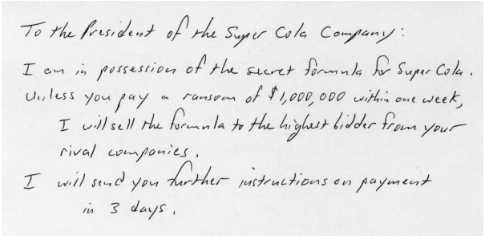

Analysis:
- What suspect did you determine wrote the note to the president of the super cola company?

- Which characteristic(s) was most helpful in making the determination?

Data Table:
Characteristic # | Yes | No | Comments (and measurements in mm) If required
1. Is line quality smooth?
2. Are words and margins evenly spaced? |  |  | Margins:
 |  |  | Words:
3. Is ratio of small letters to capital letters consistent?
4. Is the writing continuous?
5. Are letters connected between capitals and lowercase letters?
6. Are letter formations complete? |  |  | (Be specific, which letters?)
7. Is all of the writing cursive? |  |  | (Be specific, which words?)
8. Is the pen pressure the same?
9. Do all letters slant to the right?
10. Are all letters written on the line?
11. Are there fancy curls or loops? |  |  | (Which letters?)
12. Are all “i”s dotted and “t”s crossed? (top, middle, or not) |  |  | “i”s
 |  |  | “t”s

Handwriting Samples
