Handwriting Analysis Lab #4
Procedure:
Part 1. Analyzing Tops and Bottoms of Letters
- Write the words “forensic science” twice in table 1 below.
- Have two other people write the same words in table 1 below.
- Put the tracing paper on top of the writing.
- Make a small mark at the top of each letter.
  - For letters with more than one top point, like the letter y, put a dot at the top of both possible top points.
- Using a ruler, join the dots for each handwriting sample, so you have a single crooked line for each sample. (see example provided by teacher)
- Compare the resulting line for each sample. (staple your tracing paper to this lab when you are finished)
Table 1:

Part 2: Analyzing the Slant of Letters
Use the same signatures above, repeat steps 3-6 above, but this time make a line through the center of each letter, slanting in the same direction as the letter. (staple your tracing paper to this lab when you are finished)
Part 3: Solving the Case
Using both methods from Part 1 and 2, determine which of the suspect’s handwriting samples matches the sample in the box below. (staple your tracing paper to this lab when you are finished)

Suspects Handwriting Samples:

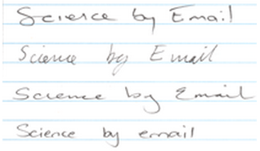
Suspect 1
Suspect 2
Suspect 3
Suspect 4

