Name: _______________________________ Heat of Reaction

Guiding Question: How much heat is absorbed or released when 0.100 moles of NaOH and NH₄Cl are dissolved in water?

Pre-Lab Questions:
- Calculate the number of grams of NaOH that are equivalent to 0.100 moles of NaOH.

- Calculate the number of grams of NH₄Cl that are equivalent to 0.100 moles of NH₄Cl.

Materials: Calorimeter, thermometer, cylinder, NaOH , NH₄Cl.

Procedure:
- Measure approximately 100mL of water into a cylinder and pour into the calorimeter.
- Record the initial temperature of the water.
- Measure out exactly 0.100 moles of NaOH and place it into the calorimeter.
- While mixing, find the highest or lowest temperature.
- Rinse and dry the calorimeter.
- Repeat steps 1-5 with 0.100moles of NH₄Cl.

Data
 | NaOH | NH₄Cl
Volume of water
Initial temperature of water
Mass of solute
Final temperature of solution

Questions: Show work, units and sigfigs.
- Using q=mcΔT, calculate the heat absorbed by water when dissolving NaOH.

- Calculate the heat released by the NaOH in kJ/mol.

- Using Table I, Write out the reaction of dissolving NaOH with your heat as either the reactant or product (depending on if the reaction is endothermic or exothermic).

- Using table I, calculate your percent error of the heat of dissolving NaOH.

- Using q=mcΔT, calculate the heat change of water when dissolving NH₄Cl.

- Calculate the heat change of the NH₄Cl in kJ/mol.

- Using Table I, write out the reaction of dissolving NH₄Cl with your heat as either the reactant or product.

- Using table I, calculate your percent error of the heat of dissolving NH₄Cl.

- Draw a model that represents how heat is transferred between the NH₄Cl and the water as it dissolves.

- Sketch potential energy diagrams that would depict the energy of the dissolving of NaOH and NH₄Cl.
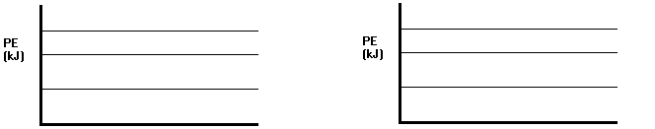
NaOH(s) 🡪 Na⁺(aq) + OH⁻(aq) NH₄Cl(s) 🡪 NH₄⁺(aq) + Cl⁻(aq)
Pre-lab and data checked by teacher:

