Determination of Height
Forensic Anthropology is a subset of Physical Anthropology. Forensic anthropologists specialize in the human skeleton. Physical or forensic anthropology concerns human identification when traditional means of identification are not possible. Forensic anthropologists examine skeletal remains to provide age, race, sex, and height of the skeleton. Comparisons to anatomical landmarks can be made using X-rays of known individuals. To determine the manner of death, analyzing of fracture patterns enable a forensic anthropologist to reconstruct a trauma. Scenarios requiring the skill of a forensic anthropologist could include a skeleton that had been burned, decomposed, mummified, or dismembered.

Purpose: To determine height of classmates based upon bone length and compare to actual height.

Procedure:
- Measure your lab partners actual height in cm using the ruler provided and record the number in data table 1.
- Using the skeleton diagram identify the following bones on your lab partner: humerus, ulna, radius and femur.
- Measure the length of each bone and record the numbers in data table 1.
- Using the formula chart below calculate the inferred height based upon each bone and record the results in data table 2.
bone | race | Male Equation | Female Equation
Femur | Caucasian | 2.32 * length + 65.53 cm | 2.47 * length + 54.13 cm
 | African-American | 2.10 * length + 72.22 cm | 2.28 * length + 59.76 cm
 | Asian | 2.15 * length + 72.57 cm | Not Available
Tibia | Caucasian | 2.42 * length + 81.93 cm | 2.90 * length + 61.53 cm
 | African-American | 2.19 * length + 85.36 cm | 2.45 * length + 72.56 cm
 | Asian | 2.39 * length + 81.45 cm | Not Available
Fibula | Caucasian | 2.60 * length + 75.50 cm | 2.93 * length + 59.61 cm
 | African-American | 2.34 * length + 80.07 cm | 2.49 * length + 70.90 cm
 | Asian | 2.40 * length + 80.56 cm | Not Available
Humerus | Caucasian | 2.89 * length + 78.10 cm | 3.36 * length + 57.97 cm
 | African-American | 2.88 * length + 75.48 cm | 3.08 * length + 64.67 cm
 | Asian | 2.68 * length + 83.19 cm | Not Available
Ulna | Caucasian | 3.76 * length + 75.55 cm | 4.27 * length + 57.76 cm
 | African-American | 3.20 * length + 82.77 cm | 3.31 * length + 75.38 cm
 | Asian | 3.48 * length + 77.45 cm | Not Available
Radius | Caucasian | 3.79 * length + 79.42 cm | 4.74 * length + 54.93 cm
 | African-American | 3.32 * length + 85.43 cm | 3.67 * length + 71.79 cm
 | Asian | 3.54 * length + 82.00 cm | Not Available
- Have your partner repeat steps 1-4 on you and record the results in data table 1.

Data Table 1:
Name | Actual Height (cm) | Length of Femur (cm) | Length of Humerus (cm) | Length of  Tibia (cm) | Length of Radius (cm)

Data Table 2:
Name | Femur (cm) | Humerus (cm) | Tibia (cm) | Radius (cm)

Conclusion: Did any bones project heights taller than you actually are? Did any bones project heights shorter than you actually are? Discuss some features of your bones below.

Scenario:
At a nearby construction zone, workers have made a startling discovery. They uncovered several bones that look like they were buried some time ago. You are part of a team of forensic anthropologists who have been called in to analyze these bones.
Unfortunately, the bones were heavily damaged by the construction equipment. The bones have all been mixed up, and several have been crushed. However, you think you can use the bones that are left to:
- determine how many people were buried at this location and
- determine the heights of the different individuals.
Analysis of Bones from Construction Site
The following bones were recovered from the construction site. A fellow forensic anthropologist has already classified the bones by sex and race. Using the mathematical formulas from Table 2, calculate the approximate height of each individual
bone# | type of bone | length(cm) | race | Sex | calculated Height (cm)
1 | Humerus | 38.2 | Caucasian | Male
2 | Femur | 44.0 | African-American | Female
3 | Ulna | 25.4 | Caucasian | Male
4 | Femur | 52.4 | Caucasian | Male
5 | Femur | 43.9 | African-American | Female
6 | Tibia | 43.7 | Caucasian | Male

1. Is it possible any of these bones came from the same person? Which bones?

2. What is the minimum number of bodies buried at this site? What is the maximum number of bodies?

Another forensic anthropologist on the team estimates the remains have been buried three to four years. A search of the local missing person’s database shows that the following people disappeared during that time:
MISSING PERSONS DATABASE
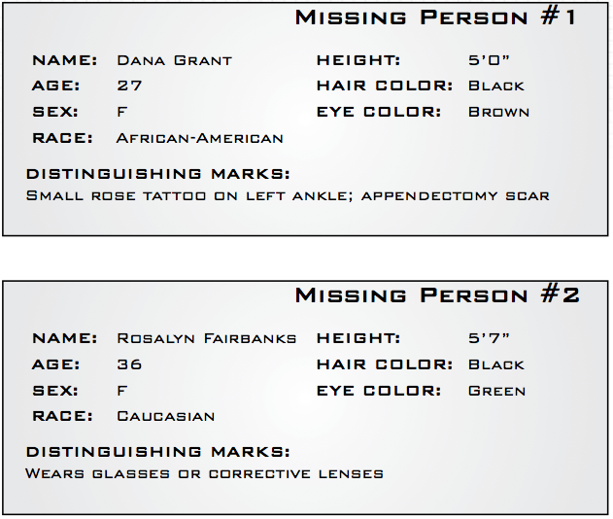

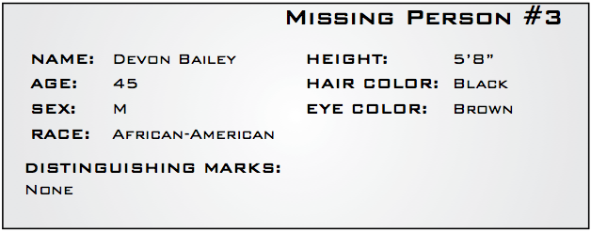
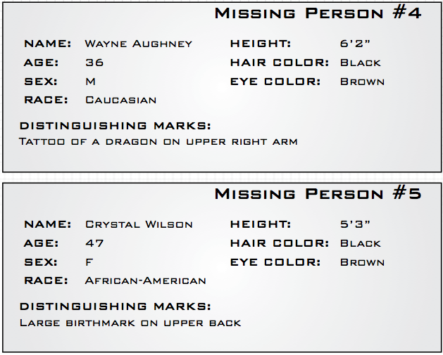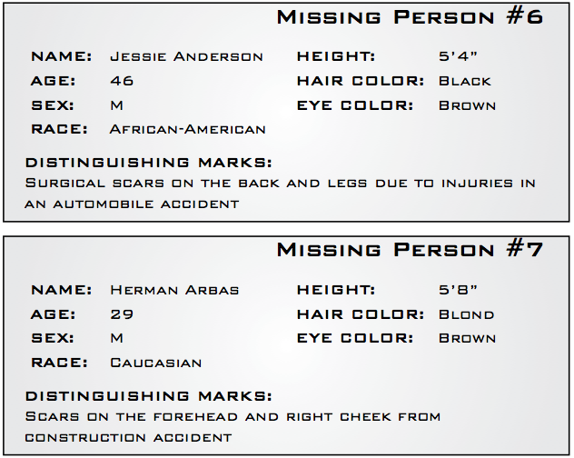

- Calculate the missing person heights in cm by first multiplying their feet by 12 and adding the inches. Then multiply that sum by 2.54. Record these measurements below:
Suspect 1: Suspect 5:
Suspect 2: Suspect 6:
Suspect 3: Suspect 7:
Suspect 4:
- Using the database, can you determine the possible identities of the people buried at the site?

- Are the heights exactly what you expected them to be? Why or why not?

- What are some possible sources of error in your identification?

- What other forensic tests could you do to test your deductions?

Humerus

Ulna

Radius

Femur
Tibula

Fibula

