Name: ________________________________ Mass and Volume Lab: upload full lab

Guiding Question: What is the relationship (if any) between mass and volume?

Materials: Metal samples, ruler, graduated cylinder, balance.

Pre-lab Questions:
- Explain Archimedes principle (volume displacement).

- Why is it important to measure the mass of the sample before the volume?

- Circle the word(s) that best describe your understanding of mass and volume. Then write a scientific explanation to defend the prediction you chose.
Prediction: The mass of a substance is (directly / indirectly / not) proportional to the volume
of the same substance.

Reasoning: ________________________________________________________________

________________________________________________________________

Procedure: Find the mass & volume of the samples. Record every measurement taken with labels, units, and correct significant figures.

Metal | Description of the substance | Mass(es)  Balance Precision: ________ | Volume(s)  Cylinder Precision: ________  Ruler Precision: ________
A

B

C

D

E

F

Analysis Questions:
- Graph your data below. Label the x axis “volume” and y axis “mass” with units and values. Be sure to use constant intervals.
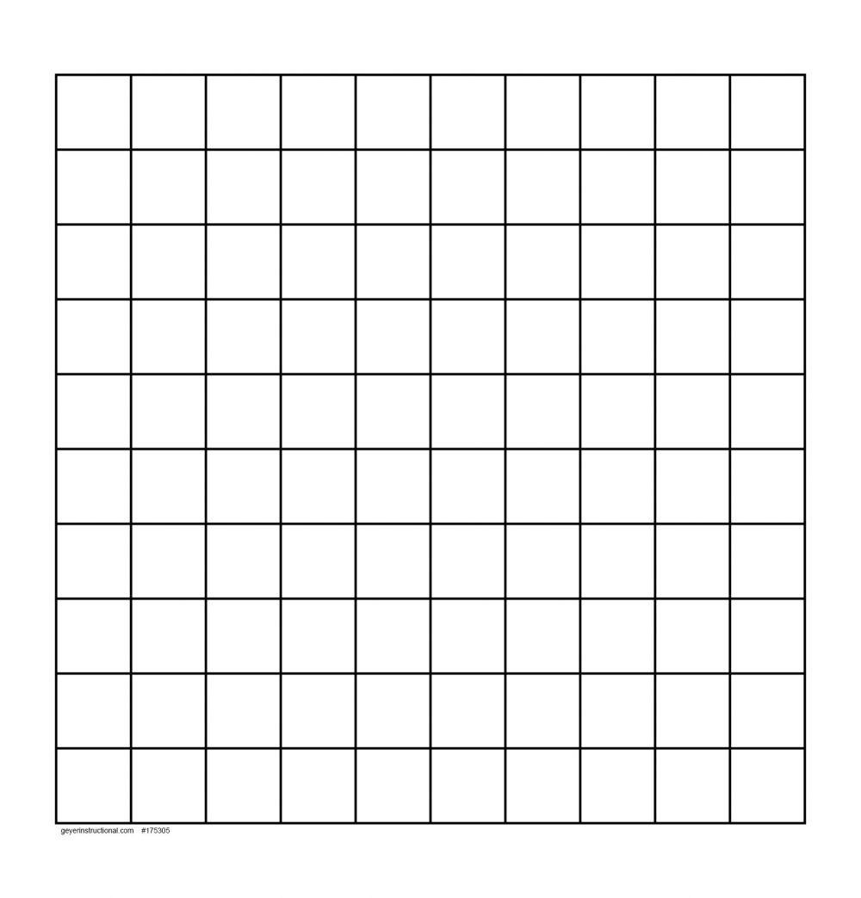

- Label each point on your graph as A-F of the metal it represents.
- Find two separate lines of best fit between samples of the same substance: Use a RULER! Explain why you chose to connect the points you did.

- Slope is determined by the formula m = ∆y/∆x.
  - Calculate the slope of the line you drew for the grey materials.

  - Calculate the slope of the line you drew for the penny colored materials.
- Claim: Using your data and graph, answer the guiding question: “What is the relationship (if any) between mass and volume?”

- What scientific term does the slope of a line created by graphing mass versus volume represent?

- This graph should have a y-intercept of zero because if the mass is zero, the volume should also be zero, and the samples don't exist. What errors may have occurred during the lab that would account for any non-zero y-intercepts on your graph?

Material | Density (g/cm³)
Lead
Copper
Brass | 8.60
Iron
Zinc
Aluminum
Glass | 2.25
Glycerol | 1.25
Wood | 0.93
Oil | 0.92
Ethanol | 0.79
- Fill in the rest of the table on the right using Table S.
- Calculate the density of each object using just your data. Show work.
- Using the table to the right, identify each object you tested.
- Calculate the percent error of your densities.

Metal | 9. Calculated Density | 10. Material | 11. Percent Error
A

B

C

D

E

F

- Draw particle diagrams that represent the metal samples. Think about our drawing rules:
- Include labels and/or a key
- Particles of the same substance have the same size, shape, and color
- Particles of a different substance have a new color
- Number of particles = mass
- Draw a reasonable amount of particles
- Solids are closely arranged, gases are spread out.

A | B | C
D | E | F

- Provide evidence (information from your data and calculations) and reasoning (explaining how the evidence is important) that supports how and why you drew your drawings above the way you did.

