Name: ____________________________ Calculating Moles, Grams, and Particles

Guiding Question: Can you calculate and measure various quantities of known substances?

Materials: Electronic balance, spoons/spatulas, blue cups, red cups, clear cups, solid sodium chloride, aluminum foil, water, plastic boats, iron.

Procedure: For each question in the chart below, solve the calculations with appropriate work shown, significant figures, and units. Then measure the quantity on a balance and bring it to your instructor to check for accuracy.

 | Calculation | Attempt
 |  | 1 | 2 | 3
 | Pretzels contain table salt, NaCl, which is reported in the “sodium” content of the food label. Calculate and measure the mass, moles, and number of particles of NaCl in one serving of pretzels. Bring that quantity to your instructor in a blue cup.  Mass:  Moles:  Particles: | 10 | 8 | 6
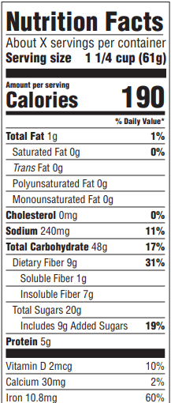  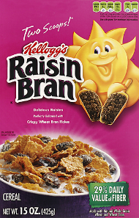 | Raisin Bran cereal contains 60% of the recommended daily iron your body needs. The iron can be removed simply with a strong magnet. Calculate and measure the mass, moles, and number of atoms of this quantity of iron. Bring it to your instructor in a weigh boat.  Mass:  Moles:  Atoms: | 10 | 8 | 6
 | Redbull packs sugar, primarily glucose which is C₆H₁₂O₆, into your drink. Calculate and measure the mass, moles and number of molecules of sugar in one half of a can of Redbull. Bring that quantity to your instructor in a red cup.  Mass:  Moles:  Molecules: | 10 | 8 | 6
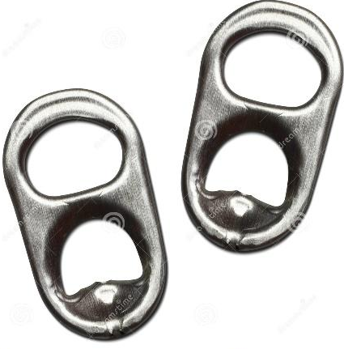 | An average soda can opener is produced using moles 0.011 moles of Aluminum. Calculate and measure the mass and number of atoms of the Aluminum foil equal to the can opener. Bring your massed aluminum to your instructor.  Mass:  Atoms: | 10 | 8 | 6
 | The average sip volume is 18.0mL of water for 12 year olds. Recall the density of water is 1.00g/mL. Calculate and measure the mass and number of molecules of water present in one sip of water. Bring that quantity to your instructor in a clear cup.  Mass:  Molecules: | 10 | 8 | 6
Conclusion: Would you rather have 321.5 grams of gold or 5.2 moles of gold?

