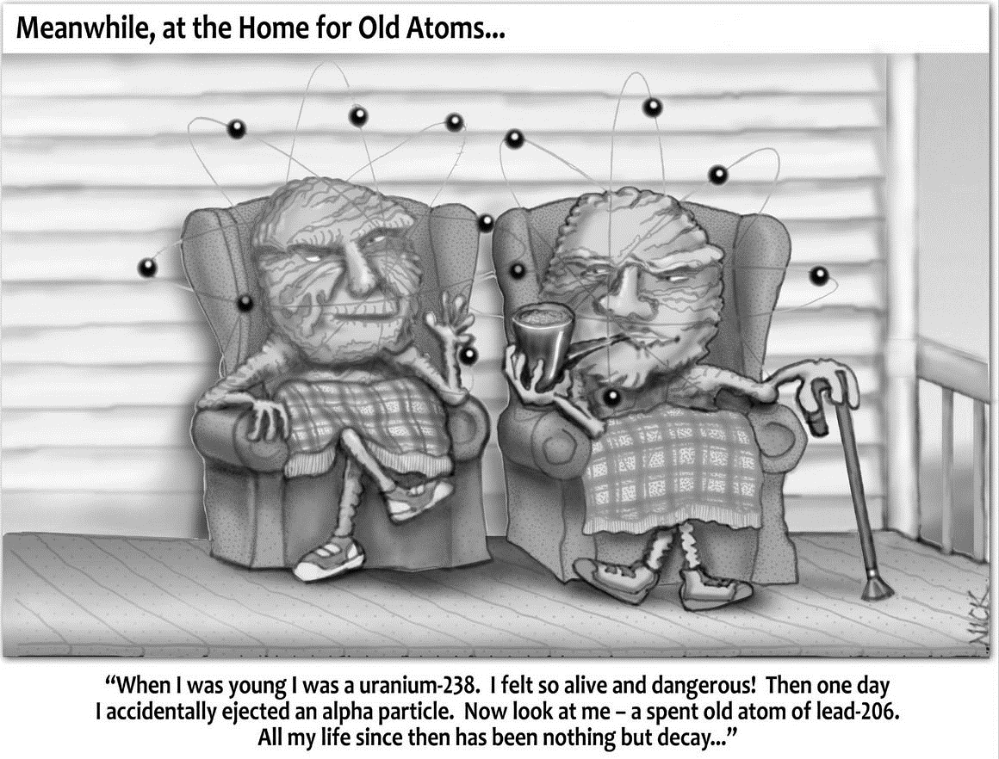

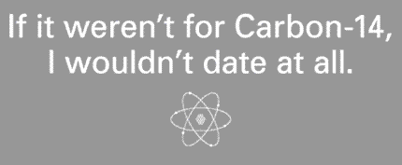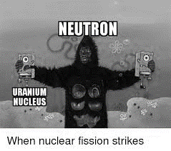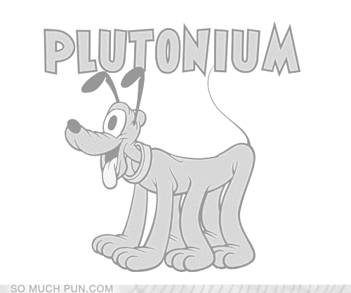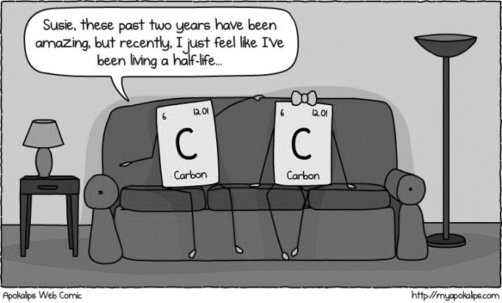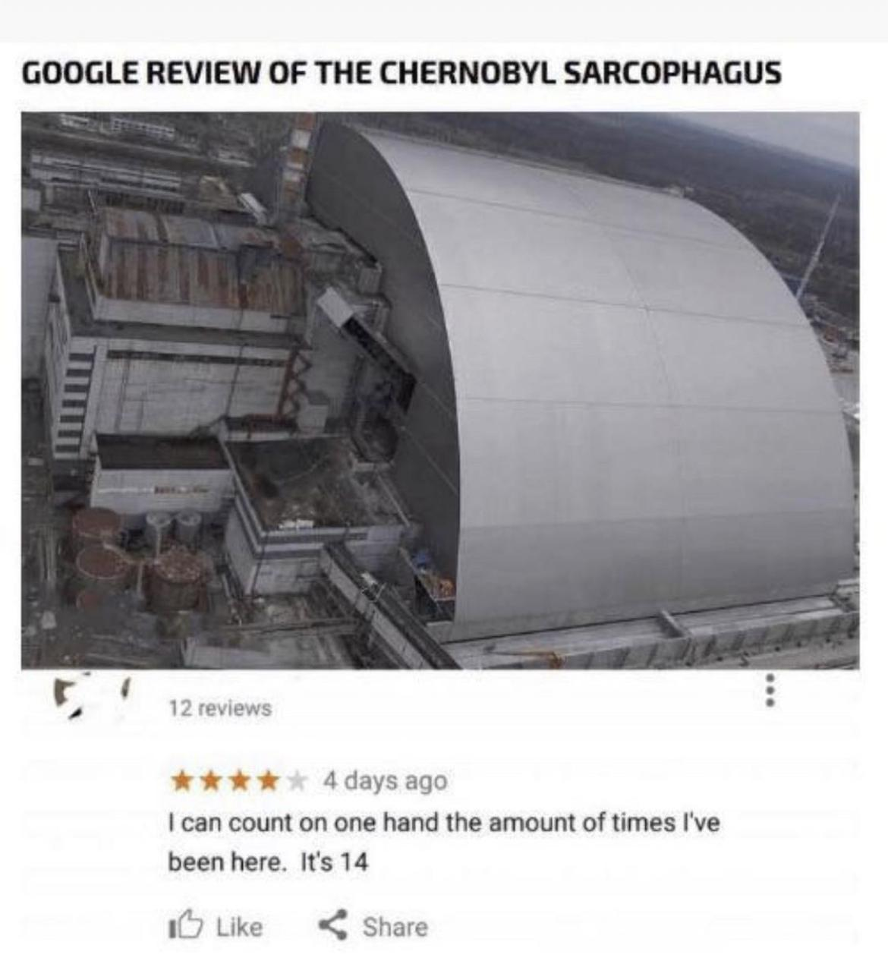

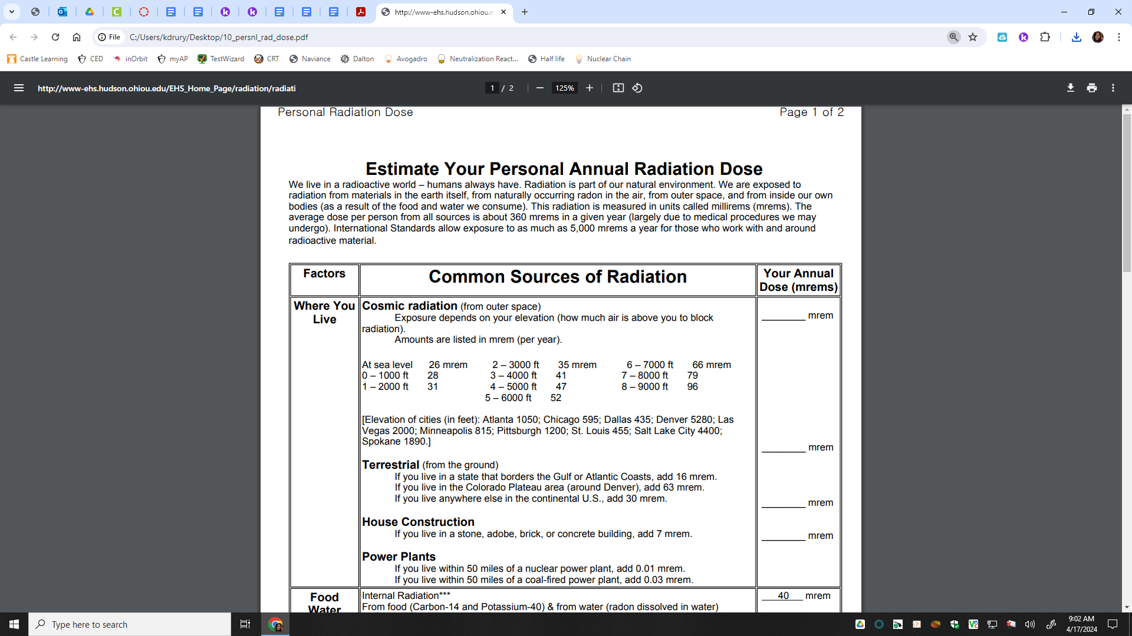

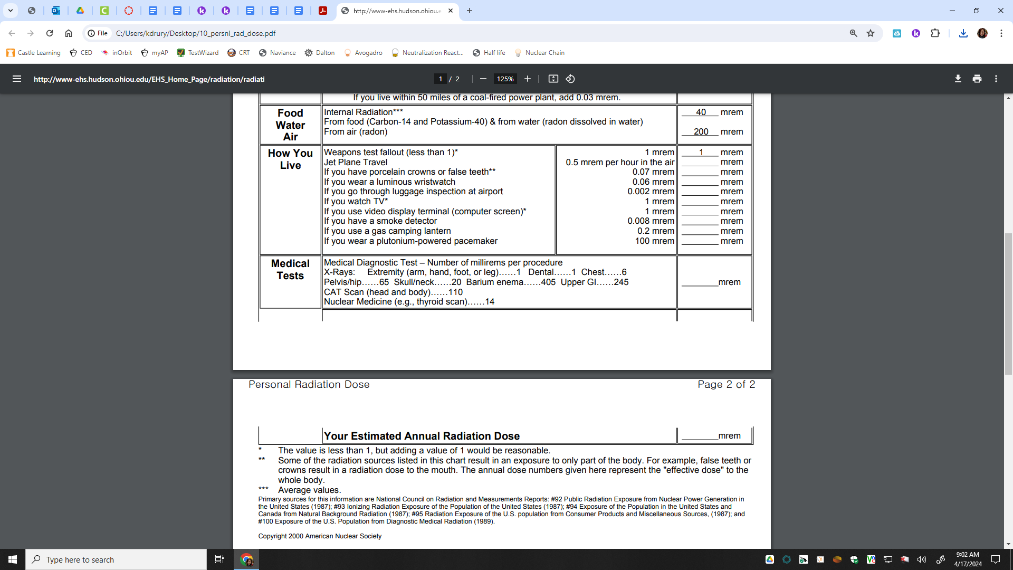

**Total: ___________**

**Nuclear Anticipation Guide**

For each statement record if you believe the statements is True or False.

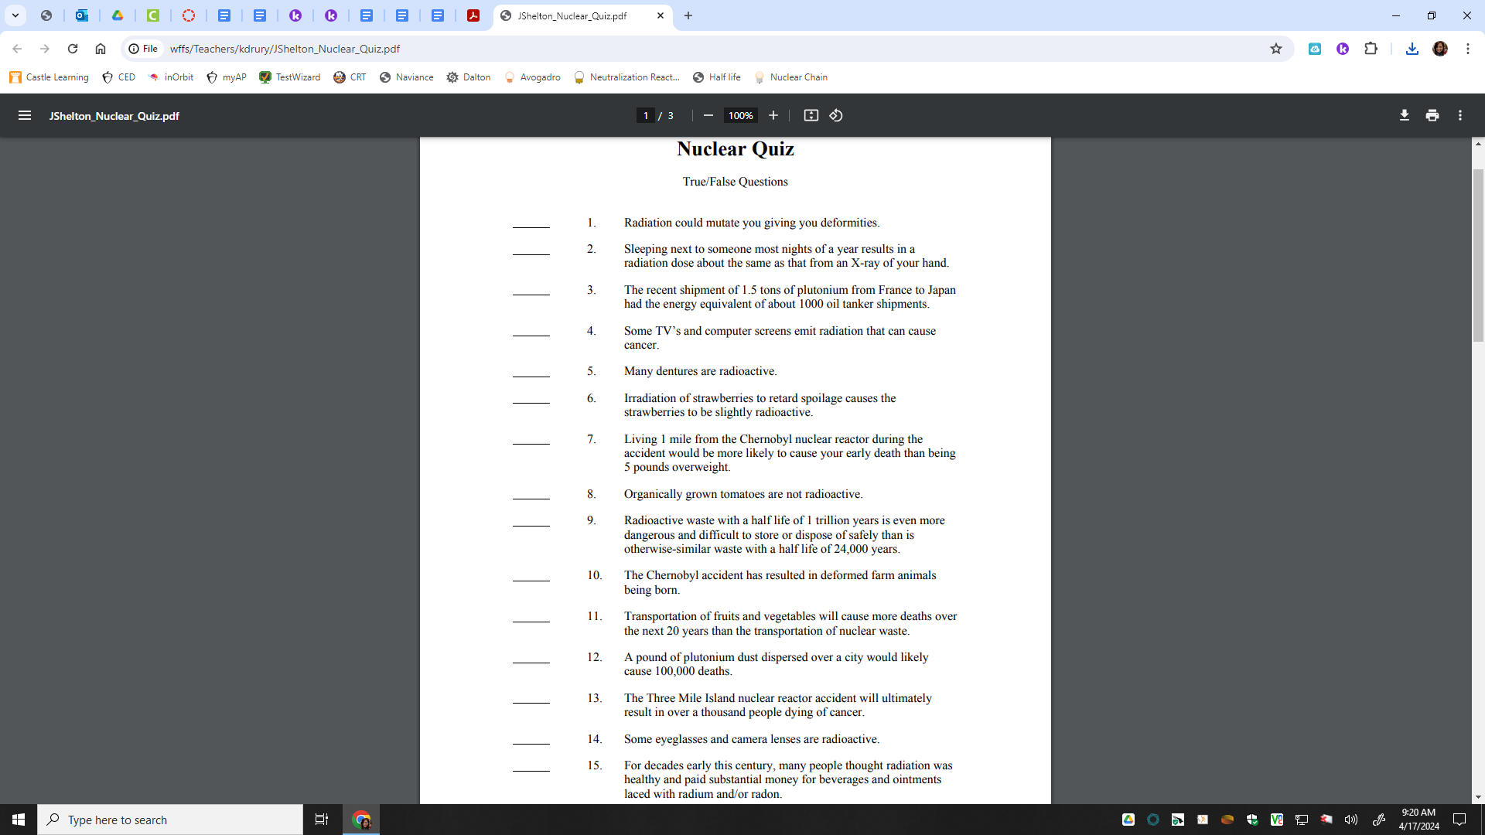

**Natural Decay** Think Tank Problems

1. Recall there are two major isotopes of carbon, C-12 and C-14. Draw both Bohr models, list their isotope symbol and identify their mass and charges.

| C-12  Isotope symbol:  Bohr:  Mass:  Atomic Number: | C-14  Isotope symbol:  Bohr:  Mass:  Atomic Number: |
| --- | --- |

1. Use Table O to fill in the chart:

| Type of Radiation | Isotope  Notation |  | | Same as what other particle? |
| --- | --- | --- | --- | --- |
| alpha particle |  | MASS |  |  |
| CHARGE |  |
| beta particle |  | MASS |  |  |
| CHARGE |  |
| gamma radiation |  | MASS |  |  |
| CHARGE |  |
| neutron |  | MASS |  |  |
| CHARGE |  |
| proton |  | MASS |  |  |
| CHARGE |  |
| positron |  | MASS |  |  |
| CHARGE |  |

**Natural Decay** Practice

**Writing Nuclear Equations** – Use Table N! When elements undergo radioactive decay, they change from one element to another. This happens by losing high energy alpha or beta particles, or by emitting positrons. The process of an atom becoming a different atom is called **transmutation**. Nuclear equations are written to track the changes that occur during transmutation. When writing nuclear equations, it is important to make sure that mass and charge are conserved. Write the complete nuclear equation for the spontaneous decay of the following nuclides:

1. 198Au _____________________________________________________________

2. iodine-131 _____________________________________________________________

3. 42K _____________________________________________________________

4. strontium-90 _____________________________________________________________

5. What is the decay mode for the nuclides above? ________________

6. 220Fr _____________________________________________________________

7. thorium-232 _____________________________________________________________

8. 239Pu _____________________________________________________________

9. radon-222 _____________________________________________________________

10. What is the decay mode for the nuclides above? ________________

11. 37Ca _____________________________________________________________

12. iron-53 _____________________________________________________________

13. 37K _____________________________________________________________

14. neon-19 _____________________________________________________________

15. What is the decay mode for the nuclides above? ________________

16. What is the decay mode of 37K?

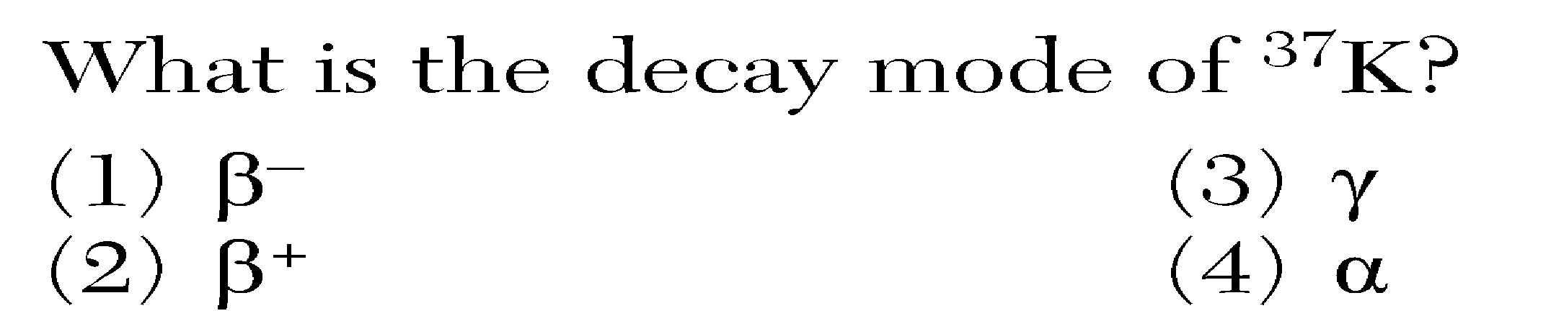

17. Which nuclear emission has the greatest penetrating power?  
 (1) alpha particle   (3) gamma radiation  
 (2) beta particle    (4) positron

18. What is the mass number of an alpha particle?  
 (1) 1    (2) 0 (3) 2    (4) 4

19. Which nuclear emission has the greatest mass? (1) alpha   (2) gamma (3) beta (4) positron

20. Which list is arranged in order from the least to the greatest penetrating power?  
(1) alpha particle, beta particle, gamma ray  
(2) alpha particle, gamma ray, beta particle  
(3) gamma ray, beta particle, alpha particle  
(4) beta particle, alpha particle, gamma ray

21. Which list of radioisotopes contains an alpha emitter, a beta emitter, and a positron emitter?  
 (1) C-14, N-16, P-32  
 (2) Cs-137, Fr-220, Tc-99  
 (3) Kr-85, Ne-19, Rn-222  
 (4) Pu-239, Th-232, U-238

22. Which consists of energy only?  
(1) alpha particle   (3) gamma radiation  
(2) beta particle    (4) positron

23. Which group of nuclear emissions is listed in order of increasing charge?  
(1) alpha, beta, gamma  
(2) gamma, alpha, beta  
(3) positron, alpha, neutron  
(4) neutron, positron, alpha

24. Which two radioisotopes have the same decay mode?

(1) 37Ca and 53Fe (3) 37K and 42K

(2) 220Fr and 60Co (4) 99Tc and 19Ne

25. The chart below shows the spontaneous nuclear decay of U-238 to Th-234 to Pa-234 to U-234.

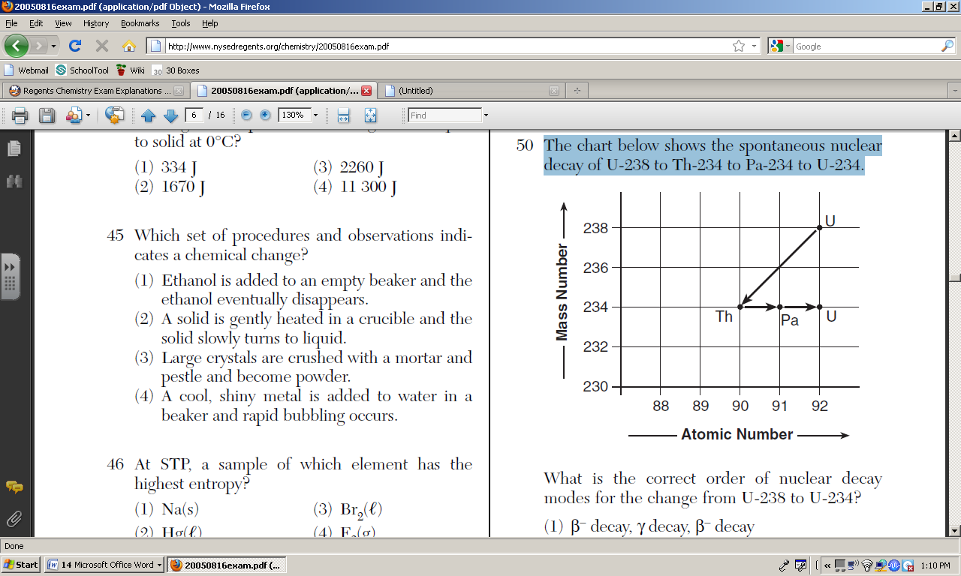

What is the correct order of nuclear decay modes for the change from U-238 to U-234?

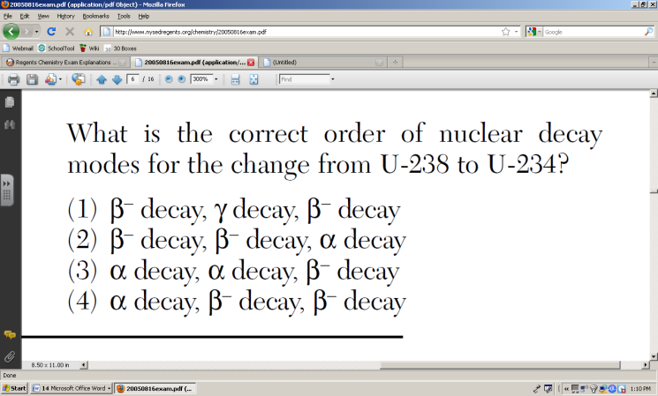

26. As a radioactive element emits gamma radiation only, the atomic number of the element

(1) increases (2) decreases (3) remains same

27. As an atom of a radioactive isotope emits an alpha particle, the mass number of the atom

(1) increases (2) decreases (3) remains same

28. A mixture of emanations from radioactive atoms is passed through electrically charged plates, as shown in the diagram below.

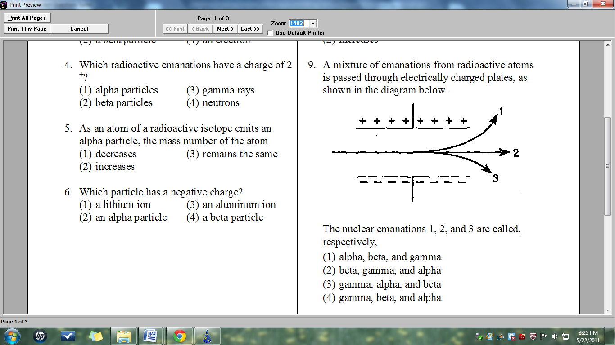

The nuclear emanations 1, 2, and 3 are called, respectively

(1) alpha, beta, and gamma

(2) beta, gamma, and alpha

(3) gamma, alpha, and beta

(4) gamma, beta, and alpha

29. In a paper-making factory, beta radiation is used to check that the paper being produced is the correct thickness. If the paper gets too thin, the reading on the detector increases causing the rollers to move apart to make the paper thicker. If the paper gets too thick, the reading on the detector goes down causing the rollers to move closer together. A diagram of this set-up is shown below:









Explain why beta radiation is used for this procedure rather than alpha or gamma radiation.

**Find the X**

Directions: Solve for the unknown particle X.

* 1. 🡪 + 





* 1. 🡪 +





* 1. 🡪 +





* 1. 🡪 +





* 1. + 🡪 +



**Transmutation** Practice

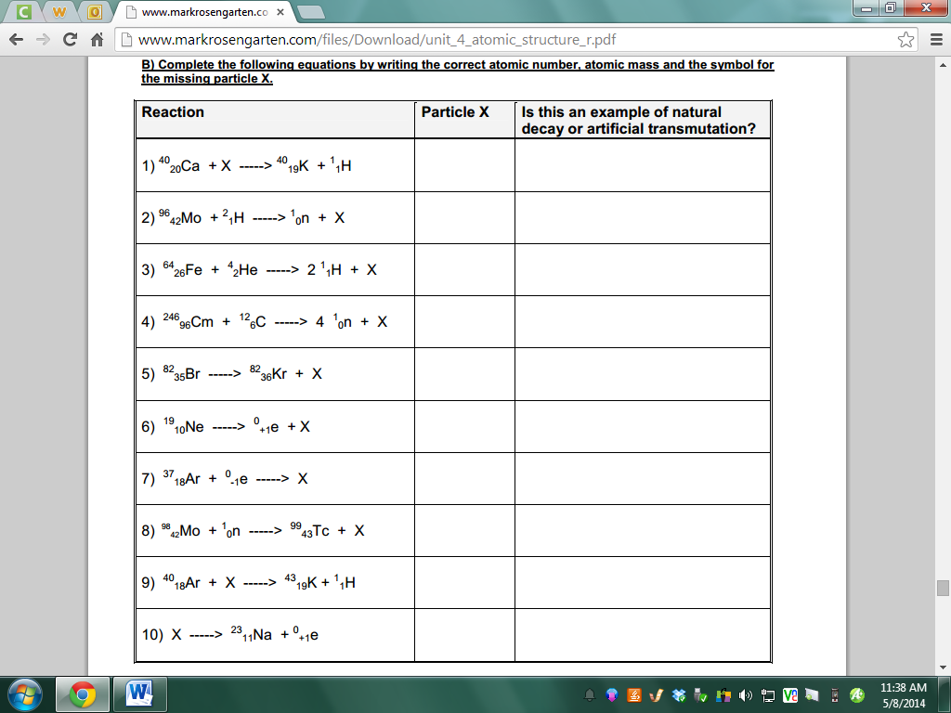

**Natural Decay Fill-ins** Challenge

Directions: Observe the first few steps of the Uranium decay process. Uranium needs 14 separate decay processes in order to reach a stable nucleus. Fill in the remaining decay equations.

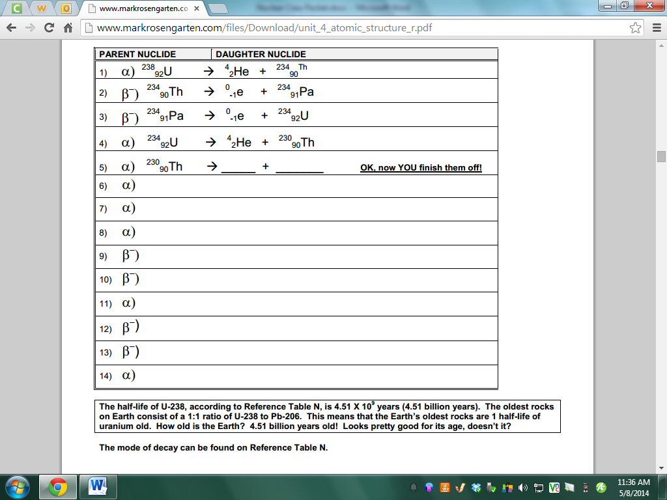

**Review**

|  | **Natural Transmutation** | **Common to Both**  **(check if the same)** | **Artificial Transmutation** |
| --- | --- | --- | --- |
| Starts with unstable or stable nucleus? |  |  |  |
| Ends with a stable or unstable nucleus? |  |  |  |
| Are new elements formed? |  |  |  |
| If new elements are formed are they heavier or lighter than the original element? |  |  |  |
| Does it produce energy? |  |  |  |

**Nuclear Chemistry** Think Tank Problems

The study of nuclear chemistry is different from other topics this year because it primarily focuses on the nucleus unlike chemical reactions we have studied that focus on electrons. When changes are made to the nucleus, the atom often changes into other atoms of different elements. This is called *transmutation* and it can be natural (due to instability of the nucleus) or artificial (due to the bombardment of the nuclei with smaller particles). Stability is based on the proton/neutron ratio. If this ratio is close to 1:1, a smaller nucleus will be more stable. If a nucleus is unstable, it will decay and is called a *radioisotope*. **All elements after 83 are radioactive.** In the examples below, mass and charge are conserved.

Alpha decay: 22688 Ra 🡪 22286Rn + **42He**

Beta decay: 146 C 🡪 147N + **0-1B**

Positron decay: 3719 K 🡪 3718 Ar + **0+1B**

**Key Questions:**

1. In isotopic notation the top number is the mass number and the bottom number is the atomic number. Explain or demonstrate how mass and charge are conserved in these equations.
2. Explain in terms of reactants, why each of the decay equations are known as natural transmutations.
3. In terms of Coulomb's law (like charges repel, opposites attract), propose a reason why neutrons are present in the nucleus along with protons.
4. In terms of Coulomb's law (like charges repel, opposites attract), propose a reason why a ratio of more neutrons than protons is more favorable than a ratio of more protons than neutrons.
5. Calculate the number of protons and neutrons in:
   1. C-12 b. N-14 c. K-38 d. F-18
   2. The isotopes in the question above are all stable, non radioactive isotopes. Explain in terms of subatomic particles why they are stable.
6. Calculate the number of protons and neutrons in:
   1. K-37 b. Ar-37 c. Ne-19 d. F-19
7. K-37 transmutates into Ar-37 and becomes more stable. Similarly, Ne-19 decays into F-19. Propose a rule to explain why certain isotopes undergo positron emission using the number of protons and neutrons.
8. Calculate the number of protons and neutrons in:
   1. C-14 b. N-14 c. I-131 d. Xe-131
9. C-14 transmutates into N-14 to become more stable. Similarly, I-131 decays into Xe-131. Propose a rule to explain why certain isotopes undergo beta decay using the number of protons and neutrons.
10. Calculate the number of protons and neutrons in:
    1. Ra-226 b. Rn-222 c. Po-218

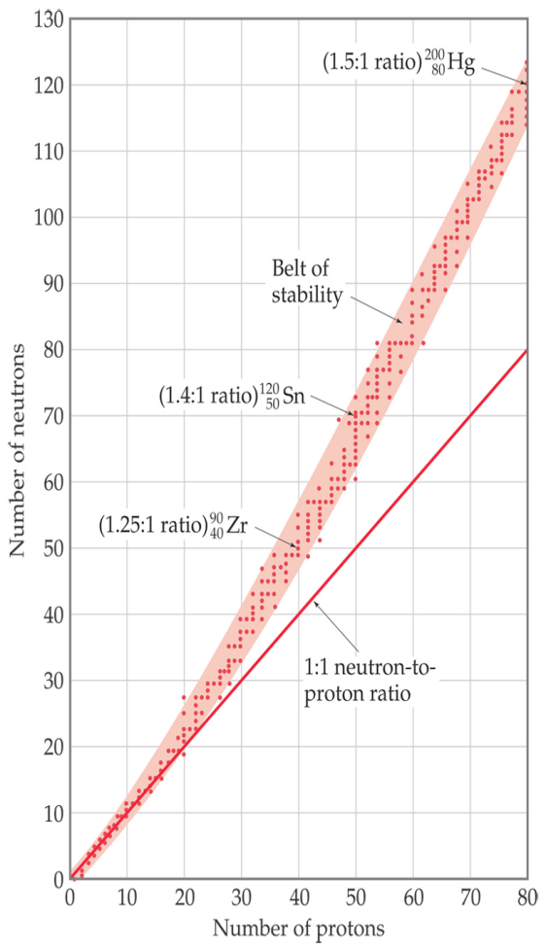

1. Ra-226 transmutates to produce Ra-222 and becomes more stable. Then the Rn-222 that was just formed decays into Po-218. Propose a rule to explain why large nuclei emit alpha particles using the number of protons and neutrons.
2. Using table N and the “Belt of Stability” graph provided:
   1. C-12. N-14, K-38, and F-18 were stable. Explain where these isotopes will be plotted on this graph (in the belt, above or below).

* 1. Identify another element that will undergo beta decay.
  2. Explain where the isotope will be plotted on the graph (in the belt, above or below).
  3. Identify another element that will undergo positron decay.
  4. Explain where the isotope will be plotted on the graph (in the belt, above or below).
  5. Propose a reason why alpha emitters are not plottable on this graph.

1. Draw how alpha, beta, and positron particles are affected by positive and negative plates.

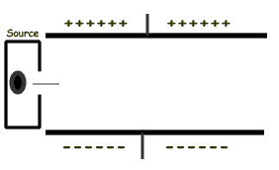

1. The gamma particle has no mass and no charge and can be listed as a product in most nuclear reactions. Why is it often omitted? How would it be affected by the plates in question 6?
2. Which particle is the most penetrating? The least?

**Exercises:**

1. Solve for X in the reactions:
   1. 31 H 🡪 32He + X ___________
   2. 23892 U 🡪 42He + X ___________
   3. X 🡪 4220Ca + 0-1e ___________
   4. 23490 Th 🡪 23491Pa + X ___________
2. Write the equations for the decay of (Use table N):
   1. Fr-220 __________________________________
   2. Au -198 __________________________________
   3. Fe-53 __________________________________

**Radioisotopes and Half-lives** Think Tank Problems

Radioactive isotopes are unstable, which means that they spontaneously (readily) decay (break apart) into different isotopes or elements. Radioactive isotopes give off radiation during the process of radioactive decay. Radiation can be in the form of particles (alpha, beta, or positron) and/or pure energy (gamma rays). For radioactive isotopes, the rate (speed) of radioactive decay is constant. All radioactive isotopes have a specific **half-life**, or **time that it takes for exactly half of the sample to decay into something else and half of the sample to remain unchanged.**  It is because of information about half-lives that we can know how old the Earth is and how old fossils are.

**Graphing Questions**

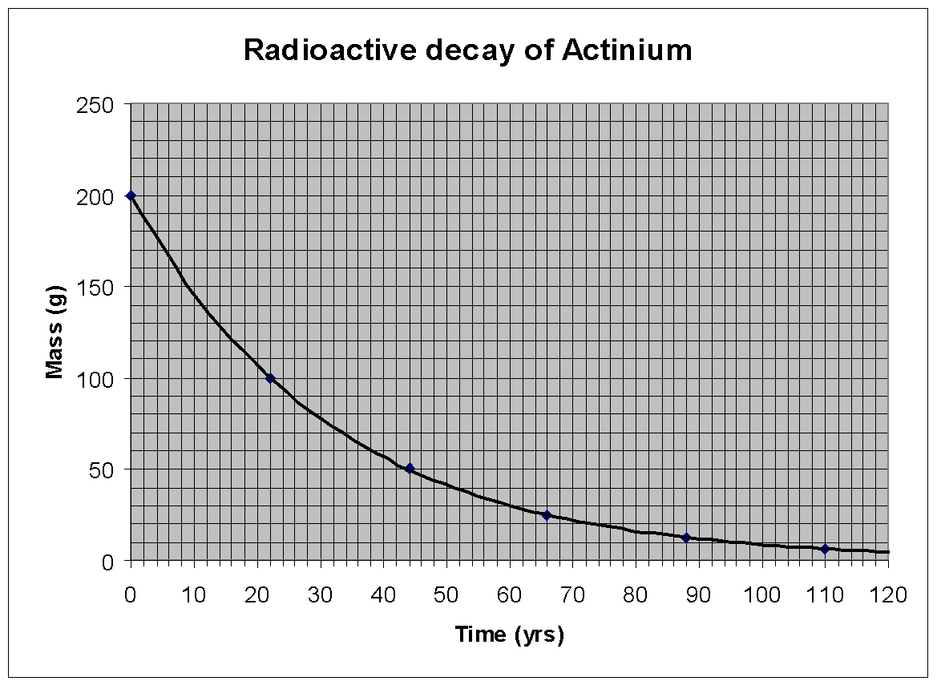

1. What was the original mass of the Ac sample?
2. How many grams of Ac remain after 40 years?
3. What is the half-life of Ac?
4. What mass of Ac remains after one half-life?
5. What fraction of Ac remains after one half-life?
6. How many half-lives must Ac go through until only 25% of the original sample mass remains?
7. How many half-lives until only 6.25% remains?
8. How many half-lives will it take for all of the original sample to decay?
9. A radioisotope’s half-life is 1 min. Given that the initial mass of the sample is 12g, calculate the mass of the radioisotope that has not decayed after 1 min, 2min, 3min, 4min, 5min and 6min. Draw a graph of the radioisotope mass versus time.

|  |  |  |  |  |  |  |  |  |  |  |  |
| --- | --- | --- | --- | --- | --- | --- | --- | --- | --- | --- | --- |
|  |  |  |  |  |  |  |  |  |  |  |  |
|  |  |  |  |  |  |  |  |  |  |  |  |
|  |  |  |  |  |  |  |  |  |  |  |  |
|  |  |  |  |  |  |  |  |  |  |  |  |
|  |  |  |  |  |  |  |  |  |  |  |  |
|  |  |  |  |  |  |  |  |  |  |  |  |
|  |  |  |  |  |  |  |  |  |  |  |  |
|  |  |  |  |  |  |  |  |  |  |  |  |
|  |  |  |  |  |  |  |  |  |  |  |  |
|  |  |  |  |  |  |  |  |  |  |  |  |
|  |  |  |  |  |  |  |  |  |  |  |  |

1. Estimate the time that must elapse in order for 1/4 of the radioisotope to be present.
2. By interpolation of the graph, estimate the grams of the radioisotope left after 1.5min.
3. The initial mass of a sample of a radioisotope is 100g. After 1 hour, 80g remain. After 2 hours, 60g remains, after 4hours, 41g remain and after 6 hours, 26.2g remain. On the next grid, draw a graph of mass of radioisotope remaining versus time. Use this graph to estimate the half-life of the radioisotope.

|  |  |  |  |  |  |  |  |  |  |  |  |  |
| --- | --- | --- | --- | --- | --- | --- | --- | --- | --- | --- | --- | --- |
|  |  |  |  |  |  |  |  |  |  |  |  |  |
|  |  |  |  |  |  |  |  |  |  |  |  |  |
|  |  |  |  |  |  |  |  |  |  |  |  |  |
|  |  |  |  |  |  |  |  |  |  |  |  |  |
|  |  |  |  |  |  |  |  |  |  |  |  |  |
|  |  |  |  |  |  |  |  |  |  |  |  |  |
|  |  |  |  |  |  |  |  |  |  |  |  |  |
|  |  |  |  |  |  |  |  |  |  |  |  |  |
|  |  |  |  |  |  |  |  |  |  |  |  |  |
|  |  |  |  |  |  |  |  |  |  |  |  |  |
|  |  |  |  |  |  |  |  |  |  |  |  |  |

1. Use your answer to number 12 to calculate the amount of time required for 25g of the radioisotope to remain. Compare that to the time you would get if you used the graph.
2. By extrapolation of the graph, find the mass of the radioisotope remaining after 8 hours.

**Half Life Calculation** Practice

**Time Elapsed**

1. How long will it take for 30. g of 222Rn to decay to 7.5 g?
2. How long will it take for a 28 g sample of 226Ra to decay to 3.5 g?
3. How long will it take for 50% of a sample of iodine-131 to decay?
4. How long will it take a sample of Fr-220 to decay to 1/4 of its original amount?
5. The fossilized remains of a plant were found at a construction site. The fossilized remains contain 1/16th the amount of carbon-14 that is present in a living plant. Determine the approximate age of these fossilized remains.

**Amount Remaining**

1. How many grams of 16N will be left from a 16.0 g sample after 21.6 s?
2. After 9.8 × 1010 years, how many grams will be left from a 256 g sample of Th-232?
3. What is the amount of a 500. gram sample of iron-53 that will remain unchanged after 34.04 minutes?
4. What amount of a 100 g sample of K-42 will remain after 24.8 hours?

**Fraction Remaining**

10. What fractionof a 100 g sample of K-42 will remainafter 24.8 hours?

11. What fraction of a radioactive I-131 sample would remain unchanged after 32.28 days?

12. What fraction of a sample of 32P will be left after 42.9 days?

13. What fraction of a sample of 3H will be left after 36.78 years?

14. A wooly mammoth fossil is determined to be 17,200 years old. What is the fraction of carbon-14 remaining in the bones of this mammoth?

**Number of Half-Lives**

15. How many half-life periods will it take for 50 g of 99Tc to decay to 6.25 g?

16. How many half-lives have elapsed if a 100 g sample of a radioactive isotope has only 12.5 g remaining?

17. How many half-lives will pass by the time a 60.0g sample of Co-60 decays to 7.5 g?

18. How many half-lives of K-37 will pass after 6.15 seconds?

**Original Mass**

19. If 2 grams of an original sample of gold-198 remained after 13.45 days, what was the mass of the original sample?

20. If 16.5 g of uranium-235 remain after 2.84 x 109 years, how much of the radioactive isotope was in the original sample?

21. After 62 hours, 1 g remains unchanged from a sample of K-42. How much K-42 was in the original amount?

**Half-Life**

22. An original sample of the radioisotope fluorine-21 had a mass of 80.0 milligrams. Only 20.0 milligrams of this original sample remain unchanged after 8.32 seconds. What is the half-life of fluorine-21?

23. What is the half-life of a 208 g sample of sodium-24 if it decays to 13.0 g of sodium-24 within 60.0 hours?

24. What is the half-life of a radioisotope if 1/16th of it remains undecayed after 26.4 days?

25. What is the half-life of a radioactive isotope if 1/32 of it remains undecayed after 7.5 days?

26. According to the big bang theory, the universe started 1.5 x 1010 years ago. How many half-lives of uranium-238 has undergone since the big bang?

**Fission and Fusion** Think Tank Problems

Fission: 23592 U + **10n** 🡪 9236Kr + 14156Ba + **310n** + Energy Fusion: 21 H + 31 H 🡪 42 He + 10n + Energy

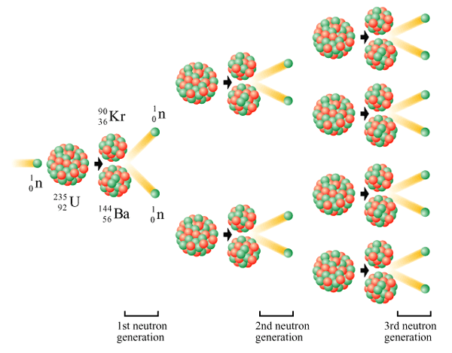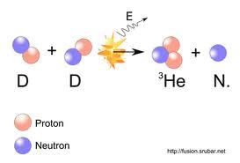

1. Explain why fission is considered a chain reaction and could be dangerous.
2. Explain why fusion is not as dangerous as fission in terms of control and products made.
3. Why is it so difficult for hydrogen atoms to combine? (Why is fusion not cost effective?)
4. Where does all the energy that is produced in fission and fusion come from?
5. What type of transmutation are both fission and fusion?

|  | **Fission** | **Fusion** |
| --- | --- | --- |
| Starts with small or large nuclei? |  |  |
| Ends with smaller or larger nuclei? |  |  |
| Produces or requires energy (or both)? |  |  |
| Occurs at STP or at high temperatures? |  |  |
| Requires control rods and moderators or not? |  |  |
| Requires neutrons or not? |  |  |
| Produces 1000x more energy than chemicals or 1000000x? |  |  |
| Used in nuclear bombs or hydrogen bombs? |  |  |
| Used in reactors or stars? |  |  |
| Produces waste or clean? |  |  |
| Requires neutral particle or needs to overcome positive repulsions? |  |  |

**Nuclear Reactions** Check Your Understanding

Directions: Fill in the table with checks for decay, artificial transmutation, fission, or fusion.

| **Property** | **Fission** | **Fusion** | **Natural Trans-mutation** | **Artificial Trans-mutation** |
| --- | --- | --- | --- | --- |
| Requires temperature of millions of degrees |  |  |  |  |
| Takes two small nuclei and combines them into a larger nuclei |  |  |  |  |
| Takes a stable nucleus and turns it into an unstable one |  |  |  |  |
| Releases millions of times more energy than chemical reactions |  |  |  |  |
| Takes a large nuclei and splits it using neutrons into smaller nuclei |  |  |  |  |
| Happens all by itself because the nucleus is unstable |  |  |  |  |
| Releases only thousands of times more energy than chemical reactions |  |  |  |  |
| Requires a particle accelerator |  |  |  |  |
| Requires a “bullet” |  |  |  |  |
| Powers the sun and other stars |  |  |  |  |
| Used in bombs in WWII |  |  |  |  |
| Used in nuclear reactors |  |  |  |  |
| Used in bombs but only tested |  |  |  |  |
| Another word for nuclear “decay” |  |  |  |  |
| 23592 U + 10n 🡪 9236Kr + 14156Ba + 310n |  |  |  |  |
| 21 H + 31 H 🡪 42 He |  |  |  |  |
| 31 H 🡪 32He + 0-1e |  |  |  |  |
| 31 H + 11p 🡪 32He + 10n |  |  |  |  |

**Multiple Choice** Regents Practice

1. Which nuclear equation represents a natural transmutation?

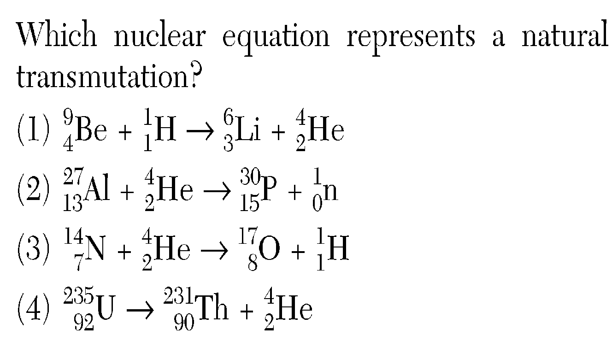

2. Which balanced equation represents nuclear fusion?

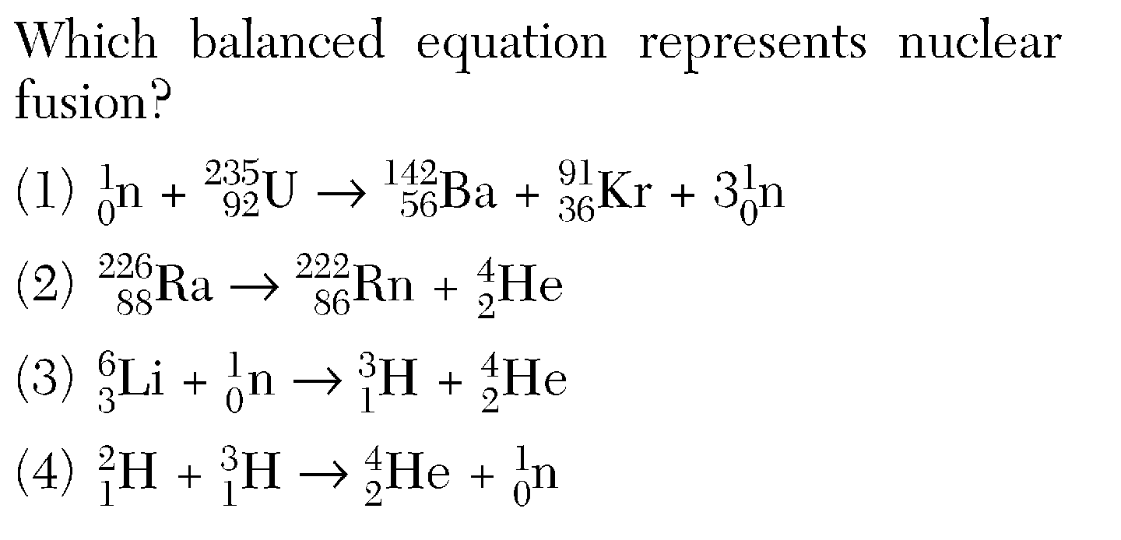

3. Which reaction converts an atom of one element to an atom of another element?  
(1) combustion        (3) saponification  
(2) polymerization   (4) transmutation

4. Which equation represents a fusion reaction?

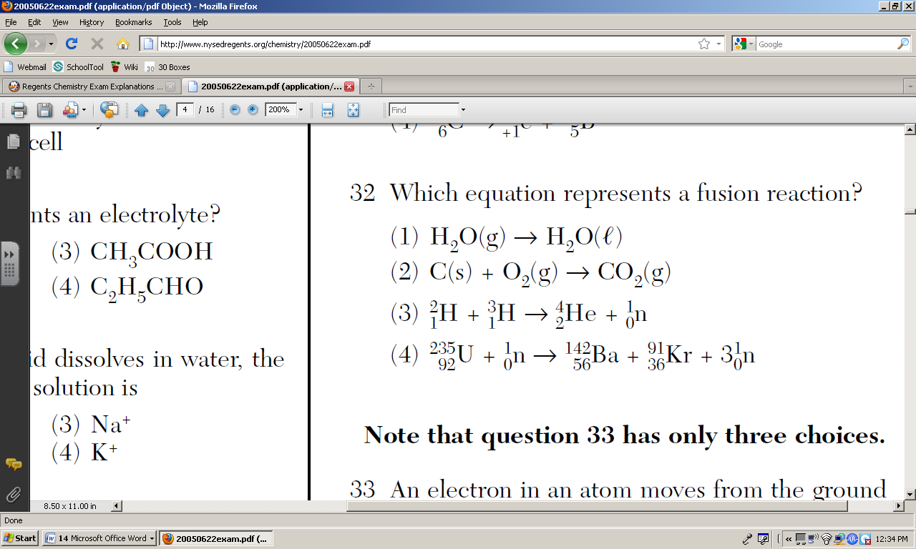

5. Which reaction represents natural nuclear decay?  
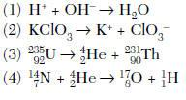

6. Which equation represents a spontaneous nuclear decay?

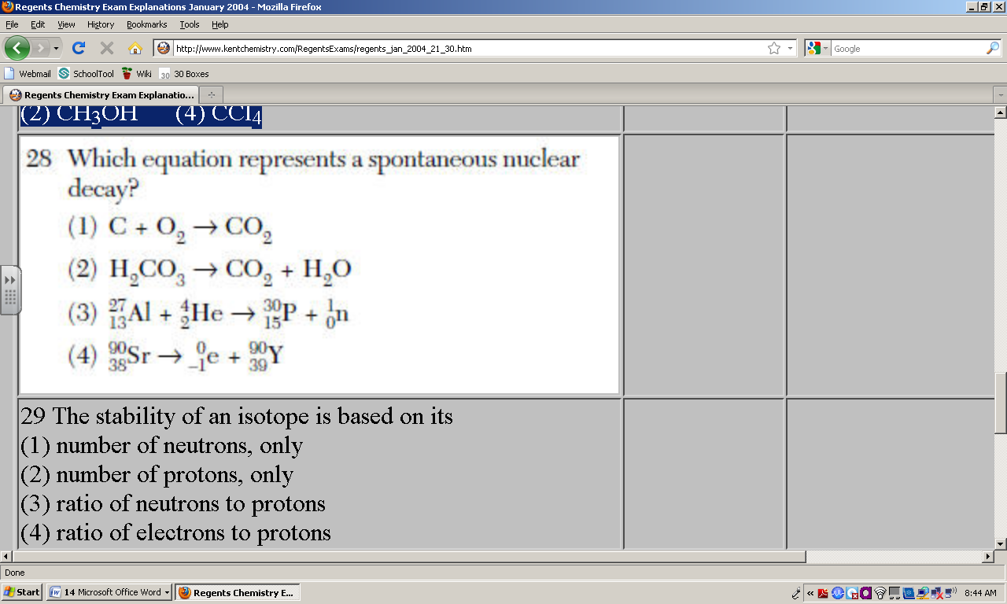

7. In a nuclear fusion reaction, the mass of the products is

(1) less than the mass of the reactants because some of the mass has been converted to energy  
(2) less than the mass of the reactants because some of the energy has been converted to mass  
(3) more than the mass of the reactants because some of the mass has been converted to energy  
(4) more than the mass of the reactants because some of the energy has been converted to mass

8. Nuclear fusion differs from nuclear fission because nuclear fusion reactions

(1) form heavier isotopes from lighter isotopes  
(2) form lighter isotopes from heavier isotopes  
(3) convert mass to energy  
(4) convert energy to mass

9. One benefit of nuclear fission reactions is

(1) nuclear reactor meltdowns  
(2) storage of waste materials  
(3) biological exposure  
(4) production of energy

10. The change that is undergone by an atom of an element made radioactive by bombardment with high-energy protons is called

(1) natural transmutation  
(2) artificial transmutation  
(3) natural decay  
(4) radioactive decay

11. A nuclear fission reaction and a nuclear fusion reaction are similar because both reactions  
(1) form heavy nuclides from light nuclides  
(2) form light nuclides from heavy nuclides  
(3) release a large amount of energy  
(4) absorb a large amount of energy

12. A nuclear reaction in which two light nuclei combine to form a more massive nucleus is called  
(1) addition    (3) fusion  
(2) fission       (4) substitution

13. A serious risk factor associated with the operation of a nuclear power plant is the production of  
(1) acid rain  
(2) helium gas  
(3) greenhouse gases, such as CO2  
(4) radioisotopes with long half-lives

14. What is a problem commonly associated with nuclear power facilities?  
(1) A small quantity of energy is produced.  
(2) Reaction products contribute to acid rain.  
(3) It is impossible to control nuclear fission.  
(4) It is difficult to dispose of wastes.

15. Which change takes place in a nuclear fusion reaction?  
(1) Matter is converted to energy.  
(2) Energy is converted to matter.

(3) Ionic bonds are converted to covalent bonds.  
(4) Covalent bonds are converted to ionic bonds.

14. Types of nuclear reactions are fission, fusion, &  
(1) single replacement (3) oxidation-reduction  
(2) neutralization (4) transmutation

15. Atoms of one element are converted to atoms of another element through

(1) fermentation    (3) polymerization  
(2) oxidation          (4) transmutation

16. Given the diagram representing a reaction:

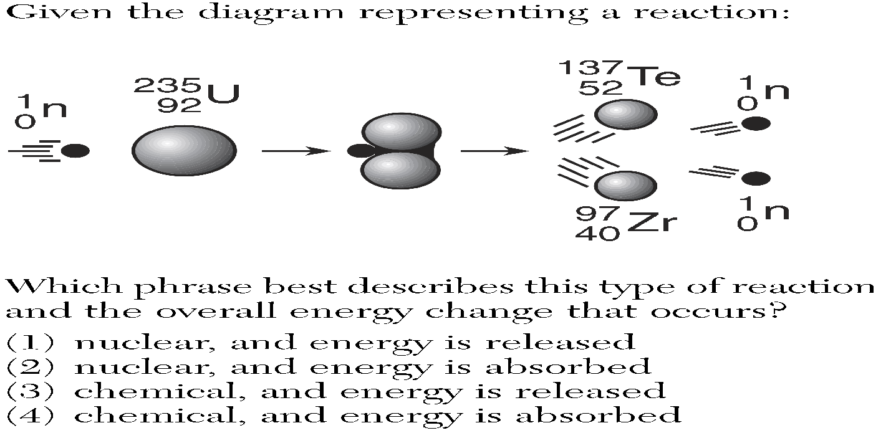

Which phrase best describes this type of reaction and the overall energy change that occurs?

(1) nuclear, and energy is released

(2) nuclear, and energy is absorbed

(3) chemical, and energy is released

(4) chemical, and energy is absorbed

17. Which nuclide is paired with a specific use of that nuclide?  
 (1) carbon-14, treatment of cancer  
 (2) cobalt-60, dating of rock formations  
 (3) iodine-131, treatment of thyroid disorders  
 (4) uranium-238, dating of once-living organisms

18. The decay of which radioisotope can be used to estimate the age of the fossilized remains of an insect?  
(1) Rn-222      (2) Co-60 (3) I-131         (4) C-14

19. According to Table N, which radioactive isotope is best for determining the actual age of Earth?

(1) 238 U         (2) 60 Co (3) 90 Sr          (4) 14 C

20. Which isotope is most commonly used in the radioactive dating of the remains of organic materials?

(1) 14C      (2)32P (3) 16N       (4)37K

21. Which radioactive isotope is used in treating cancer?

(1) carbon-14      (3) lead-206  
 (2) cobalt-60       (4) uranium-238

22. Which nuclide is used to investigate human  
thyroid gland disorders?  
 (1) carbon-14          (3) cobalt-60  
 (2) potassium-37   (4) iodine-131

**Short Answer** Regents Practice

1. A substance known as heavy water can be obtained from ordinary water and could be a significant source of energy in the future. Heavy water contains deuterium, H-2. Instead of the two hydrogen atoms in a typical water molecule, a heavy water molecule has two deuterium atoms. In 3.78 kilograms of ordinary water, the percent composition by mass of heavy water is approximately 0.0156%. Deuterium atoms completely ionize at approximately 108 K. The result is an ionized gas consisting of electrons and deuterons (the nuclei of deuterium). A triton is the nucleus of a tritium atom, H-3. These particles react according to the equations below. In the second equation, *X* represents an unidentified product.

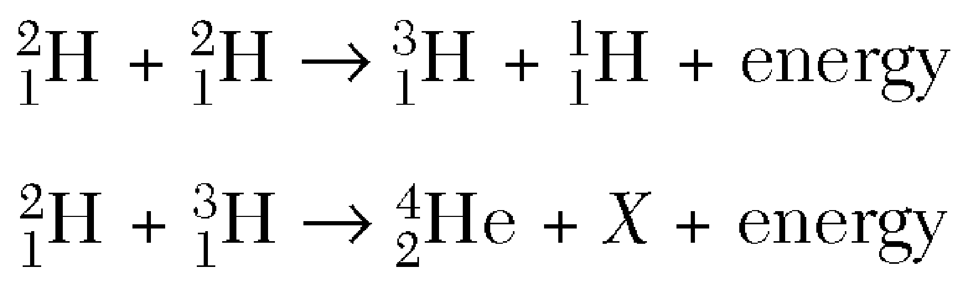

1. Calculate the mass of heavy water in a 3.78-kilogram sample of ordinary water. Your response must include *both* a correct numerical setup and the calculated result.

1. Identify particle *X* in the second nuclear equation. Your response must include the symbol, atomic number, and mass number of the particle.

2. Hydrocarbons and fissionable nuclei are among the sources used for the production of energy in the United States. A chemical reaction produces much less energy than a nuclear reaction per mole of reactant.The balanced chemical equation below represents the reaction of one molecule of a hydrocarbon with two molecules of oxygen.



The nuclear equation below represents one of the many possible reactions for one fissionable nucleus. In this equation, *X* represents a missing product.



1. Identify the type of organic reaction represented by the chemical equation. _____________________
2. On the labeled axes below*,* draw a potential energy diagram for the reaction of the hydrocarbon with oxygen.

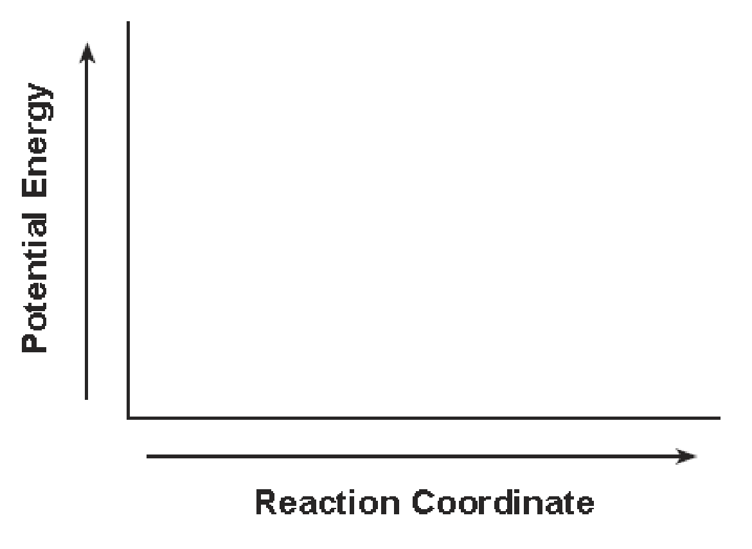

(c) Write an isotopic notation for the missing product represented by *X* in the nuclear equation.

3. When a uranium-235 nucleus absorbs a slow-moving neutron, different nuclear reactions may occur. One of these possible reactions is represented by the complete, balanced equation below.



For this reaction, the sum of the masses of the products is slightly less than the sum of the masses of the reactants. Another possible reaction of U-235 is represented by the incomplete, balanced equation below.



1. Identify the type of nuclear reaction represented by equation 1. ________________

(b) Write a notation for the missing product in equation 2. ______________

(c) Determine the half-life of krypton-92 if only 6.0 milligrams of an original 96.0-milligram sample remains unchanged after 7.36 seconds.

4. A battery-operated smoke detector produces an alarming sound when its electrical sensor detects smoke particles. Some ionizing smoke detectors contain the radioisotope americium-241, which undergoes alpha decay and has a half-life of 433 years. The emitted alpha particles ionize gas molecules in the air. As a result, an electric current flows through the detector. When smoke particles enter the detector, the flow of ions is interrupted, causing the alarm to sound.

1. Complete the nuclear equation below for the decay of Am-241. Your response must include the symbol, mass number, and atomic number for *each* product.

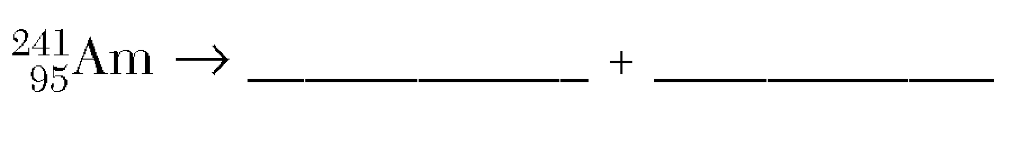

1. State *one* scientific reason why Am-241 is a more appropriate radioactive source than Fr-220 in an ionizing smoke detector.
2. Explain, in terms of particle behavior, why smoke particles cause the detector alarm to sound.