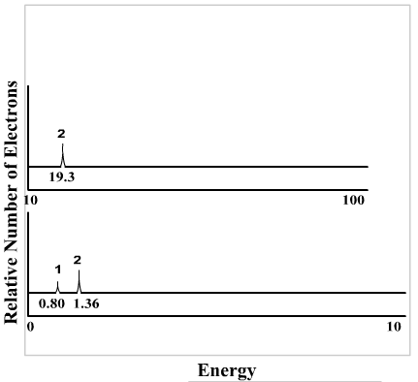
PES activity
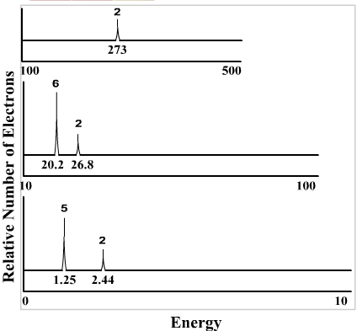
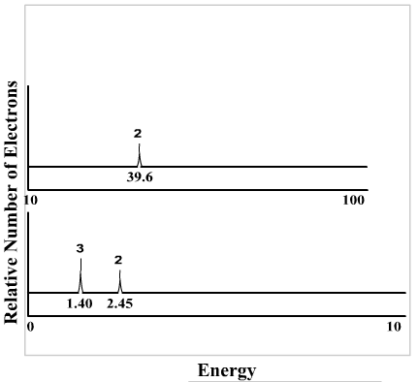
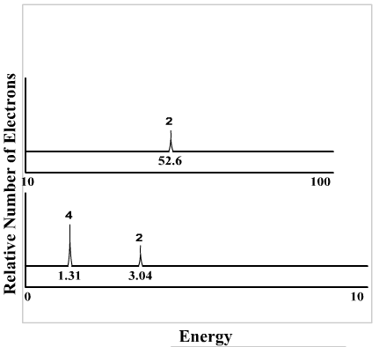
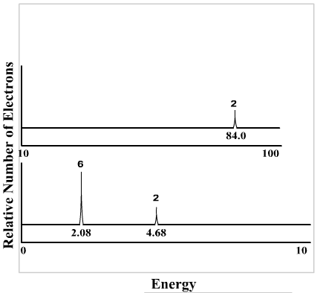
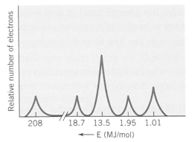

Match the PES graph with the element symbol. Once all graphs and elements are match look at the differences and similarities between the graphs and be able to explain what would account for the differences when your group is called on.
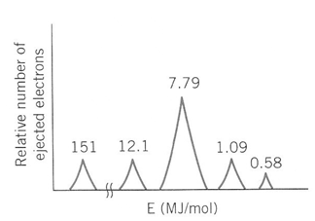

B | P | N
O | Ne
Al |  | Cl

1s²2s²2p⁶3s²3p⁵ | 1s²2s²2p⁶3s²3p¹
1s²2s²2p⁶3s²3p³ | 1s²2s²2p¹
1s²2s²2p³ | 1s²2s²2p⁴
1s²2s²2p⁶

