Recipe Scavenger Hunt
Calculate the empirical and/or molecular formula for each ingredient. Then, you are given the quantity of that ingredient needed for your recipe. Convert the chemical quantity to a normal kitchen measurement. If you obtain the correct recipe and measurements you can have the baked good itself!
- A compound is made of 27.4% Na, 1.2% H, 14.3% C, and 57.1% O.
  - Find the empirical formula.

  - The recipe calls for 0.0276moles of vanilla. 1 teaspoon of vanilla equals 4.2g. How many teaspoons are needed?

- A compound is made of 63.14% C, 5.31% H, and 31.46% O.
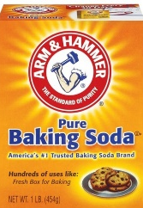
  - Find the empirical formula.

  - The recipe calls for 0.0834 moles of baking soda. 1 teaspoon of baking soda equals 7.0g. How many teaspoons are needed?

- A compound is made of 46.7% C, 4.5% H, 31.1% N, and 17.8% O. The molar mass is 180.1 g/mol.
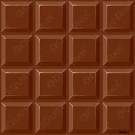
  - Find the molecular formula.

  - The recipe calls for 1.89 moles of chocolate. 1 ounce equals 28.35g. How many ounces are needed?

- A compound is made of 39.34% Na and the rest is Cl.
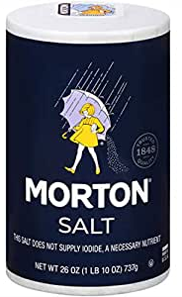
  - Find the empirical formula.

  - The recipe calls for 0.0428 moles of salt. 1 teaspoon of salt equals 5.0g. How many teaspoons are needed?

- A compound is made of 42.1% C, 6.5% H, and 52.4% O. The molar mass is 180.1g/mol.
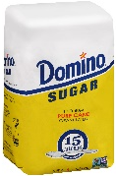
  - Find the molecular formula.

  - The recipe calls for 2.25 moles of simple sugar. 1 cup equals 120.0g. How many cups are needed?

- A compound is made of 76.5% C, 12.2% H, and 11.3% O. The molar mass is 282.52g/mol.
  - Find the empirical formula.

  - The recipe calls for .792 moles of oil. 1 cup equals 224.0g. How many cups are needed?

