Name: ____________________________ Redox Pennies

Background Information: Before 1982, U.S. pennies were made entirely of copper. The increase in the price of copper made this economically unfeasible. As a result, the inner core of the penny was changed to zinc and it was only coated with copper after 1982.

Guiding Question: Determine the percent composition of zinc and copper in a post-1982 penny.

Pre-lab Questions:
- Which metal will react with the HCl? Why?

- Write the balanced equation for the reaction that will occur in this lab.

- What class of reactions is the reaction you wrote in question 2?

- This reaction is also a REDOX reaction. Why?

- Write the half reactions for the reaction of zinc and hydrochloric acid.

- Predict whether the penny will have more copper or more zinc atoms. Defend your prediction with a reason.

Procedure:
- Using a triangular file, score three places around the edge of the post-1982 penny. It needs to be deep enough to expose zinc.
- Mass the penny and record it in the data table.
- Place the penny in a 50 ml beaker, labeled with your last name.
- Add 20 ml of 6M HCl. (You must have goggles on and be VERY careful!)
- Place the beaker in a safe place overnight, as instructed by your teacher.
- After 24 hours, carefully pour off the acid as directed. Gently rinse your penny and place it on a piece of filter paper. Let the penny dry overnight.
- Re-mass the penny and record the mass in the data table.

Data:
Original Mass of penny: _______________ g

Mass of copper coating of the penny: _______________ g

Mass of the inner zinc core: _______________ g

Calculations:

- Calculate the percent by mass of copper and zinc in the penny.

- How many moles of copper were in the original penny?

- How many moles of zinc were in the original penny?

- How many atoms of copper were in the penny?

- How many atoms of zinc were in the penny?

- Defend or amend your prediction in the pre-lab with evidence from the lab.

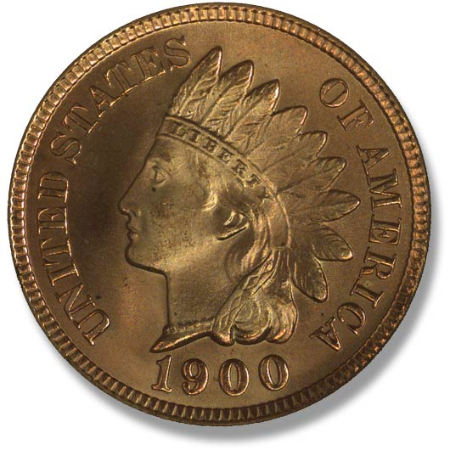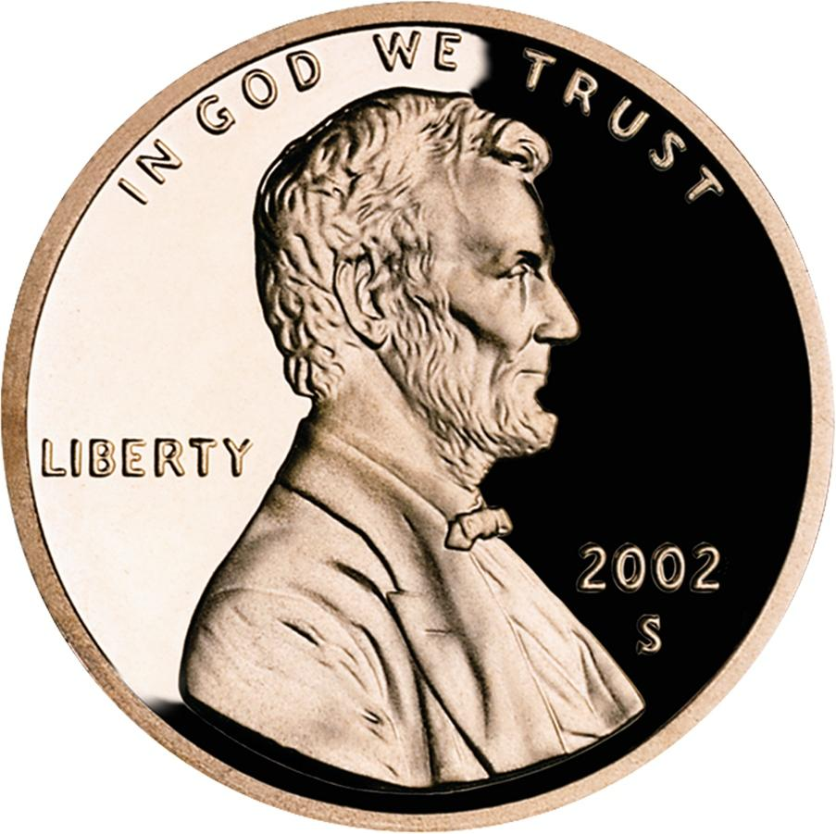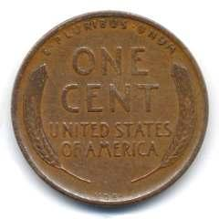
Pre-lab and data checked by teacher:

