STATION 6

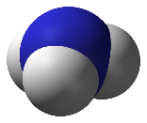
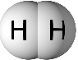
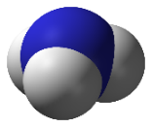
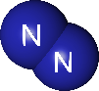

Low pressure High Pressure

N₂ + 3H₂ ↔ 2NH₃

