Testimonials of Hiroshima and Nagasaki

Directions: As a team, each person will read one testimony and underline some important information. Next, students will share information from their testimonial with the team and add notes to the table below. Once all students have read a testimony and shared their notes, answer the questions below. Be prepared to share your answers with the class.

Akihiro Takahashi | Taeko Teramae
Hiroko Fukada | Hiroshi Sawachika

- Identify some observations the witnesses have about the sky during the explosion.

- Identify some injuries that people sustained.

- What are some of the long lasting side effects of this bomb?

- How does a nuclear bomb like this compare to a chemical bomb?

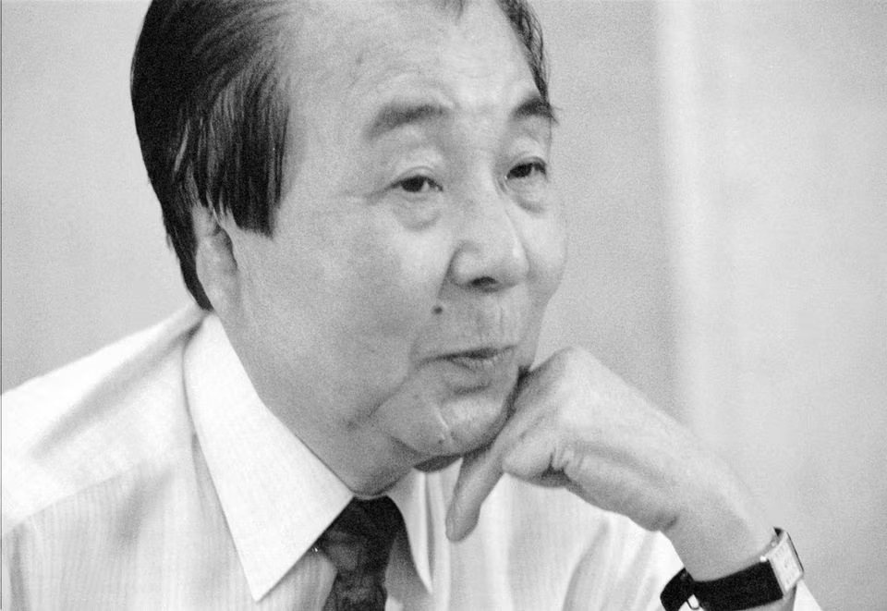
Testimony of Akihiro Takahashi
Mr. Akihiro Takahashi was 14 years old when the bomb was dropped. He was standing in line with other students of his junior high school, waiting for the morning meeting 1.4 km away from the center. He was under medical treatment for about a year and half. And even today black nail grows at his finger tip, where a piece of glass was stuck.

MR. TAKAHASHI: We were about to fall on the ground at the Hiroshima Municipal Junior High School on this spot. The position of the school building was not so different from what it is today and the platform was not positioned, too. We were about to form lines facing the front, we saw a B-29 approaching and about to fly over us. All of us were looking up at the sky, pointing out the aircraft. Then the teachers came out from the school building and the class leaders gave the command to fall in. Our faces were all shifted from the direction of the sky to that of the platform. That was the moment when the blast came. And then the tremendous noise came and we were left in the dark. I couldn't see anything at the moment of explosion just like in this picture. We had been blown by the blast. Of course, I couldn't realize this until the darkness disappeared. I was actually blown about 10 m. My friends were all marked down on the ground by the blast just like this. Everything collapsed for as far as I could see. I felt the city of Hiroshima had disappeared all of a sudden. Then I looked at myself and found my clothes had turned into rags due to the heat. I was probably burned at the back of the head, on my back, on both arms and both legs. My skin was peeling and hanging like this. Automatically I began to walk heading west because that was the direction of my home. After a while, I noticed somebody calling my name. I looked around and found a friend of mine who lived in my town and was studying at the same school. His name was Yamamoto. He was badly burnt just like myself. We walked toward the river. And on the way we saw many victims. I saw a man whose skin was completely peeled off the upper half of his body and a woman whose eyeballs were sticking out. Her whole baby was bleeding. A mother and her baby were lying with skin completely peeled off. We desperately made a way of crawling. And finally we reached the river bank. At the same moment, a fire broke out. We made a narrow escape from the fire. If we had been slower by even one second, we would have been killed by the fire. Fire was blowing into the sky becoming 4 or even 5m high. There was a small wooden bridge left, which had not been destroyed by the blast. I went over to the other side of the river using that bridge. But Yamamoto was not with me any more. He was lost somewhere. I remember I crossed the river by myself and on the other side, I purged myself into the water three times. The heat was tremendous . And I felt like my body was burning all over. For my burning body the cold water of the river was as precious as the treasure. Then I left the river, and I walked along the railroad tracks in the direction of my home. On the way, I ran into another friend of mine, Tokujiro Hatta. I wondered why the soles of his feet were badly burnt. It was unthinkable to get burned there. But it was undeniable fact the soles were peeling and red muscle was exposed. Even though I myself was terribly burnt, I could not go home ignoring him. I made him crawl using his arms and knees. Next, I made him stand on his heels and I supported him. We walked heading toward my home repeating the two methods. When we were resting because we were so exhausted, I found my grandfather's brother and his wife, in other words, my great uncle and great aunt, coming toward us. That was quite a coincidence. As you know, we have a proverb about meeting Buddha in Hell. My encounter with my relatives at that time was just like that. They seem to be the Buddha to me wandering in the living hell.
Afterwards I was under medical treatment for one year and half and I miraculously recovered. Out of sixty of junior high school classmates, only ten of us are alive today. Yamamoto and Hatta soon died from the acute radiation disease. The radiation corroded the bodies and killed them. I myself am still alive on this earth suffering from the after-effects of the bomb. I have to see an ear doctor, an eye doctor, a dermatologist and a surgeon. I feel uneasy about my health every day. Further, on both of my hands, I have keloids. My injury was most serious on my right hand and I used to have terrible keloids right here. I had it removed by surgery in 1954, which enabled me to move my wrist a little bit like this. For my four fingers are fixed just like this, and my elbow is fixed at one hundred twenty degrees and doesn't move. The muscles and bones are attached to each other. Also the fourth finger of my right hand doesn't have a normal nail. It has a black nail. A piece of glass which was blown by the blast stuck here and destroyed the cells of the base of the finger now. That is why a black nail continues to grow and from now on, too, it will continue to be black and never become normal. Anyway I'm alive today together with nine of my classmates for this forty years. I've been living believing that we can never waste the depth of the victims. I've been living on dragging my body full of sickness and from time to time I question myself. I wonder if it is worth living in such hardship and pain and I become desperate. But it's time I manage to pull myself together and I tell myself once my life was saved, I should fulfill my mission as a survivor, in other words it has been and it is my belief that those who survived must continue to talk about our experiences. The hand down the awful memories to future generations representing the silent voices of those who had to die in misery. Throughout my life, I would like to fulfill this mission by talking about my experience both here in Japan and overseas.

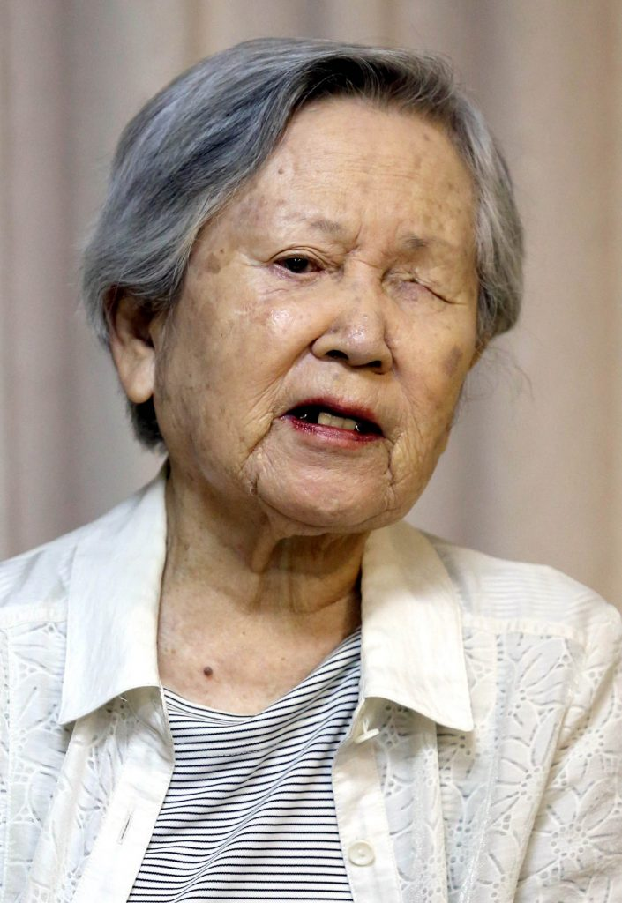
Testimony of Taeko Teramae
Ms. Taeko Teramae was 15 years old when the bomb was dropped. She was in the central telephone office, 0.5 kilometers away from the hypocenter. Many mobilized students were working in the central telephone center that day. Some 7000 mobilized students were killed by the A-bomb in the city of Hiroshima.

TERAMAE: When the bomb fell, I was 15 years old. I was a third grader at the girls' junior high school. I saw something shining in the clear blue sky. I wondered what it was, so I stared at it. As the light grew bigger, the shining thing got bigger as well. And at the moment when I spoke to my friend,there was a flash, far brighter than one used for a camera. It exploded right in front of my eyes. There was a tremendous noise when all the buildings around me collapsed. I also heard people crying for help and for their mothers. I was caught under something which prevented me from moving freely. I was so shocked that I couldn't believe what had happened. I thought maybe I was having some kind of nightmare, but of course, I wasn't. I felt pain when I pinched myself to see if it was real. I thought the bomb had been dropped on the central telephone office. The dust was rising and something sandy and slimy entered my mouth. I couldn't figure out what it was since I couldn't move or see. I couldn't see anything in the dark. A little later, I smelt something like sulfur. It smelt like the volcano, Mt. Aso and I threw up. I heard more voices calling "Mother! Mother!" But when our class teacher, Mr.Wakita, told us to behave like good students and stop crying, all the cries for help and for Mother stopped all of a sudden. We began to calm down and try to behave as Mr. Wakita told us to. I tried very hard to move my arms and my legs and finally I was able to move a little. I was so surprised to see the dark sky with all the red flames through the window because it was only a few minutes before when the sky was blue and clear. It was all quiet and the city was wrapped, enveloped in red flames. Mr. Wakita came to help me. He asked me if I wanted to swim across the river. The bridge was burning and the river was very high. I had no choice. I could barely see by then, though. And Mr. Wakita took my arms and told me to swim across the river together with him, so together we went into the river and began to swim. When we reached the middle of the river, I could no longer see anything and I was starting to feel faint. And as I began to feel faint, I also began to lose control. Mr. Wakita encouraged me and helped me to reach the other side of the river. Finally, we reached the other side. What surprised me so much was all the cries of the students for help and for their mothers. It just didn't stop. I couldn't see anything. All I could do was listen to their cries. I asked my teacher, I asked him what was going on. Mr. Wakita explained to me how the high school students were burnt and crouching in pain in the streets. I couldn't see anything. There were many students who were mobilized to destroy buildings to widen the streets and the area of Tsurumi Bridge, City Hall and the Chugoku Newspaper on that day. And since they were outside, they were directly exposed to the bomb. Many of them died, many of them died right there. Someone called for help in vain, and some jumped into the river and drowned to death. If my teacher, Mr. Wakita had not come to help me, I would have died in the river.

INTERVIEWER: How were your wounds?

TERAMAE: If my wounds had been on my arms or my legs, I would have known it was, but my wounds were on my face, so I had no idea for some time. I just didn't know. I asked my parents how I looked, but they just said that I had only minor wounds. They didn't tell me the truth. After I got better, I found a piece of mirror and looked into it. I was so surprised I found my left eye looked just like a pomegranate, and I also found cuts on my right eye and on my nose and on my lower jaw. It was horrible. I was very shocked to find myself looking like a monster. I even wished I had died with my sisters. I was just overcome with apprehension when I thought about it.

INTERVIEWER: What is your biggest hope or dream now that you want to realize?

TERAMAE: Well, my hope is to have a comprehensive meeting of A-bomb survivors. That's what I want. We had such a meeting the other day and in that meeting, both male and female A-bomb survivors repeatedly said that they wanted their health back again, even for just one day. They said they can't even wear short sleeve shirts because of the scars on their arms left from the bomb. Lonely A-bomb survivors include those who lost their families and also the mobilized students who have remained single because of the wounds caused by the A-bomb. There are many of them. So, I do hope to do something to support lonely people.

Testimony of Hiroko Fukada
Ms. Hiroko Fukada was 18 years old when the bomb was dropped. She was inside the Bureau of Post Communications, then located in Hakushima 1 km away from the center of the explosion. She lost her parents and one sister and never since the war ended. She has been working taking care of her two younger brothers who survived.

MS. FUKADA: This is my first time coming back to this place you know in 41 years since the A-bomb was dropped. I don't know what to say really. The memory of that day seems to be gradually coming back to be though. At the moment when I sat down at my desk and took out my notebooks and pens, I suddenly saw a very strong flash of light. Then it was tremendous impact. The atomic bomb is often described as Pika-don or spark and bang and that's a very good description, I think.

INTERVIEWER: What was the color of the light?

MS. FUKADA: I remember it was yellow. I clearly remember it now and despite the shower of glass, fortunately I didn't have any major injuries. I thought it was hopeless because I thought the buildings directly overhead and I went out of the building because I thought it would be dangerous to stay inside. Soon I found soldiers walking in this direction. I was with my friends and we thought it would be safe to go with soldiers, and so we came here.

INTERVIEWER: What were the conditions outside the building?

MS. FUKADA: Everybody was terribly injured. We were even embarrassed because we were not injured. I have no words to describe the scene. A flood of people went down this cliff just like dominoes down.

INTERVIEWER: So you were also pushed forward, weren't you?

MS. FUKADA: Yes, Yes. I was almost crashed and it was very hard to stay on this side. And the other side was burning and a tremendous heat attacked us on this side, too. And more and more people came from behind me crashing us and crashing us. And since it was so hot, I dipped my face under the water so many times.

INTERVIEWER: So you jumped into the river right here?

MS. FUKADA: Yeah. I was pushed into the river with many other people. And since I thought it would be dangerous to stay on this side, I swam over to the other side. It was so frightening.

INTERVIEWER: What happened when you were swimming across the river?

MS. FUKADA: Well an awful thing happened when I reached the other side, and was relieved. I was suddenly spun around by the current. And then large pieces of hail begin to fall and my face started hurting. So to avoid that I again plunged my face into the water time and time again. And then I spun around again and again. It just didn't stop.

INTERVIEWER: What actually happened in the water?

MS. FUKADA: The water was swirling around me and later I learned that it was a tornado. And my friends somehow managed to survive it.

INTERVIEWER: Did you think you were going to die?

MS. FUKADA: Yes. The faces of my family came to my mind one after another. And I really thought I was dying because I drank a lot of water, too.

INTERVIEWER: This is a picture which you drew describing the moment, isn't it? Would you explain this again? Do you remember this picture? How many years ago did you last see this picture?

MS. FUKADA: Well, I'm not really sure. I really thought I was dying because I drank so much water, too. I don't know how many minutes have passed but anyway I found something like a piece of wood which is very soft and sticky and I touched it. That was actually my friend's leg. And she was alive and we were so glad to see each other. Then I began to wonder what my family were doing. Since we lived in Takaramachi, I thought that they went to Ujina rather than in this direction. And I also thought they might have already been killed by the bomb. I just didn't know what was going on.

INTERVIEWER: How are your mother and brothers?

MS. FUKADA: Well, my mother was at the first aid center in Ninoshima. And she died on August 10.

INTERVIEWER: How about your brothers?

MS. FUKADA: Although the small one was together with my mother since they had been mobilized to tear down houses to make streets wider for military purposes. He survived because he happened to be standing just by chance under the eaves of the building and the younger brother was at his elementary school. He was stuck under the collapsed school building but he managed to get out. He escaped to Hijiyama Bridge and survived.

INTERVIEWER: How was your younger sister?

MS. FUKADA: She was in Zakoba-cho and she had also been mobilized to pull down houses. We never found her. At that time I was only 18 years old and have lost my parents all of a sudden. I didn't know what to do. But I had two small brothers that I had to take care of and support. So I could not afford to bend myself to grief. It was very hard to raise my brothers and try not to depend on others. I went frantically day after day. Well, it was so cruel. It is hard to talk about it. I can't.

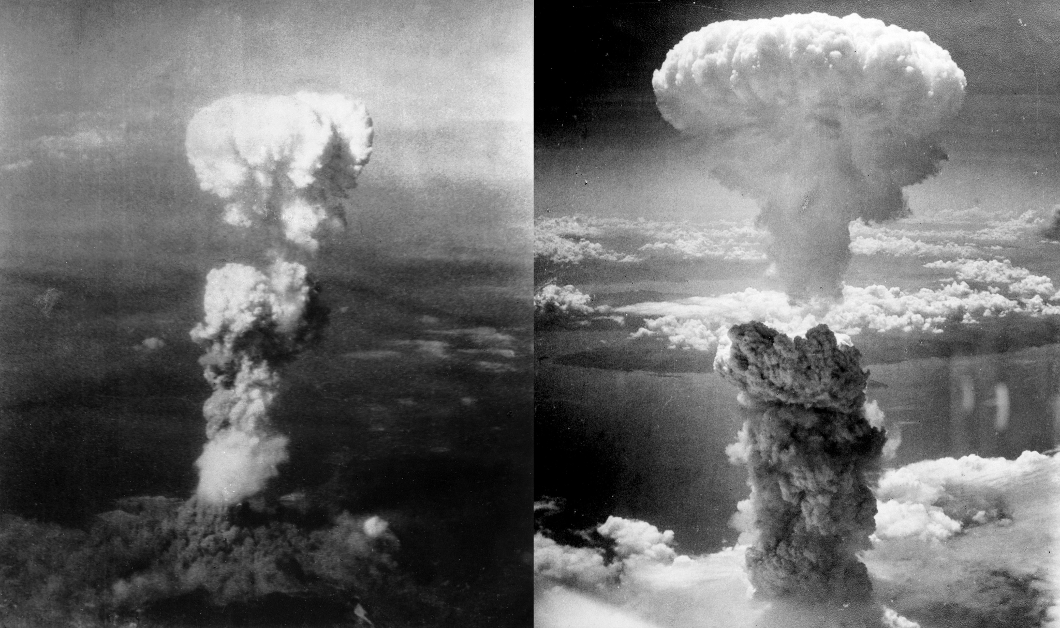
Testimony of Hiroshi Sawachika
Mr. Hiroshi Sawachika was 28 years old when the bomb was dropped. He was an army doctor stationed at the army headquarters in Ujina. When he was exposed, he was inside the building at the headquarters, 4.1 km from the hypocenter. Being rather far from the hypocenter, he was not seriously injured. Afterwards, he was very busy getting medical treatment to the survivors.

MR. SAWACHIKA: I was in my office. I had just entered the room and said "Good morning." to colleagues and I was about to approach my desk when outside it suddenly turned bright red. I felt very hot on my cheeks. Being the chief of the room, I shouted to the young men and women in the room that they should evacuate. As soon as I cried, I felt weightless as if I were an astronaut. I was then unconscious for 20 or 30 seconds. When I came to, I realized that everybody including myself was lying at one side of the room. Nobody was standing. The desks and chairs had also blown off to one side. At the windows, there was no window glass and the window frames had been blown out as well. I went to the windows to find out where the bombing had taken place. And I saw the mushroom cloud over the gas company. The sound and shock somehow suggested that the bomb had been dropped right over the gas company. I still had no idea what had happened. And I kept looking towards the gas company. After a while, I realized that my white shirt was red all over. I thought it was funny because I was not injured at all. I looked around and then realized that the girl lying nearby was heavily injured, with lots of broken glass stuck all over her body. Her blood had splashed and made stains on my shirt. In a few minutes, I heard my name called. I was told to go to the headquarters where there were lots of injured people waiting. I went there and I started to give treatment with the help of nurses and medical course men. We first treated the office personnel for their injuries. Most of them had broken glass and pieces of wood stuck into them. We treated them one after another. Afterwards, we heard a strange noise. It sounded as if a large flock of mosquitoes were coming from a distance. We looked out of the window to find out what was happening. We saw that citizens from the town were marching towards us. They looked unusual. We understood that the injured citizens were coming towards us for treatment. But we thought that there should be Red Cross Hospitals and another big hospitals in the center of the town. So why should they come here, I wondered, instead of going there. At that time, I did not know that the center of the town had been so heavily damaged. After a while, with the guide of the hospital personnel, the injured persons reached our headquarters. With lots of injured people arriving, we realized just how serious the matter was. We decided that we should treat them also. Soon afterwards, we learned that many of them had badly burned. As they came to us, they held their hands aloft. They looked like they were ghosts. We made the tincture for that treatment by mixing edible peanut oil and something else. We had to work in a mechanical manner in order to treat so many patients. We provided one room for the heavily injured and another for the slightly injured. Treatment was limited to first aid because there were no facilities for the patients to be hospitalized. Later on, when I felt that I could leave the work to other staff for a moment, I walked out of the treatment room and went into another room to see what had happened. When I stepped inside, I found the room filled with the smell that was quite similar to the smell of dried squid when it has been grilled. The smell was quite strong. It's a sad reality that the smell human beings produce when they are burned is the same as that of the dried squid when it is grilled. The squid - we like so much to eat. It was a strange feeling, a feeling that I had never had before. I can still remember that smell quite clearly. Afterwards, I came back to the treatment room and walked through the roads of people who were either seriously injured or waiting to be treated. When I felt someone touch my leg, it was a pregnant woman. She said that she was about to die in a few hours. She said, "I know that I am going to die. But I can feel that my baby is moving inside. It wants to get out of the room. I don't mind if I die. But if the baby is delivered now, it does not have to die with me. Please help my baby live." There were no obstetricians there. There was no delivery room. There was no time to take care of her baby. All I could do was to tell her that I would come back later when everything was ready for her and her baby. Thus I cheered her up and she looked so happy. But I have to return to the treatment work. So I resumed work taking care of the injured one by one. There were so many patients. I felt as if I was fighting against the limited time. It was late in the afternoon towards the evening. And the image of that pregnant woman never left my mind. Later, I went to the place where I had found her before, she was still there lying in the same place. I patted her on the shoulder, but she said nothing. The person lying next to her said that a short while ago, she had become silent. I still recalled this incident partly because I was not able to fulfill the last wish of this dying young woman. I also remember her because I had a chance to talk with her however short it was.

INTERVIEWER: How many patients did you treat on August 6?

MR. SAWACHIKA: Well, at least 2 or 3 thousand on that very day if you include those patients whom I gave directions to. I felt that as if once that day started, it never ended. I had to keep on and on treating the patients forever. It was the longest day of my life. Later on, when I had time to reflect on that day, I came to realize that we doctors learned a lot through the experience, through the suffering of all those people. It's true that the lack of medical knowledge, medical facilities, integrated organization and so on prevented us from giving sufficient medical treatment. Still there was a lot for us medical doctors to learn on that day. I learned that the nuclear weapons which gnaw the minds and bodies of human beings should never be used. Even the slightest idea using nuclear arms should be completely exterminated

