Unit 1: DNA Evidence

DNA contains genetic information. DNA is found on chromosomes located in the nucleus of our cells. DNA is biological, circumstantial, and individual evidence
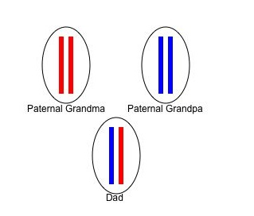
- Made up of base pairs: (think of a bar code)
  - A – T adenine pairs with thymine
  - C – G cytosine pairs with guanine
- The order of the base pairs determines the genetic code

Human DNA
- 50% of a person’s DNA comes from each parent
  - 23 pairs (46 chromosomes) in nucleus of most cells
  - 1 chromosome in each pair is inherited from mother and other from the father
- Every person has a different DNA sequence expect identical twins.
- Types of Human DNA
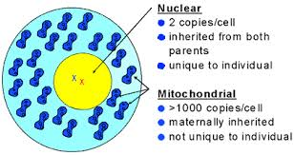
  - NUCLEAR DNA: found in chromosomes
    - Used for DNA Fingerprinting
    - Unique to individual
  - MITOCHONDRIAL DNA: Found in mitochondria
    - Inherited from mother
    - Not unique
    - Example: bone, hair shaft
    - More stable over time/conditions*
    - Can get more DNA if sample is limited
    - Can get DNA from a highly degraded source
- How is DNA used?
  - Identify a victim
  - Link or exclude suspect to crime scene/evidence
  - Link multiple crime scenes
  - Establish Maternity/Paternity
- What Factors Affect DNA evidence?
  - Heat, sunlight, moisture, bacteria, and mold (this was a major issue in the O.J. Simpson Case)
  - Not all DNA evidence will result in a usable DNA profile.
  - DNA testing cannot identify when the suspect was at the crime scene or for how long.
- What is CODIS?
  - Electronic database of DNA profiles that can identify suspects.
  - DNA profiles from individuals convicted of certain crimes, such as rape, murder, and child abuse, are entered into CODIS and help identify possible suspects when no prior suspect existed.

2 Main Types of DNA Testing
- RFLP: analyzes variable lengths of DNA cut by restriction enzymes.
  - RFLP: Restriction Fragment Length Polymorphism.
  - requires large amounts of DNA and no degradation.
  - Restriction enzymes: cut DNA at specific base sequences resulting in variable lengths of DNA
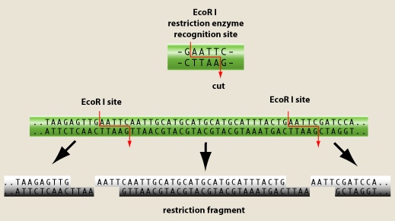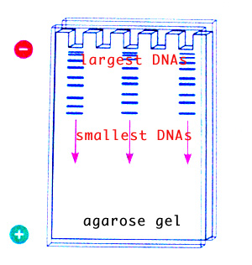
  - Gel electrophoresis: Method of separating molecules of DNA within an electric field based on the size and charge of DNA fragments
  - More probes taken, the better the match probability will be.
  - Denim blue jeans actually interfere with the restriction enzymes!
- PCR: (Polymerase Chain Reactions) specific sequences of DNA that have high variability (differences) are copied millions of times
  - Less DNA needed and can be partially degraded
- Newest type of DNA testing: STR
  - STR: Evaluates specific short repeating regions (loci) within nuclear DNA
  - FBI uses 13 standard specific STR regions for CODIS

