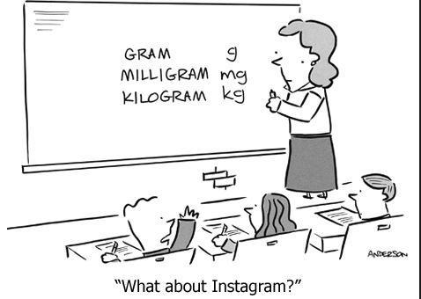
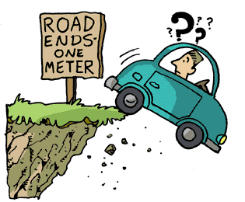

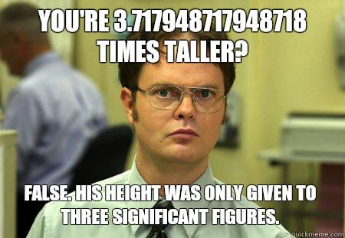

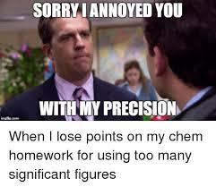
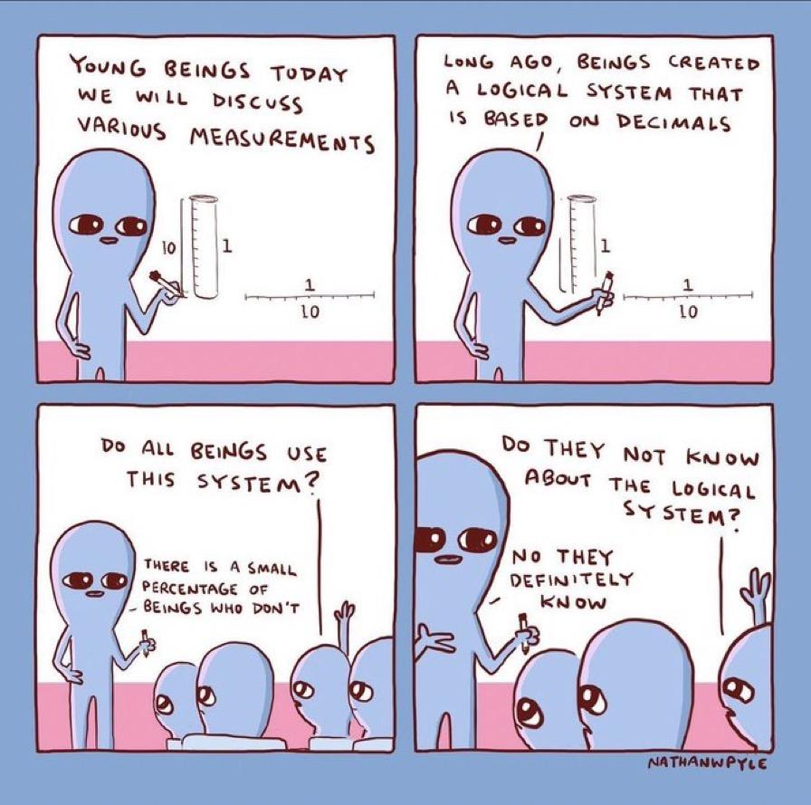
Measurements, Precision and Significant Figures Introduction
Measurements differ from numbers. In mathematics, a number is a number. For example, 4.7 and 4.70 are identical. Measurements are not numbers, they are ranges. For example:
- 4.7 ml means a range between 4.65 mL and 4.75 mL
- 4.70 ml means a range between 4.695 mL and 4.705 mL
So, 4.7 and 4.70 are completely different when it comes to measurements even though they look mathematically equivalent.
Think about this….
If you have about 5,000 dollars and someone gives you a quarter, how much money do you have now? Would you say you have about 5,000.25 dollars or would you still say you have about 5,000 dollars?
Example: 6 ml x 4 ml = 24?
The number 6 represents a very large measurement range (5.5 to 6.5) and the number 4 also represents a very large measurement range (3.5 to 4.5).
- Multiplying the bottom ends of the range you get 3.5 x 5.5 = 19.25
- Multiplying the top ends of the range you get 4.5 x 6.5 = 29.25
So, saying 6 x 4 = 24 mL, the answer is too precise given the lack of precision of the measurements 6 mL and 4 mL. Let’s look into this further.
Consider the following: Two rulers measuring the same object.
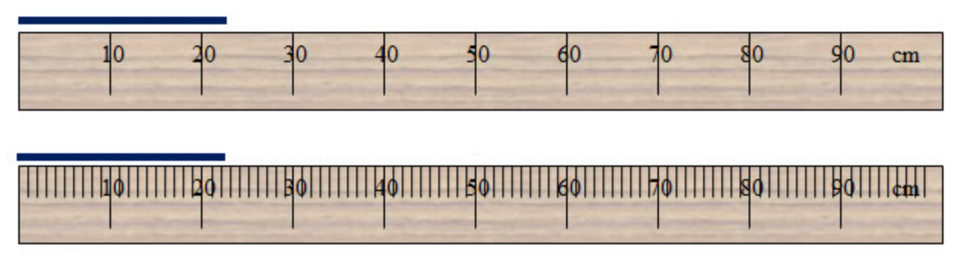
The top ruler has a very large range and is not as precise as the bottom ruler. According to the top ruler, the line is between 20 and 30 cm but it is less than halfway (closer to 20 than 30). We might say the length is 22 or 23 cm. Measuring the same line with the second ruler gives us a narrower range. We can clearly see it is between 22 and 23 cm. So now we might say that the length is 22.2 or 22.3 cm. Our measurements must communicate about the quality (precision) of the instrument used to obtain them.

Performing Calculations with Significant Digits
Suppose you are trying to calculate the area of a rectangular object using the two rulers below. You measure the length using the top ruler and determine the length is 23 cm. Next you measure the width using the bottom ruler and determine the width is 42.7 cm.
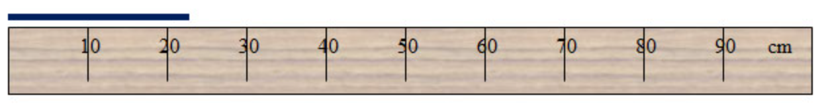

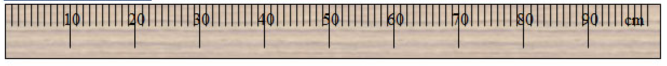
When you calculate the area (22 cm x 42.7 cm) your calculator gives you an answer of 982.1 cm². The problem with that answer is that it is too precise. We must communicate the answer but also how precise it is. The measurement of the length using the top ruler is not that precise. Think about the range for the length measurement. It could be 22 or 23 cm. So, the lower range of answers is 939.4 cm² and the higher range of answers is 982.1 cm². So how do we report our answer to account for the lack of precision of the top ruler?
Look at your two potential answers (939.4cm² and 982.1 cm²). What digits are certain (the same) and where do they differ?

We can be certain that the area is at least 900 but we cannot be certain about the tens or one’s place. So, we report the certain digit 9 and the next uncertain (estimated) digit of 8. So, the reported answer would be 980 cm². This tells us that the 9 was certain but the number in the 10’s place is estimated.

Check Your Understanding: Reading Scales Using Significant Figures

Read this: When a measurement is recorded properly, all the digits that are read directly (certain) from the measuring device and one estimated (uncertain) digit are called significant digits. The number of allowable significant digits is determined by the marks or gradations of the instrument. Determine what place value is certain from the instrument and estimate one place value past it.

Record the volume of each graduated cylinder to the proper precision.
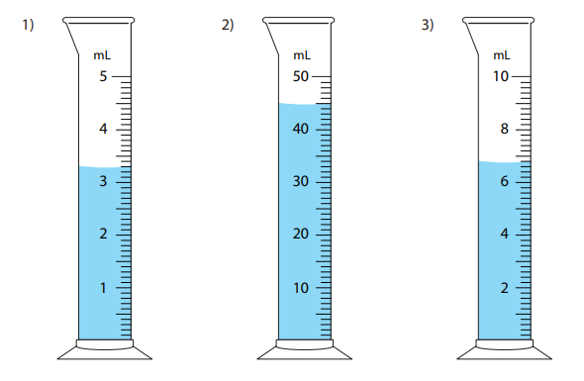

For each of the following, write the scale reading, then the number of significant figures in the reading.
Reading SF’s
1. 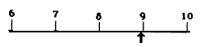
2. 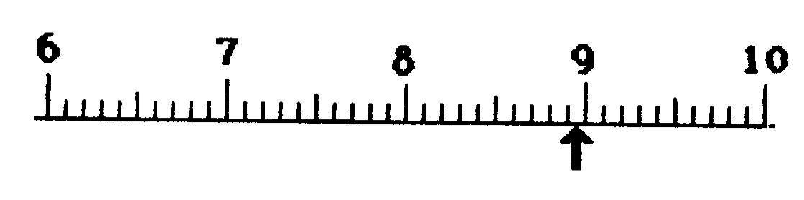

3. 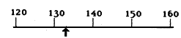

4. 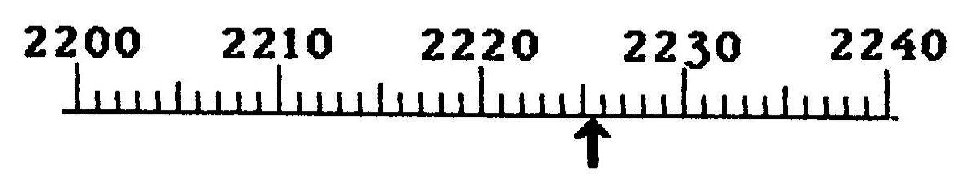

5. 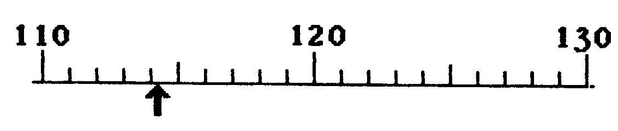

6. 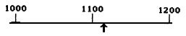

7. 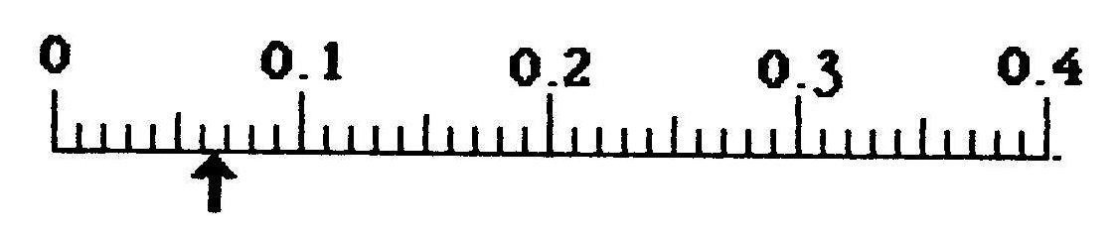

8. 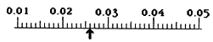

For each of the volume devices below record the scale reading then the number of significant figures
in the reading.
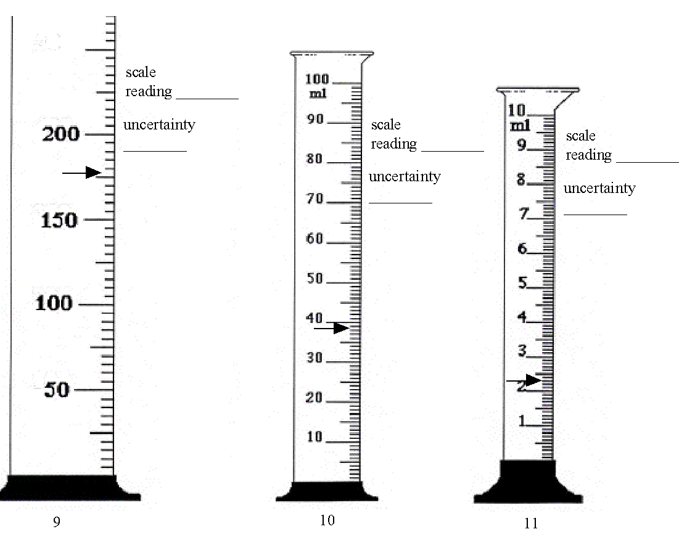

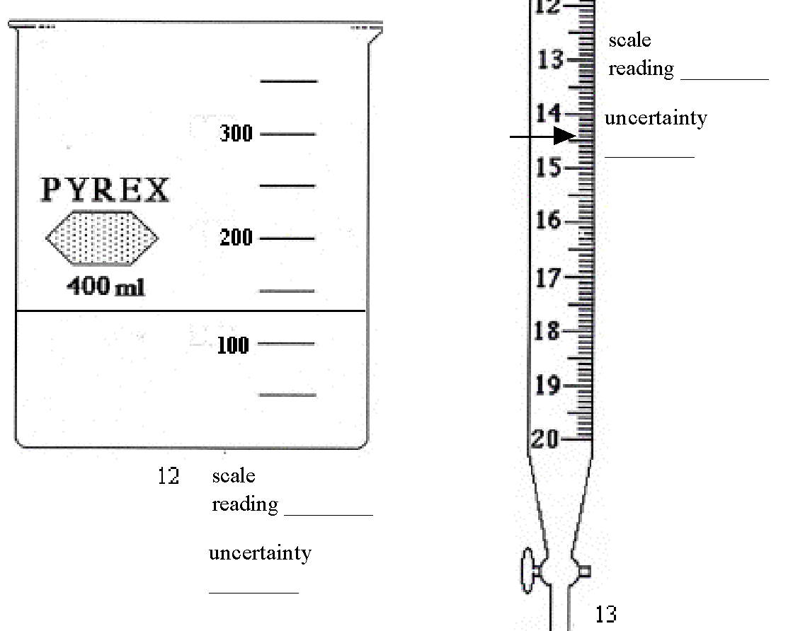

More Significant Figures

1. A beaker has marks every 50mL. A cylinder has marks every 10mL. A pipette has marks every 1mL. Is the pipette the most accurate or precise tool? Explain your answer.

2. Sally measures 11mL of water in the beaker described in question 2. Henry measures 11mL in the pipette described in question 2. When they add their water together in one cup, do they have exactly 22mL combined? Why or why not?

In order to report the most precise and accurate data possible we must learn to count significant figures. When measuring a substance's mass, volume, etc. the device requires you to measure “one place beyond.” All the numbers you report count as a significant figure (sig fig) except leading zeros and sometimes the trailing zeros. Let’s investigate:
- Example 1: A piece of aluminum has a mass of 0.0521 grams which had 3 sig figs. This is not 5 sig figs because if we convert that mass to mg the mass becomes 52.1 mg. Again the number has 3 sig figs which shows it didn’t get any more precise. Proof that leading zeros never count.
- Example 2: A beaker of water contains 520 mL which has 2 sig figs. The trailing zero doesn’t count this time because if we convert to liters the volume is .52 L. The trailing zero was not measured. If we want to show that it was exactly 520 mL we would report it as 520. mL with a decimal point. That way if we convert to liters it is .520L.
- Example 3: A reaction takes 0.0025050 s which has 5 sig figs. Remember the first three zeros are “place holders and don’t count. If we convert to ms we get 2.5050 ms, also with 5 sig figs. The trailing zero was measured or else the student wouldn’t have reported it. The rule is: Leading zeros never count, trapped zeros always count, they are measured) and trailing zeros count if there is a decimal.

Using the rules above, count the number of significant figures in the following measurements:

3. 3.456 L _____ 6. 0.000206 m _____

4. 2.300 g _____ 7. 0.025600 L _____

5. 1.258092 m _____ 8. 0.520301 J _____

If a piece of glassware is very precise it may have a lot of sig figs, as many as 4. A less accurate piece of glassware such as a beaker will only have 1 sig fig. If both pieces of glassware are used to measure quantities in a lab we have to round our results to the least precise measurement. When working with measurements the quantity with the least decimal places is the least precise. For example, if the beaker measures 10mL and a cylinder measures 10.1mL the cylinder is more precise. If the two quantities are added together the new volume is 20mL. The decimal must be rounded to make our answer to one sig fig. Therefore the rule is: When adding or subtracting measurements, round your answer to the lowest number of decimal places given.
Complete the following operations and report to the correct number of significant figures.

10. 10.2 + 21 ________ 14. 0.023 - 0.0004 _______

11. 31.3 + 54.45 ________ 15. 5.068 - 0.1 _______

12. 22.59 + 21 ________ 16. 45.6 - 22.12 + 11 _______

13. 0.023 + 20.1 ________ 17. 0.0123 +5.689 – 0.014 _______

When performing calculations with our data sometimes we have to multiply and divide our data. In this case, the most precise answer is the one with the most sig figs. Since we need to round to our least precise measurement, we should round to the least number of sig figs given. For example, if the mass of a substance is 10.0 grams (3 sig figs) and the volume is 2 mL (1 sig fig) the density is 5 g/mL (also 1 sig fig). The rule is: When multiplying or dividing measurements, round your answer to the lowest number of significant figures given.

Complete the following operations and report to the correct number of significant figures.

18. 5.87 * 2.1 ________ 22. 589 / 12 _______

19. 4 * 78 ________ 23. 78.632 / 52.3 _______

20. 0.0235 * 9 ________ 24. 1569 / 24 * 2 _______

21. 0.014 * 0.01 ________ 25. ( 596 * 32 ) / 22 _______

If both types of operations are used, always follow the multiplication rules least sig figs). Finally, in scientific notation, only the base number counts not the exponent or the 10). Use PEMDAS!

26. (22.1-10.0) / 2 ________ 28. 6.23x10⁻³/2.15x10⁻⁴ _________

27. 12.35 / ( 4.56-2.14) ________ 29. (2.1x10² – 1.4x10¹) * 2 _________
Rounding Significant Figures

 | Unrounded Answer | Rounded Answer
- 1.2m + 2.35m
- 2.6358cm * 2.1cm
- 5.681mm - 2.mm
- 3845.2L / 25.2354L
- 25cm + 3cm
- 1.2m * 2m
- 859678.2354cm – 568426.1cm
- 5.3m * 5.2398m * 2m
- 45.25252nm + 45.8563nm
- 68.23m / 38.255m
- 10000g / 10.0g
- 1L * 1.0L
- 1254.1cm / 100cm
- 0.000456m + 0.00524m
Percent Error Introduction
Group Think: You enter a contest to guess the number of gumballs in a jar. Your guess is 261 gumballs. The actual number of gumballs in the jar was 242. How off was your guess? What percentage of the actual amount were you off by?

What mathematical steps did you take to arrive at your answer?

Describe what percent error is measuring?

Percent Error Formula:

Check Your Understanding:
- What would a negative percent error indicate?

- If a student’s percent error for the mass of a substance is 100% and the actual mass of the substance is 50 grams, what was the student’s measured mass?

- There are 140 calories in one can of Coke. In an experiment you determine that there are 210. You are a bit off, but what is your percent error for the experiment?

- There are 35 mg of sodium in a can of Coke. You determine it to be 15 mg. What is your percent error?

- There is 3.5 grams of fat in a granola bar. You determine the fat content to be 4.0 g in the lab. What is the percent error?

- Working in the laboratory, a student finds the density of a piece of pure aluminum to be 2.85 g/cm³. The accepted value for the density of aluminum is 2.699 g/cm³.

- A student experimentally determines the specific heat of water to be 4.29 J/g x Cº. He then looks up the specific heat of water on a reference table and finds that it is 4.18 J/g• Cº. What is his percent error?

- A student measures the volume of a substance to be 34.5 mL. What is their percent error for this measurement if the actual volume was 0.0250 L?

Our Model so far…

Explain mass:
Diagram | Narrative
Graphical | Mathematical

Explain volume:
Diagram | Narrative
Graphical | Mathematical

Check Your Understanding: Mass, Volume, and Density

1. Study the matter shown in Figure 1. Each dot represents a particle of matter. [Assume the particles are uniformly distributed throughout each object, and particles of the same size have the same mass.]  - In the table below, show how the masses, volumes, and densities of A and B compare by adding the symbol <, >, or = to the statement in the second column.  - Explain your reasoning for each answer in the last column. | A B

Property | Relationship | Reasoning
Mass | A ____ B
Volume | A ____ B
Density | A ____ B

2. Study the matter in Figure 2. [Assume the particles are uniformly distributed throughout each object, and particles of the same size have the same mass.]
a. In the table below show how the masses, volumes, and densities compare by adding the symbol <, >, or = to the statement in the second column.
b. Explain your reasoning for each
Property | Relationship | Reasoning
Mass | A ____ B  A ____ C
Volume | A ____ B  A ____ C
Density | A ____ B  A ____ C
3. Is object E or object F more dense? [Assume the particles are uniformly distributed throughout each object, and particles with a larger size have a larger mass.] Explain your reasoning.

E F

4. In Figure 4 below, a graph shows the relationship between mass and volume for two substances, A and B. Use the graph to answer questions about these two substances.

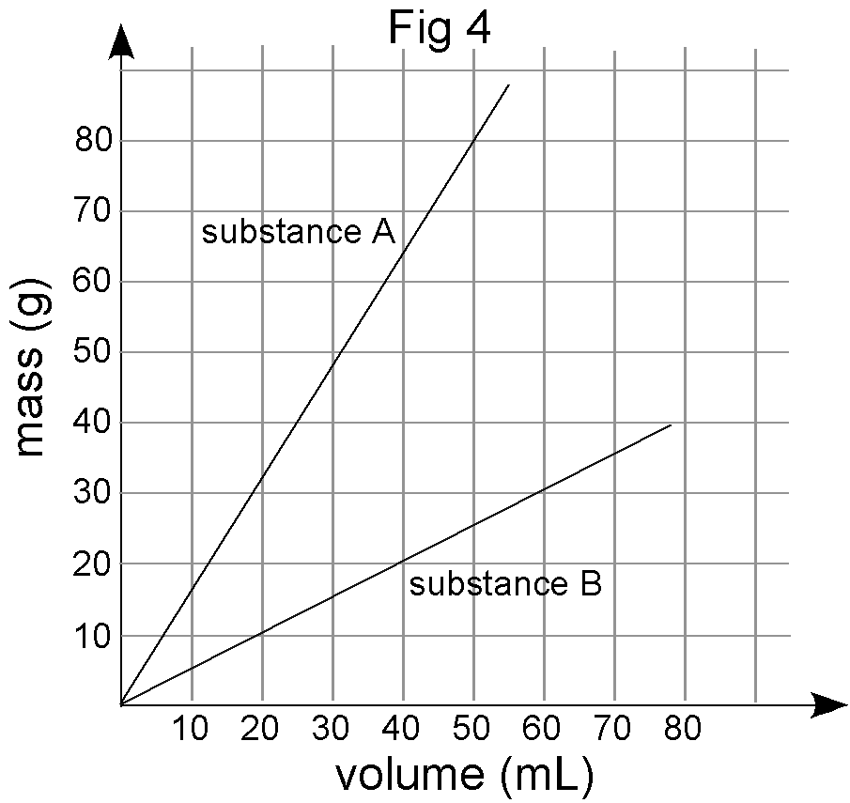
A B

- You have built a simple two-pan balance shown above to compare the masses of substances A and B. What would happen to the balance if you put equal masses of A and B in the two pans? Equal volumes of A and B in the two pans? Explain your reasoning.

b) Find the slope of the line for both A and B using correct units. State the physical meaning of the slope for each substance.

c) If you put 10.0 mL of A in one balance pan, what mass of B would you need in the other pan to make it balance? Explain your reasoning.

d) If you put 35.0 mL of B in one balance pan, what volume of A would you need in the other pan to make it balance? Explain your reasoning.

e) Water has a density of 1.00 g/mL. Sketch the line representing water on the graph in Figure 4.

f) Determine whether substance A and B will sink or float when placed in a bucket of water.
A: sink float B: sink float (circle correct response)

Refer to the table of densities at the right to answer the following questions.
5. Sketch a graph of mass vs. volume for titanium, copper and mercury.
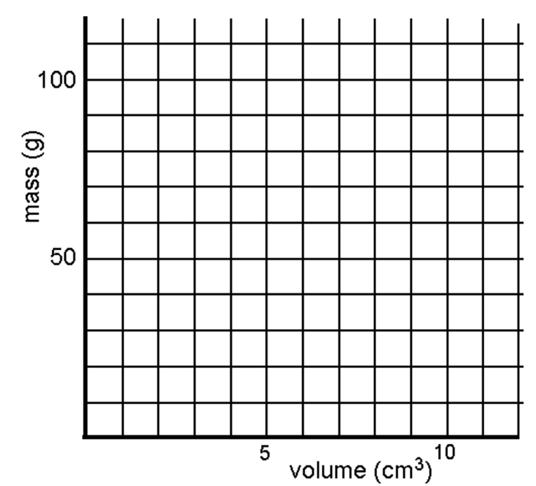
Substance | Density (g/mL)
Aluminum | 2.70
Titanium | 4.54
Zinc | 7.13
Tin | 7.31
Iron | 7.87
Nickel | 8.90
Copper | 8.96
Silver | 10.50
Lead | 11.35
Mercury | 13.55
Gold | 19.30

6.You made some cubes out of each metal in the table that each measures 2.00 cm on every side. (all except mercury – why can’t you make a cube of mercury?)
a. What is the volume of each cube in cm³? in mL? (Show your thinking)

V = ______ cm³ V = ______ mL

b. Find the mass of these metal cubes: (Show your work below)
lead cube ______________
nickel cube ______________
zinc cube ______________

7. Alicia’s boyfriend gave her a ring he claims is 24 carat gold. Alicia is skeptical. After chem class the next day she measures the mass of the ring, finds the volume of the ring by water displacement, and then calculates the density of the ring. Should she treasure the ring as his first truly generous gift to her, or throw it at him the next time he walks by? Defend your answer.

DATA:
Mass: 15.28 g
Final volume: 43.7 mL
Initial volume: 42.2 mL
Volume of ring: __________
Density: __________

- A student filled a graduated cylinder with water and read the meniscus at 25.8 mL. The student then dropped a solid material into the graduated cylinder and the water level rose to 35.9 mL. If the solid material had a density of 2.99 g/mL, determine the mass of the solid object.

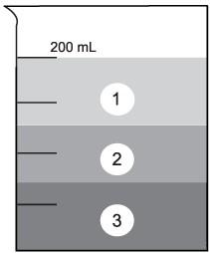
- Three liquids found in many households are listed with their densities below. Label the beaker to show where each of those liquids would be if they were put in layers into the beaker.

Liquid | Density
Glycerol | 1.3 g/ml
Mineral Oil | 0.8 g/ml
Acetone | 0.7 g/ml
- Calculate the mass of a 10 ml volume of gasoline with a density of 0.7 g/ml. SHOW ALL WORK.

- Calculate the volume of a 20 g sample of water. Remember that the density of water is 1 g/ml.
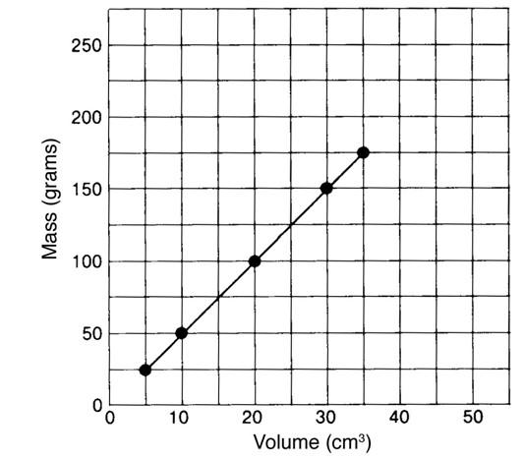

- According to the graph, what is the density of pyrite? Show your work.

- If a sample of pyrite has a volume of 50 cm³, what is its mass (g)? Show your work.

- Which diagram below best represents what a graph would look like if the density of pyrite and the density of water (1.0 gram/cm³) are plotted on the same graph?
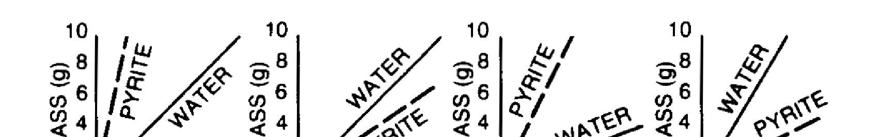
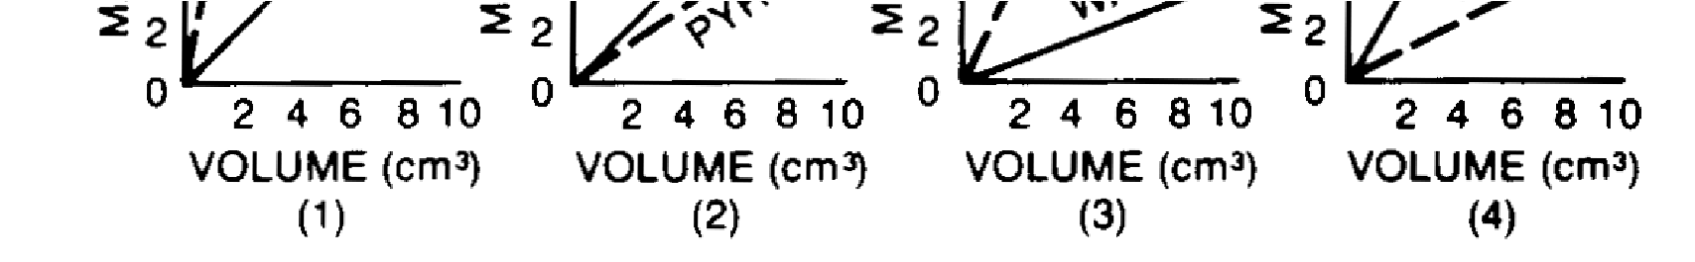

Check Your Understanding: Density

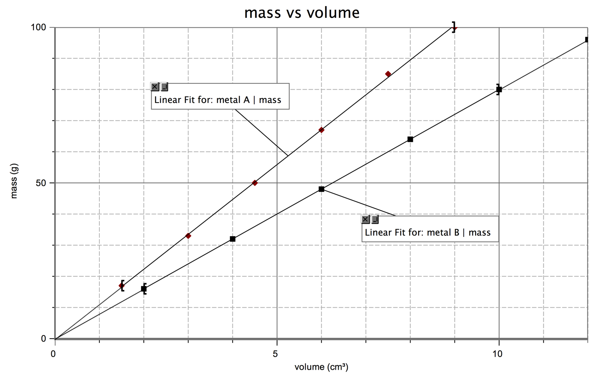

1. Determine the density of each metal. Show all your work and include appropriate units.

2. From the graph, estimate
a. the mass of 8.0 cm3 of metal A.

b. the volume of 70 g of metal B.

c. mark on the graph how you found the answers above.

3. Use the density of B as a factor to determine the answer to 2b. Show the set-up including how the units cancel.
4. Ethanol has a density of 0.789 g/cm³.
  - What is the mass of 225 cm³ of ethanol?

b. What is the volume of 75.0 g of ethanol?

5. What is the density of water in g/mL? What does that mean?

6. The cup is a volume widely used by cooks in the U.S. One cup is equivalent to
237 cm³. One cup of olive oil has a mass of 216 g; what is the density of olive oil?

7. What would you expect to happen if the cup of olive oil in question 6 is poured into a container of ethanol? Why?

Gold has a density of 19.3 g/ cm³. A cube of gold measures 4.23 cm on each edge:
8. What is the volume of the cube?

9. What is its mass? How many significant figures should you include in your answer and why?

10. A standard backpack is approximately 30cm x 30cm x 40cm. Suppose you find a hoard of pure gold while treasure hunting in the wilderness. How much mass would your backpack hold if you filled it with the gold? An average student has a mass of 70 kg. How do these values compare?

Additional Density Practice

1. Reference table S gives the densities of many elements. Which of the first 10 elements is the least dense?

2. Which of the first ten elements has the greatest density?

3. Generally, what phase (solid, liquid, or gas) are all elements in that have low densities? What phase has high densities?

4. Bubbles in soda rise to the surface. Explain this in terms of density.

5. Sand in the ocean always settles to the ocean floor. Explain this in terms of density.

6. A sample of sulfur has a mass of 28.5 grams. What is this sample’s volume in mL?

7. A sample of oxygen has a mass of 16.0 grams, what is the volume of the sample in Liters?

8. A balloon is filled with helium to a volume of 2.00L. What is the mass of the helium in grams?

9. A lead cube with a length of 2.2cm has what volume? What is the mass?

10. A pure elemental gas has a mass of 0.018 g and a volume of 20.0 mL. What gas could it be?

12. A pure metallic liquid has a mass of 162.6 g and a volume of 12mL. What element could it be?

13. A 2.75 kg sample of a substance occupies a volume of 250.0 cm³. Find its density in g/cm³.

14. A rectangular block of lead (Pb) measures 20.0 mm X 30.0 mm X 45.0 mm. If the density of Pb is
11.34 g/cm³, calculate the mass of the block.

Temperature Conversions Introduction

Classroom thermometers measure temperature in degrees Celsius. Water freezes at 0 °C and boils at 100 °C. The lowest possible temperature is -273°C.
- If you wanted to make a new scale with zero to be the lowest possible temperature instead of -273, what value would you have to add to make it zero?

- Using your new temperature scale, at what temperature would water boil?

You have created what is called the Kelvin Scale. What mathematical formula did you use to convert between the Celsius scale and the new kelvin scale? Write it in the box below.

Check Your Understanding:

1) Convert 83 °C to Kelvin

2) How many Celsius degrees separate the freezing and boiling points of water? _______

What are these two temperatures? ________ & _________

3) What is the lowest possible temperature in °C? _________

4) How many Kelvin separate the freezing and boiling points of water? ______

What are these two temperatures? ________ & ________

5) What is the lowest possible temperature in Kelvin? __________

6) Using Table S in your reference table what temperature does Sulfur melt?

7) Using table S, what is the freezing point of Silver (Ag)?

8) Using table S, what is the boiling point of Mercury (Hg)?

9) Using Table S, if room temperature is 22C, is Bromine a solid, liquid, or gas?
Our Model so far…

Explain density:

Diagram | Narrative
Graphical | Mathematical

Explain temperature:

Diagram | Narrative
Graphical | Mathematical
Check Your Understanding: Metric Conversions

Use Reference Tables C and D to help you answer the following questions about the metric system.
- Give the unit used to describe the following:

a. Mass _______ d. Time: ______

b. Volume _______ e. Temperature: ______

c. Energy _______ f. Pressure: ______

- Complete the following number line by adding the prefixes that pertain to the marked values:

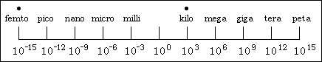

- Convert the following:

a. 900 km = __________ m h. 568 mm = __________ m

b. 200 kg = __________ g i. 52 mg = __________ g

c. 5.00 m = __________ km j. 0.025 J = __________ mJ

d. 7000 J = __________ kJ k. 0.859 s = __________ ms

e. 800 cm = __________ m l. 0.0256 m = __________ μm

f. 20 cg = __________ g m. 0.000589g = __________ ng

g. 2.0 L = __________ cL n. 0.00005987 m = __________ pm
Unit 1 Review

1. What is the difference between mass of an object and its volume?

2. If the box at left contains atoms of aluminum in the liquid phase, represent the same atoms in the solid phase in the box at right.
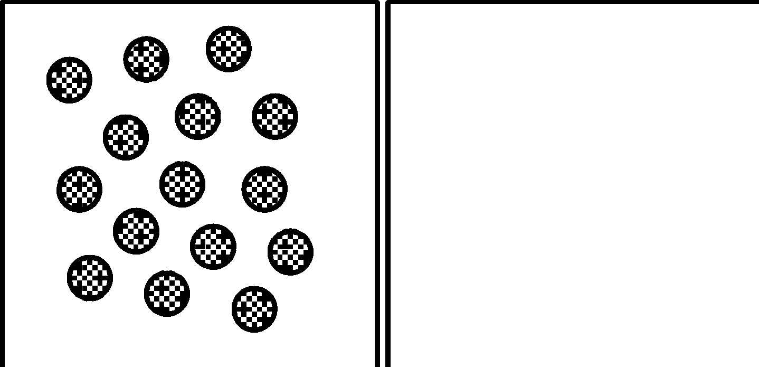

3. How would you represent the atoms of aluminum in the gaseous phase?

4. If the box at left contains atoms of iron in steel wool, represent the atomic structure of the steel wool after strong heating in the box at right.
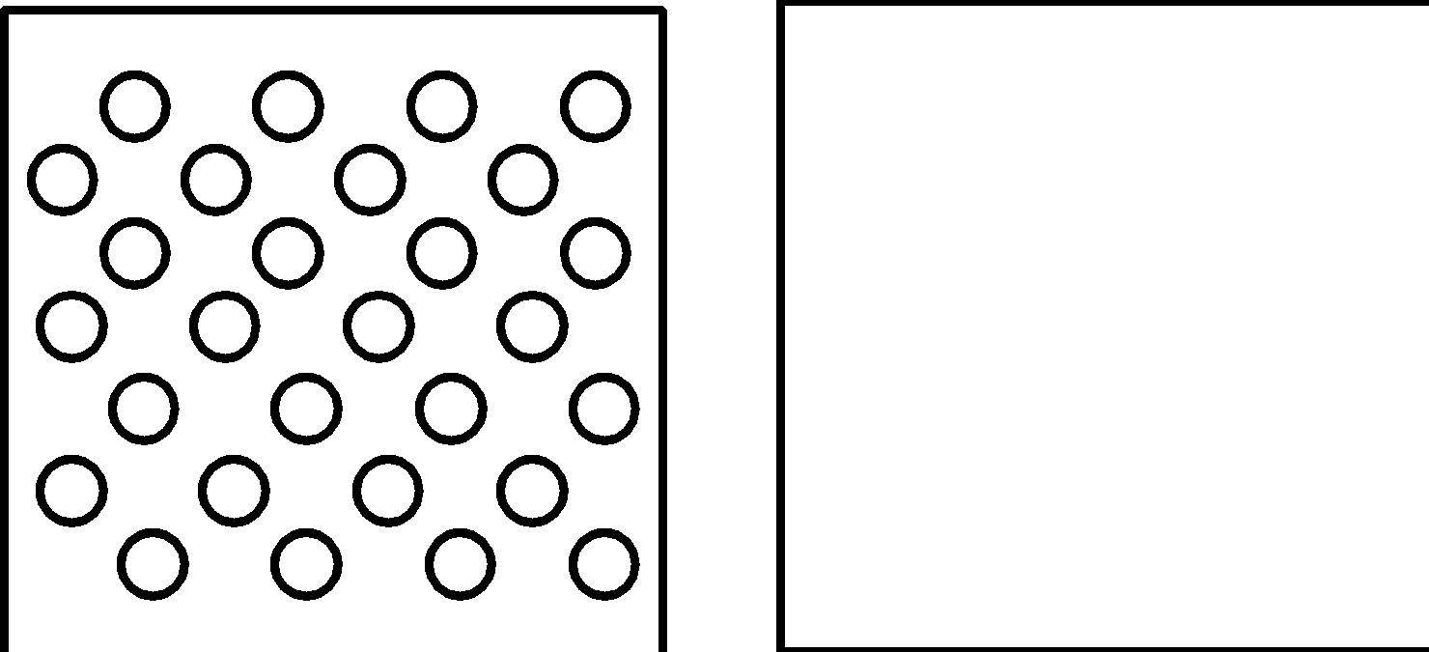

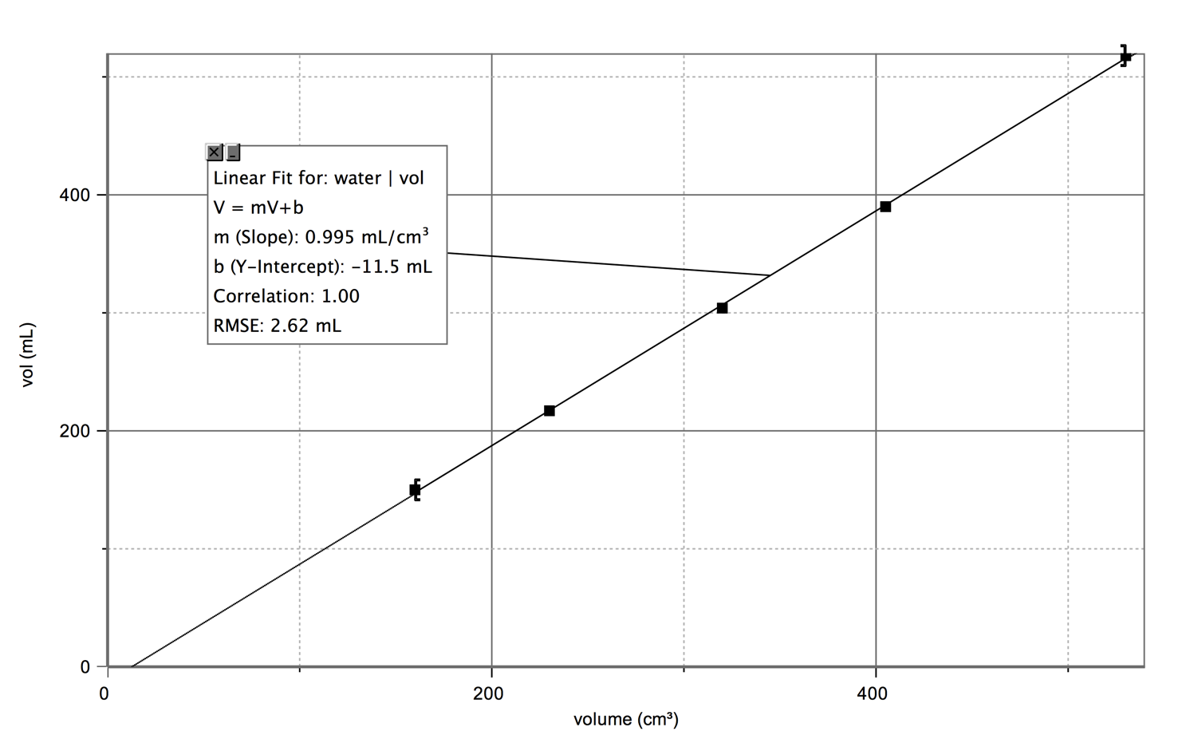
5. The 8th period chemistry class produced the following graph when they plotted the volume of water in mL vs. the volume of the container measured in cm3.
a. What does the slope tell you?

b. How could you account for the fact that they obtained a negative y-intercept?

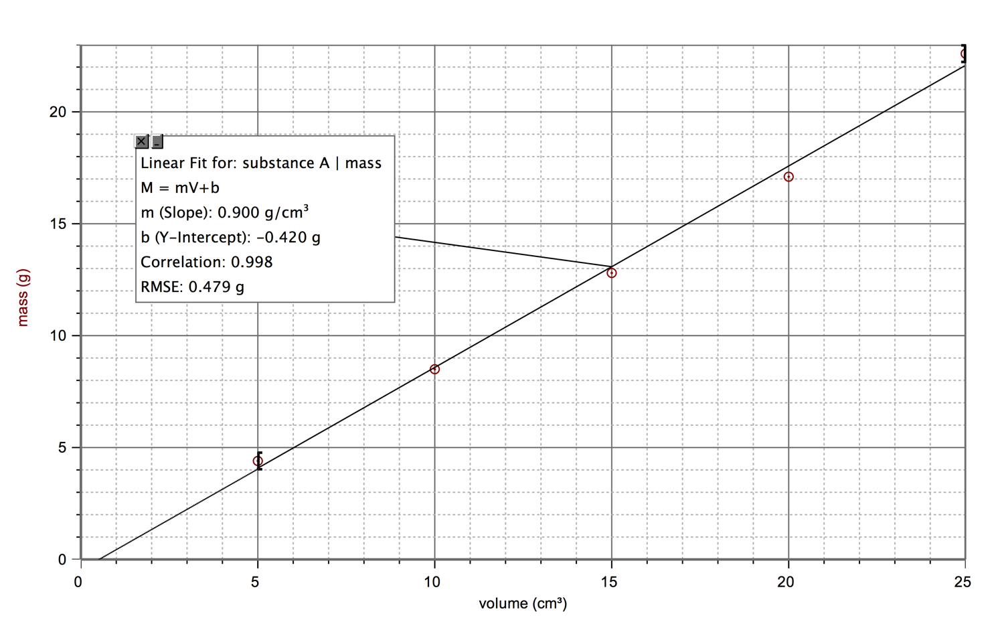
6. The 2nd period chemistry class produced the following graph when they were measuring the mass and volume of a set of objects in the lab.

a. What information is given by the slope of the graph?

b. What would you predict would happen if you were to put one of the objects in water? Explain.

c. What would you expect to be the mass of a 45 cm³ piece of the same substance?

7. Mercury has a density of 13.6 g/mL. What is the volume occupied by 112.0 grams of mercury?

8. A cube of gold-colored metal with a volume of 54 cm3 has a mass of 980 g. The density of gold is 19.3 g/cm3. Is this sample of metal pure gold? Why or why not?

Common Sense Chemistry Review Volume 1
Can you apply what you’ve learned to seem smarter than your friends?

- A student read the packaging slip for the recent Amazon order and he was charged an extra fee for shipping a package over 20kg. The student knows his package weighs 5 pounds and 5 pounds equals approximately 2260 grams. Should he be charged the fee?

- Grandma needs to take a minimum of 1200mg of calcium a day to help her bones. The Calcium vitamins you bought for her specify that it provides a half of a gram of calcium per tablet. How many tablets does Grandma need to take?

- Your friend created a raft to hang out on in the bay. The raft weighs 180 kg and measures 160.0 cm in length, 80.0cm in width, and 20.0 cm in depth. Will the raft float in water with a density of 1.00g/mL?

- You are traveling in Canada in late May and want to paddleboard. The weather man reports that the water is going to be 12°C tomorrow. Will you freeze, boil, or survive in that water? Explain.

- You took the top 20 quiz in social studies (graded out of 20 points) and earned a 16. What is your percent error?

- In terms of density or particle arrangement, why is nitrogen used rather than helium to extinguish a fire?

- While preparing for your flight to England, you decide to weigh all your travel items. You weighed your toiletries on your mom’s food scale and they totaled 327.97grams. You weighed all your clothes on the bathroom balance and they totaled 20,672.5 grams. The label on your new suitcase boasted a low weight of 1kg. You get to the airport knowing the weight limit is 22kg and mom is freaking out. You are cool as a cucumber. Why?

