AP Learning Objectives:

Explain the quantitative relationship between the mass spectrum of an element and the masses of the element’s isotopes.(1.2)
Represent the electron configuration of an element or ions of an element using the Aufbau principle. (1.5)
Explain the relationship between the photoelectron spectrum of an atom or ion and: a. The electron configuration of the species. b. The interactions between the electrons and the nucleus.(1.6)
Explain the relationship between trends in atomic properties of elements and electronic structure and periodicity (1.7).
Explain the relationship between trends in the reactivity of elements and periodicity(1.8).
Explain the relationship between a region of the electromagnetic spectrum and the types of molecular or electronic transitions associated with that region (3.11)
Explain the properties of an absorbed or emitted photon in relationship to an electronic transition in an atom or molecule. (3.12)

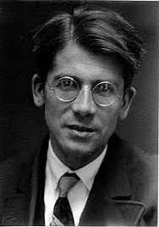
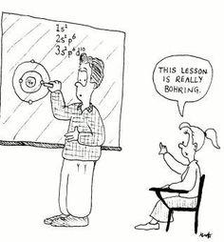
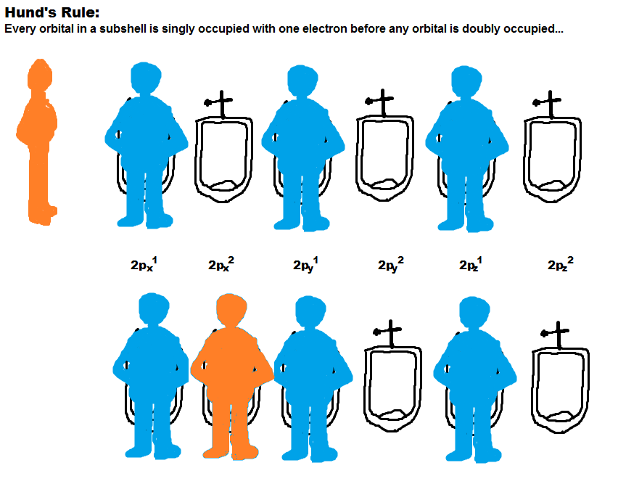
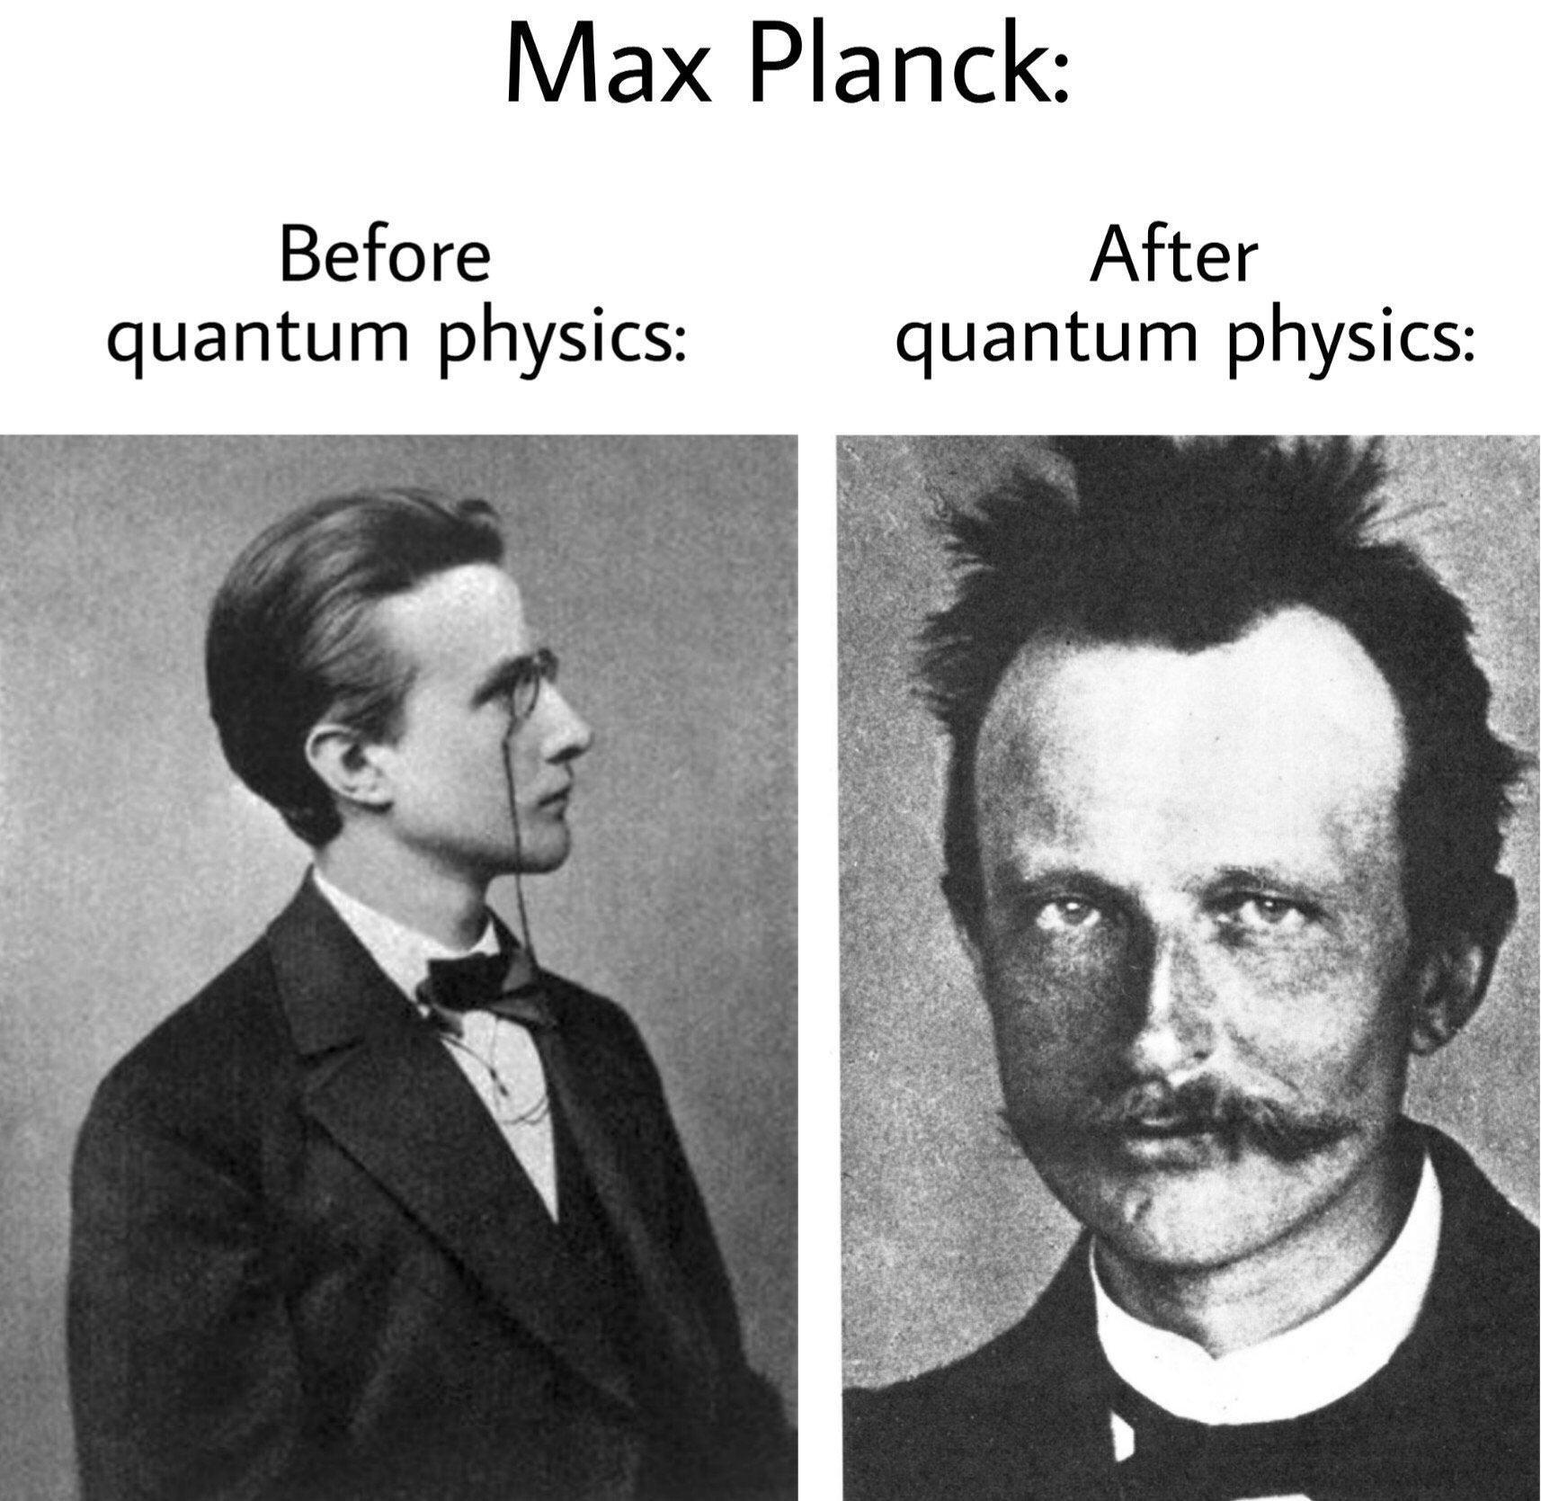
REVIEW

Directions: Fill in the table below using your AP reference tables. There are isotopes and ions on this table.
Name (and charge) | Symbol | Protons | Neutrons | Electrons | Atomic # | Mass # | Nuclear charge
Oxygen |  |  | 8 | 8 | 8 | 16 | 8+
 |  | 7 | 7 |  | 7
 | ³⁴₁₆S |  |  | 18 |  | 34
Hydrogen (deuterium) |  | 1 | 1 |  | 1
Hydrogen (tritium) |  | 1 |  |  | 1 | 3
 |  | 9 |  |  |  | 19
Beryllium ion |  |  |  | 2 |  | 9
 |  | 12 |  |  |  | 24
 |  | 12 |  |  |  | 25
 |  |  |  | 92 |  | 238 | 92+
Chloride ion |  |  |  | 18 |  | 35
 |  | 17 |  |  |  | 37
 | ⁸⁴₃₆Kr |  |  | 36 |  | 84
Iron (III) ion |  | 26 |  |  |  | 56
Silver ion |  |  | 60 | 46
- Give the name, symbol, charge and location of all subatomic particles in an atom:

- Define ions with an example from above:

- Define isotopes with an example from above:

- Naturally occurring chlorine that is put in pools is 75.53% Cl-34.969 and 24.47% Cl-36.9666. Calculate the atomic mass.

- Copper is used in electric wires and comes as two isotopes, Cu-63 and Cu-65. Cu-63 has an actual mass of 62.9298amu and Cu-65 has an actual mass of 64.9233 amu. If they are 69.09% and 30.91% abundant respectively, what is the atomic mass?

- Magnesium has three isotopes Mg-24 (78.70%), Mg-25 (10.13%), and Mg-26 (11.7%). The actual mass of Mg-25 is 24.98584 and the actual mass of Mg-26 is 25.98259. What is the actual mass of Mg-24 if the atomic mass of magnesium equals 24.3050 amu?

- The results taken from a mass spectrum of chlorine gas show peaks at m/z 35.00 and m/z 37.00 (The m/z peaks on a mass spectrum identify the different isotopes of an element that are present in the sample).
- Given that the relative abundances of Cl 35.00 and Cl 37.00 are 77.50% and 22.50% respectively, calculate the average relative atomic mass of chlorine atoms to four significant figures.

- Suggest all the possible masses of CI₂ molecules that are made when two chlorine atoms bond together.

- Which of the molecules you have suggested in (b) will be the most abundant? Explain your answer.

- Draw the model, give the nickname and scientific experiment where appropriate.
Dalton | Thompson | Rutherford | Bohr
Model Nickname: | Model Nickname: | Model Nickname: | Model Nickname:
Experiment: | Experiment: | Experiment: | Experiment:
Discovery: | Discovery: | Discovery: | Discovery:

ELECTRON CONFIGURATIONS
 | Full e- Configuration | # Valence e- | Valence orbital notation | Lewis Diagram
H
He
Li
Be
B
C
N
O
F
Ne
Mg
Si
S
Ar
K
Fe
Zn
As
Br
Sr
Zr
Te
Xe
IONS AND EXCEPTIONS

 | Atom’s e- Configuration  (Noble Gases Short Cut Allowed) | # Valence e- | Ion’s e- Configuration  (Noble Gases Short Cut Allowed) | Ion’s Lewis Diagram
Li⁺
Cu⁺²
Co⁺³
Mg⁺²
Sc⁺²
Na⁺
Ag⁺
Ca⁺²
O⁻²
Zn⁺²
K⁺
Br⁻
As⁻³
Cu⁺¹
Au⁺
N⁻³
Mo⁺
S⁻²
F⁻
As⁺⁵
P⁻³
As⁺³
- Explain why arsenic can form three different ions in terms of valence electrons and stability.

- The electron configuration 1s² 2s² 2p⁶ 3s² 3p⁶ 4s² 3d¹⁰ 4p⁶ 5s² has _____ unpaired electrons and represents element _________________.
- The electron configuration 1s² 2s² 2p⁶ 3s² 3p⁶ 4s² 3d¹⁰ 4p² has _____ unpaired electrons and represents element ______________________.
- Which electron configuration(s) are in the excited state? Circle all that apply:
1s² 2p⁶ 3s² 3p⁶ 4s² 3d¹⁰ 4p² 1s² 2s² 2p⁶ 3s² 3p¹

1s² 2s² 2p⁶ 3s² 3p⁶ 4s² 3d¹⁰ 4p² 1s² 2p⁶ 3s² 3p⁶ 4s² 3d¹⁰ 4p²

1s² 2s² 2p⁶ 3s² 4s² 3d¹⁰ 4p² 1s² 2s² 2p⁶ 3s¹

1s² 2s² 2p⁶ 3s² 3p⁵ 4s² 3d¹⁰ 4p² 1s² 2s² 2p⁶ 3s³

1s² 2s² 2p⁶ 3s² 3p⁶ 4s² 3d⁸ 1s² 2s² 2p⁶ 3s² 3p⁸

1s² 2s² 2p⁶ 3s² 3p⁶ 4s² 3d⁵ 1s² 2s² 3s²
- Where any of the above configurations not allowed? Box them and explain their errors.
- Draw shapes for the s p and d orbitals.

- How many electrons can fill each orbital? Why? (Give a rule and explanation)

- How many electrons fill the s orbital? ____
- How many electrons fill the 4p sublevel? ____
- How many electrons fill the 3d sublevel? ____
- How many electrons fill the 5f sublevel? ____
- How many electrons will fill a p orbital? ____
- Which rule states that the 3d must be filled using a 4s electron for Copper? ______________________
- What is the term given to describe that all 3d orbitals have the same energy? _____________________
ELECTRON CONFIGURATIONS PRACTICE

- Give full and abbreviated (noble gas core method) electronic configurations for the following.

(a) Br FULL ______________________________
NOBLE GAS CORE ______________________________
(b) Cr FULL ______________________________
NOBLE GAS CONF ______________________________
(c) Fe FULL ______________________________
NOBLE GAS CONF ______________________________
(d) S²⁻ FULL ______________________________
NOBLE GAS CONF ______________________________

2. For each of the following sets of orbitals, indicate which orbital is higher in energy.
(a) 1s, 2s _________ (c) 4s, 3dyz _________
(b) 2p, 3p _________ (d) 3px, 3py, 3pz _________

3. Indicate the block (s, p or d) in which each of the following elements found.
(a) Sc ______ (d) Ni ______
(b) P ______ (e) As ______
(c) Fr ______ (f) Sr ______

4. An atom has two electrons with principal quantum number (n) = 1, eight electrons with principal quantum number (n) = 2 and seven electrons with principal quantum number (n) = 3. From these data, supply the following values
(a) The mass number _________
(b) The atomic number _________
(c) The electron configuration ___________________________
5. Identify the element from the electron configurations of atoms shown below.
(a) [Ne] 3s² 3p² _________
(b) [Ar] 4s² 3d⁷ _________
(c) [Xe] 6s² _________

6. Give the symbol of the atom or ion represented by the following sets of atomic numbers and configurations.
Atomic # Electronic Configuration Symbol of Atom or Ion
(a) 8 1s² 2s² 2p⁴ ________
(b) 11 1s² 2s² 2p⁶ ________
(c) 14 1s² 2s² 2p⁶ 3s² 3p² ________
(d) 22 1s² 2s² 2p⁶ 3s² 3p⁶ 3d² ________

7. Give the electron configurations for the following transition metal ions.
(a) Sc³⁺ __________________________________
(b) Cr²⁺ __________________________________
(c) Ni³⁺ __________________________________

8. Consider the element Scandium, atomic # 21.
(a) If the configuration of the element were constructed, into which orbital would the final electron be placed?

(b) When scandium forms an ion with a charge of +1, from which orbital would the electron be removed?

9. Of the following species (Sc, Ca²⁺, Cl, S²⁻, Ti³⁺), which are isoelectronic? ____________________________

10. Identify the element that is composed of atoms where the last electron;

(a) Enters and fills the 4s sub-shell ________
(b) Enters but does not fill the 4s sub-shell ________
(c) Is the first to enter the 2p sub-shell ________
(d) Is the second to enter the 4d sub-shell ________

11. Write the full electronic configuration for argon. _______________________________________________

12. Identify two positive and two negative ions that are isoelectronic with argon.
ORBITAL FILLING RULES

The rules that you have been applying in order to determine the electronic configuration of an atom are:
- Lowest energy orbitals are filled first. THE AUFBAU PRINCIPLE.
- Orbitals can only contain a maximum of two electrons and when two electrons enter the same orbital they must have opposite spins so that each electron has a unique set of quantum numbers. (In the electrons in boxes diagram they must be drawn NOT OR ). THE PAULI EXCLUSION PRINCIPLE.
- When orbitals of identical energy (degenerate) are available electrons enter these orbitals singly before any spin pairing takes place. HUNDS RULE.
- There are some notable exceptions. For example Cr and Cu achieve extra stability by forming a half-filled and completely filled d sub-shell respectively by using one of their 4s electrons.
Consider each of the elements listed and the INCORRECT electronic configuration associated with each one. In each case identify which of the above rules or principles (A, B, C or D) is violated and insert the correct electronic configuration.

Element | Incorrect Configuration | Violation | Correct Configuration
N | 1s² 2s² 2px² 2py¹ | C | 1s² 2s² 2px¹ 2py¹ 2pz¹
Al | 1s² 2s² 2p⁶ 3p³
B | 1s² 2s³
P | 1s² 2s² 2p⁶ 3p⁵
Cu | [Ar] 4s2 3d⁹
C | 1s² 2s¹ 2px¹ 2py¹ 2pz¹
C | 1s² 2s² 2px²
Ag | [Kr] 5s² 4d⁹
Mn | [Ar] 4s¹ 3d⁶
Ni | [Ar] 4s² 3dxy⁸
Sc | [Ar] 3d³
B | 1s² 2s¹ 2px¹ 2py¹
Na | 1s¹ 2s² 2p⁶ 3s²
S | [Ne] 3s² 3px² 3py²
V | [Ar] 3d⁵
P | [Ne] 3s² 3px² 3py¹
Kr | [Ar] 4s² 3d¹⁶

ELECTROMAGNETIC RADIATION

Light, which is also called electromagnetic radiation, carries energy and has characteristics of both particles and waves (deBroglie). The absorption and emission of ER is one of the powerful tools used to probe molecular structure and chemical reactions, forms the basis of medicine’s magnetic resonance imaging (MRI), and is intrinsic to many analytical techniques used to monitor manufacturing processes and the environment. You will use the emission and absorption of light by matter to obtain the relative energies of the atomic and molecular orbitals and other energy levels, which are associated with vibration, rotation, electron spin and nuclear spin as well as spectra.

Reference Table Formulas:
E = hν E = energy Planck’s constant, h = 6.626x10⁻³⁴ Js
c = λν ν = frequency Speed of light, c = 2.998x10⁸ m s⁻¹
λ = wavelength Avogadro’s number = 6.022x10²³ mol⁻¹
Electron charge, e = -1.602x10⁻¹⁹ coulombs
Key Questions:

- What is the equation showing the relationship between energy of a photon and frequency of light? How are they correlated (direct or indirect?) Explain.

- What is the relationship between frequency and wavelength? Explain how they are correlated.

Exercises:

- The laser in a cd uses light with a wavelength of 780nm.

  - Calculate the frequency of this light.

  - Calculate the energy of a single photon of this light.

LIGHT EQUATIONS PRACTICE

- Find the frequency of the following:
  - A wave with a wavelength of 5.60x10⁻⁵m.

  - A wave with a wavelength of 7.21x10⁻²m.

  - A wave with a wavelength of 555 nm.

  - A wave with a wavelength of 22.3 nm.

  - A wave with 2.31x10⁻²⁰ J of energy.

  - A wave with 3.56x10⁻³⁰ kJ of energy.

- Find the wavelength of the following in nanometers:
  - A wave with a frequency of 40050 s⁻¹.

  - A wave with a frequency of 58900 s⁻¹.

  - A wave with a frequency of 2.00x10⁶ Hertz.

  - A wave with a frequency of 3.45x10¹⁰ Hertz.

  - A wave with 3.89x10⁻²⁵ J of energy.

  - A wave with 4.57x10⁻³¹ kJ of energy.

- Find the energy of the following:
  - A wave with a frequency of 1.00x10³ s⁻¹.

  - A wave with a frequency of 3.40x10¹⁸ Hertz.

  - A wave with a wavelength of 2.89x10³ m.

  - A wave with a wavelength of 567 nm.

- Find the type of energy emitted using the following diagram for questions 3a to 3d.

3a. _____________________________________________

3b. _____________________________________________

3c. _____________________________________________

3d. _____________________________________________

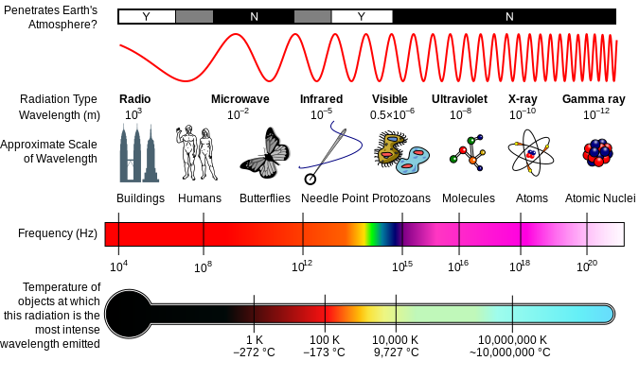

MASS SPEC
Mass Spectrometry, Percent Abundance & Atomic Mass
Mass spectrometry is a technique used in chemistry to determine average atomic mass values for the elements. It can also be used to identify unknown compounds, such as in forensics and archeology.
How a Mass Spectrometer Works:
A gaseous sample is hit with electrons, which produces positive ions
These positive ions are sent through a magnetic field, which exerts a force on the charged ions
The ions are deflected by the force of the magnetic field and hit a film on the other side of the magnetic field – this is how they are detected
The lighter (less massive) particles are affected by the force of the magnetic field more than the heavier particles, and so will be deflected more from the straight-line path.
By comparing the amount or degree of deflection for the particles in a sample of a given element to the standard deflection angles for a sample of carbon-12, atomic masses* can be determined. *These are relative atomic masses – relative to the standard (carbon-12).
From the number of hits at each deflection point, the relative abundances of the isotopes in the sample can be determined.

Mass Spectrometer
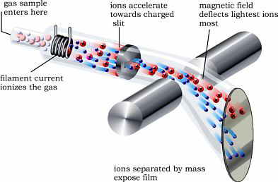

Mass Spectrometer Reading for Neon
How to Read a Mass Spectrogram:
A peak indicates that particles with that mass number were detected
The taller the peak, the more particles there were in the sample with that particular mass
This spectrogram for neon shows a very tall peak at mass = 20 and a short peak at mass = 22. This means that there were more neon-20 atoms than neon-22 atoms. The neon-20 isotope contributes more to the average atomic mass for neon because there are more atoms of neon-20 than neon-22. Looking up the average atomic mass for neon on the Ref. Tables, we find that it is 20.18 amu, which makes sense because there are many more neon-20 atoms than neon-22 atoms, making the average atomic mass closer to 20 than to 22.
You may be asked to pick out a correct spectrogram for an element, given its atomic mass, on the AP Exam.

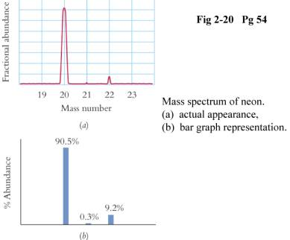

For example: Which mass spectrometer reading represents naturally occurring magnesium?
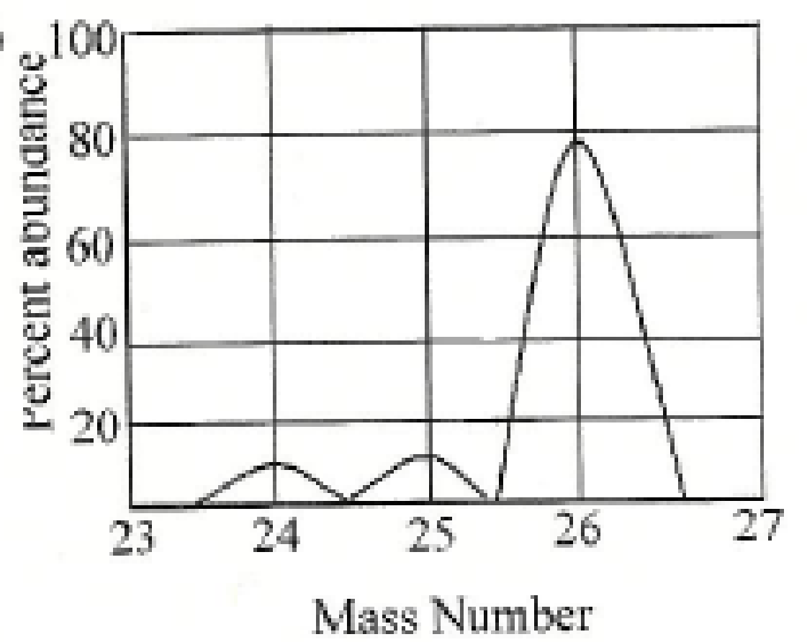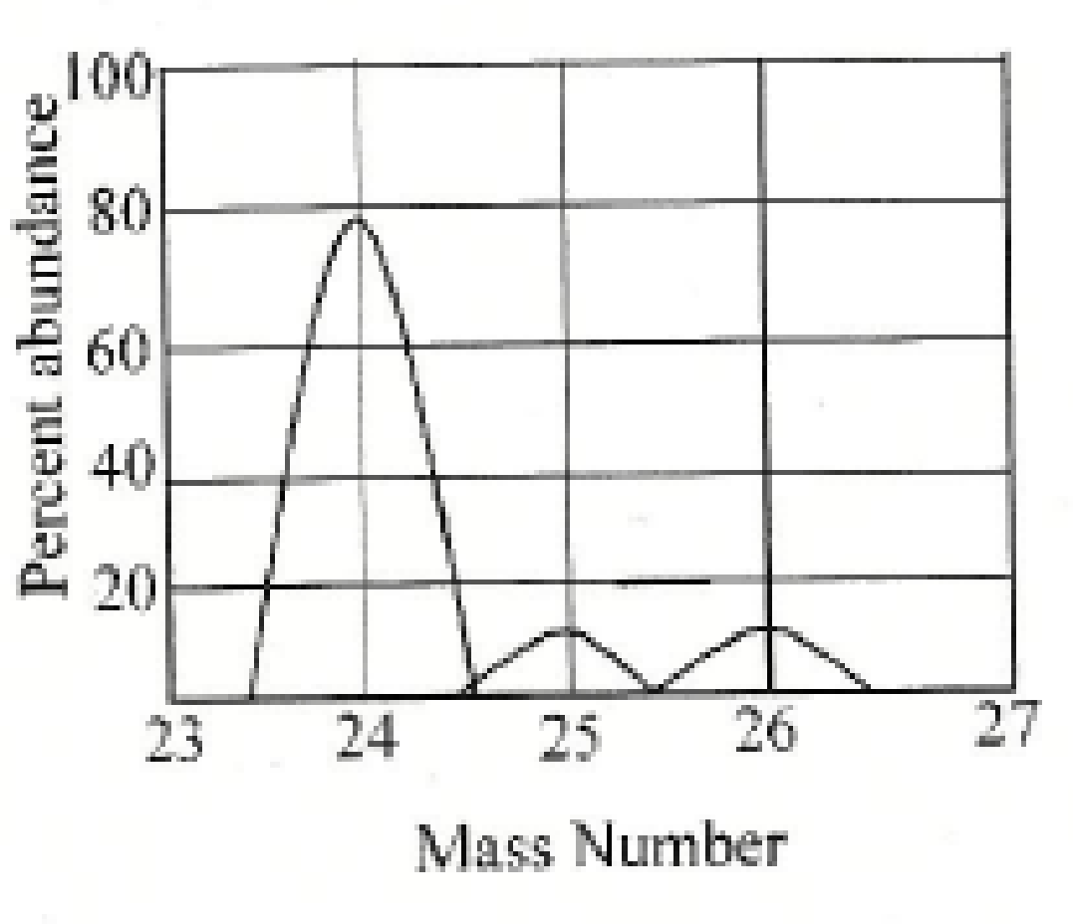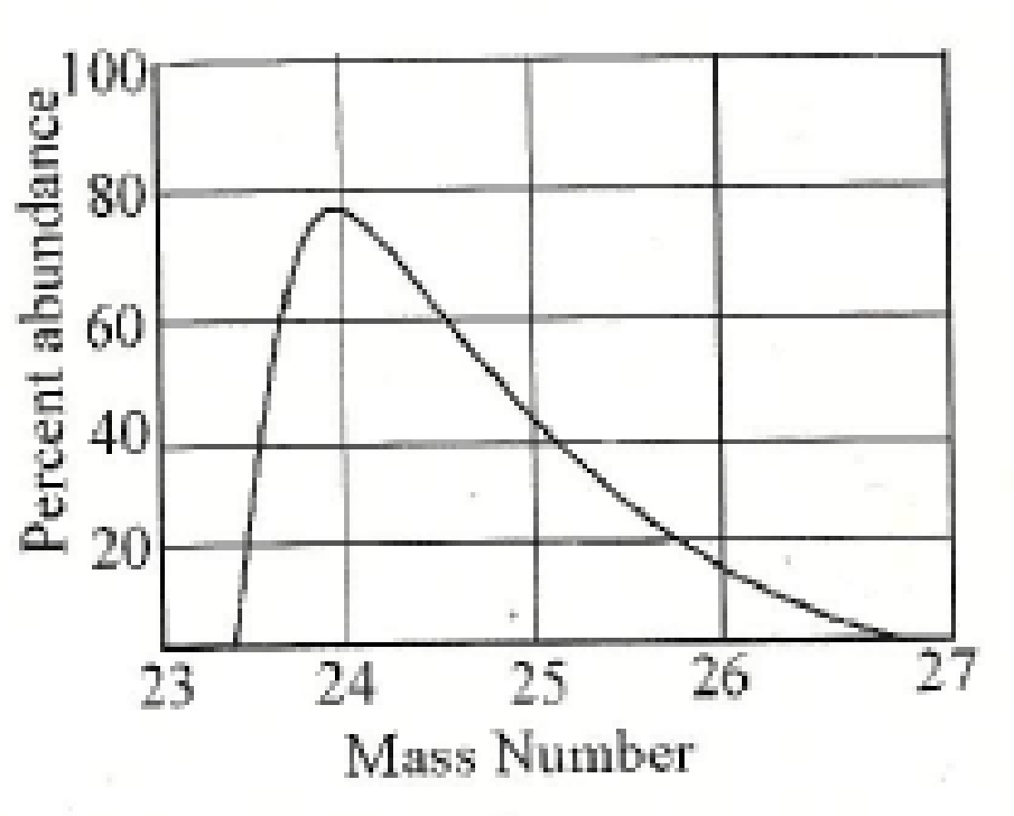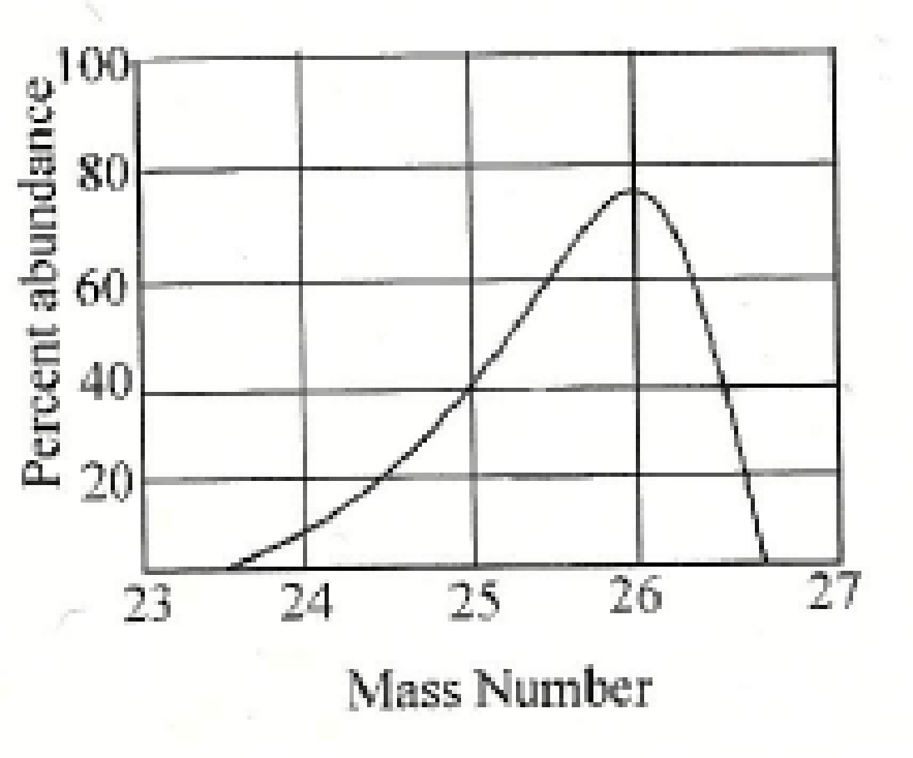
- (B) (C) (D)
- An unknown element ‘Z’ is analyzed in a mass spectrometer and is found to have the following isotopes with the corresponding relative abundances.
Isotope Z Relative Abundance
50 Z 4.34
52 Z 83.79
53 Z 9.50
54 Z 2.37
- Sketch the expected mass spectrum that these data would provide. Label the axes and pay attention to the size of any lines that you draw.

- Calculate the average atomic mass of Z and identify the element.

- Consider the following mass spectrum that was generated from the analysis of an element. What does the existence of only a single peak in the spectrum suggest about the element? What is the element’s identity?
100

Relative
Abundance

0
24 25 26 27 28
m/z
- How many peaks would be observed in the mass spectrum of O₂⁺, given that there are three, commonly occurring isotopes of O with mass numbers of 16, 17 and 18?

- Bromine has two isotopes, Br-79 and Br-81. The isotopes occur in a 50:50 (1:1) ratio. Given that the mass spectrum of bromine contains peaks for both bromine atoms and diatomic bromine molecules, predict the number of peaks in the spectrum. What would be the relative height of the atomic peaks? What would be the relative height of the molecular peaks? Assume that z = +1 in each case.

- A sample of carbon atoms were chemically combined with a sample of oxygen atoms to yield the compound carbon dioxide. The sample of oxygen atoms was artificially manufactured to have a 3:1 ratio of O-16 and O-18, Assuming carbon to have only a single isotope C12, predict the mass spectrum that the resulting sample of carbon dioxide would produce in terms of the number of peaks. Which peak would be the smallest? Explain. Assume the mass spectrum only includes peaks for the compound carbon dioxide and that z = +1 in each case.

- Neon atoms are known to produce a mass spectrum that consists of three peaks at m/z values of 20, 21 and 22, with the relative abundance of the peaks found to be in the ratio 112 : 0.21 : 11.1. Assuming the z value of the species causing the peaks to be +1 in each case, calculate the average atomic mass of neon based on these data.

PES

C

A

B

The photoelectric spectrum of Neon

1000 800 600 400 200 0

Binding Energy (eV)

- The peaks A, B, and C represent the binding energies of electrons in which subshells of neon?
  - 1s, 2s and 2p c. 1s, 1s and 1s
  - 2p, 2s and 1s d. 2s, 2p and 2p

- Which of the following statements best accounts for the peak A being far to the left of peaks B and C:
  - The electron configuration of neon is 1s² 2s² 2p⁶
  - Neon has 8 electrons located in its valence shell
  - Core electrons of the atom experience a much higher effective nuclear charge that the valence electrons
  - Peaks B and C show first ionization energies of electrons in neon, whereas peak A shows the second ionization energy or neon.

- Which of the following statements best accounts for peak C being three times the height of peak B:
  - The intensity of the photoelectron signal at a given energy is a measure of the number of electrons in that energy level.
  - Electrons represented by peak B have approximately triple binding energy than those represented by peak C.
  - In the photoelectron spectrum, as binding energy increases, the relative number of elctrons decreases.
  - The height of the peaks in a photoelectron spectrum does not have any relation to the structure of the atom.

- Nitrogen shows 3 peaks in its photoelectron spectrum. These 3 peaks correspond to the binding energies of nitrogen’s 1s, 2s and 2p electrons. The relative heights of the 1s, 2s, and 2p peaks in the PES spectrum of nitrogen will be:
a. 1, 1, 1 b. 2, 2, 3
c. 1, 1, 2 d. 2, 2, 5

5. If the binding energy of an electron is between 0 - 10 eV, it can be assumed that the electron originated in:
a. an s orbital b. a p orbital c. a core orbital d. a valence orbital

6. Shown below are the photoelectron spectra of nitrogen (atomic number 7) and fluorine (atomic number 9).

Photoelectron Spectrum of Nitrogen

A

B C

1000 800 600 400 200 0
Binding Energy (eV)

C

A

B

Photoelectron Spectrum of Fluorine

1000 800 600 400 200 0

Binding Energy (eV)

Given the data in the two spectra, what do you expect the binding energy of the 1s electrons in oxygen (atomic number 8) to be?
a. 0 - 50 eV b. 50 - 400 Ev c. 400 -700 eV d. 700 ‐ 1000 eV

7. The photoelectron spectrum below shows the binding energies for all electrons in neutral element Z:

C

A

B

D

Photoelectron Spectrum of Element Z

1300 1200 1100 200 100 0

Binding Energy (eV)

What is the identity of element Z?
- boron b. carbon c. neon d. magnesium

Photoelectron Spectrum of Sodium

C

A

B

D

1300 1200 1100 200 100 0

Binding Energy (eV)
8. Identify the peak (A‐D) in the photoelectron spectrum of sodium that represents the binding energy of electrons in the 2s orbital.

- Identify the peak (A‐D) in the photoelectron spectrum that gives the binding energy of sodium’s valence electrons.

- Which peak (A‐D) in the photoelectron spectrum of sodium shows electrons closest to the nucleus?

- Which peak (A‐D) in the photoelectron spectrum of sodium represents an orbital containing 6 electrons?

C

A

B

D E

Photoelectron Spectrum of Element Q

1800 1700 1600 100 0

Binding Energy (eV)
12. The electrons that feel the strongest effective nuclear charge are given by which peak?
a. A b. B c. E
d. all electrons in this spectrum experience the same effective nuclear charge

13. Which peaks in the photoelectron spectrum represent valence electrons of element Q?
a. A only b. B and C c. D and E d. E only

14. Which peaks in the photoelectron spectrum of Q are given by the binding energy of p orbital electrons?
a. C only b. D only c. C and E d. B, C, and D

15. What is the identity of element Q?
a. carbon b. oxygen c. magnesium d. silicon
PERIODIC TABLE REVIEW

- Define and name the periodic groups (alkali, alkaline earth, transition metals, halogens, noble gases) with properties. Explain what property each element in a specific group has in common with each other.

- Define the periodic periods and explain what elements in the same period have in common with each other.

- Put a check in each box that correctly describes the element given.
 | Metal | Metalloid | Nonmetal | Alkali  Metal | Alkaline  Earth  Metal | Transition  metal | Halogen | Noble  gas | Monatomic | Diatomic
Sb
Sr
Rn
P
Pt
Cs
S
Fe
Br
Ar
H
Si
B
F
He
Se
Zn
Ra

4. Write in the space, “metals”, “metalloids”, or “nonmetals” to indicate which type of element.
 |  | Located on the left side of the P.T.
b. |  | Located on the right side of the P.T.
c. |  | Solids are brittle
d. |  | Majority of the elements
e. |  | Gain electrons to form negative ions
f. |  | Located along the “staircase”
g. |  | Have luster
h. |  | Malleable
i. |  | Lose electrons to form positive ions
j. |  | Ductile
k. |  | Excellent conductors of heat & electricity
l. |  | Poor electrical & heat conductors
m. |  | Low electronegativity values
n. |  | Low ionization energy
o. |  | High ionization energy
p. |  | High electronegativity values
q. |  | Ions are larger than their atoms
r. |  | Ions are smaller than their atoms

5. Check all the boxes which describe the element.

 | Physical Properties |  |  |  |  | Chemical Properties
 | State at STP  (s, l, or g) | Brittle | Malleable  /ductile | Conductor |  | Ionization  energy |  | Electro-  negativity |  | Electrons
 |  |  |  | Good | Poor | Low | High | Low | High | Lose | Gain
C
Ag
Mg
I
S
Au
Fe
Br
Ar
H
Hg

ATOMIC RADIUS

Trends:
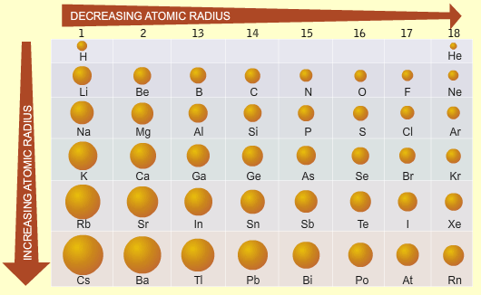
Across a period atomic radius _________________________

due to ____________________________________________________

____________________________________________________________

Down a group atomic radius _________________________

due to ____________________________________________________

1. Identify and explain the trend in atomic size for the following transitions in the periodic table.
(a) Moving vertically from Ar to He

(b) Moving horizontally from Na to Ar

2. In each of the following pairs, pick the larger species. Explain you answer in each case.
(a) Cu and Cu²⁺

(b) F and F-

(c) Na⁺ and K⁺

3. Only one of the following statements is correct. Which one?
(a) All cations are larger than their corresponding atoms
(b) All anions are smaller than their corresponding atoms
(c) Atomic size increases on transitioning from left to right across period 2 of the periodic table
(d) The most common ion of chlorine is smaller than a chlorine atom
(e) The most common ion of strontium is larger than a strontium atom
(f) The most common potassium ion is larger than the most common sodium ion
(g) The ions most commonly formed by group 16 elements are smaller than their corresponding atoms

4. Consider the plot below that shows atomic and ionic radii of the most commonly formed ion (in units
of pm) for selected elements, plotted against atomic number. (Blue line is first, red line is second in each case.)

- Which color represents the plot for atomic radii? Explain your answer by using any element as an example.

(b) What do the elements that have smaller ionic radii than their corresponding atomic radii have in
common?

(c) Suggest a reason for the absence of comparative atomic and ionic radii data for elements with
atomic numbers of 2, 10 and 18.

(d) Identify the element with atomic number 19, identify the formula of the ion that it commonly
forms, and convert the radii of both the atom and the ion to units of cm.

(e) What common feature can be identified for all of the non-metals on the plot?

(f) What accounts for the sharp increase in height of the blue lines that occurs at elements with
atomic numbers 3, 11 and 19 respectively?

(g) Make a prediction about the relative heights of the blue line and red line if data were added to the plot for the element with an atomic number of 15. Explain.

(h) The element with atomic number 1 has a red line that is significantly taller than its blue line. Under what circumstance would the red line be shorter than the blue line for this element?

(i) If data were added to the plot for the element with atomic number 7, which would be taller, the
blue or the red line? Explain.

IONIZATION ENERGY (and more radii)

- Using the metal magnesium as an example, write two separate equations to show the first and second ionization energy of magnesium. (Remember state symbols are important as they form part of the definition).
First Ionization: ______________________________________________________________________

Second Ionization: ____________________________________________________________________

- Which of the following elements (one from each pair) would you expect to have the highest first ionization energy? Explain your answers.
Ca or Be: ___________________________________________________________________________

Na or Ar: ___________________________________________________________________________

- Consider the table:
IE | 1st | 2nd | 3rd | 4th
 | 578 | 1817 | 2745 | 11580

(a) In which group does this element appear on the periodic table?

(b) Predict the formula of the compound that this element forms with fluorine.

(c) What is the minimum number of electrons that this element must have?

- Arrange the following species in order of increasing size. Rb⁺, Y³⁺, Br⁻, Kr, Sr²⁺ and Se^{2-.}

- Are there any atoms for which the second ionization energy is greater than the first? Explain your answer.

- Is it possible for two different atoms to be isoelectronic? If so, give examples.

- Is it possible for two different anions to be isoelectronic? If so, give examples.

- Consider the table below:
IE | 1st | 2nd | 3rd | 4th | 5th | 6th
 | 737 | 1450 | 7732 | 10540 | 13360 | 17995

(a) In which group will X be found? Explain.

(b) Predict the formula of X’s bromide.

- Explain carefully why rubidium tends only to form a +1 ion?

- Explain carefully why elements in the same group react in similar ways?

- Identify any (and all) isoelectronic species in the following list; Fe²⁺, Sc³⁺, Ca²⁺, F⁻, Co²⁺, Co^{3+,}Sr²⁺, Cu⁺, Zn²⁺ and Al³⁺.

- Arrange the following atoms into order of increasing first ionization energy. Sr, Cs, S, F and As.

- Explain each of the following observations.

- Sodium has a lower first-ionization energy than lithium.

- Oxygen has a lower first-ionization energy than nitrogen.

- There is a general increase in the first ionization energy from sodium to argon.

- Boron has a lower first ionization energy than beryllium.

- The first ionization energy of neon (atomic number 10) is significantly higher than that of argon (atomic number 18) but significantly lower than the first ionization energy of helium (atomic number 2), despite all three elements being in the same group.

(f) Helium has the highest first ionization of all the elements shown.

- Consider the ionization energies of elements X and Y shown below in kJmol-1. X and Y are in the same period of the periodic table and are adjacent to one another in the table.
IE | 1st | 2nd | 3rd | 4th | 5th | 6th | 7th | 8th | 9th
x | 1680 | 3375 | 6050 | 8409 | 11022 | 15165 | 17868 | 92038 | 106440
y | 2080 | 3950 | 6122 | 9370 | 12180 | 15239 | 20000 | 23068 | 115375

(a) In which group would one find element X? Explain.

- Does element X lie to the right or the left of element Y in the periodic table? Explain.

- Which is the first period on the periodic table that these elements could be in? Explain.

- Why are the second ionization energies of both elements larger than their respective first ionization energies?

- It is found that Y has the largest first ionization energy in the period that it is found. What does this tell us about Y?

- It is found that element Q, which is in the same period as X and Y but lies to the left of element X in the periodic table, only has values for its first four ionization energies. Suggest a reason for this observation.

- (a) Define first ionization.

(b) Write an equation to show the second ionization energy of calcium.

- Why does N have a higher first IE than O? Explain using orbital notations.

- Why does Be have a higher IE than B? Explain using orbital notations.

AP Chemistry: Atomic Structure and PT Multiple Choice
22. 1s² 2s²2p⁶ 3s²3p³
Atoms of an element, X, have the electronic configuration shown above. The compound most likely formed with magnesium, Mg, is…
(A) MgX (B) Mg₂X (C) MgX₂ (D) MgX₃ (E) Mg₃X₂
58. Which of the following represents the ground state electron configuration for the Mn³⁺ ion? (Atomic number Mn = 25)
(A) 1s² 2s²2p⁶ 3s²3p⁶3d⁴ (B) 1s² 2s²2p⁶ 3s²3p⁶3d⁵ 4s² (C) 1s² 2s²2p⁶ 3s²3p⁶3d² 4s²
(D) 1s² 2s²2p⁶ 3s²3p⁶3d⁸ 4s² (E) 1s² 2s²2p⁶ 3s²3p⁶3d³ 4s¹
Use the following answers for questions 1 - 3.
(A) F (B) S (C) Mg (D) Ar (E) Mn
1. Forms monatomic ions with 2⁻ charge in solutions
2. Forms a compound having the formula KXO₄
33. Which of the following conclusions can be drawn from J. J. Thomson's cathode ray experiments?
(A) Atoms contain electrons.
(B) Practically all the mass of an atom is contained in its nucleus.
(C) Atoms contain protons, neutrons, and electrons.
(D) Atoms have a positively charged nucleus surrounded by an electron cloud.
(E) No two electrons in one atom can have the same four quantum numbers.
1. Which element exhibits the greatest number of different oxidation states?
(A) O ( B) La (C) Rb (D) Mg (E) N
4. Use these answers for questions 4 - 7.
(A) 1s² 2s²2p⁵ 3s²3p⁵ (B) 1s² 2s²2p⁶ 3s²3p⁶ (C) 1s² 2s²2p⁶2d¹⁰ 3s²3p⁶
(D) 1s² 2s²2p⁶ 3s²3p⁶3d⁵ (E) 1s² 2s²2p⁶ 3s²3p⁶3d³ 4s²
4. An impossible electronic configuration
5. The ground-state configuration for the atoms of a transition element
6. The ground-state configuration of a negative ion of a halogen
7. The ground-state configuration of a common ion of an alkaline earth element
(A) Heisenberg uncertainty principle (B) Pauli exclusion principle (C) Hund's rule
(D) Shielding effect (E) Wave nature of matter
1. Can be used to predict that a gaseous carbon atom in its ground state is paramagnetic
2. Indicates that an atomic orbital can hold no more than two electrons
3. Predicts that it is impossible to determine simultaneously the exact position and the exact velocity of an electron
5. Questions 5-8 refer to atoms for which the occupied atomic orbitals are shown below:
5. Represents an atom that is chemically unreactive
6. Represents an atom in an excited state
7. Represents an atom that has four valence electrons.
8. Represents an atom of a transition metal.
51. Which of the following is a correct interpretation of the results of Rutherford's experiments in which gold atoms were bombarded with alpha particles?
(A) Atoms have equal numbers of positive and negative charges.
(B) Electrons in atoms are arranged in shells.
(C) Neutrons are at the center of an atom.
(D) Neutrons and protons in atoms have nearly equal mass.
(E) The positive charge of an atom is concentrated in a small region.
19. Which of the following represents a pair of isotopes?
 |  |  |  | Atomic Number |  | Mass Number
(A) |  | I. |  | 6 |  | 14
 |  | II. |  | 7 |  | 14
(B) |  | I. |  | 6 |  | 7
 |  | II. |  | 14 |  | 14
(C) |  | I. |  | 6 |  | 14
 |  | II. |  | 14 |  | 28
(D) |  | I. |  | 7 |  | 13
 |  | II. |  | 7 |  | 14
(E) |  | I. |  | 8 |  | 16
 |  | II. |  | 16 |  | 20

Questions 1-2
Consider atoms of the following elements. Assume that the atoms are in the ground state.
(A) S
(B) Ca
(C) Ga
(D) Sb
(E) Br
1. The atom that contains exactly two unpaired electrons.
2. The atom that contains only one electron in the highest occupied energy sublevel.
17. In which of the following groups are the three species isoelectronic, i.e. have the same number of… electrons?
(A) S²¯, K⁺, Ca²⁺
(B) Sc, Ti, V²⁺
(C) O²¯, S²¯, Cl⁻
(D) Mg²⁺, Ca²⁺, Sr²⁺
(E) Cs, Ba²⁺, La³⁺

