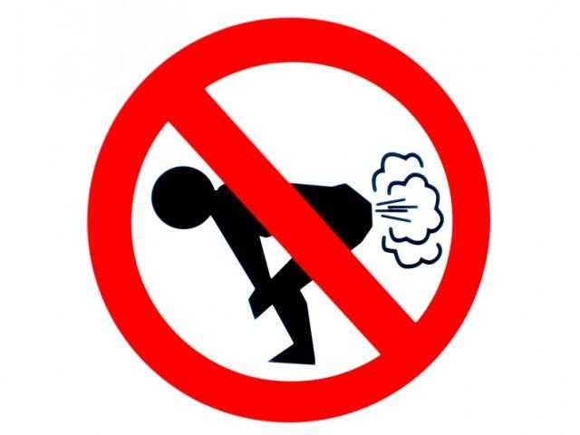

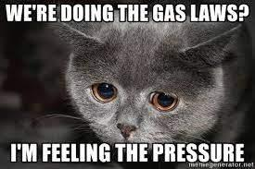
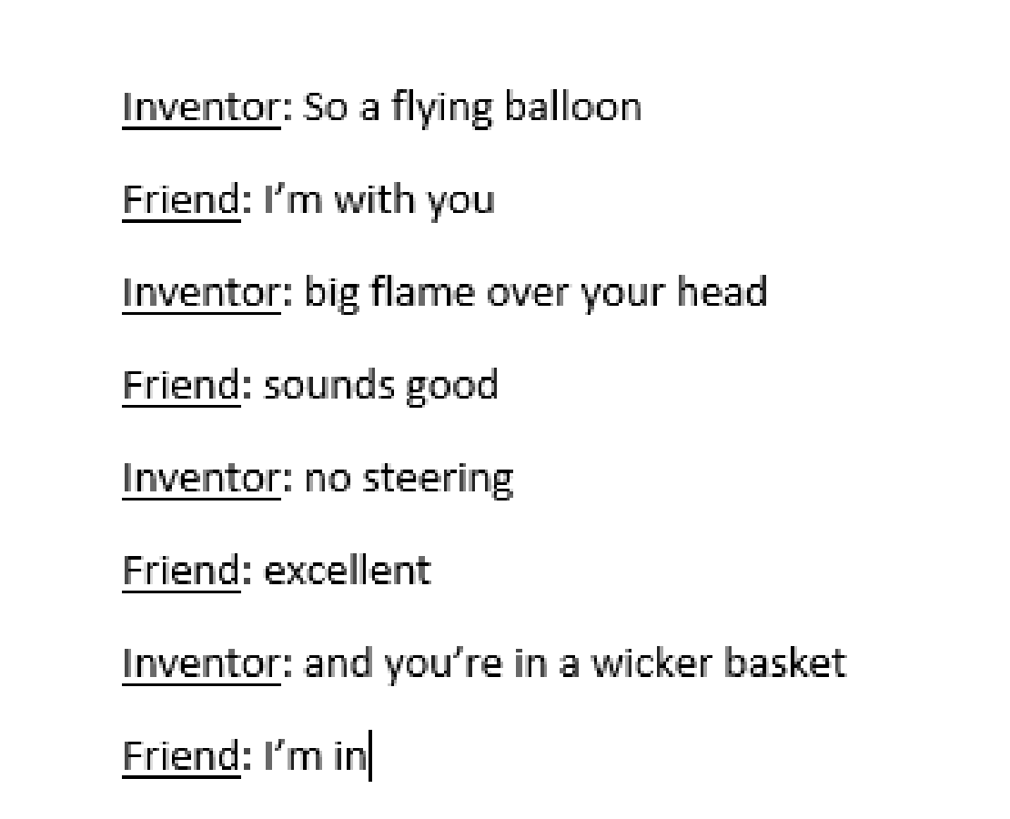
This Activity does not SUCK
How do suction cups work?

- Push the suction cup onto the table top and pull it off. Experiment with the amount of force used to push the suction cup down with. How does the force you use to push the suction cup down affect how difficult it is to pull the suction cup off?

- Push the suction cup onto the top of the lab bench and pull it off. Push the suction cup on the side of the lab bench and pull it off. Push the suction cup on a surface so it is upside down. Is it more, less, or the same difficulty to pull the suction cup off if it is pushed with the same force?

- What symbol(s) can we use to show the force on an object when we create models?

- What is another word for force on an object? For example, if your friend tried to force you to join a club in school, you would feel “peer _______.” Explain your choice.

- Gasses exert a force on everything they surround. You are just used to our atmospheric gasses held at 101.3kPa. Wave your hand near your face as if to cool off. That wind you made up of air particles. Why do you feel that force/wind? What are the particles doing to you?

- When the suction cup is sitting loosely on the desk, how does the behavior of gas particles outside of the suction cup compare to those inside the suction cup?

- Is there more pressure above the cup, below the cup, or equal when the cup is not “suctioned?”

- When you pressed the suction cup to the desk with force to “suction it on” what happened to the gas particles inside and outside of the suction cup? Did they move?

- When the suction cup is stuck to the desk, how does the behavior of gas particles outside of the suction cup compare to those inside the suction cup?

- Is there more pressure above the cup, below the cup, or equal when the cup is “suctioned” to a surface?

- Does the force of gravity play a role in how the suction cup works?

- Claim:On your white boards, draw the suction cup sitting on the table before the push, during the push, and after it is pushed onto the table. Compare your models with other teams. Draw your final model below. Consider the following:
  - There is air both above and below the cup
  - Air always has a pressure, shown by colliding arrows with surfaces
  - More arrows or thicker arrows can show a stronger force or pressure
  - Consider which surface of the cup has more pressure, or are they equal
  - Be sure to EXPLAIN BY DRAWING how the suction cup stays on a surface

Before push | During push | After push

- Reasoning: Explain in words how a suction cup works.

Class Demo: What happens when the suction cup is placed in the vacuum chamber?
- Describe what a vacuum chamber does when it is powered on.

- Describe what happened to the suction cup when the vacuum pump was powered on.

- Explain why the name suction cup is not an accurate name by describing what was actually happening to keep a cup stuck on a surface.

Energy Think Tank Problems
- Observe the demonstrations provided by your teacher and record observations in the table. Then create a model to help demonstrate your observations but at the particle level.
 | Gas Diffusion | Heat Diffusion in Liquids
Observation
Model
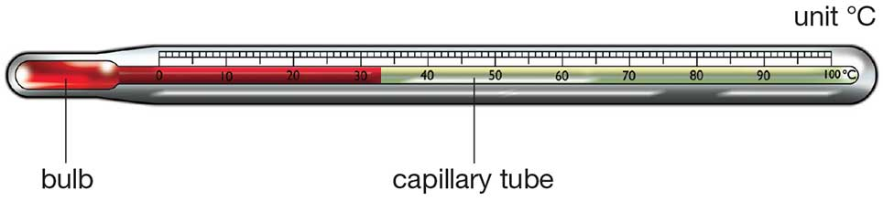
- Observe the thermometer diagram above.
  - When placed in hot water, what happens to the particles of the liquid (mercury or alcohol) in the bulb?

  - Why/how does the thermometer read a higher temperature when placed in hot water?

  - When placed in cold water, what happens to the particles of the liquid (mercury or alcohol) in the bulb?

  - Why/how does the thermometer read a lower temperature when placed in cold water?

  - If you feel feverish, why can't you take your own temperature with your hand?

  - Which would feel warmer to the touch - a bucket of water at 50˚C or a bathtub filled with water at 25˚C? Which of these stores more energy? Account for any differences in your answers to these questions.
Pressure Think Tank Problems
- Observe the demonstrations provided by your teacher and record observations in the table. Then create a model to help demonstrate your observations but at the particle level.
 | Bent Straw Before | Bent Straw After
Observation
Model
- What do we mean by atmospheric pressure? What causes this pressure?

- How do we measure atmospheric pressure? Is atmospheric pressure the same everywhere on the surface of the earth?

- Try to describe how a manometer works to determine the pressure of a gas at the particle level. Use the demonstration above as an analogy.
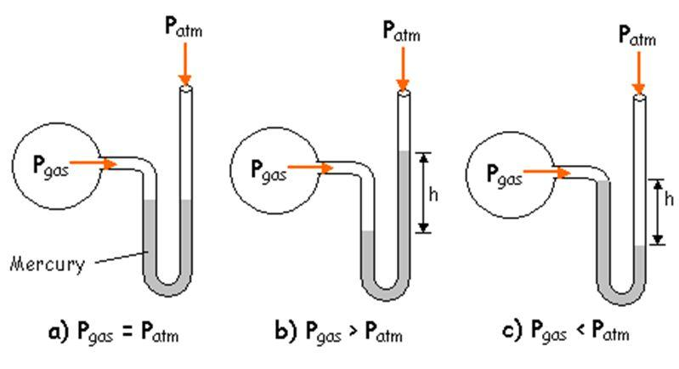

- Calculate the pressure of each gas:
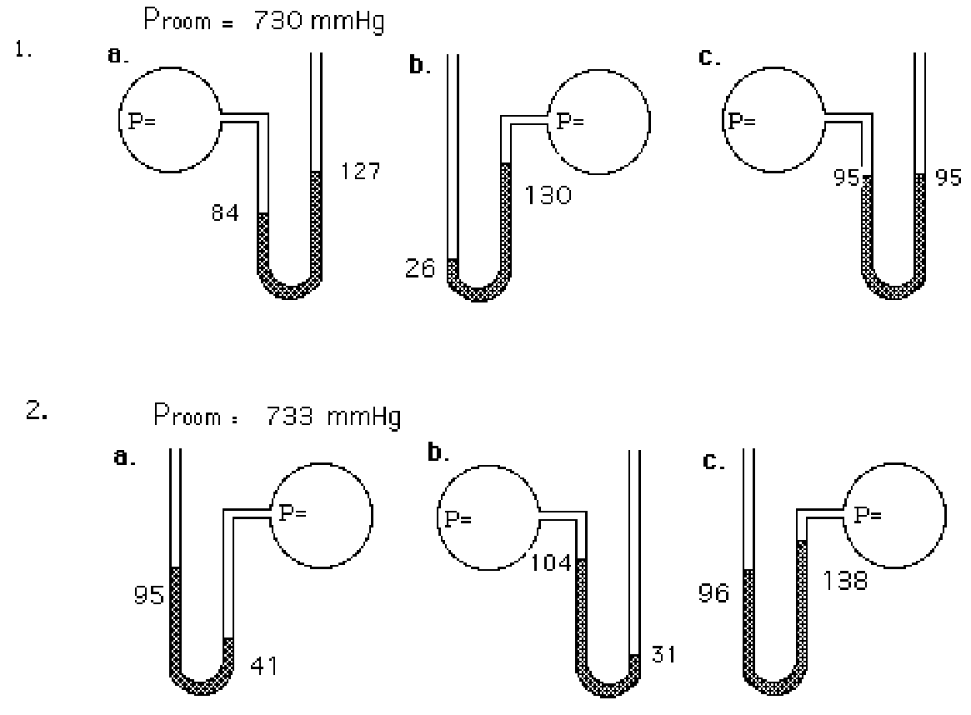

- One standard atmosphere of pressure (SP) is equivalent to mmHg.

- Convert pressure measurements from one system of units to another in the following problems.
a. 320 mmHg = __________________________________ atm
b. 30.0 atm = ______________ mmHg
c. The barometric pressure in Breckenridge, Colorado (elevation 9600 feet) is 580 mm Hg. How many atmospheres is this?

Check Your Understanding: Pressure Conversions

1 atmosphere is equal to ________ kPa = __________ mmHg = _________ torr

Convert the following to atmospheres: Convert the following to kilopascals:
- 560.0 mmHg 7. 1.2 atm

- 7600 mmHg 8. 0.86 atm

- 250.0 mmHg 9. 3.25 atm

- 202.6 kPa 10. 850 mmHg

- 50.6 kPa 11. 450.0 mmHg

- 150.0 kPa 12. 1560 mmHg

Kinetic Molecular Theory Think Tank Problems
- Kinetic Molecular Theory (KMT) describes how ideal gases behave. What does ideal mean? (For example, think about your ideal day off.)

- Based on the demonstration performed by your teacher, describe how “ideal” gas particles behave below.
Motion | Collisions
Volume | Attractions

- Draw models of gas particles in both low and high temperatures. Which seems more ideal?
low temperature | high temperature
- Draw models of gas particles in both low and high external pressures. Which seems more ideal?
low pressure | high pressure

- Under what conditions of Temperature and external Pressure can you get a real gas to behave the MOST like an ideal gas?

- Under what conditions of Temperature and external Pressure can you get a real gas to behave the LEAST like an ideal gas?

- Summarize your thoughts by completing the statement below:

Kinetic Molecular Theory is the study of real gases (such as water vapor, oxygen, and helium) which may behave ideally when they are held at ____________ temperatures and ______________ pressures.

- What could happen to the gas if it is held at extreme cold temperatures and high pressures?
Gas Laws Think Tank Problems

FILL IN THE BLANKS WITH INCREASE(S) OR DECREASE(S).

Boyle’s Law relates pressure and volume. When pressure is increased on a gas at constant temperature, the volume _____________________. This is an indirect relationship.
- Pilots suffer from intestinal pain when they fly because at higher altitudes, the pressure is decreased so the air volume in their body _______________________.
- Your lungs suck in air when the diaphragm is enlarged. When the diaphragm opens, the lung expands, the volume _______________ and the pressure ________________ which allows air in. When the diaphragm collapses, there is less room so the volume ___________ and the pressure _____________.
- Scuba divers need to be careful when checking their air tanks. When they descend in the water the water pressure increases and pushes on the tank. The tank air pressure increases and the volume of the air _______________. When they ascend to the surface, the pressure decreases and the volume of the gas in their tank and body _______________________.
- Why do your ears pop on an airplane? (Hint: the air pressure decreases at high altitudes.) Explain in terms of pressure and volume.

Charles’ Law relates volume and temperature. When temperature is increased on a gas at constant pressure, the volume _____________________. This is a direct relationship.
- Hot air balloons work based on density changes affected by Charles law. To rise, the temperature is __________________ and the volume ____________________ to make the density low. To come back down the fire is turned off so the temperature _______________ and volume ________________ so the density increases. The balloon is always inflated so the pressure is relatively constant.
- To un-dent ping pong balls, submerge them in hot water. Explain this phenomenon in terms of volume and temperature.

- A balloon outside in the winter seems to deflate but inside it re-inflates. However the number of gas particles stays constant. How does that happen? Explain in terms of volume and temperature.
Gay Lussac’s Law relates pressure and temperature. When temperature is increased on a gas at constant volume (in a rigid container), the pressure ______________ because the gas particles move more. This is a direct relationship.
- Drivers need to check the air pressure on their tires during the change of seasons. In the winter the temperatures are decreased, the pressure inside the tires is ____________________ and the tires are flat. In the summer temperatures are increased and pressures are__________________ so the tires are swollen. But the volume the tires air can occupy stays the same.
- Don’t put aerosol spray cans in direct heat or flames because they explode. Explain this phenomenon in terms of pressure and temperature.

Check Your Understanding: Gases Regents Questions
- Which term is defined as a measure of the average kinetic energy of the particles in a sample?

  - temperature B) pressure C) thermal energy D) chemical energy

- At which temperature would particles of a He(g) sample have the greatest average kinetic energy?
A) 25°C B) 37°C C) 273 K D) 298 K

- The average kinetic energy of water particles is greatest in which of these samples?
  - 10 g of water at 35°C C) 10 g of water at 55°C
  - 100 g of water at 25°C D) 100 g of water at 45°C

- Which change in the temperature of a 1-gram sample of water would cause the greatest increase in the average kinetic energy of its particles?
  - 1°C to 10°C B) 10°C to 1°C C) 50°C to 60°C D) 60°C to 50°C

- What is the equivalent of 0 Kelvin on the Celsius scale?
A) –100º B) 100º C) –273º D) 273º

- The temperature of a sample of a substance changes from 10.°C to 20.°C. How many Kelvin does the temperature change? A) 10. B) 20. C) 283 D) 293

- The temperature 30. K expressed in degrees Celsius is
A) 243ºC B) –243ºC C) 303ºC D) –303ºC

- Which temperature is equal to +20 K?
A) –253ºC B) –293ºC C) 253°C D) 293°C

- Which Kelvin temperature is equal to –73ºC?
A) 100 K B) 173 K C) 200 K D) 346 K
- Under which conditions of temperature and pressure would He behave most like an ideal gas?
  - 50 K and 20 kPa B) 50 K and 600 kPa C) 750 K and 20 kPa D) 750 K and 600 kPa

- The kinetic molecular theory assumes that the particles of an ideal gas
  - are in random, constant, straight-line motion
  - are arranged in a regular geometric pattern
  - have strong attractive forces between them
  - have collisions that result in the system losing energy

- Under which conditions does a real gas behave most like an ideal gas?
  - at low temperatures and high pressures C) at low temperatures and low pressures
  - at high temperatures and high pressures D) at high temperatures and low pressures

- An assumption of the kinetic theory of gases is that the particles of a gas have

  - little attraction for each other and a significant volume
  - little attraction for each other and an insignificant volume
  - strong attraction for each other and a significant volume
  - strong attraction for each other and an insignificant volume

- According to the kinetic theory of gases, which assumption is correct?
  - Gas particles strongly attract each other.
  - Gas particles travel in curved paths.
  - The volume of gas particles prevents random motion.
  - Energy may be transferred between colliding particles.

- When a sample of a gas is heated at constant pressure, the average kinetic energy of its particles
  - decreases, and the volume of the gas increases
  - decreases, and the volume of the gas decreases
  - increases, and the volume of the gas increases
  - increases, and the volume of the gas decreases

- Under which conditions of temperature and pressure would a sample of H₂(g) behave most like an ideal gas?
  - 0°C and 100 kPa B) 0°C and 300 kPa C) 150°C and 100 kPa D) 150°C and 300 kPa

- A real gas differs from an ideal gas because the particles of real gas have
  - some volume and no attraction for each other
  - some volume and some attraction for each other
  - no volume and no attraction for each other
  - no volume and some attraction for each other
PVTn Think Tank Problems

- For each of the variables below, draw models to describe how gas particles may change as the variable changes. Use one puff of gas = 5 particles for each model.
  - Volume of a gas at low temperature and high temperature (constant pressure-balloon)

  - Pressure of a gas at low temperature and high temperature (constant volume-closed box)

  - Pressure of a gas at low volume and high volume (constant temperature-balloon)

- For each of the variables below, draw models to describe how gas particles may change as the variable changes. Use one puff of gas = 5 particles and multiply to determine how many particles for each model.
  - Volume of a gas with 1 puff and 2 puffs added (constant pressure-balloon)

  - Pressure of a gas with 1 puff and 2 puffs added (constant volume-closed box)
Gas Calculations

For the following calculation questions, if variables are held constant their boxes can be ignored or crossed out. Fill in the initial and final conditions using the prompt below. Identify how the given variable has changed to determine how the unknown variable will change. Then set up a proportion in the space to the right to verify your ratios and solve the question.

- What would be the final pressure if initially 300 cm³ volume of gas at standard pressure is compressed to a final volume of 150 cm³ ? (n and T = constant)
 | P | T | V | n
Initial
Final
Effect

- A sample of gas initially occupies 300 mL at 100K. What is its final volume when the temperature is increased to 200K? (P and n = constant)
 | P | T | V | n
Initial
Final
Effect

- A gas is initially held at 27˚C and 600 mmHg. If the pressure changed to 300 mmHg what is the final temperature? (n and V= constant)

 | P | T | V | n
Initial
Final
Effect
- Sam’s bike tire contains 20 units of air particles and the pressure reads 30 psi. The tire develops a leak. Now it contains 10 units of air. What would be the new tire pressure?
 | P | T | V | n
Initial
Final
Effect
- A closed flask of air contains 4.0 “puffs” of particles. The pressure probe on the flask reads 100 kPa. A student uses a syringe to add an additional 4.0 “puffs” of air through the stopper. Find the new pressure inside the flask.
 | P | T | V | n
Initial
Final
Effect
- A 500 mL sample of gas has a temperature of 27˚C and a pressure of 1.00 atm. What temperature would be needed for the same amount of gas to fit into a 250 mL flask at standard pressure?
 | P | T | V | n
Initial
Final
Effect
- A 1000 cm³ sample of gas at standard temperature and pressure is allowed to expand until it occupies a volume of 2000. cm³. What temperature would be needed to return the gas to standard pressure?
 | P | T | V | n
Initial
Final
Effect

Combined Gas Law Think Tank Problems
- Using the work you have completed in the handouts before, determine the relationship between each variable set (direct, inverse) and show a sample set up of a calculation using the variables. The first is done for you.

 | relationship | calculation
volume and temperature | direct | V₁/T₁ = V₂/T₂
volume and pressure
pressure and temperature

- Record the combined gas law equation on Table T of the reference tables.

- Compare and contrast the variables identity and locations in the calculations you created in question 1 and the combined gas law recorded in question 2.

- What units could be used for each variable:
  - volume

  - pressure

  - temperature

Combined Gas Law Check For Understanding
- If the temperature of a 50mL sample of a gas is changed from 200K to 400K under constant pressure, what is the new volume of the gas?

- The volume of a gas is 204mL when the pressure is 925kPa. At constant temperature, what is the final pressure if the volume increases to 306ml?

- When extended, a bike pump has a volume of 0.952dm³ at standard pressure. Assuming the temperature is constant, what is the new pressure if the volume changes to 0.225dm³?

- A balloon has a volume of 1.75L at a temperature of 298K. What will be the volume of the balloon if you take it out into the winter cold air at 258K? Assume pressure is constant.

- A 1.53L sample of sulfur (IV) oxide at a pressure of 5.60kPa. If the pressure is changed to 15.0kPa at constant temperature, what will be the new volume of the gas? Assume temperature is constant.

- The Hindenburg exploded in 1937. It held 2.0x10⁵ m³ of hydrogen gas at 23C at standard pressure. How much gas would that be at standard pressure on a warm day of 45C?

- An aerosol spray can with a volume of 456mL contains 3.18g of propane gas as a propellant. If the can is at 23C, and 0.50atm, what volume would the propane occupy at STP?

- Suppose the P and T was tripled on a 6.0L sample of a gas. What is the new volume?

- A gas has a volume of 50.0 mL at a temperature of 10.0 K and a pressure of 760. kPa. What will be the new volume when the temperature is changed to 20.0 K and the pressure is changed to 380. kPa?

- The volume of a sample of a gas at 273 K is 100.0 L. If the volume is decreased to 50.0 L at constant pressure, what will be the new temperature of the gas?

- A gas has a volume of 2.00 L at 323 K and 3.00 atm. What will be the new volume if the temperature is changed to 273 K and the pressure is changed to 1.00 atm?

- What will be the new volume of 100. mL of gas if the Kelvin temperature and the pressure are both halved?

- A gas occupies a volume of 500. mL at a pressure of 380. kPa and a temperature of 298 K. At what temperature will the gas occupy a volume of 250. mL and have a pressure of 760. kPa?

- A gas at STP has a volume of 1.00 L. If the pressure is doubled and the temperature remains constant, what is the new volume of the gas?

- A 2.5 L sample of gas is at STP. When the temperature is raised to 373°C and the pressure remains constant what will the new volume of the gas be?

- A cylinder of a car’s engine has a volume of 0.725 L when the piston is at the bottom of the cylinder. When the piston is at the top of the cylinder it has a volume of 0.050L. If the cylinder is filled with air at a pressure of 1 atm when the piston is at the bottom, what is the pressure when the piston is at the top if the temperature remains constant?

- A sample of gas is held at constant pressure. Increasing the kelvin temperature of this gas sample causes the average kinetic energy of its particles to
  - decrease and the volume of the gas sample to decrease
  - decrease and the volume of the gas sample to increase
  - increase and the volume of the gas sample to decrease
  - increase and the volume of the gas sample to increase

- A sample of helium gas has a volume of 900. milliliters and a pressure of 2.50 atm at 298 K. What is the new pressure when the temperature is changed to 336 K and the volume is decreased to 450. milliliters?
  - 0.177 atm b. 4.43 atm c. 5.64 atm d. 14.1 atm

- A gas occupies a volume of 444 mL at 273 K and 79.0 kPa. What is the final kelvin temperature when the volume of the gas is changed to 1880 mL and the pressure is changed to 38.7 kPa?
  - 31.5 K b. 292 K c. 566K d. 2360K

Avogadro’s Law Think Tank Problems

- Imagine you were tasked to place tennis balls all around the gym. You should place a ball ten steps from the wall, then walk ten more steps and place another ball, repeat until the gym is covered with balls. How many tennis balls might fit in the gym?

- Repeat question 1 but with large beach volley balls. Explain your reasoning with a model and/or description.

- Draw a model of two same sized closed containers at the same temperature and pressure. Container 1 should have one puff (5 particles) of helium and container 2 should have one puff of water vapor. Identify similarities and differences in the gases inside the containers.

Check For Understanding: Regents Questions

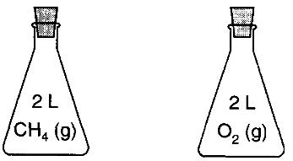
- A sample of oxygen gas is sealed in container X. A sample of hydrogen gas is sealed in container Z. Both samples have the same volume, temperature, and pressure. Which is true?
  - Container X contains more gas particles than container Z.
  - Container X contains fewer gas particles than container Z.
  - Containers X and Z both contain the same number of gas particles.
  - Containers X and Z both contain the same mass of gas.

- Each stoppered flask to the right contains 2 liters of a gas at STP. Each gas sample has the same

  - Density B) mass C) number of particles

- A sample of H₂(g) and a sample of N₂(g) at STP contain the same number of particles. Each sample must have
  - the same volume, but a different density
  - different volumes but the same density
  - the same volume and same density
  - neither the same volume nor the same density

- The diagrams below represent three 1-liter containers of gas, A, B, and C. Each container is at STP.
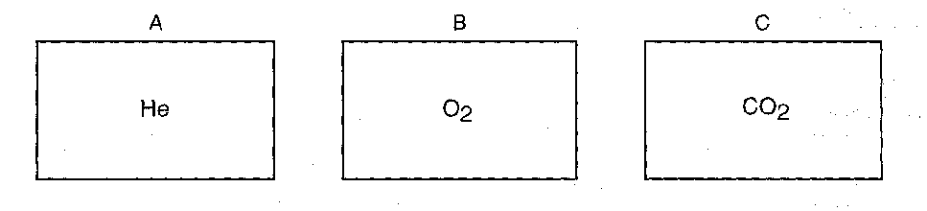
Which statement correctly compares the number of particles in the containers?
  - Container A has the greatest number of particles.
  - Container B has the greatest number of particles.
  - Container C has the greatest number of particles.
  - All three containers have the same number of particles.
Dalton’s Law Think Tank Problems

- Draw models that represent:
  - one puff of helium gas (5 particles) in a 1L container at 273K and 1atm
  - two puffs of neon gas in a 1L container at 273K and 1atm
  - three puffs of gas: one of helium, two of neon at 273K. This is a combination of containers a and b.
a | b | c

  - What do you think the pressure is inside container c? Explain your reasoning.

Check Your Understanding: Regents Questions

- What is the pressure of a mixture of CO₂, SO₂, and H₂O gases, if each gas has a partial pressure of 25 kPa?
  - 25 kPa B) 50 kPa C) 75 kPa D) 101 kPa

- A flask contains a mixture of N₂(g) and O₂(g) at STP. If the partial pressure exerted by the N2(g) is 40.0 kPa, the partial pressure of the O₂(g) is
  - 21.3 kPa B) 37.3 kPa C) 61.3 kPa D) 720 kPa

- Gas samples A, B, and C are contained in a system at STP. The partial pressure of sample A is 38.0 kPa and the partial pressure of sample B is 19.0 kPa. What is the partial pressure of sample C?
  - 19.0 kPa B) 38.0 kPa C) 44.3 kPa D) 63.3 kPa

- The partial pressures of gases A, B, and C in a mixture are 0.750 atmosphere, 0.250 atmosphere, and 1.25 atmospheres, respectively. What is the total pressure of the gas mixture in kPa?
  - 2.25 kPa B) 202 kPa C) 228 kPa D) 301 kPa

- A mixture of oxygen, nitrogen, and hydrogen gases exerts a total pressure of 74 kPa at 0ºC. The partial pressure of the oxygen is 20 kPa and the partial pressure of the nitrogen is 40 kPa. What is the partial pressure of the hydrogen gas in this mixture?
  - 14 kPa B) 20 kPa C) 40 kPa D) 74 kPa
Review

Think of energy as a quantity that is always involved when there is a change in the state of matter. When a substance gets hotter or colder or changes phase, energy is either transferred into or out of the system. One way energy is stored in a system is thermal energy (due to the motion of the particles). As particles move faster, their thermal energy increases. As the particles move faster, they tend to move farther apart from one another. Temperature is a measure of the thermal energy of the system.
- Explain why the alcohol level in a thermometer rises when it is placed in a warmer fluid.

- Explain why the alcohol level in a thermometer falls when it is placed in a cooler fluid.

- Explain how the Celsius scale was devised and why it is not appropriate to use it when describing the behavior of gases.

The Kinetic Molecular Theory describes all matter as being composed of tiny particles in endless random motion. In a solid, the particles vibrate, but are locked into an orderly array. In a liquid, the particles are still touching but are free to move around past one another. In a gas, the particles are moving very rapidly and are widely separated. gases are spread out and constantly moving in random straight line motion. Ideal gases have no mass, no volume, and no attractive forces.
- Using particle diagrams represent samples of a cold gas and a hot gas.

- Draw models to represent real versus ideal gases.

- Under what conditions of temperature and pressure will a gas behave ideally?

Volume is the amount of space a substance takes up. Temperature is the measure of kinetic energy a sample has measured in degrees Celsius or Kelvin. Standard temperature and pressures are listed on Table A. The calculation formula is on table T. Gas pressure is a measure of the collisions of the particles with the sides of the container. A barometer is used to measure atmospheric pressure; a manometer is used to measure the pressure in a container. Any factor that affects the number of collisions has an effect on the pressure.
- What are the possible values for standard temperature? _____________ and _______________
- What are the possible values for standard pressure? _____________ and _______________
- When pressure increases, volume ____________________.
- When pressure increases, temperature _______________________.
- When temperature increases, volume ____________________.
- The pressure of a gas is 1.2 atm at 300K. Calculate the pressure at 250K if the gas is in a rigid container.

- The volume of a gas at 500K is 50.6L. Calculate the volume at 750K.Suppose that you lowered the temperature of a gas from 100˚C to 50 ˚C, would the volume of the gas decrease by half as well? Explain.

- Suppose that 25.0 mL of a gas at 725 mm Hg and 20˚C is converted to standard pressure and temperature. What would be the new volume?

- A 1.5L sample of a gas at 150kPa and 250K is changed to STP. What is the new volume?

- Sketch graphs to represent the following relationships:
  - Pressure and volume
  - Pressure and temperature
  - Volume and temperature

Avogadro’s Law states that two different gases at the same temperature, pressure and volume must have the same number of particles.

- Which sample would have the same number of particles as 11.2L of He (g) at 273K and 202kPa?
  - 11.2L of N₂(g) at 300K and 202kPa
  - 22.4L of Ne(g) at 546K and 404K
  - 11.2L of CH₄(g) at 273K and 202kPa
- At what volume will 22.4L of O₂ (g) at 303K and 1.2atm have the same number of particles as Neon gas at 303K and 1.2atm?

Gas Laws
What do the dots in Model 1 represent?

If the containers were flexible like a balloon, would the values in model one be the same?

In experiment A, what are the dependent and independent variables?

In experiment A, what are the constants?

In experiment A, how are the dependent and independent variables related to one another?

- In experiment B, what are the dependent and independent variables?

- In experiment B, what are the constants?

- In experiment B, how are the dependent and independent variables related to one another?

- The length of the arrows represents the amount of Kinetic Energy the particles have. Why are all arrows in experiment A the same size and arrows in experiment B increase in size?

- The containers in Model 1 are “nonflexible.” What does this mean? What could they be made out of?

- If the containers in Model 1 were flexible like a balloon, draw a representation for experiment A.

- If the containers in Model 1 were flexible like a balloon, draw a representation for experiment B.
- Compare your representation in question 11 with experiment C in Model 2.

- Compare your representation in question 12 with experiment D in Model 2.

- What are the independent and dependent variables in experiment E in Model 2?

- What are the constants in experiment E?

- What is the relationship between the variables in experiment E?

- Compare the internal and external pressures in the balloons of experiments C-E.

- Compare the internal and external pressures in each container of experiments A-B.

- Summarize the findings from these experiments:
Experiment | Independent variable | Dependent variable | Relationship
A
B
C
D
E

