AP Learning Objectives:
- Explain the relationship between the chemical structures of molecules and the relative strength of their intermolecular forces when: a. The molecules are of the same chemical species. b. The molecules are of two different chemical species. (3.1)
- Explain the relationship among the macroscopic properties of a substance, the particulate-level structure of the substance, and the interactions between these particles.(3.2)
- Represent the differences between solid, liquid, and gas phases using a particulate level model.(3.3)
- Explain the relationship between the macroscopic properties of a sample of gas or mixture of gases using the ideal gas law. (3.4)
- Explain the relationship between the motion of particles and the macroscopic properties of gases with: a. The kinetic molecular theory (KMT). b. A particulate model. c. A graphical representation.(3.5)
- Explain the relationship among non-ideal behaviors of gases, interparticle forces, and/or volumes.(3.6)
- Calculate the number of solute particles, volume, or molarity of solutions.(3.7)
- Using particulate models for mixtures: a. Represent interactions between components. b. Represent concentrations of components. (3.8)
- Explain the relationship between the solubility of ionic and molecular compounds in aqueous and nonaqueous solvents, and the intermolecular interactions between particles. (3.9)
- Explain the relationship between the solubility of ionic and molecular compounds in aqueous and nonaqueous solvents, and the intermolecular interactions between particles. (3.10)
- Explain the relationship between a region of the electromagnetic spectrum and the types of molecular or electronic transitions associated with that region. (3.11)
- Explain the properties of an absorbed or emitted photon in relationship to an electronic transition in an atom or molecule.(3.12)
- Explain the amount of light absorbed by a solution of molecules or ions in relationship to the concentration, path length, and molar absorptivity(3.13)
- Represent changes in matter with a balanced chemical or net ionic equation: a. For physical changes. b. For given information about the identity of the reactants and/or product. c. For ions in a given chemical reaction. (4.2)
- Explain the relationship between macroscopic characteristics and bond interactions for: a. Chemical processes. b. Physical processes.(4.4)
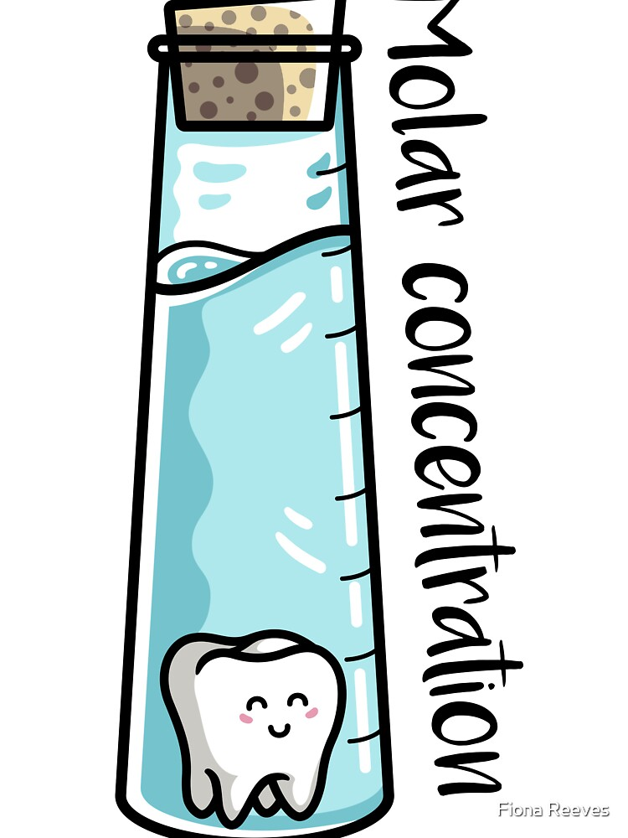
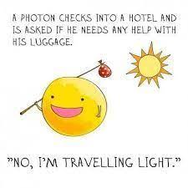

KMT Review
- Kinetic Molecular Theory (KMT) describes how ideal gases behave. What does ideal mean? (For example, think about your ideal day off.)

- Based on the demonstration performed by your teacher, describe how “ideal” gas particles behave below.
Motion | Collisions
Volume | Attractions

- Draw models of gas particles in both low and high temperatures. Which seems more ideal?
low temperature | high temperature

- Draw models of gas particles in both low and high external pressures. Which seems more ideal?
low pressure | high pressure

- Under what conditions of Temperature and external Pressure can you get a real gas to behave the MOST like an ideal gas?

- Under what conditions of Temperature and external Pressure can you get a real gas to behave the LEAST like an ideal gas?

- Summarize your thoughts by completing the statement below:
Kinetic Molecular Theory is the study of real gases (such as water vapor, oxygen, and helium) which may behave ideally when they are held at ____________ temperatures and ______________ pressures.

- What could happen to the gas if it is held at extreme cold temperatures and high pressures?
Combined Gas Law Review

- If the temperature of a 50mL sample of a gas is changed from 200K to 400K under constant pressure, what is the new volume of the gas?

- The volume of a gas is 204mL when the pressure is 925kPa. At constant temperature, what is the final pressure if the volume increases to 306ml?

- A 1.53L sample of sulfur (IV) oxide at a pressure of 5.60kPa. If the pressure is changed to 15.0kPa at constant temperature, what will be the new volume of the gas? Assume temperature is constant.

- An aerosol spray can with a volume of 456mL contains 3.18g of propane gas as a propellant. If the can is at 23C, and 0.50atm, what volume would the propane occupy at STP?

- A gas has a volume of 50. mL at a temperature of 10.0 K and a pressure of 760. kPa. What will be the new volume when the temperature is changed to 20.0 K and the pressure is changed to 380. kPa?

- The volume of a sample of a gas at 273 K is 100.0 L. If the volume is decreased to 50.0 L at constant pressure, what will be the new temperature of the gas?

- A gas has a volume of 2.00 L at 323 K and 3.00 atm. What will be the new volume if the temperature is changed to 273 K and the pressure is changed to 1 atm?

- A gas occupies a volume of 500. mL at a pressure of 380. kPa and a temperature of 298 K. At what temperature will the gas occupy a volume of 250. mL and have a pressure of 760. kPa?

Graham’s Law of Diffusion Review

- At STP, which gas diffuses at the faster rate?
A) H₂ B) N₂ C) CO₂ D) NH₃

- Under the same conditions of temperature and pressure, which gas will diffuse at the slowest rate?
  - He B) Ne C) Ar D) Rn

- Which gas would diffuse most rapidly under the same conditions of temperature and pressure?
  - gas A, molecular mass = 4 C) gas B, molecular mass = 16
  - gas C, molecular mass = 36 D) gas D, molecular mass = 49

- Arrange the following gas in order of increasing average molecular speed at 25C: He, O₂, CO₂, H₂O.

Avogadro’s Law Review

- A sample of oxygen gas is sealed in container X. A sample of hydrogen gas is sealed in container Z. Both samples have the same volume, temperature, and pressure. Which statement is true?
  - Container X contains more gas molecules than container Z.
  - Container X contains fewer gas molecules than container Z.
  - Containers X and Z both contain the same number of gas molecules.
  - Containers X and Z both contain the same mass of gas.

- At the same temperature and pressure, 1.0 liter of CO(g) and 1.0 liter of CO2(g) have
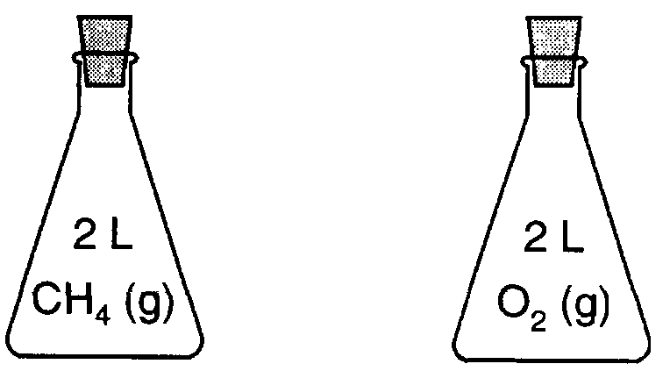
  - equal masses and the same number of molecules
  - different masses and a different number of molecules
  - equal volumes and the same number of molecules
  - different volumes and a different number of molecules

- Each stoppered flask to the right contains 2 liters of a gas at STP. Each gas sample has the same

  - Density B) mass C) number of molecules D) number of atoms

Dalton’s Law of Partial Pressures Review

- Draw models that represent:
  - one puff of helium gas (5 particles) in a 1L container at 273K and 1atm
  - two puffs of neon gas in a 1L container at 273K and 1atm
  - three puffs of gas: one of helium, two of neon at 273K. This is a combination of containers a and b.
a | b | c

  - What do you think the pressure is inside container c? Explain your reasoning.

- What is the pressure of a mixture of CO₂, SO₂, and H₂O gases, if each gas has a partial pressure of 25 kPa?
  - 25 kPa B) 50 kPa C) 75 kPa D) 101 kPa

- A flask contains a mixture of N₂(g) and O₂(g) at STP. If the partial pressure exerted by the N₂(g) is 40.0 kPa, the partial pressure of the O₂(g) is
  - 21.3 kPa B) 37.3 kPa C) 61.3 kPa D) 720 kPa

- Gas samples A, B, and C are contained in a system at STP. The partial pressure of sample A is 38.0 kPa and the partial pressure of sample B is 19.0 kPa. What is the partial pressure of sample C?
  - 19.0 kPa B) 38.0 kPa C) 44.3 kPa D) 63.3 kPa

- The partial pressures of gases A, B, and C in a mixture are 0.750 atmosphere, 0.250 atmosphere, and 1.25 atmospheres, respectively. What is the total pressure of the gas mixture in kPa?
  - 2.25 kPa B) 202 kPa C) 228 kPa D) 301 kPa

- A mixture of oxygen, nitrogen, and hydrogen gases exerts a total pressure of 74 kPa at 0ºC. The partial pressure of the oxygen is 20 kPa and the partial pressure of the nitrogen is 40 kPa. What is the partial pressure of the hydrogen gas in this mixture?
  - 14 kPa B) 20 kPa C) 40 kPa D) 74 kPa

- A mixture of gases contains 0.75mol nitrogen, 0.30mol oxygen, and 0.15 mol of carbon dioxide. If the total pressure is 2.3atm, what are the partial pressures?

Maxwell-Boltzmann Distributions

Model 1 — Graphing Particle Speeds at Different Temperatures: The diagram below on the left shows a collection of gas particles in a rigid container. The speed of each particle is shown. The diagram to the right shows the same sample of particles heated using a lab burner.
COLD HOT

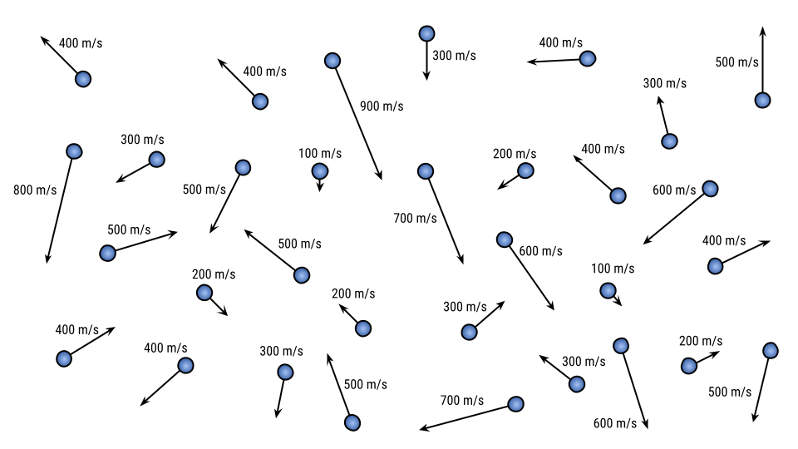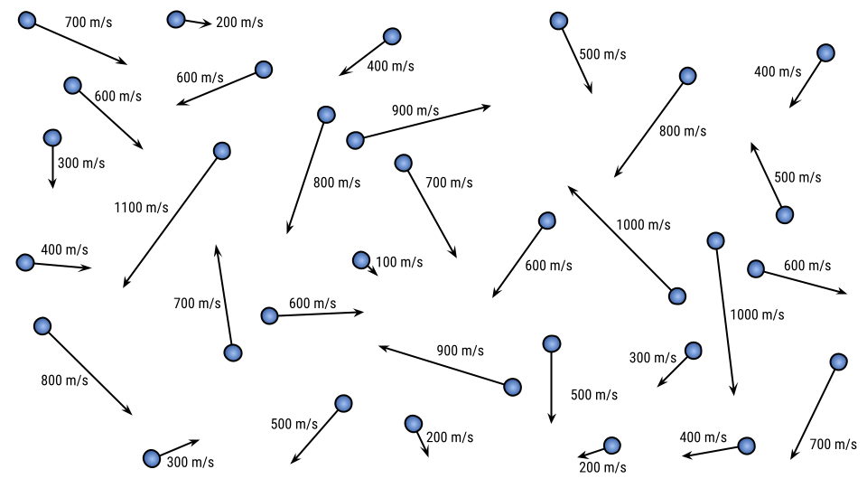
- Create a line graph that shows the number of particles moving at each particle speed for the cold gas. Then also plot a curved line for the hot gas speeds.
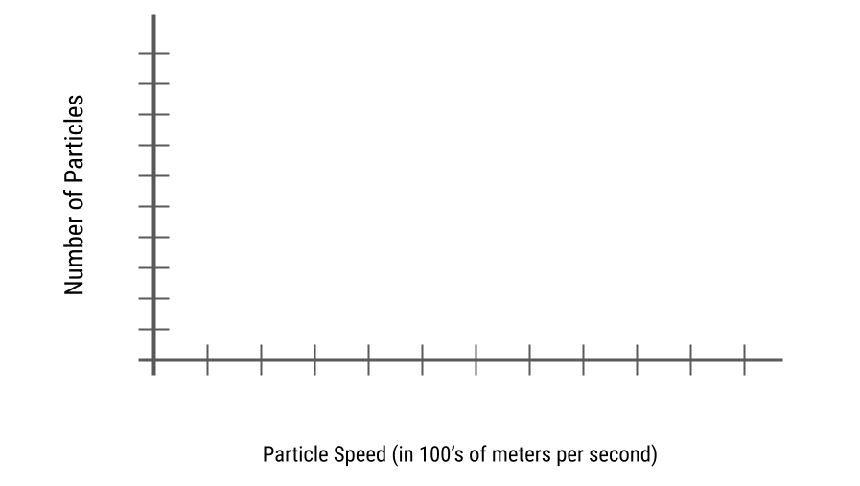
- What do you notice about the particle speeds after being heated? Also, are there still slow particles?

- What do you notice about how the graph has shifted after heating? What happened to the peak height and location? What is the same about the number of particles?

Model 2 — Graphing Particle Speeds for Particles of Different Mass: Here is another sample of gas particles. Each particle has four times the mass of the particles from Model 1. However, the temperature of this sample of particles is actually nearly exactly the same as the cold particles in Model 1.
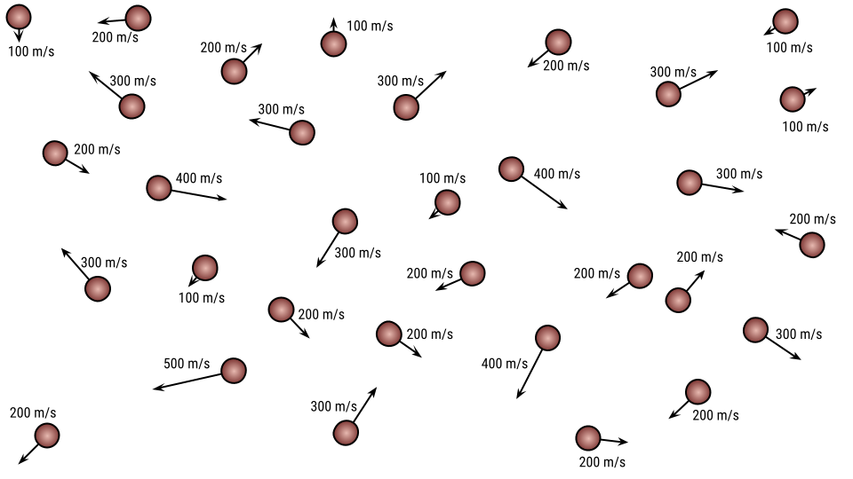

- Create two Maxwell-Boltzmann distributions on the graph below, one for the less-massive particles (Model 1) and one for the more-massive particles (Model 3). Label the curves “less massive” and “more massive.”
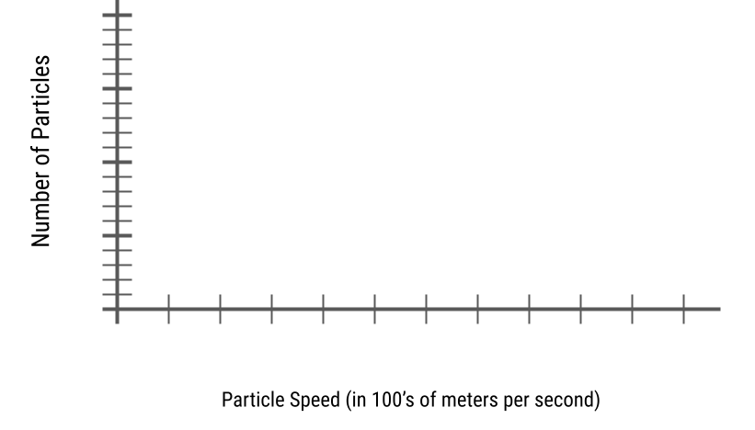
- Keeping in mind that temperature is a measure of the average kinetic energy of a collection of particles, and that KE_{average} = ½ mv², explain how these particles could have the same temperature of the particles in Model 1 even though their speeds are much slower.

Ideal Gas Law

- A 7.8g piece of solid carbon dioxide is placed in a 4.0L container at 27 degrees Celsius. What is the pressure in atmospheres in the container after all the carbon dioxide vaporizes?

- Automobile air bags inflate when sodium azide (NaN₃) decomposes into its elements. If 97.5g of sodium azide are added to an air bag that will inflate to a volume of 0.30L and heat up to 100.°C, then what is the pressure exerted on the bag by the nitrogen gas produced in the reaction?

- Using the Haber process to produce ammonia gas, you can obtain the greatest yield of ammonia at high temperatures and pressures, but it is dangerous, so lower T and P is used. Typically, the Haber process is performed at 500.°C and 250. atmospheres. Assuming the reaction goes to completion, what volume would ammonia occupy if 21.0g of nitrogen is reacted with excess hydrogen?

- The Hindenburg exploded in 1937. It held 2.0x10⁵ m³ of hydrogen gas at 23C and standard pressure. What mass of hydrogen was present?

- A scuba diver's tank contains 0.29kg of oxygen compressed into a volume of 2.3L. What is the pressure in the tank at 9.0°C?

Ideal Gas Law with Density

- What is the density of nitrogen gas at 1.50atm and 298K?

- What is the density of NO₂ gas at 0.970 atm and 35C?

- Which gas is most dense at 1.00atm and 298K? CO₂, N₂O, or Cl₂?

- A 44.8L balloon is filled with Helium with a pressure of 1atm at 25C. What is the density of the gas?

- An AP student decided to bribe me with cookies for a better grade. He allowed the yeast to ferment so the dough would rise. If 200.0g of glucose (sugar) is used at standard pressure and 30C what is the volume of carbon dioxide gas produced? What is the density?

AP Gas Problems

1. Observations about real gases can be explained at the molecular level according to the kinetic molecular theory of gases and ideas about intermolecular forces. Explain how each of the following observations can be interpreted according to these concepts, including how the observation supports the correctness of these theories.
(a) When a gas-filled balloon is cooled, it shrinks in volume; this occurs no matter what gas is originally placed in the balloon.

(b) When the balloon described in (a) is cooled further, the volume does not become zero; rather, the gas becomes a liquid or solid.

(c) When NH₃ gas is introduced at one end of a long tube while HCl gas is introduced simultaneously at the other end, a ring of white ammonium chloride is observed to form in the tube after a few minutes. This ring is closer to the HCl end of the tube than the NH₃ end.

2. A student collected a sample of hydrogen gas by the displacement of water as shown by the diagram above. The relevant data are given in the following table.
GAS SAMPLE DATA
Volume of sample | 90.0 mL
Temperature | 25°C
Atmospheric Pressure | 745 mm Hg
Equilibrium Vapor Pressure of H₂O (25°C) | 23.8 mm Hg
(a) Calculate the number of moles of hydrogen gas collected.

(b) Calculate the number of molecules of water vapor in the sample of gas.

(c) Explain the ratio of the average speed of the hydrogen molecules to the average speed of the water vapor molecules in the sample.

(d) Which of the two gases, H₂ or H₂O, deviates more from ideal behavior? Explain your answer.

3. 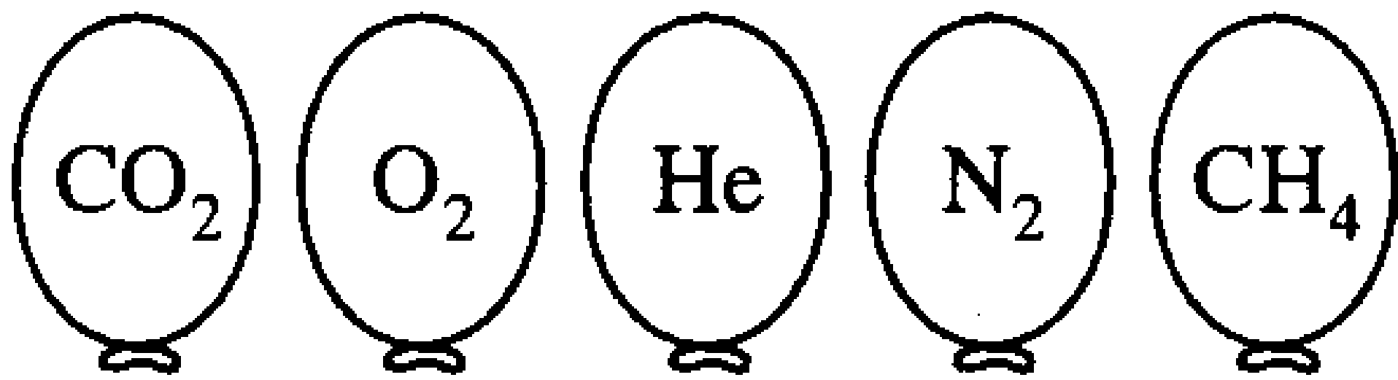

Represented above are five identical balloons, each filled to the same volume at 25°C and 1.0 atmosphere pressure with the pure gases indicated.
(a) Which balloon contains the greatest mass of gas? Explain.

(b) Compare the average kinetic energies of the gas molecules in the balloons. Explain.

(c) Which balloon contains the gas that would be expected to deviate most from the behavior of an ideal gas? Explain.

(d) Twelve hours after being filled, all the balloons have decreased in size. Predict which balloon will be the smallest. Explain your reasoning.

AP Chemistry: Gases Multiple Choice
21. When a sample of oxygen gas in a closed container of constant volume is heated until its absolute temperature is doubled, which of the following is also doubled?
(A) The density of the gas (B) The pressure of the gas (C) The average velocity of the gas
(D) The number of molecules per cm³ (E) The potential energy of the molecules
23. The density of an unknown gas is 4.20 grams per liter at 3.00 atmospheres pressure and 127 °C. What is the molecular weight of this gas? (R = 0.0821 L-atm / mole-K)
(A) 14.6 (B) 46.0 (C) 88.0 (D) 94.1 (E) 138
39. Equal masses of three different ideal gases, X, Y, and Z, are mixed in a sealed rigid container. If the temperature of the system remains constant, which of the following statements about the partial pressure of gas X is correct?
(A) It is equal to 1/3 the total pressure
(B) It depends on the intermolecular forces of attraction between molecules of X, Y, and Z.
(C) It depends on the relative molecular masses of X, Y, and Z.
(D) It depends on the average distance traveled between molecular collisions.
(E) It can be calculated with knowledge only of the volume of the container.
50. Two flexible containers for gases are at the same temperature and pressure. One holds 0.50 grams of hydrogen and the other holds 8.0 grams of oxygen. Which of the following statements regarding these gas samples is FALSE?
(A) The volume of the hydrogen container is the same as the volume of the oxygen container.
(B) The number of molecules in the hydrogen container is the same as the number of molecules in the oxygen container.
(C) The density of the hydrogen sample is less than that of the oxygen sample.
(D) The average kinetic energy of the hydrogen molecules is the same as the average kinetic energy of the oxygen molecules.
(E) The average speed of the hydrogen molecules is the same as the average speed of the oxygen molecules.
52. 3 Ag_{(s)} + 4 HNO₃ ⇄ 3 AgNO₃ + NO_{(g)} + 2 H₂O
The reaction of silver metal and dilute nitric acid proceeds according to the equation above. If 0.10 moles of powdered silver is added to 10.0 milliliters of 6.0-molar nitric acid, the number of moles of NO gas that can be formed is…
(A) 0.015 mole (B) 0.020 mole (C) 0.030 mole (D) 0.045 mole (E) 0.090 mole
78. When the actual gas volume is greater than the volume predicted by the ideal gas law, the explanation lies in the fact that the ideal gas law does NOT include a factor for molecular…
(A) volume (B) mass (C) velocity (D) attractions (E) shape

72. A compound is heated to produce a gas whose molecular weight is to be determined. The gas is collected by displacing water in a water-filled flask inverted in water. Which of the following is needed to calculate the molecular weight of the gas, but does NOT need to be measured during the experiment?
(A) Mass of the compound used in the experiment (B) Temperature of the water in the trough
(C) Vapor pressure of the water (D) Barometric pressure
(E) Volume of water displaced from the flask
85. A sample of 9.00 grams of aluminum metal is added to an excess of hydrochloric acid. The volume of hydrogen gas produced at standard temperature and pressure is…
(A) 22.4 liters (B) 11.2 liters (C) 7.46 liters (D) 5.60 liters (E) 3.74 liters
16. A gaseous mixture containing 7.0 moles of nitrogen, 2.5 moles of oxygen, and 0.50 mole of helium exerts a total pressure of 0.90 atmospheres. What is the partial pressure of the nitrogen?
(A) 0.13 atm (B) 0.27 atm (C) 0.63 atm (D) 0.90 atm (E) 6.3 atm
24. A sample of 0.010 moles of oxygen gas is confined at 127 °C and 0.80 atmospheres. What would be the pressure of this sample at 27 °C and the same volume?
(A) 0.10 atm (B) 0.20 atm (C) 0.60 atm (D) 0.80 atm (E) 1.1 atm
30. Hydrogen gas is collected over water at 24 °C. The total pressure of the sample is 755 millimeters of mercury. At 24 °C, the vapor pressure of water is 22 millimeters of mercury. What is the partial pressure of the hydrogen gas?
(A) 22 mm Hg (B) 733 mm Hg (C) 755 mm Hg (D) 760 mm Hg (E) 777 mm Hg
32. A 2.00-liter sample of nitrogen gas at 27 °C and 600. millimeters of mercury is heated until it occupies a volume of 5.00 liters. If the pressure remains unchanged, the final temperature of the gas is…
(A) 68 °C (B) 120 °C (C) 477 °C (D) 677 °C (E) 950. °C
40. 2 K + 2 H₂O 🡪 2 K⁺ + 2 OH⁻ + H₂
When 0.400 moles of potassium reacts with excess water at standard temperature and pressure as shown in the equation above, the volume of hydrogen gas produced is…
(A) 1.12 liters (B) 2.24 liters (C) 3.36 liters (D) 4.48 liters (E) 6.72 liters
62. As the temperature is raised from 20 °C to 40 °C, the average kinetic energy of neon atoms changes by a factor of…
(A) ½ (B) √313/293) (C) 313/293 (D) 2 (E) 4
24. A sample of 0.0100 moles of oxygen gas is confined at 37 °C and 0.216 atmospheres. What would be the pressure of this sample at 15 °C and the same volume?
(A) 0.0876 atm (B) 0.175 atm (C) 0.201 atm (D) 0.233 atm (E) 0.533 atm
74. Which of the following gases deviates most from ideal behavior?
A) SO₂ B) Ne C) CH₄ D) N₂ E) H₂

33. A hydrocarbon gas with an empirical formula CH₂ has a density of 1.88 grams per liter at 0 °C and 1.00 atmospheres. A possible formula for the hydrocarbon is…
(A) CH₂ (B) C₂H₄ (C) C₃H₆ (D) C₄H₈ (E) C₅H₁₀
37. A sample of 3.0 grams of an ideal gas at 121°C and 1.0 atmospheres pressure has a volume of 1.5 Liters. Which of the following expressions is correct for the molar mass of the gas? (R = 0.082 L-atm / mole-K)
(A) [(0.082)(394)] / [(3.0)(1.0)(1.5)]
(B) [(l.0)(l.5)] / [(3.0)(0.082)(394)]
(C) [(0.082)(1.0)(1.5)] / [(3.0)(394)]
(D) [(3.0)(0.082)(394)] / [(1.0)(1.5)]
(E) [(3.0)(0.082)(1.5)] / (1.0)(394)]
39. Samples of F₂ gas and Xe gas are mixed in a container of fixed volume. The initial partial pressure of the F₂ gas is 8.0 atmospheres and that of the Xe gas is 1.7 atmospheres. When all of the Xe gas reacted, forming a solid compound, the pressure of the unreacted F₂ gas was 4.6 atmospheres. The temperature remained constant. What is the formula of the compound?
(A) XeF (B) XeF₃ (C) XeF₄ (D) XeF₆ (E) XeF₈

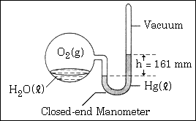
40. The system shown in the picture is at equilibrium at 28°C.
At this temperature, the vapor pressure of water is 28 millimeters
of mercury. The partial pressure of O_{2(g)} in the system is…
(A) 28 mm Hg (B) 56 mm Hg (C) 133 mm Hg
(D) 161 mm Hg (E) 189 mm Hg
45. A sample of an ideal gas is cooled from 50.0 °C to 25.0 °C in a sealed container of constant volume. Which of the following values for the gas will decrease?
I. The average molecular mass of the gas
II. The average distance between the molecules
III. The average speed of the molecules
(A) I only (B) II only (C) III only (D) I and III (E) II and III
64. At 25 °C, a sample of NH₃ (molar mass 17 grams) effuses at the rate of 0.050 moles per minute. Under the same conditions, which of the following gases effuses at approximately one-half that rate?
(A) O₂ (molar mass 32 grams) (B) He (molar mass 4.0 grams) (C) CO₂ (molar mass 44 grams)
(D) Cl₂ (molar mass 71 grams) (E) CH₄ (molar mass 16 grams)
 | Pressure of O_{2 (g)} above H₂O_{(l)} (atm) | Temperature of H₂O_{(l)} °(C)
(A) | 5 | 80
(B) | 5 | 20
(C) | 1 | 80
(D) | 1 | 20
(E) | 0.5 | 20
52. Under which of the following sets of conditions could the most O_{2 (g)} be dissolved in H₂O_{(l)} ?
23. A hot-air balloon, shown at the right, rises. Which of the following is the best explanation?
(A) The pressure on the walls of the balloon increases with increasing temperature.
(B) The difference in temperature between the air inside and outside
the balloon produces convection currents.
(C) The cooler air outside the balloon pushes in on the walls of the balloon.
(D) The rate of diffusion of cooler air is less than that of warmer air.
(E) The air density inside the balloon is less than that of the surrounding air.
44. A rigid metal tank contains oxygen gas. Which of the following applies to the gas in the tank when additional oxygen is added at constant temperature?
(A) The volume of the gas increase. (B) The pressure of the gas decreases.
(C) The average speed of the gas molecules remains the same.
(D) The total number of gas molecules remains the same.
(E) The average distance between the gas molecules increases.
53. W_{(g)} + X_{(g)} 🡪 Y_{(g)} + Z_{(g)}
Gas W and X react in a closed, rigid vessel to form Gas Y and Z according to the equation above. The initial pressure of W_{(g)} is 1.20 atm and that of X_{(g)} is 1.60 atm. No Y_{(g)} or Z_{(g)} is initially present. The experiment is carried out at constant temperature. What is the partial pressure of Z_{(g)} when the partial pressure of W_{(g)} has decreased to 1.0 atm?
(A) 0.20 atm (B) 0.40 atm (C) 1.0 atm (D) 1.2 atm (E) 1.4 atm

60. NH₄NO_{3(s)} à N₂O_{(g)} + 2 H₂O_{(g)} (Container Volume = 1.0 L)
A 0.03 mol sample of NH₄NO_{3(s)} decomposes completely according to the balanced equation above. The total pressure in the flask measured at 400 K is closest to which of the following? (R = 0.08 L-atm / mole-K)
(A) 3 atm (B) 1 atm (C) 0.5 atm (D) 0.1 atm (E) 0.03 atm
64. Equal numbers of moles of He_{(g)}, Ar_{(g)}, and Ne_{(g)} are placed in a glass vessel at room temperature. If the vessel has a pinhole-sized leak, which of the following will be true regarding the relative values of the partial pressures of the gases remaining in the vessel after some of the gas mixture has effused?
(A) P_{He} < P_{Ne} < P_{Ar} (B) P_{He} < P_{Ar} < P_{Ne} (C) P_{Ne} < P_{Ar} < P_{He}
(D) P_{Ar} < P_{He} < P_{Ne} (E) P_{He} = P_{Ar} = P_{Ne}

Questions 8-10 refer to the following gases at 0°C and 1 atm:
(A) Ne
(B) Xe
(C) O₂
(D) CO
(E) NO
8. Has an average atomic or molecular speed closest to that of N₂ molecules at 0°C and 1 atm.
9. Has the greatest density.
10. Has the greatest rate of effusion through a pinhole.
20. A flask contains 0.25 mol of SO_{2(g)}, 0.50 mole of CH_{4(g)}, and 0.50 mole of O_{2(g)}. The total pressure of the gases in the flask is 800 mm Hg. What is the parital pressure of the SO_{2(g)} in the flask?
(A) 800 mm Hg
(B) 600 mm Hg
(C) 250 mm Hg
(D) 200 mm Hg
(E) 160 mm Hg
66. A 2 L container will hold about 4 g of which of the following gases at 0°C and 1 atm?
(A) SO₂
(B) N₂
(C) CO₂
(D) C₄H₈
(E) NH₃

Solutions Review

Solubility Rules: Compounds containing Alkali metals, NH₄⁺, C₂H₃O₂⁻, and NO₃⁻ are always soluble.

1. Which of the following must be soluble? NaCl, PbBr₂ K₃PO₄ MgCO₃ calcium hydroxide, copper (II) nitrate

2. State whether each of the following solutions is saturated, unsaturated, or supersaturated.
(a) 80 g NaNO₃ in 100 g H₂O at 10ºC ___________________________
(b) 75 g NaNO₃ in 100 g H₂O at 10ºC ___________________________
(c) 90 g NaNO₃ in 100 g H₂O at 10ºC ___________________________
(f) 5 g KClO₃ in 100 g H₂O at 5ºC ___________________________
(h) 35 g NaNO₃ in 50 g H₂O at 10ºC ___________________________
(i) 5 g KClO₃ in 50 g H₂O at 5ºC ___________________________
(j) 5 g KClO₃ in 200 g H₂O at 5ºC ___________________________
(k) 30 g NH₄Cl in 200 g H₂O at 10ºC ___________________________
3. Identify how many MORE grams of each solute must be added to 100 g of water to form a saturated solution at that temperature.

Grams Solute per  100 g H₂O | Solute Added to make Saturated |  | Grams Solute per  100 g H₂O | Solute Added to make Saturated
a. 35 g KNO₃ at 40ºC |  |  | e. 35 g NaCl at 90ºC
b. 50 g NH₃ at 10ºC |  |  | f. 5 g NH₃ at 90ºC
c. 15 g KCl at 75ºC |  |  | g. 10 g KClO₃ at 40ºC
d. 95 g KI at 15ºC |  |  | h. 17 g KCl at 60ºC

4. Identify how many grams of each solute will crystallize/precipitate/settle. Assume all solutions are saturated and in 100 grams of H₂O.
Amount cooled | Amount Precipitated
a. KNO₃ (aq) is cooled from 70ºC to 40ºC
b. NH₄Cl (aq) is cooled from 90ºC to 20ºC
c. KCl (aq) is cooled from 55ºC to 30ºC
d. KI (aq) is cooled from 20ºC to 5ºC
5. Rank the following solids in order from least to most soluble in 100 g H₂O at 50ºC :
NH₄Cl, NaNO₃, KClO₃, KNO₃
Phase Changes Review

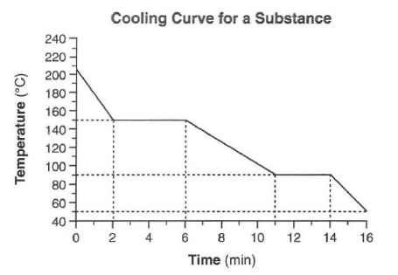
- Label the line segments with their phase(s).
- What is this substance’s melting point? _________
- What is this substance’s boiling point? __________
- Does this represent an endothermic or exothermic reaction?
- Heat is being released at 60.0 kilojoules per minute.
How much heat is released when the substance freezes?

- Label the point with the most kinetic energy with a star.
__________________________________________________________________________________________

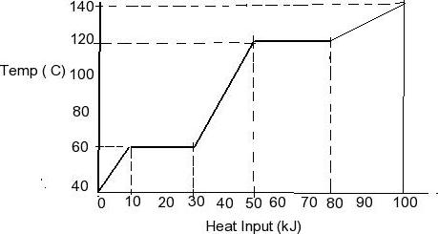
- Draw six particles of this substance as it looks for the
first line segment in the box below.

- Draw six particles of this substance as it looks for the
last line segment in the box below.

- At which point is the potential energy the highest? Label it with a star.
- What is the boiling point of this substance? _____________
- What is the melting point of this substance? _____________
- What would you expect the graph to do if the substance continued to be heated?

Concentration

A solution is a homogeneous mixture. Even though concentrations of solutions can be presented in a variety of different ways in chemistry, concentrations can be broken into 2 big groups: those that depend on mass only, and those that depend on both mass and volume. Since volume of an aqueous solution is temperature dependent, concentrations that depend on volume are only used when temperature is constant.
Density (d): Mass solution Mole Fraction (x) = Moles Part
Volume solution Total moles

Molarity (M): Moles solute Mass percent = Mass part x 100%
Volume solution (L) Total mass

Molality (m): Moles solute
Mass solvent (kg)

Parts per Million (ppm):mass of part x 1,000,000
Total mass whole

Fill in each box in the column with “X” if that measurement is needed to calculate the concentration.
Density | Molarity | Mole fraction | Molality | Mass percent | Parts per  Million | Measurement  needed
 |  |  |  |  |  | Mass solute
 |  |  |  |  |  | Mass solvent
 |  |  |  |  |  | Volume solution
Which of these concentrations would be temperature dependent?

This question will ask you to calculate the concentration of an aqueous solution of concentrated HCl in a variety of the concentration units outlined above using the information given in the question.
- You will need to work with a specific volume of the concentrated HCl solution, so choose any volume you want and record it here________________.

- Concentrated hydrochloric acid solution has a density of 1.19 g/mL. Calculate the mass of this solution for the sample volume you chose in #1.

- Concentrated hydrochloric acid solution is 37.2 % by mass HCl. Calculate:
  - The mass of HCl in this sample.

  - The moles of HCl in this sample.

  - The mass of the solvent in this sample.

  - The moles of solvent in this sample.

- Calculate the following for a sample of the concentrated HCl solution:
  - Molarity of HCl

  - Molality of HCl

  - χ_{HCl}

  - χ_{H2O}

  - parts per million HCl

- A solution of Na₂CO₃ is prepared by dissolving 25.0 g in water to prepare a solution with a total volume of 350.0 mL. Calculate the concentration of each of the following.
  - Na₂CO₃

  - Na⁺

  - CO₃⁺²
- Explain why the procedure shown above for preparing 350.0 mL of a solution of Na₂CO₃(aq) is incorrect.
(1) Add 25.0 g Na₂CO₃(s) to a 350.0 mL volumetric flask
(2) Add 350.0 mL distilled water to the flask.
(3) Swirl the solution until all of the solid dissolves completely.

- A student needs to prepare 500.0 mL of 0.800 M CuSO₄(aq).
  - Calculate the mass of CuSO₄(s) needed to prepare this solution.

  - The most common form of CuSO4 found in the laboratory is not anhydrous CuSO₄, but rather the hydrate compound, copper(II) sulfate pentahydrate, which has the chemical formula CuSO₄•5H₂O. Calculate the mass of CuSO₄•5H₂O(s) needed to prepare 500.0 mL of 0.600 M.

- A student needs to prepare 200.0 mL of 0.750 M KOH(aq). Calculate the volume of 3.00 M KOH(aq)needed to prepare this solution. Describe the dilution procedure.

- The solubility of Ca(OH)₂ in water is equal to 0.0118 M at room temperature. Calculate the minimum volume of distilled water (in milliliters) that must be added to a sample of 0.300g Ca(OH)₂(s) in order to dissolve the solid completely.

- Draw particle diagrams to represent the following:
  - 1M NaCl b. 2M NaCl c. 1M MgCl₂

Separating Mixtures
- A student investigates various dyes using paper chromatography. The student has samples of three pure dyes, labeled A, B, and C, and an unknown sample that contains one of the three dyes. The student prepares the chromatography chambers shown above on the left by putting a drop of each dye at the indicated position on the chromatography paper (a polar material) and standing the paper in a nonpolar solvent. The developed chromatograms are shown above on the right.
  - Which dye (A, B, or C) is the least polar? Which dye is the most polar? Justify your answers in terms of the interactions between the dyes and the solvent or between the dyes and the paper.

  - Which dye is present in the unknown sample? Justify your answer.
- Suppose that you have a mixture of dyes or pigments, and you need to separate the mixture into separate components and collect a substantial sample of each component. You could use column chromatography to do this. The mixture of dyes would be loaded onto a column that usually contains a solid such as silica gel (a form of hydrated SiO₂). A solvent runs through the column and serves as the mobile phase. The mixture travels downward through the column, and each component of the mixture should have different strengths of their attractions for the mobile phase and the stationary phase. Each dye should pass through the column at a different rate, and this allows for collection of each dye separately.
  - If the mobile phase is polar, which type of dye should come out of the column first?

  - If the mobile phase is non polar, which type of dye should come out of the column first?

- The diagram shows a distillation setup. If a mixture of ethanol (BP = 78°C) and water (BP = 100°C) is gently heated, which component of the mixture, ethanol or water, will appear in the collection flask first? Justify your answer.

- A mixture containing equal numbers of moles of ethyl acetate and butyl acetate was separated using distillation. Based on the diagrams shown above, which of the following identifies the substance that would be initially present in higher concentration in the distillate and correctly explains why that occurs?

  - Ethyl acetate, because it has fewer C–C bonds to break
  - Ethyl acetate, because it has a shorter carbon chain and weaker London dispersion forces
  - Butyl acetate, because it has more C–C bonds to break
  - Butyl acetate, because it has a longer carbon chain and weaker dipole-dipole attraction

Spectroscopy

Spectroscopy is the study of how electromagnetic radiation interacts with a sample of matter. A sample of matter can absorb energy, and it can also emit energy. Different forms of radiation will have different effects on a sample of matter. Each form of radiation has a different effect on a molecule. This information is summarized in the table below. https://phet.colorado.edu/en/simulations/molecules-and-light

Radiation | Effect on Molecule | Relative Energy
microwave | molecules rotate (like the plate in a microwave) | low
infrared | chemical bonds stretch and vibrate | medium
visible and UV | electrons absorb energy to transition to excited state and some chemical bonds can break | high

- N₂ molecules absorb ultraviolet light but not visible light. I₂ molecules absorb both visible and ultraviolet light. Which of the following statements explains the observations?
  - More energy is required to make N₂ molecules vibrate than is required to make I₂ molecules vibrate.
  - More energy is required to remove an electron from an I₂ molecule than is required to remove an electron from a N₂ molecule.
  - Visible light does not produce transitions between electronic energy levels in the N₂ molecule but does produce transitions in the I₂ molecule.
  - The molecular mass of I₂ is greater than the molecular mass of N₂
- The diagram above represents the absorption spectrum for a pure molecular substance. Which of the following correctly indicates the type of transition observed for the substance in each of the regions of the absorption spectrum?
Region X Region Y Region Z
  - Molecular vibration Molecular rotation Electronic transition
  - Electronic transition Molecular rotation Molecular vibration
  - Molecular rotation Molecular vibration Electronic transition
  - Electronic transition Molecular vibration Molecular rotation
- Which of the following best explains what happens as photons of visible light are absorbed by dye molecules?
  - Certain electrons in the dye molecule move to a higher energy level, with the difference in energy between the lower and higher energy levels being the same as the energy of the absorbed photons.
  - Certain chemical bonds in the dye molecules begin to bend and stretch, with the difference in energy between the lower and higher vibrational states being the same as the energy of the absorbed photons.
  - The dye molecules begin to rotate faster in certain modes, with the difference in energy between the lower and higher rotational states being the same as the energy of the absorbed photons.
  - Certain covalent bonds in the dye molecules begin to break and reform, with the bond energies of the bonds being the same as the energy of the absorbed photons.

In spectroscopy, a sample is exposed to a source of electromagnetic radiation. This radiation causes the sample to be affected in some way, involving both the absorption and the emission of energy. The changes in energy are processed through a detector, producing a spectrum. The energy absorbed or emitted from a sample can be described in terms of photons. A photon refers to a particle of radiation that has a specific wavelength, frequency, and energy. Recall the following calculations:

- The Cl−Cl bond has a bond energy of 242 kJ mol–1.
  - Calculate the amount of energy, in joules, needed to break a single Cl−Cl bond.

  - Calculate the longest wavelength of light, in meters, that can supply the energy per photon necessary to break the Cl−Cl bond.

Instruments such as spectrophotometers or colorimeters are designed to measure the absorbance of a
a particular sample. Many substances are able to absorb light. When a substance absorbs light, electrons in the ground state become excited and move up to higher energy levels. For many transition metal ions, electrons absorb photons of light in the visible portion of the electromagnetic spectrum. That is why many transition metal ions appear colored. The color wheel below illustrates that the perceived color has a complementary relationship with the color of visible light that is absorbed. For example, Cu²⁺ (aq) appears blue to our eyes because the solution has a strong absorbance in the orange portion of the visible spectrum (around 600 nm). A spectrophotometer or colorimeter is an instrument that consists of a light source and a diffraction grating that separates the light into different wavelengths. The light passes through a cuvette, which is a small test tube or square container used to hold the sample that is being analyzed. After the light passes through the sample, a detector measures how much light passes through the sample. Most spectrophotometers are designed to measure absorbance in the visible or the ultraviolet region of the electromagnetic spectrum. A spectrophotometer can be used to scan the sample over a wide range of wavelength values. The instrument produces an absorption spectrum for that particular sample. In the spectrum shown above, the maximum value for absorbance is at a wavelength of approximately 500 nm. When using a spectrophotometer to analyze a sample, it is important to set the instrument to a particular wavelength in which there is a relatively high absorbance value. Based on the absorbance spectrum shown above, any wavelength that is between 400 nm and 600 nm would be an appropriate setting for the instrument .Before inserting a sample into the spectrophotometer, a blank sample of water is inserted to calibrate the instrument. The absorbance value for the blank sample is set to zero. When the samples are analyzed in the instrument, the absorbance values are compared to that of the blank sample. The cuvette should be filled with enough solution so that the beam of light passes entirely through the solution and not through empty air space. A standard cuvette normally has a diameter (path length) of 1.0 cm. Cuvettes are normally wiped with a lint-free tissue to remove any moisture or fingerprints before they are placed in the instrument. Any smudges, dirt, or fingerprints on the transparent sides of the cuvette will scatter or block the light, preventing it from reaching the detector. This will result in a measured value for absorbance that will be too high.

Solutions Webquest Activity
- Open a browser and go to https://phet.colorado.edu/
- Go to the “Beer's Law Lab” simulation under the “Chemistry simulations”. Click on “Beer’s Law.”
- Choose the Cobalt (II) Nitrate, Co(NO₃)₂ solution to start.
- Set the concentration to 0 mM (millimolar).
- Use the ruler to make sure the container has a “path length” of 1.0cm.
- The wavelength of the light on the left should be at a preset wavelength of 549nm and if you click the red button to turn it on the color will shine green through your solution.
- Record the transmittance and absorbance reported by the meter on the right.

- Change the concentration of the Cobalt (II) Nitrate to 100mM. Record the transmittance and absorbance and color change.

- Using your previous answers, what do you think transmittance and absorbance means in this simulation?

- Hypothesize what you think will happen to the transmittance and absorbance if you change the concentration to 400 mM. Then change the concentration and record the actual values.
  - Did the transmittance increase, decrease, or remain the same?
  - Did the absorbance increase, decrease, or remain the same?

  - What did you notice about the color?

- Choose another salt, Nickel (II) chloride, NiCl₂, from the drop down list. What happened to the wavelength and color of light coming from the device on the left?

- At 0 mM, are the values different from cobalt (II) nitrate?

- At 100mM, are the values different from cobalt (II) nitrate?

- Play around with more salts and concentrations.
  - What is the relationship between concentration and absorbance?

  - What is the relationship between concentration and transmittance?

  - Record the color of the solution as well as the wavelength and color of light used for each solution.
Solution | Color of solution | color of light | wavelength light
Co(NO₃)₂
CoCl₂
K₂Cr₂O₇
K₂CrO₄
NiCl₂
CuSO₄
KMnO₄

  - What do you notice about the color of the solution versus the color of the light used?

- Reset the simultion to 100mM of NiCl₂.Use the ruler to change the width of the container. This is called the path length of the light through the solution. What is the relationship between pathlength and absorbance?

- The Beer’s Law formula is A=εbc. Use your reference table to define each letter.

- Choose copper sulfate, CuSO₄ at 100mM. Create a path length of 1cm. Record the absorbance. Calculate the molar absorptivity (with units) of copper sulfate using the concentration and path length.

- Use Beer’s law formula to calculate the Absorbance of light for CuSO₄ at 200mM. Show work. Then verify with the simulation.

- Use Beer’s law formula to calculate the concentration of CuSO₄ at 150mM. Show work. Then verify with the simulation.

- What values are constant for a solution in Beer’s Law?

- Will the values you selected above be constant for a new solute?

- In a lab, a student used the formula below to calculate various absorbance values and concentrations. Explain how this formula is applicable as long as the solute stays the same?
A₁ = A₂
C₁ C₂
- An ore containing cobalt and some inert materials is analyzed in a laboratory. A spectrophotometer is used to determine the mass percent of cobalt present in the ore sample. Solutions of known concentration of Co²⁺(aq) are prepared, and the absorbance of each solution is measured at the wavelength of optimum absorbance. The data are used to create a calibration plot, which is shown above. A sample of the ore with a mass of 0.630 g is completely dissolved in concentrated HNO₃(aq). The mixture is diluted with water to a final volume of 50.00 mL. Assume that all of the cobalt present in the ore sample is converted into Co²⁺(aq). The absorbance of a sample of this solution is measured as 0.74.
  - What is the concentration of Co²⁺(aq) in this solution?

  - Calculate the number of moles of Co²⁺(aq) in the 50.00 mL solution.

  - Calculate the mass percent of Co in the 0.630 g sample of the ore.

AP Chemistry: Solutions Multiple Choice

59. When 70. milliliters of 3.0-molar Na₂CO₃ is added to 30. milliliters of 1.0-molar NaHCO₃ the resulting concentration of Na⁺ is…
(A) 2.0 M (B) 2.4 M (C) 4.0 M (D) 4.5 M (E) 7.0 M
67. A student wishes to prepare 2.00 liters of 0.100-molar KIO₃ (molecular weight 214). The proper procedure is to weigh out…
(A) 42.8 grams of KIO₃ and add 2.00 kilograms of H₂O
(B) 42.8 grams of KIO₃ and add H₂O until the final homogeneous solution has a volume of 2.00 liters
(C) 21.4 grams of KIO₃ and add H₂O until the final homogeneous solution has a volume of 2.00 liters
(D) 42.8 grams of KIO₃ and add 2.00 liters of H₂O
(E) 21.4 grams of KIO₃ and add 2.00 liters of H₂O
15. The weight of H₂SO₄ (molecular weight 98.1) in 50.0 milliliters of a 6.00-molar solution is…
(A) 3.10 grams (B) 12.0 grams (C) 29.4 grams (D) 294 grams (E) 300. grams
26. How many milliliters of 11.6-molar HCl must be diluted to obtain 1.0 liter of 3.0-molar HCl?
(A) 3.9 mL (B) 35 mL (C) 260 mL (D) 1,000 mL (E) 3,900 mL
43. Which of the following does NOT behave as an electrolyte when it is dissolved in water?
(A) CH₃OH (B) K₂CO₃ (C) NH₄Br (D) HI (E) Sodium acetate, CH₃COONa
28. Given that a solution is 5 percent sucrose by mass, what additional information is necessary to calculate the molarity of the solution?
I. The density of water II. The density of the solution III. The molar mass of sucrose
(A) I only (B) II only (C) III only (D) I and III (E) II and III
53. If 87 grams of K₂ SO₄ (molar mass 174 grams) is dissolved in enough water to make 250 milliliters of solution, what are the concentrations of the potassium and the sulfate ions?
 | [K⁺] | [SO₄²⁻]
(A) | 0.020 M | 0.020 M
(B) | 1.0 M | 2.0 M
(C) | 2.0 M | 1.0 M
(D) | 2.0 M | 2.0 M
(E) | 4.0 M | 2.0 M
56. A yellow precipitate forms when 0.5 M NaI_{(aq)} is added to a 0.5 M solution of which of the following ions?
(A) Pb²⁺_{(aq)} (B) Zn²⁺_{(aq)} (C) CrO₄²⁻_{(aq)} (D) SO₄²⁻_{(aq)} (E) OH⁻_{(aq)}
70. When 100 mL of 1.0 M Na₃PO₄ is mixed with 100 mL of 1.0 M AgNO₃, a yellow precipitate forms and [Ag⁺] becomes negligibly small. Which of the following is a correct listing of the ions remaining in solution in order of increasing concentration?
(A) [PO₄³⁻] < [NO₃⁻] < [Na⁺] (B) [PO₄³⁻] < [Na⁺]<[NO₃⁻] (C) [NO₃⁻] < [PO₄³⁻] < [Na⁺]
(D) [Na⁺] < [NO₃⁻] < [PO₄³⁻] (E) [Na⁺] < [PO₄³⁻] < [NO₃⁻]
73. The volume of distilled water that should be added to 10.0 mL of 6.00 M HCl_{(aq)} in order to prepare a 0.500 M HCl_{(aq)} solution is approximately…
(A) 50.0 mL (B) 60.0 mL (C) 100. mL (D) 110. mL (E) 120. mL
Use the following answers for questions 10 - 13.
(A) CO₃²⁻ (B) Cr₂O₇²⁻ (C) NH₄⁺ (D) Ba²⁺ (E) Al³⁺
Assume that you have an "unknown" consisting of an aqueous solution of a salt that contains one of the ions listed above. Which ion must be absent on the basis of each of the following observations of the "unknown"?
10. The solution is colorless
11. The solution gives no apparent reaction with dilute hydrochloric acid.
12. No odor can be detected when a sample of the solution is added drop by drop to a warm solution of sodium hydroxide.
13. No precipitate is formed when a dilute solution of H₂SO₄ is added to a sample of the solution.
28. Which of the following is probably true for a solid solute with a highly endothermic heat of solution when dissolved in water?
(A) The solid has a low lattice energy.
(B) As the solute dissolves, the temperature of the solution increases.
(C) The resulting solution is ideal.
(D) The solid is more soluble at higher temperatures.
(E) the solid has a high energy of hydration.
14. Which of the following is lower for a 1.0-molar aqueous solution of any solute than it is for pure water?
(A) pH (B) Vapor pressure (C) Freezing point (D) Electrical conductivity (E) Absorption of visible light
31. If the temperature of an aqueous solution of NaCl is increased from 20 °C to 90 °C, which of the following statements is true?
(A) The density of the solution remains unchanged. (B) The molarity of the solution remains unchanged.
(C) The molality of the solution remains unchanged. (D) The mole fraction of solute decreases.
(E) The mole fraction of solute increases.
43. A sample of 61.8 g of H₃BO₃, a weak acid is dissolved in 1,000 g of water to make a 1.0-molal solution. Which of the following would be the best procedure to determine to molarity of the solution? (Assume no additional information is available.)
(A) Titration of the solution with standard acid (B) Measurement of the pH with a pH meter
(C) Determination of the boiling point of the solution (D) Measurement of the total volume of the solution
(E) Measurement of the specific heat of the solution
67. Substances X and Y that were in a solution were separated in the laboratory using the technique of fractional crystallization. This fractional crystallization is possible because substances X and Y have different…
(A) boiling points (B) melting points (C) densities (D) crystal colors (E) solubilities
45. What is the mole fraction of ethanol, C₂H₅OH, in an aqueous solution that is 46 percent ethanol by mass? (The molar mass of C₂H₅OH is 46 g; the molar mass of H₂O is 18 g.)
(A) 0.25 (B) 0.46 (C) 0.54 (D) 0.67 (E) 0.75
26. Approximately what mass of CuSO₄·5H₂O (250 g mol⁻¹) is required to prepare 250 mL of 0.10 M copper (II) sulfate solution?
(A) 4.0 g (B) 6.2 g (C) 34 g (D) 85 g (E) 140 g
38. A 0.10 M aqueous solution of sodium sulfate, Na₂SO₄, is a better conductor of electricity than a 0.10 M aqueous solution of sodium chloride, NaCl. Which of the following best explains this observation?
(A) Na₂SO₄ is more soluble in water than NaCl is.
(B) Na₂SO₄ has a higher molar mass than NaCl has.
(C) To prepare a given volume of 0.10 M solution, the mass of Na₂SO₄ needed is more than twice the mass of NaCl needed.
(D) More moles of ions are present in a given volume of 0.10 M Na₂SO₄ than in the same volume of 0.10 M NaCl.
(E) The degree of dissociation of Na₂SO₄ in solution is significantly greater than that of NaCl.
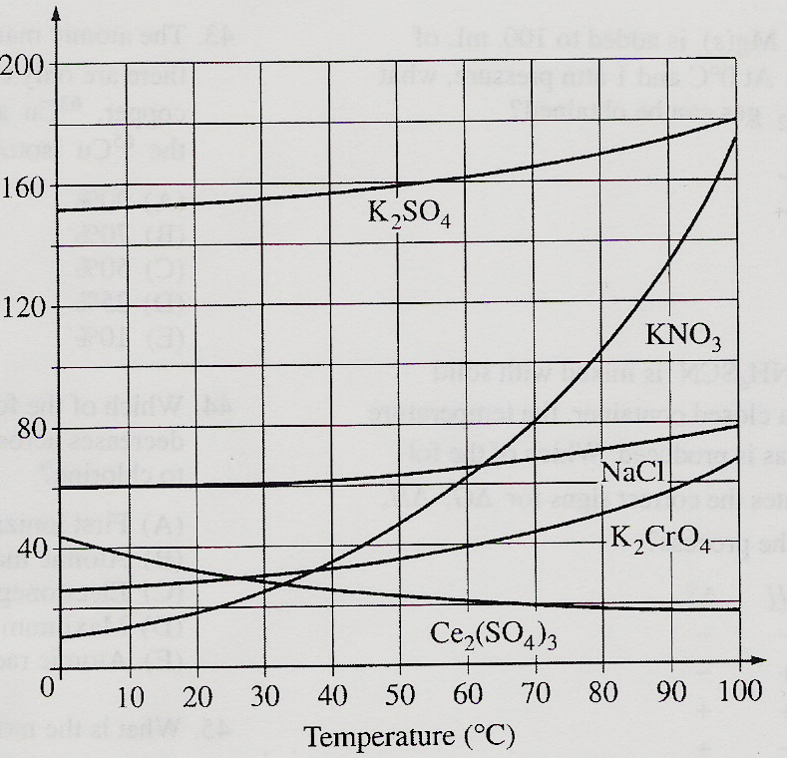
39. On the basis of the solubility curves shown, the greatest
percentage of which compound can be recovered
by cooling a saturated solution of that compound
from 90°C to 30°C ?
(A) NaCl
(B) KNO₃
(C) K₂CrO₄
(D) K₂SO₄
(E) Ce₂(SO₄)₃

69. If 200. mL of 0.60 M MgCl_{2(aq)} is added to 400. mL of distilled water, what is the concentration of Mg²⁺_{(aq)} in the resulting solution? (Assume volume are additive.)
(A) 0.20 M (B) 0.30 M (C) 0.40 M (D) 0.60 M (E) 1.2 M

