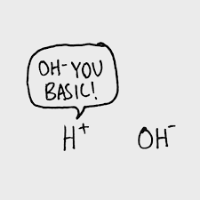
AP Learning Objectives

Identify evidence of chemical and physical changes in matter. (4.1)
Represent changes in matter with a balanced chemical or net ionic equation: a. For physical changes. b. For given information about the identity of the reactants and/or product. c. For ions in a given chemical reaction. (4.2)
Represent a given chemical reaction or physical process with a consistent particulate model. (4.3)
Explain the relationship between macroscopic characteristics and bond interactions for Chemical processes and Physical processes. (4.4)
Explain changes in the amounts of reactants and products based on the balanced reaction equation for a chemical process. (4.5)
Identify the equivalence point in a titration based on the amounts of the titrant and analyte, assuming the titration reaction goes to completion (4.6)
Identify a reaction as acid base, oxidation-reduction, or precipitation. (4.7)
Identify species as BrønstedLowry acids, bases, and/or conjugate acid-base pairs, based on proton-transfer involving those species. (4.8)
Represent a balanced redox reaction equation using half-reactions. (4.9)

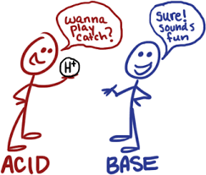

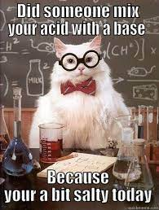
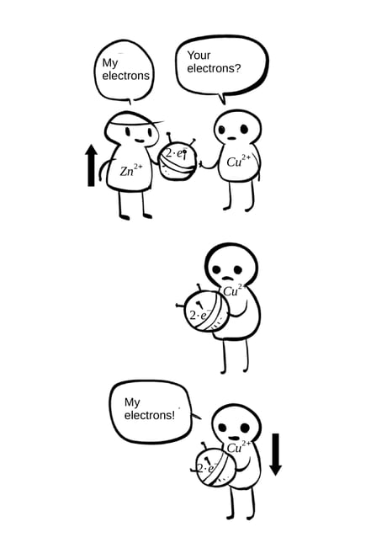
Net Ionic Equations for Precipitate Reactions Review

Observe the reaction between aqueous cobalt (II) nitrate and aqueous sodium carbonate. Imagine how they look at the molecular level.
- Write the molecular equation for this reaction:

- Write the balanced net ionic equation for this reaction:

- What is/are the spectators in this reaction?

- What is the precipitate name?

- Draw the reactants before the reaction and the products after.

initial--> final

- Write the net ionic equation for the following reactions of aqueous reactants:
- lithium phosphate and calcium acetate

- ammonium sulfate and strontium perchlorate

Acid Base Equilibrium Review

- Identify the rules for determining whether a substance is an acid, a base, or a salt based on the formula. Underline all the acids, circle bases, and box in salts. Leave the covalent substances alone.
NH₃ NaCl CH₃OH H₂SO₄ Ca(OH)₂ CH₄

NH₄Br HCl Na₂SO₄ HNO₃ CH₃COOH NaOH

H₃PO₄ LiOH CH₂(OH)₂ NH₄OH Ca(NO₃)₂ HC₂H₃O₂

- All acids have the ____________ ion in common.
- All bases have the _____________ ion in common.
- All salts have formulas: _________________________________________________________________
- All other compounds have formulas: ______________________________________________________
- Organic acids have the general formula: ________________
- The most electropositive H is lost from the acid. Draw ethanoic acid and circle which H⁺ ion is lost:

2. Which formula represents a hydronium ion?
(1) H₃O⁺ (2) OH– (3) NH₄⁺ (4) HCO₃–

3. Which compound is an Arrhenius acid?
(1) H₂SO₄ (2) NaOH (3) KCl (4) NH₃

4. Which compound releases hydroxide ions in an aqueous solution?
(1) CH₃COOH (2) HCl (3) CH₃OH (4) KOH

5. Given the equation: HCl(g) + H₂O(l)→X(aq) + Cl⁻(aq) Which ion is represented by X?
(1) hydroxide (2) hypochlorite (3) hydronium (4) perchlorate

6. Which substance, when dissolved in water, forms a solution that conducts an electric current?
(1) C₂H₅OH (2) C₁₂H₂₂O₁₁ (3) C₆H₁₂O₆ (4) CH₃COOH

Strength versus Concentration
Directions: For each case, decide if the picture shows a weak or strong, and concentrated or dilute solution.

Acid: H+ ion: Anion A-:

 |  | W/S and C/D | Example
Case 1

Case 2

Case 3

Case 4

5. What does concentrated mean in terms of the amount of particles? ________________________________
6. What does dilute mean in terms of amount of particles?__________________________________________
7. What does strong mean in terms of ions? ______________________________________________________
8. What does weak mean in terms of ions? _______________________________________________________

9. List strong acids and bases:
Reactions with Acids

1. Neutralization Reactions: If equal mole amounts of acid and base are added together, the resulting solution is NEUTRAL! )

Acid + Base → Salt + Water

Example: HCl (aq) + NaOH (aq) → NaCl (aq) + H₂O (l)

Predict the products of and balance the following reactions:

___ HF (aq) + ___ LiOH (aq) → __________ (aq) + ___ HOH (l)

___ HCl (aq) + ___ Ca(OH)₂ (aq) → __________(aq) + ___ HOH (l)

___ HClO₃ (aq) + ___ Mg(OH)₂ (aq) → __________(aq) + ___ HOH (l)

___ H₂CO₃ (aq) + ___ NaOH (aq) → __________(aq) + ___ HOH (l)

___ H₂SO₄ (aq) + ___ LiOH (aq) → __________ (aq) + ___ HOH (l)

___ H₂SO₃ (aq) + ___ Ca(OH)₂ (aq) → __________(aq) + ___ HOH (l)

___ H₃PO₃ (aq) + ___ KOH (aq) → __________(aq) + ___ HOH (l)

___ H₃PO₄ (aq) + ___ Ca(OH)₂ (aq) → __________(s) + ___ HOH (l)

2. Reactions of Acids with Metals (only 3 metals do NOT react with acids: Cu, Au, Ag)

acid + more active metal 🡪 H₂(g) + a salt

Predict the products of the following reactions:

Zn (s) + 2HCl (aq) → _______ + _________

Ag (s) + H₂SO₄ (aq) → _______ + _________

Ca (s) + H₂SO₄ (aq) → _______ + _________

3. What type of change is occurring in each reaction? Justify your answers.
- acid base neutralization

- acid and metal

Bronsted Lowry Theory

- When an acid dissolves it dissociates or ionizes (breaking up into two ions). The ions are separated due to the polarity of water, as shown below. Draw what happens to the other acid, base, and salt in water.
NaOH(s) + H₂O(l) NaOH(aq)

HCl(g) + H₂O(l) HCl(aq)

HNO₃(g) + H₂O(l) HNO₃(aq)

NaCl(s) + H₂O(l) NaCl(aq)

Cl⁻
+
+

-
H⁺

- Explain why they are known as electrolytes when in solution but not when they are in solid or gas phases.
Acids are defined as proton (H⁺) donators. They donate protons to the base. Bases are defined as proton
acceptors. They accept protons from the acid. HBr + NH₃ ↔NH₄⁺ + Br⁻
According to Bronsted-Lowry theory, acid-base reactions involve a transfer of a proton. Above, the acid on
the left, ___________, transfers (donates) a proton (H⁺) and becomes a base on the right, __________.
The donating acid and the base it becomes are called conjugate acid - base pairs. The base on the left, __________, accepts a proton (H⁺) and becomes an acid on the right, _________. This is also a conjugate pair.
HF_{(aq)} + H₂O _{(l)} H₃O⁺_{(aq)} + F⁻_{(aq)} (1)
HI_{(aq)} + NH_{3(aq)} NH₄⁺_{(aq)} + I⁻_{(aq)} (2)
NH₄⁺_{(aq)} + OH⁻_{(aq)} NH_{3(aq)} + H₂O _{(l)} (3)
H₂SO_{4(aq)} + H₂O _{(l)} HSO₄⁻_{(aq)} + H₃O⁺_{(aq)} (4)

- In the reactions above, list the acids in the reactants and explain what they all have in common.

- In the reactions, list the bases in the first half of the equation and explain what they all have in common.

- If you reverse the equations, list the new acids and bases.
Acids: Bases:

- Now you can see that each acid on the left hand side produces a corresponding base on the right hand side. The base is called the conjugate base. Similarly, a base on the right hand side will produce a conjugate acid. These pairs are known as conjugate acid-base pairs. List the conjugate acid-base pairs for equations (1) and (2).

5. Write the acid-base reaction for NH₃ reacting with HClO₂ and identify the acid, the base, the conjugate acid and the conjugate base.

___6. One acid-base theory defines a base as an
(1) H⁺ donor (2) H donor (3) H⁺ acceptor (4) H acceptor

___7. One alternate acid-base theory states that an acid is a(n)
(1) H⁺ donor (2) OH⁻ donor (3) H⁺ acceptor (4) OH⁻ acceptor

___8. According to one acid-base theory, a water molecule acts as an acid when the water molecule
(1) accepts an H+ (2) accepts an OH– (3) donates an H+ (4) donates an OH–

___9. Given the equation representing a reaction at equilibrium:
NH₃(g) + H₂O(l) 🡨🡪 NH₄⁺(aq) + OH–(aq)
The H⁺ acceptor for the forward reaction is
(1) H₂O (l) (2) NH₄⁺ (aq) (3) NH₃ (g) (4) OH– (aq)

___10. Given the balanced equation representing a reaction:
NH₃(g) + H₂O (l) 🡨🡪 NH₄⁺(aq) + OH–(aq)
According to one acid-base theory, the NH₃(g) molecules act as
(1) an acid because they accept H⁺ ions
(2) an acid because they donate H⁺ ions
(3) a base because they accept H⁺ ions
(4) a base because they donate H⁺ ions

Acid Base Titrations Review

Titrations are procedures used to determine the concentration (M) of an acid or a base. You combine together an acid and a base knowing the volume of each and the concentration of only one of them.
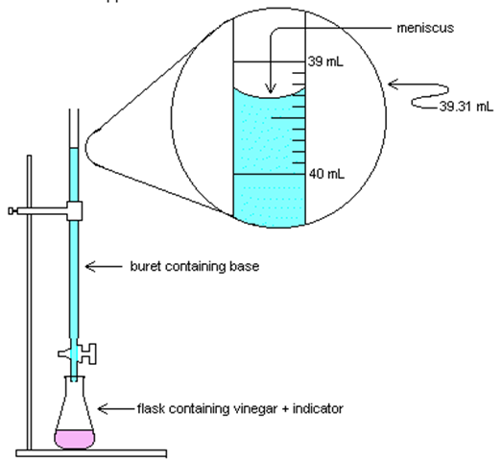
1. What number would be at the top of the buret?
2. Read the volume of the base in the buret.
3. If the buret holds 50mL, how much base is actually in the buret?
4. If a student started at 2.0mL and released base until it was at the level shown, how much base was added?
5. Why is it not necessary to subtract all your volumes from 50mL?

Using the equation from last year, you can solve for either the molarity/concentration (M) or a volume added (V).
M_{A} V_{A} = M_{B} V_{B}
M_{A}= molarity of H⁺ V_{A} = volume of acid

M_{B} = molarity of OH– V_{B} = volume of base

1. A 25.0-milliliter sample of HNO₃ (aq) is neutralized by 32.1 milliliters of 0.150 M KOH (aq). What is the concentration of the acid?

2. How many milliliters of 0.200 M NaOH are needed to neutralize 100. mL of 0.100 M HCl?

3. In a titration, 20.0 milliliters of 0.15 M HCl(aq) is exactly neutralized by 18.0 milliliters of KOH(aq).

Net Ionic Equations for Acid Base Reactions

Observe the reaction between aqueous hydrochloric acid and aqueous magnesium hydroxide. Imagine how they look at the molecular level.
- Write the molecular equation for this reaction:

- Write the balanced net ionic equation for this reaction:

- What is/are the spectators in this reaction?

- What is the precipitate name?

- Draw the reactants before the reaction and products after the reaction.

initial → final

- Write the net ionic equation for the following reactions of aqueous reactants:
  - hydrobromic acid and lithium hydroxide

  - acetic acid and potassium hydroxide

  - hydroiodic acid and ammonia
Redox Review

Oxidation numbers are very important in this chapter “Redox Reactions.” Without the complete understanding of how to assign these numbers, we cannot move ahead with this chapter. They are much like ionic charges, except that every element will be assigned a number. The most important rules that cannot be broken are:
- Free elements are zero.
- Group 1 is +1
- Group 2 is +2
- Fluorine is -1

Assign oxidation numbers to each element in the following:
- NaCl Na___ Cl___
- H₂S H___ S___
- H₂O H___ O ___
- CO₂ C ___ O___
- H₂SO₄ H ___ S___ O___
- FeCO₃ Fe___ C___ O___
- AgI Ag___ I___
- H₂ H___
- PbCl₂ Pb___ Cl___
- BaCO₃ Ba___ C ___ O___
- Fe₂O₃ Fe___ O___
- I₂ I____
- BeO Be____ O____
- CaF₂ Ca____ F ____
- FeCl₃ Fe____ Cl____
- PF₅ P____ F____
- H₃PO₄ H____ P____ O___
- KCl K ____ Cl____
- K₂O K ____ O____
- O₃ O ____
- LiH Li ____ H____
- HBr H ____ Br____
- Li⁺ Li____
- PO₄³⁻ P____ O___
- CaH₂ Ca___ H___
- Cr₂O₃ Cr___ O___
- KClO K___ Cl___ O___
- KClO₂ K___ Cl___ O___
- KClO₃ K___ Cl___ O___
- KClO₄ K___ Cl___ O___
- Na₂SO₄ Na___ S___ O___
- Ca(OH)₂ Ca___ O___ H___
- Na₂SO₄ Na___ S___ O___
- B₂(Cr₂O₇)₃ B___ Cr___ O___
- Al₂(SO₄)₃ Al___ S___ O___
- Al(NO₃)₃ Al___ N___ O___
- (NH₄)₃PO₄ N___ H___ P___ O____
Redox Reactions

A redox reaction is a reaction in which electrons are transferred from one element to another. The reaction involves at least two elements, one that will give up an electron, and one that will receive that electron. The term redox comes from two words, “oxidation” and “reduction.” If something is oxidized, it “burns” in oxygen, as shown below:
Mg + O 🡪 Mg⁺² + O⁻²

Take a moment to write out their Lewis dot structures. As you can see, Mg is being oxidized and it loses its two valence electrons, while oxygen gains them. Oxidation is defined as the loss of electrons.

Considering the name of this reaction, if something is being oxidized, the other element must be reducing. Neither reduction nor oxidation can happen alone. That means that oxygen, in this example, is being reduced because it gains the electrons. Reduction is defined as the gain of electrons.

A simple way to remember this is to remember that LEO the lion goes GER.
LEO = loss of electrons is oxidation.
GER = gain of electrons is reduction.

Also, Mg and O are “free” elements, which means their oxidation numbers are both 0. Now you can see that if and element’s oxidation number increases, that element is being oxidized. If an element’s oxidation number decreases it is being reduced (the number is reducing).

_____________________________________________________________________________

EXAMPLES: Indicate which element is being oxidized, and which is being reduced with half reactions.

- Cr³⁺ + Fe²⁺ 🡪 Cr²⁺ + Fe³⁺
- F₂ + O²⁻ 🡪 F¹⁻ + O₂
- Sn + N⁵⁺ 🡪 Sn⁴⁺ + N⁴⁺
- NaCl 🡪 Na⁺ + Cl⁻
- Cu₂O 🡪 Cu + O₂
- Cl₂ + KBr 🡪 KCl + Br₂
- CH₄ + O₂ 🡪 CO₂ + H₂O
- H₃PO₄ + Ca(OH) ₂ 🡪 Ca₃(PO₄) ₂ + H₂O
Net Ionic Equations for Redox Reactions

Observe the reaction between copper sulfate and solid lead. Imagine how they look at the molecular level.
- Write the molecular equation for this reaction:

- Write the balanced net ionic equation for this reaction:

- What is/are the spectators in this reaction?

- What is the precipitate name?

- Draw the reactants before the reaction.

initial → final

- Write the net ionic equation for the following reactions:
  - nickel metal and hydrochloric acid

  - nitrogen and hydrogen gas to form ammonia gas

Unit 4 Multiple Choice Practice

- Which of the following is the net ionic equation for the reaction between aqueous sodium fluoride and hydrochloric acid?
  - NaF(aq) + HCl(aq) → NaCl(aq) + HF(aq)
  - Na⁺(aq) + F⁻(aq) + H⁺(aq) + Cl⁻(aq) → Na⁺(aq) + Cl⁻(aq) + HF(aq)
  - Na⁺(aq) + Cl⁻(aq) → NaCl(aq)
  - F⁻(aq) + H⁺(aq) → HF(aq)

- Equal volumes of 0.2M solutions of lead(II) nitrate and potassium bromide are combined to form lead(II) bromide as a yellow precipitate. Which of the following is the correct net ionic equation for the reaction?
  - Pb²⁺(aq) + 2Br⁻(aq) → PbBr₂(s)
  - K⁺(aq) + NO₃−⁻(aq) → KNO₃(aq)
  - Pb²⁺(aq) + 2NO₃⁻(aq) + 2K⁺(aq) + 2Br⁻(aq) → 2K⁺(aq) + 2NO₃⁻(aq) + PbBr₂(s)
  - Pb(NO₃)₂(aq) + 2KBr(aq) → PbBr₂(s) + 2KNO₃(aq)

- . . . C₁₀H₁₂O₄S(s) + . . . O₂(g) → . . . CO₂(g) + . . . SO₂(g) + . . . H₂O(g)
When the equation above is balanced and all coefficients are reduced to their lowest whole-number terms, the coefficient for O₂(g) is
- 6 b. 7 c. 12 d. 14 e. 28

- 2F₂(g) + 2NaOH(aq) → OF₂(g) + 2NaF(aq) + H₂O(l)
A 2 mol sample of F₂(g) reacts with excess NaOH(aq) according to the equation above. If the reaction is repeated with excess NaOH(aq) but with 1 mol of F₂(g), which of the following is correct?
- The amount of OF₂(g) produced is doubled.
- The amount of OF₂(g) produced is halved.
- The amount of NaF(aq) produced remains the same.
- The amount of NaF(aq) produced remains the same.

- MgCl₂(aq) + 2NaOH(aq) → 2NaCl(aq) + Mg(OH)₂(s) A 100mL sample of 0.1M MgCl₂(aq) and a 100mL sample of 0.2M NaOH(aq) were combined, and Mg(OH)₂(s) precipitated, as shown by the equation above. If the experiment is repeated using solutions of the same molarity, which of the following changes in volume will double the amount of Mg(OH)₂(s) produced?
  - Using the same volume of MgCl₂(aq) but twice the volume of NaOH(aq)
  - Using twice the volume of MgCl₂(aq) but half the volume of NaOH(aq)
  - Using twice the volume of MgCl₂(aq) but the same volume of NaOH(aq)
  - Using twice the volume of MgCl₂(aq) and twice the volume of NaOH(aq)

- A solution of 0.100 M HCl and a solution of 0.100 M NaOH are prepared. A 40.0 mL sample of one of the solutions is added to a beaker and then titrated with the other solution. A pH electrode is used to obtain the data that are plotted in the titration curve shown opposite.
  - Identify the solution that was initially added to the beaker. Explain your reasoning.
  - On the titration curve above, circle the point that corresponds to the equivalence point.
  - At the equivalence point, how many moles of titrant have been added?
  - What is the difference between the equivalence point of a titration and the end point of a titration?
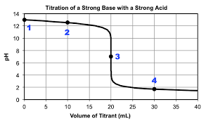

- 2 H₂O₂(aq) → 2 H₂O(l) + O₂(g)
The decomposition of H₂O₂(aq) is represented by the equation above. Which of the following identifies the element(s) being oxidized and reduced in the reaction?
- Hydrogen is oxidized and oxygen is reduced.
- Oxygen is oxidized and hydrogen is reduced.
- Oxygen is both oxidized and reduced
- No elements are oxidized or reduced; the reaction is not a redox reaction.

- 5 H₂O₂(aq) + 2 MnO₄⁻(aq) + 6 H⁺(aq) → 2 Mn²⁺(aq) + 8 H₂O(l)+ 5 O₂(g)
In a titration experiment, H₂O₂(aq) reacts with aqueous MnO₄⁻(aq) as represented by the equation above. The dark purple KMnO4 solution is added from a buret to a colorless, acidified solution of H₂O₂(aq) in an Erlenmeyer flask. (Note: At the end point of the titration, the solution is a pale pink color.) Which element is being oxidized during the titration, and what is the element’s change in oxidation number?
- Oxygen, which changes from -1 to 0
- Oxygen, which changes from 0 to -2
- Manganese, which changes from -1 to +2
- Manganese, which changes from +7 to +2

HCl + H₂O → H₃O⁺ + Cl⁻
- For the dissolution of HCl in water represented above, which of the following pairs includes the Brønsted-Lowry bases?
  - HCl(aq) and Cl⁻ (aq)
  - HCl(aq) and H₃O⁺(aq)
  - H₂O(l) and H₃O⁺(aq)
  - H₂O(l) and Cl⁻(aq)

- Ni(s) → Ni²⁺(aq) + 2e⁻ Ag⁺(aq) + e⁻ → Ag(s)
Which of the following is the balanced net ionic equation for an oxidation-reduction reaction between Ag+(aq) and Ni(s) based on the half-reactions represented above?
- Ag⁺(aq) + Ni(s) → Ag(s) + Ni²⁺(aq)
- 2Ag⁺(aq) + Ni(s) → Ag(s) + 2Ni²⁺(aq)
- Ag⁺(aq) + 2Ni(s) → Ag(s) + 2Ni²⁺(aq)
- 2Ag⁺(aq) + Ni(s) → 2 Ag(s) + Ni²⁺(aq)

