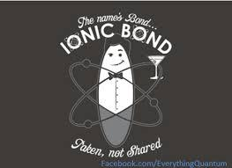
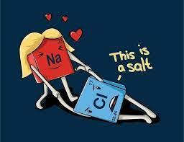
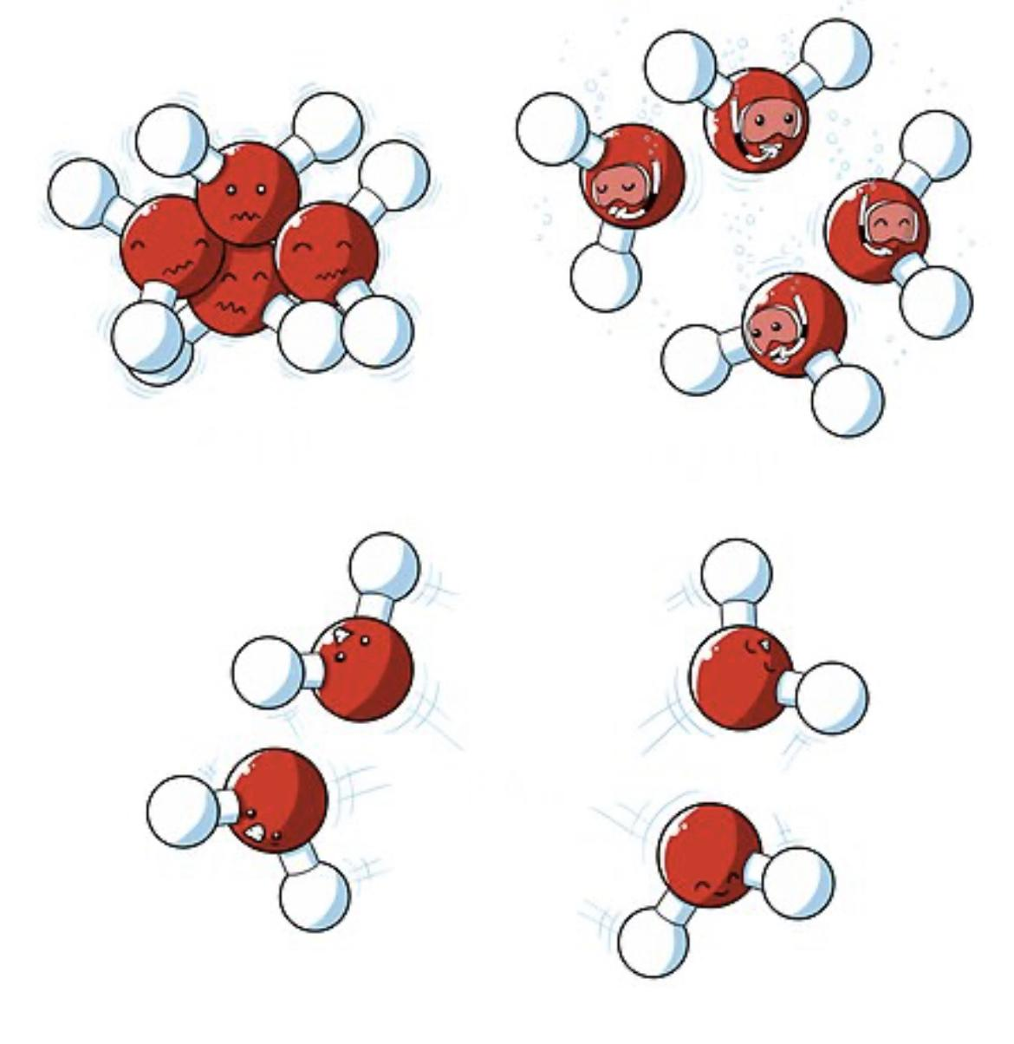
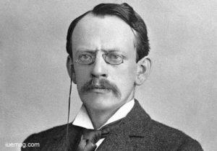
Thomson Model of the Atom: Think Tank Problems

J. J. Thomson performed experiments in 1897 with cathode rays in an attempt to understand electricity – which was still a mystery in the late 1800s. State the conclusions Thomson drew from each of his famous cathode ray experiments:

- First Experiment: Thomson directed the beam at an electrometer and tried to separate the evidence of charge from the path of the beam. What connection did Thomson find between charge and the cathode rays? Was the charge positive or negative? Model your answer and write a narrative to explain the model.
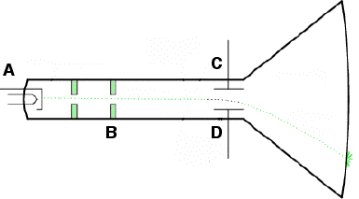

- Second Experiment: Thomson tried passing the cathode ray through an electric field. How did cathode ray beam behave when it passed through an electric field? What did he conclude after his second experiment? Model your answer and write a narrative to explain the model.

- Third Experiment: Thomson did some careful measurements on how much the path of the cathode ray was bent in a magnetic field and how much energy they carried. From this work Thomson could describe the mass/charge ratio of the cathode ray particles. What amazing result did Thomson find?

- Thomson’s Atomic Model: Thomson presented three hypotheses from his experiments. Only two were accepted by physicists – in fact the third was shown to be wrong! From the first two came a model of the atom known as the Plum Pudding model. Complete the atom drawing below to illustrate Thomson’s plum pudding model. Explain how this fits with his observations.

Ionic Compounds Think Tank Problems
We have observed evidence that aqueous ionic compounds conduct electricity but the solid form does not. Dalton determined that compounds form from individual atoms of elements in very specific whole number ratios. Thompson determined that those same atoms consist of a positive sphere with negative electrons embedded throughout. We will now examine the patterns that exist for the ratios in which these elements combine in order and why their solid forms do not conduct electricity.

Write the formula and draw the particle diagram for each compound.
1. | Atoms  involved | 1 lithium  1 fluorine | 1 lithium  1 chlorine | 2 lithium  1 oxygen | 2 lithium  1 sulfur | 3 lithium  1 nitrogen | 3 lithium  1 phosphorus
 | formula
 | particle diagram
2. | Atoms  involved | 1 sodium  1 fluorine | 1 sodium  1 chlorine | 2 sodium  1 oxygen | 2 sodium  1 sulfur | 3 sodium  1 nitrogen | 3 sodium  1 phosphorus
 | formula
 | particle diagram
3. | Atoms  involved | 1 magnesium  2 fluorine | 1 magnesium  2 chlorine | 1 magnesium  1 oxygen | 1 magnesium  1 sulfur | 3 magnesium  2 nitrogen | 3 magnesium  2 phosphorus
 | formula
 | particle diagram
4. | Atoms  involved | 1 calcium  2 fluorine | 1 calcium  2 chlorine | 1 calcium  1 oxygen | 1 calcium  1 sulfur | 3 calcium  2 nitrogen | 3 calcium  2 phosphorus
 | formula
 | particle diagram
5. | Atoms  involved | 1 gallium  3 fluorine | 1 gallium  3 chlorine | 2 gallium  3 oxygen | 2 gallium  3 sulfur | 1 gallium  1 nitrogen | 1 gallium  1 phosphorus
 | formula
 | particle diagram
6. | Atoms  involved | 1 aluminum  3 fluorine | 1 aluminum  3 chlorine | 2 aluminum  3 oxygen | 2 aluminum  3 sulfur | 1 aluminum  1 nitrogen | 1 aluminum  1 phosphorus
 | formula
 | particle diagram
- What patterns do you find in the formulas of the compounds formed?
  - Is there a relationship between question 1 and 2?

  - Is there a relationship between columns a and b?

  - What other relationship pairs are present?

- Using your periodic table, what do you notice about the placement of the following elements that had similar bonding patterns:
  - Li and Na

  - Mg and Ca

  - Ga and Al

  - F and Cl

  - O and S

  - N and P

- If Li and Na react the same way and are in the same group, what other elements may react in the same ratios and Li and Na?

- Based on these patterns, predict the formulas of the compounds formed by the ions below.

Atoms involved | Ratio of ions in compound
 | ___ potassium  ___ fluorine | ___ potassium  ___ chlorine | ___ potassium  ___ oxygen | ___potassium  ___ sulfur | ___potassium  ___ nitrogen | ___potassium  ___ phosphorous
formula

Particle diagram

- Based on these patterns, predict the formulas of the compounds formed by the ions below.

Atoms involved | Ratio of ions in compound
 | ___ beryllium  ___ iodine | ___ cesium  ___ bromine | ___ beryllium  ___ selenium | ___cesium  ___ tellurium | ___boron  ___ iodine | ___ cesium  ___ phosphorous
formula

Particle diagram

- How does a neutral atom become a positive ion? A negative ion?

- Recall metals conduct electricity in all phases. Is this because the electrons were mobile or stationary?

- When the top (+) tape was held near the metal aluminum foil, it attracted the foil by moving the electrons in the foil.
  - Based on your model, if the top tape were permitted to touch the foil, would the foil gain or lose electrons?

  - Would the aluminum become positively charged or negatively charged?

  - If metals attract nonmetals, what charges do nonmetals form?

- In ionic compounds, the metal particles tend to form positively charged ions (cations), while non-metal particles tend to form negatively charged ions (anions). However, when these same metal and non-metal particles are combined to form compounds they do not conduct electricity as solids. Use your evidence to explain why ions may conduct in the liquid phase and not in the solid phase. Draw a model to help your explanation.

- Are all cations equal but oppositely charged from all anions? Use the ratio or metals to nonmetals observed in question 1 to help you answer this question.

- Make the generalizations you can about the charge of the ions formed by elements in groups 1, 2, 13, 15, 16, and 17 based on the ratio of atoms in each of the compounds they form. It might help to look at your particle diagrams in #1 and consider what charges the elements might have in order to result in neutral compounds. Write your generalizations on the periodic table provided.
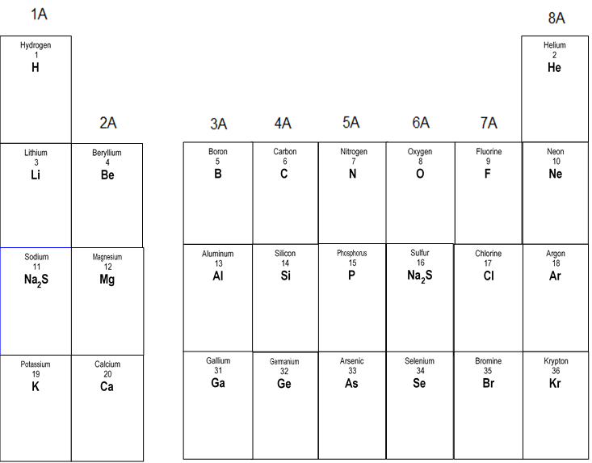

- Complete the models below to show how neutral atoms transfer electrons to form neutral compounds. Include the charges of the ions in the model of the compound.

Na(s) Cl₂(g) 🡪 NaCl(s)

Ca(s) Cl₂(g) 🡪 CaCl₂(s)

Oxidation Numbers Check Your Understanding

Assign oxidation numbers to each element in the following:

- NaCl Na___ Cl___
- Fr₂S Fr___ S___
- Rb₂O Rb___ O ___
- CaO Ca ___ O___
- KI K___ I___
- AlP Al___ P___
- H₂ H___
- MgCl₂ Mg___ Cl___
- I₂ I____
- BeO Be____ O____
- Na₃P Na___ P___
- SrF₂ Sr____ F ____
- AlCl₃ Al____ Cl____
- CsF Cs____ F____
- KCl K ____ Cl____
- K₂O K ____ O____
- O₃ O ____
- LiI Li ____ I____
- NaBr Na ____ Br____
- BaBr₂ Ba___ Br___
- Al₂O₃ Al___ O___
- RaTe Ra___ Te___
- Ga₂Se₃ Ga___ Se___
- Ca₃N₂ Ca___ N___

REDOX Reactions Think Tank Problems

A redox reaction is a reaction in which electrons are transferred from one element to another. The reaction involves at least two elements, one that will give up an electron, and one that will receive that electron. The term redox comes from two words, “oxidation” and “reduction.” If something is oxidized, it “burns” in oxygen, as shown below:
Mg(s) + O(g) 🡪 Mg⁺² + O⁻² 🡪 MgO(s)

As you can see, Mg is being oxidized and it loses its two electrons, while oxygen gains them. Oxidation is defined as the loss of electrons. Considering the name of this reaction, if something is being oxidized, the other element must be reducing. Neither reduction nor oxidation can happen alone. That means that oxygen, in this example, is being reduced because it gains the electrons. Reduction is defined as the gain of electrons. A simple way to remember this is to remember that LEO the lion goes GER.
LEO = loss of electrons is oxidation.
GER = gain of electrons is reduction.

A half reaction shows either the oxidation or reduction portion of a redox equation including if the electrons are gained or lost. A reduction half reaction shows an atom or ion gaining one of more e⁻: Fe³⁺ + 3e⁻ 🡪 Fe Notice that the e⁻ is on the left.
An oxidation half reaction shows an atom or ion losing one or more e-:
Mg 🡪 Mg²⁺ + 2 e⁻ Notice that the e⁻ is on the right.

- What do all of these oxidation number changes have in common? Do they increase or decrease? Do they represent oxidation or reduction?
Cr⁺⁵ 🡪 Cr⁺² Mn⁺⁷ 🡪 Mn⁺⁴
Fe⁺² 🡪 Fe⁰ O⁰ 🡪 O⁻²
F⁰ 🡪 F⁻¹ N⁺³ 🡪 N⁻²

- What do all of these oxidation number changes have in common? Do they increase or decrease? Do they represent oxidation or reduction?
Cr⁺² 🡪 Cr⁺⁴ Mn⁺⁵ 🡪 Mn⁺⁷
Fe⁰ 🡪 Fe⁺² O⁻² 🡪 O⁰
F⁻¹ 🡪 F⁰ N⁻³ 🡪 N⁺⁴

- For the following examples, determine if they represent oxidation or reduction.
- e⁻ + Cr⁺³ 🡪 Cr⁺²
- 2e⁻ + Mn⁺⁷ 🡪 Mn⁺⁵
- Mg⁺² + 2e⁻ 🡪 Mg
- K 🡪 e⁻ + K⁺¹
- e⁻ + Cu⁺² 🡪 Cu⁺¹
- Al🡪 Al⁺³ + 3e⁻
- Li⁺ + e⁻ 🡪 Li
- S⁻² 🡪 2e⁻ + S
- For the following examples, add in the e- to balance the charge.
- Cr⁺⁵ 🡪 Cr⁺²
- Mn⁺⁴ 🡪 Mn⁺⁷
- Ca⁺² 🡪 Ca
- Rb 🡪 Rb⁺¹
- Cu⁺¹ 🡪 Cu⁺²
- B⁺³ 🡪 B
- N⁻³ 🡪 N⁺⁴
- Te⁻² 🡪 Te

- In these full reactions, indicate which element is being oxidized, and which is being reduced.

- Cr³⁺ + Fe²⁺ 🡪 Cr²⁺ + Fe³⁺

- F₂⁰ + O²⁻ 🡪 2F¹⁻ + O₂⁰

- Sn + 4N⁵⁺ 🡪 Sn⁴⁺ + 4N⁴⁺

- In these full reactions, add oxidation numbers and indicate which element is being oxidized, and which is being reduced.

- Li₂O 🡪 Li + O₂

- Cl₂ + KBr 🡪 KCl + Br₂

Also, Mg and O are “free” elements, which means their oxidation numbers are both 0. Now you can see that if an element’s oxidation number increases, that element is being oxidized. If an element’s oxidation number decreases it is being reduced (the number is reducing). Check your answers above to confirm this trick works.

In the following examples state if they are redox reactions and provide evidence.
- 2Ca + O₂ 🡪 2CaO
- Cl₂ + 2NaBr 🡪 2NaCl + Br₂
- 2LiCl + CaO 🡪 CaCl₂ + Li₂O

Spontaneous Reactions and Activity Series Formulas Think Tank Problems

Iron is one substance which is used in abundance on the ship. A ship is continuously in contact with water and moisture-laden winds which makes it highly susceptible to corrosion (rust).
- Write the oxidation half reaction for metallic iron becoming iron (II) ion.

- What happens to the phase of iron as it rusts?

- What happens to the mass of iron remaining on the boat as it rusts?
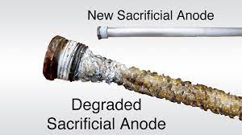

It is for this reason sacrificial anodes are used to protect the parent material. Another metal, such as zinc, is drilled into the ship to oxidize instead of the iron. The anode is one of the metal electrodes in a battery used in the “Electrolysis of Water Lab” where water is separated into hydrogen and oxygen gas. The oxygen gas was collected at the anode.
2H₂O(l) → 2H₂(g) + O₂(g)

- Write the two half reactions that occurred in the electrolysis lab. Label with the type of half reaction (reduction or oxidation).

- Which process, oxidation or reduction, occurs at an anode?

- Why would zinc be placed as the sacrificial anode? What does that mean the zinc will do?

- Look at table J of the reference tables. Compare the location and reactivity of zinc and iron on the table.

- What other metals could be used as a sacrificial anode on an iron boat?

- What metals could be used as a sacrificial anode on an aluminum boat?

- Why would the sacrificial anode need to be replaced after a few years?

- When storing jewelry, do not place gold and silver jewelry near aluminum and other “cheaper” jewelry in an environment known to have high humidity. Explain why using table J.

Spontaneous Reactions and Activity Series Formulas Check Your Understanding

Use Table J to help you with the following questions.
- Write the oxidation and reduction half reaction for:
Ca + Cu²⁺ 🡪 Ca²⁺ + Cu

- According to Table J, the element higher on the list will oxidize. Which element is oxidizing here and does that mean that this reaction is spontaneous?

- Write the oxidation and reduction half reaction for
Mg + Ca²⁺ 🡪 Mg²⁺ + Ca

- Which element is oxidizing in number 3 and is the reaction spontaneous?

- Which element is most easily oxidized?
  - Cu b. Mg c. Al d. Zn

- Which element will reduce Mg²⁺ to Mg?
  - Fe b. Ba c. Pb d. Ag

- Which metal will react spontaneously with Ag⁺ but not Zn²⁺?
  - Cu b. Au c. Al d. Mg

- Which reaction will take place spontaneously?
  - LiCl _ Na → NaCl + Li
  - NaCl + Li → LiCl + Na
  - LiCl + K → KCl + Li
  - KCl + Na → K + NaCl

Formulas of Binary Ionic Compounds Think Tank Problems

Look at the formulas and corresponding names of various ionic compounds. What naming rules can you infer with these examples?
Sodium fluoride NaF Calcium iodide CaI₂
Lithium chloride LiCl Magnesium bromide MgBr₂
Potassium Bromide KBr Aluminum oxide Al₂O₃
Cesium Iodide CsI Beryllium Phosphide Be₃P₂

- What type of element is always written first in the formula?

- What type of element is always written second in the formula?

- How many elements are present in these compounds?

- How do all of these names end?

- Did the subscripts influence the names of the formulas?

- Based on your knowledge of chemistry so far, where do the subscripts come from?

Formulas of Binary Ionic Compounds Check Your Understanding

- Name the following compounds:

  - NaF __________________________ f. NaH ______________________________

  - MgCl₂ __________________________ g. K₃P ______________________________

  - Al₂O₃ __________________________ h. MgO ______________________________

  - MgI₂ __________________________ i. Li₂Te ______________________________

  - H₂O __________________________ j. AlCl₃ ______________________________

- Give the formula for the following compounds. One is provided for you.
 | Cation charge | Anion Charge | Formula
Sodium chloride | Na⁺¹ | Cl⁻¹ | NaCl
Potassium oxide
Lithium nitride
Calcium bromide
Magnesium sulfide
Beryllium nitride
Aluminum fluoride
Aluminum oxide

- Give the formula for the following compounds.

  - Cesium fluoride: ______________ d. Barium sulfide: ______________

  - Potassium oxide: ______________ e. Aluminum chloride: ______________

  - Magnesium iodide: ______________ f. Calcium phosphide: ______________
RedOx Reaction Regents Review

1. In an oxidation-reduction reaction, reduction is defined as the
(1) loss of mass (3) loss of electrons
(2) gain of mass (4) gain of electrons

2. When a neutral atom undergoes oxidation,
the atom’s oxidation state
- decreases as it gains electrons
- decreases as it loses electrons
- increases as it gains electrons
- increases as it loses electrons

3. In a redox reaction, there is a conservation of
- mass, only
- both mass and charge
- neither mass nor charge

4. In any redox reaction, the substance that undergoes reduction will
(1) lose e- & have a decrease in oxidation number
(2) lose e- & have an increase in oxidation number
(3) gain e- & have a decrease in oxidation number
(4) gain e- & have an increase in oxidation number

5. Given the reaction:
Which species undergoes oxidation?
- Mg(s) (3) Cl–(aq)
- H⁺(aq) (4) H₂(g)

6. Given the redox reaction:
As the reaction takes place, there is a transfer of
- electrons from Al to Cr³⁺
- electrons from Cr³⁺ to Al

7. Given the redox reaction:
2 Fe³⁺ + 3 Zn 🡪 2 Fe + 3 Zn²⁺
As the reaction takes place, there is a transfer of electrons
- from Fe³⁺ to Zn
- from Zn to Fe³⁺
- from Zn²⁺ to Fe
(4) from Fe to Zn²⁺
_________________________________________________________________________________________
9. Circle the electrons in the half-reactions below and identify as oxidation or reduction.
Br₂ + 2 e– → 2 Br–

(b) Na → Na⁺ + e–

(c) Ca²⁺ + 2e– → Ca

(d) Cl₂ + 2 e– → 2 Cl–

(e) Na⁺ + e– → Na

(f) S^{2–} → S + 2e–

(g) Cu²⁺ + 2 e– → Cu

(h) Fe → Fe²⁺ + 2 e–

(i) Mn⁷⁺ + 3 e– → Mn⁴⁺

10. Complete the half-reactions below by ADDING in electrons to the correct side in order to equalize charge (show conservation of charge).

- Fe²⁺ 🡪 Fe³⁺
- K 🡪 K⁺
- Sn⁴⁺ 🡪 Sn²⁺
- Cr⁶⁺ 🡪 Cr³⁺
- Mn³⁺ 🡪 Mn⁴⁺
- Cr²⁺ 🡪 Cr³⁺
- Cl⁷⁺ 🡪 Cl¹⁺
11. Which half-reaction correctly represents oxidation?
- Fe(s) → Fe²⁺(aq) + 2e–
- Fe²⁺(aq) → Fe(s) + 2e–
- Fe(s) + 2e– → Fe²⁺(aq)
- Fe²⁺(aq) + 2e– → Fe(s)

12. Given the balanced ionic equation:
Which equation represents the oxidation
half-reaction?
- Zn(s) + 2e– → Zn²⁺(aq)
- Zn(s) → Zn²⁺(aq) + 2e–
- Cu²⁺(aq) → Cu(s) + 2e–
- Cu²⁺(aq) + 2e– → Cu(s)

13. Which half-reaction equation represents the reduction of a potassium ion?
(1) K⁺ + e– 🡪 K (3) K⁺ 🡪 K + e–
(2) K + e– 🡪 K⁺ (4) K 🡪 K⁺ + e–

14. Given the equation:
The reduction half-reaction is
- Al → Al³⁺ + 3e–
- Cu²⁺ + 2e– → Cu
- Al + 3e– → Al³⁺
- Cu²⁺ → Cu + 2e–
15. Base your answers to the questions below on the following redox reaction, which occurs in a battery.
____ Zn + ____ Cr³⁺ 🡪 ____ Zn²⁺ + ____ Cr
- Write the half-reaction for the reduction that occurs.

- Write the half-reaction for the oxidation that occurs.

- Which species loses electrons and which species gains electrons?

16. The outer structure of the Statue of Liberty is made of copper metal. The framework is made of iron. Over time, a thin green layer (patina) forms on the copper surface.
- When copper oxidized to form this patina layer, the copper atoms became copper(II) ions (Cu²⁺). Write a balanced half-reaction for this oxidation of copper.
CCu+ 2e–

- Where the iron framework came in contact with the copper surface, a reaction occurred in which iron was oxidized. Using information from Reference Table J, explain why the iron was oxidized. more reactive than Ni.
- Describe how JJ Thomson concluded that the mobile charged particle in the atom had a (–) charge.

- A solution of salt conducts electricity; a solution of sugar does not. Explain.

- Below left is a 2-D array that represents an ionic lattice. At right is a 2-D array that represents a molecular solid. In what ways are they similar? In what ways are they different?

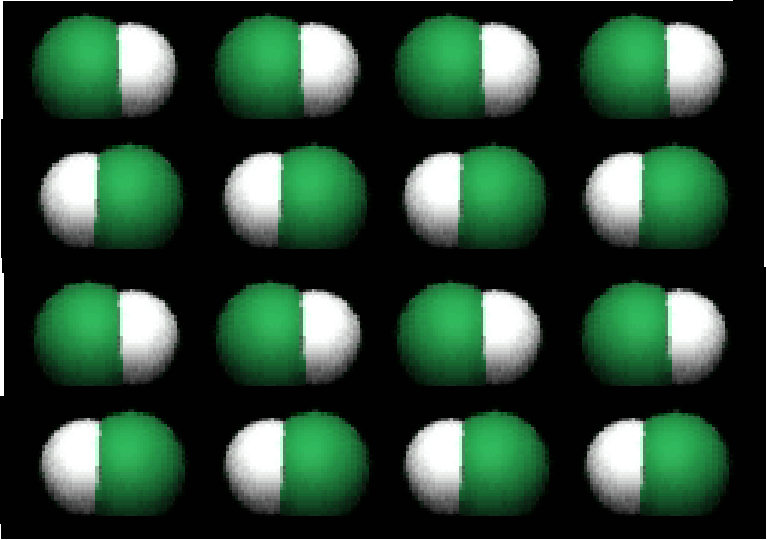
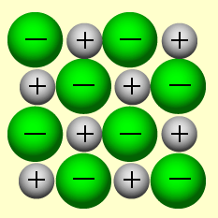

- What evidence helped us to conclude that chloride ions have a (–) charge?

- How do you decide how many ions of each type combine to form an ionic compound?

- Why do ionic solids have higher melting and boiling points than do most molecular solids?

Additional RedOX Review

Directions Questions 1-8: Provide the oxidation number of the indicated atoms.
- Na
- Na in NaCl
- H in H₂O
- Ba in BaBr₂
- S in Al₂S₃
- N in Na₃N
- Mn in MnO2
- Br₂

9. Explain why sodium is not charged when it is a pure metal but becomes charges when it is in a compound like table salt.

10. Explain the difference between pure silver, in clean jewelry or silverware utensils, versus tarnished silver when jewelry and utensils are reacted with oxygen in the air in terms of charges and electrons.
Directions Questions 11- 14: Assign oxidation states to each species below. Identify which species is being oxidized and which is being reduced. In the space below each reaction write the oxidation and reduction half reactions and add in electrons to balance the charge.

oxidation

Example: Li⁰ + Cu⁺² → Li¹⁺ + Cu⁰
reduction
Oxidization: Li⁰ → Li¹⁺ + 1e- Reduction: Cu⁺² +2e- → Cu⁰

- Cr⁺ + Sn⁴⁺ → Cr³⁺ + Sn²⁺

Oxidization: Reduction:

- CaCl₂(aq) + Li(s) → LiCl(aq) + Ca(s)

Oxidized: Reduced:

- As(s) + Cl₂(g) → AsCl₃(s)

Oxidized: Reduced:

- Zn(s) + Cu²⁺(aq) → Zn²⁺(aq) + Cu(s)

Oxidized: Reduced:

- Explain how Zn(s) is physically and chemically different than the Zn⁺²(aq).

Model 1: Recall that atoms and compounds are neutral (positive charges = # of negative charges). If element X has 4 negative charges it would also have a positive charge equal in strength to the electrons as shown below.

- -

- -
- Element X is a metal so it loses electrons (oxidation) to form a cation (positive ion). Draw a model of the atom showing a loss of 2 negative charges (electrons).

- How strong is the positive charge in the ion (how many electrons is it equal to)?
- How many negative charges does the ion have?
- What is the overall charge of the ion?

Model 2: Recall that atoms and compounds are neutral (positive charge = # of negative charges). If element Z has 8 negative charges it would also have a positive charge equal in strength to the negative charges as shown below.

- - - -

- - - -

- Compare Model 1 atom of element X to Model 2 atom of element Z.
- Which has more electrons?
- If both atoms are neutral, what can be said about the strength of the positive charge in element Z versus X?
- How is the strength of the positive charge of element Z in Model 2 shown differently than Model 1 of element X?
19. Element Z is a nonmetal so it gains electrons (reduction) to form an anion (negative ion). Draw a model of the atom showing a gain of 2 negative charges (electrons).

20. How strong is the positive charge in the ion (how many electrons is it equal to)?

21. How many negative charges does the ion have?

22. What is the overall charge of the ion?

23. In terms of oxidation state, why is this called reduction when it is gaining electrons?

