Learning Objectives:

- Explain the relationship between the rate of a chemical reaction and experimental parameters (5.1)
- Represent experimental data with a consistent rate law expression.(5.2)
- Identify the rate law expression of a chemical reaction using data that show how the concentrations of reaction species change over time. (5.3)
- Represent an elementary reaction as a rate law expression using stoichiometry(5.4)
- Explain the relationship between the rate of an elementary reaction and the frequency, energy, and orientation of molecular collisions.(5.5)
- Represent the activation energy and overall energy change in an elementary reaction using a reaction energy profile.(5.6)
- Identify the components of a reaction mechanism.(5.7)
- Identify the rate law for a reaction from a mechanism in which the first step is rate limiting. (5.8)
- Identify the rate law for a reaction from a mechanism in which the first step is not rate limiting.(5.9)
- Represent the activation energy and overall energy change in a multistep reaction with a reaction energy profile.(5.10)
- Explain the relationship between the effect of a catalyst on a reaction and changes in the reaction mechanism.(5.11)

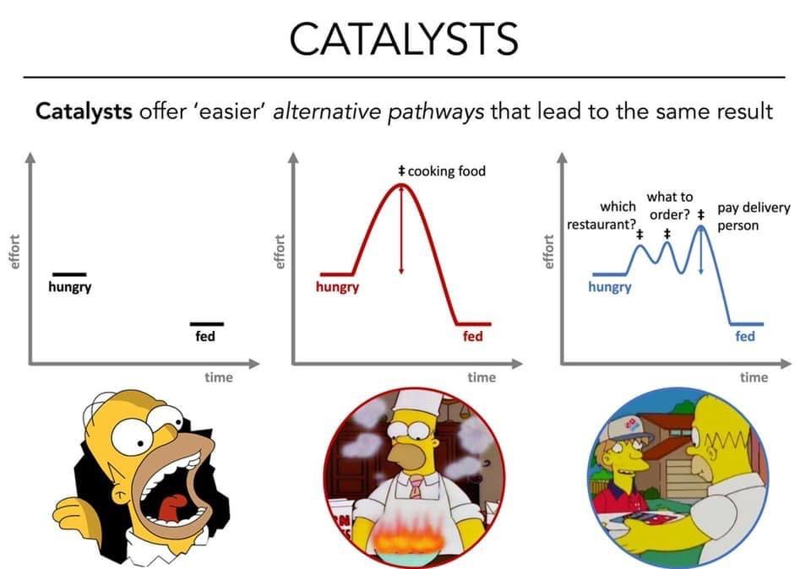
Kinetics Review

- In order for a reaction to occur the particles must __________________with proper ______________ and ________________. Therefore, the more collisions the reactant particles have, the faster the rate.
- Recall 5 ways to increase the rate of reaction. Be specific.

- Which event must always occur for a chemical reaction to take place?
    - formation of a precipitate
    - formation of a gas
    - effective collisions between reacting particles
    - addition of a catalyst to the reaction system

- Increasing the temperature increases the rate of a reaction by
    - lowering the activation energy
    - increasing the activation energy
    - lowering the frequency of effective collisions between reacting molecules
    - increasing the frequency of effective collisions between reacting molecules

- After being ignited in a Bunsen burner flame, a piece of magnesium ribbon burns brightly, giving off heat and light. In this situation, the Bunsen burner flame provides
    - ionization energy c) activation energy
    - heat of reaction d) heat of vaporization

- As the number of effective collisions between reacting particles increases, the rate of reaction
    - Decreases b)increases c)remains the same

- In aqueous reactions as temperature increases, the effectiveness of collisions between particles
    - Decreases b) increases c) remains the same

- At which temperature will the reaction occur at the greatest rate?
- 25ºC b) 50ºC c) 75ºC d) 100ºC

- A 5.0-gram sample of zinc and a 50.-milliliter sample of hydrochloric acid are used in a chemical reaction. Which combination of these samples has the fastest reaction rate?
- a zinc strip and 1.0 M HCl(aq) c) zinc powder and 1.0 M HCl(aq)
- a zinc strip and 3.0 M HCl(aq) d) zinc powder and 3.0 M HCl(aq)

- At STP, which 4.0-gram zinc sample will react fastest with dilute hydrochloric acid?
    - lump b) bar c)powdered d) sheet metal
- Which statement best explains the role of a catalyst in a chemical reaction?
    - A catalyst is added as an additional reactant and is consumed but not regenerated.
    - A catalyst limits the amount of reactants used.
    - A catalyst changes the kinds of products produced.
    - A catalyst provides an alternate reaction pathway that requires less activation energy.
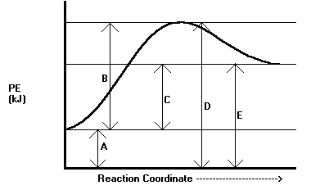
12. Define potential energy (PE).

13.Using the first diagram to the right, record the letter that describes each statement:
  - Reactants PE: ___
  - Products PE: ___
  - Activated complex PE: ___
  - Activation Energy: ___
  - Heat of Reaction: ___
14. Is the diagram above depicting an endothermic or exothermic reaction? Defend your answer.

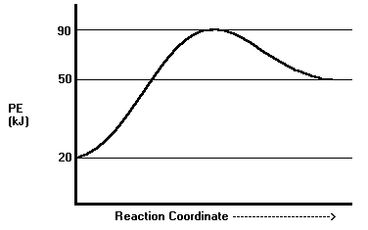
15. On the second diagram to the right find the value of the following statements in kJ:
  - Reactants PE: ___
  - Products PE: ___
  - Activated complex PE: ___
  - Activation Energy: ___
  - Heat of Reaction: ___
  - Activation Energy of the
reverse reaction: ___
  - Enthalpy of reverse reaction: ___
  - Is the diagram above depicting an endothermic or exothermic reaction? Defend your answer.
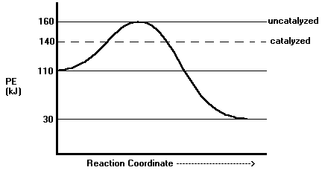
16. On the third diagram to the right find the value of the following statements in kJ for the uncatalyzed reaction:
  - Reactants PE: _____
  - Products PE: _____
  - Activated complex PE: _____
  - Activation Energy: _____
  - Heat of Reaction: _____
  - Activation Energy of the reverse reaction: ____
  - Enthalpy of reverse reaction: _____
- On the third diagram, what values changed for the catalyzed reactions? Give the new values:
  - Reactants PE: _____
  - Products PE: _____
  - Activated complex PE: _____
  - Activation Energy: _____
  - Heat of Reaction: _____

- Using the graph below please draw a reaction potential energy diagram for a reaction with the following:
Potential Energy of Reactants = 350 kJ/mole
Activation Energy of Forward Reaction = 100 kJ/mole
Potential Energy of Products = 150 kJ/mole

Potential Energy (kJ)
Reaction Coordinate (X + Y → Z)

- Is the reaction endothermic or exothermic?
- Please identify the following on the diagram you created in question #1. Place this letter above its corresponding line segment on the graph and the value in the adjacent column.

Component of Potential Energy Diagram | Symbol | Value
Potential Energy of Reactants | A
Potential Energy of Products | B
Potential Energy of Activated Complex | C
Heat of Reaction | D
Activation Energy of Forward Reaction | E
Activation Energy of Reverse Reaction | F
- Using a dotted line, show how the reaction potential energy diagram would be altered upon the addition of a catalyst to the reaction in the graph above.
- If a catalyst were added, which lettered quantities, if any would change?
Average Reaction Rate

- Write rate expressions for the following reactions:
  - H₂ + O₂ 🡪 H₂O

  - N₂ + H₂ 🡪 NH₃

  - SF₂ + 2F₂ 🡪 SF₆

- In the decomposition of dinitrogen pentoxide: 2N₂O₅ 🡪 4NO₂ + O₂ at 45C, the following data was found:

[N₂O₅] (M) | Time (s)
1.00 | 0
0.88 | 200
0.78 | 400
0.69 | 600
0.61 | 800
0.54 | 1000
- Calculate the average rate between 200 and 400s.

- Calculate the average rate between 600 and 800s.

- Calculate the average rate between 800 and 1000s.

- Explain the trend in rate versus time.

- Thiosulfate ions oxidized by Iodine: 2S₂O₃²⁻ + I₂ 🡪 S₄O₆²⁻ + 2I⁻
- If 0.0080 moles of the S₂O₃²⁻ are consumed in 1L of solution each second, what is the rate of consumption of I₂?

- If 2.50M S₄O₆⁻² is produced every 4.0 seconds, what is the rate of consumption of I₂?

Rate Laws

- The reaction gave the following data: 2ClO₂ + 2OH⁻ 🡪 ClO₃⁻ + ClO₂⁻ + H₂O

[ClO₂] (M) | [OH-] (M) | Rate (M/s)
0.050 | 0.10 | 0.0575
0.10 | 0.10 | 0.230
0.10 | 0.050 | 0.115
- What is the rate law?

- Calculate the rate constant using the first experiment.

- Calculate the rate constant using the second experiment.

- Calculate the rate constant using the third experiment.

- The following data was measured for the reaction: 2NO + O₂ 🡪 2NO₂

[NO] (M) | [O₂] (M) | Rate (M/s)
0.0126 | 0.0125 | 0.0141
0.0252 | 0.0250 | 0.113
0.0252 | 0.0125 | 0.0564

- What is the rate law?

- Calculate the average rate constant.

- The following data was measured for the reaction: I⁻ + OCl⁻ 🡪 IO⁻ + Cl-

[I-] (M) | [OCl-] (M) | [OH-] (M) | Rate (M/s)
0.0013 | 0.012 | 0.10 | 9.40
0.0026 | 0.012 | 0.10 | 18.7
0.0013 | 0.006 | 0.10 | 4.70
0.0013 | 0.018 | 0.10 | 14.0
0.0013 | 0.012 | 0.05 | 18.7
0.0013 | 0.012 | 0.20 | 4.70
0.0013 | 0.018 | 0.20 | 7.00

- Determine the reactant orders including OH-. (OH- will have a weird order since it is only a catalyst)

- Write the rate law.

- Determine the rate constant using any experiment.

- The following data was obtained during the reaction: 5Br⁻ + BrO₃⁻ + 6H⁺ 🡪 3Br₂ + 3H₂O

[Br⁻] (M) | [BrO₃⁻] (M) | [H⁺] (M) | Rate (M/s)
0.00100 | 0.00500 | 0.100 | 2.50 x 10⁻⁴
0.00200 | 0.00500 | 0.100 | 5.00 x 10⁻⁴
0.00100 | 0.00750 | 0.100 | 3.75 x 10⁻⁴
0.00100 | 0.01500 | 0.200 | 3.00 x 10⁻³
- Determine the order for each reactant.

- Determine the overall order of the reaction.

- Determine the order of the rate constant, using the third experiment, with correct units.

AP Rate Law Questions

1. 2 A + 2 B → C + D
The following data about the reaction above were obtained from three experiments:

Experiment | [A] | [B] | Initial Rate of Formation of C (mole.liter⁻¹min⁻¹)
1 | 0.60 | 0.15 | 6.3×10⁻³
2 | 0.20 | 0.60 | 2.8×10⁻³
3 | 0.20 | 0.15 | 7.0×10⁻⁴

(a) What is the rate law for the reaction?

(b) What is the numerical value of the rate constant k? What are its units?

- For a hypothetical chemical reaction that has the stoichiometry 2 X + Y → Z, the following initial rate data were obtained. All measurements were made at the same temperature.
Initial Rate of Formation of Z, (mol.L^{-1.}sec⁻¹) | Initial [X]_{o}, (mol.L⁻¹) | Initial [Y]_{o}, (mol.L⁻¹)
7.0×10⁻⁴ | 0.20 | 0.10
1.4×10⁻³ | 0.40 | 0.20
2.8×10⁻³ | 0.40 | 0.40
4.2×10⁻³ | 0.60 | 0.60

(a) Give the rate law for this reaction from the data above.

(b) Calculate the specific rate constant for this reaction and specify its units.

(c) How long must the reaction proceed to produce a concentration of Z equal to 0.20 molar, if the initial reaction concentrations are [X]_{o} = 0.80 molar, [Y]_{o} = 0.60 molar and [Z]₀ = 0 molar?

2 HgCl₂(aq) + C₂O₄²⁻ → 2 Cl⁻ + 2 CO₂(g) + Hg₂Cl₂(aq)
- The equation for the reaction between mercuric chloride and oxalate ion in hot aqueous solution is shown above. The reaction rate may be determined by measuring the initial rate of formation of chloride ion, at constant temperature, for various initial concentrations of mercuric chloride and oxalate as shown in the following table
Experi-ment | Initial [HgCl₂] | Initial [C₂O₄²⁻] | Initial Rate of Formation of Cl⁻  (mol.L^{-1.}min⁻¹)
(1) | 0.0836 M | 0.202M | 0.52×10⁻⁴
(2) | 0.0836 M | 0.404M | 2.08×10⁻⁴
(3) | 0.0418 M | 0.404M | 1.06×10⁻⁴
(4) | 0.0316 M | ? | 1.27×10⁻⁴
(a) According to the data shown, what is the rate law for the reaction above?

(b) On the basis of the rate law determined in part (a), calculate the specific rate constant with units.

(c) What is the numerical value for the initial rate of disappearance of C₂O₄²⁻ for Experiment 1?

(d) Calculate the initial oxalate ion concentration for Experiment 4.

C₂H₄(g) + H₂(g) → C₂H₆(g) ΔH° = -137 kJ
- Account for the following observations regarding the exothermic reaction represented by the equation above.
(a) An increase in the pressure of the reactants causes an increase in the reaction rate.

(b) A small increase in temperature causes a large increase in the reaction rate.

(c) The presence of metallic nickel causes an increase in reaction rate.

(d) The presence of powdered nickel causes a larger increase in reaction rate than does the presence of a single piece of nickel of the same mass.
2 A + B → C + D
- The following results were obtained when the reaction represented above was studied at 25°C.
Experiment | Initial [A] | Initial [B] | Initial Rate of Formation of C (mol L⁻¹ min⁻¹)
1 | 0.25 | 0.75 | 4.3×10⁻⁴
2 | 0.75 | 0.75 | 1.3×10⁻³
3 | 1.50 | 1.50 | 5.3×10⁻³
4 | 1.75 | ? | 8.0×10⁻³
(a) Determine the order of the reaction with respect to A and to B. Justify your answer.

(b) Write the rate law for the reaction. Calculate the value of the rate constant, specifying units.

(c) Determine the initial rate of change of [A] in Experiment 3.

(d) Determine the initial value of [B] in Experiment 4.

First and Second Order Reactions

- Cyclopropane converts to propene in a first order reaction at 500C with k=6.7x10⁻⁴s⁻¹.
  - Draw cyclopropane and propene.

  - If the initial concentration of cyclopropene is 0.25M, what is the concentration after 8.8 minutes?

  - How long will it take the concentration of cyclopropane to decrease from 0.25M to 0.15M?

- The rate constant for the second order reaction given equals 0.80/Ms at 300C.
2NOBr 🡪 2NO + Br₂
The starting concentration of NOBr equals 0.086M, what is the concentration after 22 seconds?

- The rate constant for the reaction is 0.54/Ms at 300C. How long does it take the NO₂ to decrease from 0.62M to 0.28M? 2NO₂ 🡪 2NO + O₂

- The following reaction is a first order reaction: SO₂Cl₂ 🡪 SO₂ + Cl₂
  - At 600K the half life is 2.x10⁵s. What is the rate constant at that temperature?

  - At 320C the rate constant is 2.2x10⁻⁵/s. What is the half life?

- Answer the following questions regarding the kinetics of chemical reactions.
(a)The diagram below at right shows the energy pathway for the reaction O₃ + NO → NO₂ + O₂. Clearly label the following directly on the diagram.
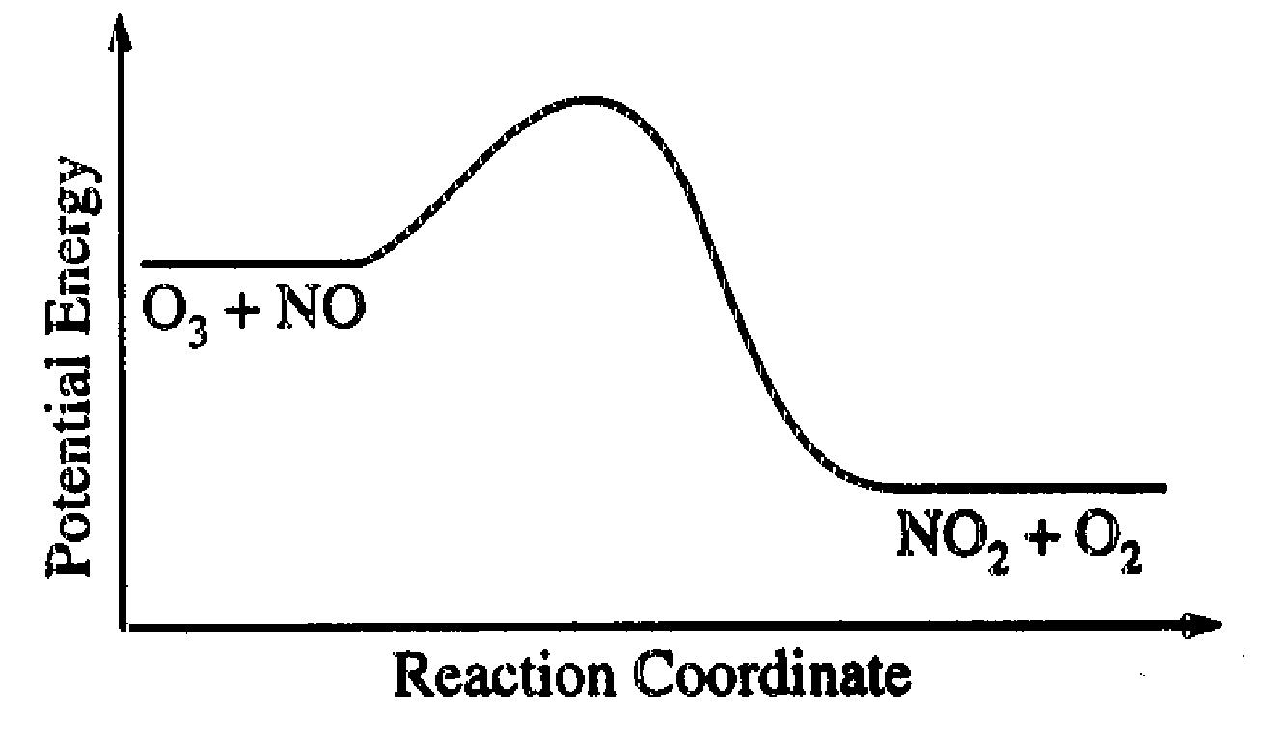
(i) The activation energy (E_{a}) for the forward reaction

(ii) The enthalpy change (ΔH) for the reaction

(b) The reaction 2 N₂O₅ → 4 NO₂ + O₂ is first order with respect to N₂O₅.
(i) Using the axes at right, complete the graph that represents the change in [N₂O₅] over time as
the reaction proceeds.
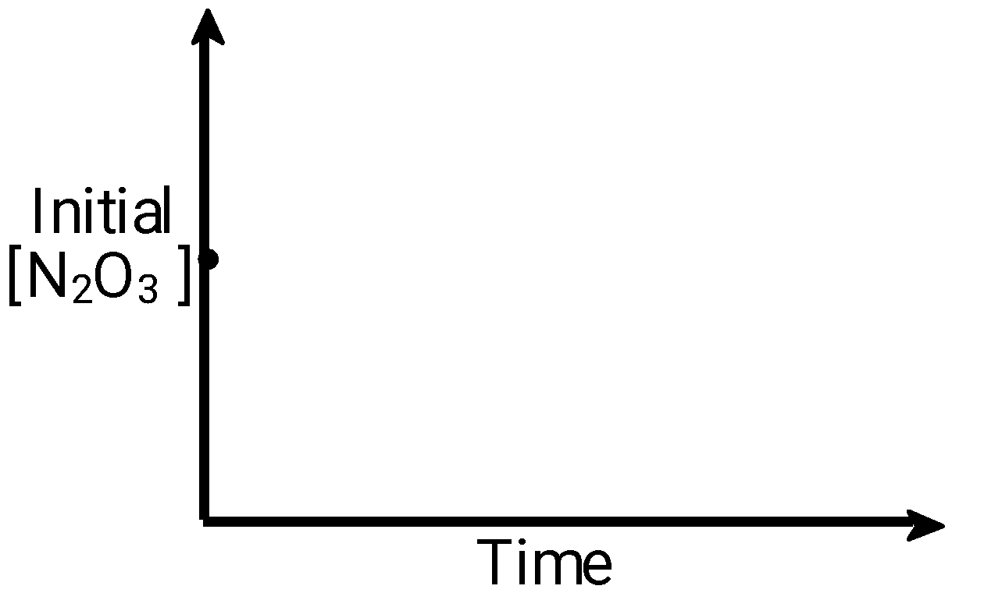
(ii) Describe how the graph in (i) could be used to find the reaction rate at a given time, t.

(iii) Considering the rate law and the graph in (i), describe how the value of the rate constant, k, could be determined.

(iv) If more N₂O₅ were added to the reaction mixture at constant temperature, what would be the effect on the rate constant, k ? Explain.

- Kinetic results for a reaction involving substance A are shown below.
Time (mins) [A] in mol L-1
0.000 1.00
2.00 0.82
4.00 0.67
7.00 0.49
10.0 0.37
14.0 0.24
20.0 0.14
(a) Plot and record data from a graph of these results.

(b) What is the order of this reaction with respect to A?

(c) Use your graph to calculate the half-life for this reaction.

(d) Given that in this reaction, A reacts with G, and that the order with respect to G is second, write
the rate equation for this reaction.

- Time in minutes [B] in mol L-1
0.00 1.00
2.00 0.790
4.00 0.590
7.00 0.300

(a) Plot and record data from a graph of these results.

(b) What is the order with respect to B in this reaction?

(c) What can be said about the rate of consumption of B in this reaction?

- [X] in mol L⁻¹ 0.0032 0.0064 0.0096 0.0100 0.0111 0.0200
Rate in m min⁻¹ 9.2 9.2 9.2 9.2 9.2 9.2

(a) Plot and record data from a graph of these results.

(b) What is the order with respect to X in this reaction?
Reaction Mechanisms

- A mechanism is proposed for the decomposition of hydrogen peroxide:
H₂O₂ 🡪 2OH
H₂O₂ + OH 🡪 H₂O + HO₂
HO₂ + OH 🡪 H₂O + O₂

Write the overall reaction for the decomposition of hydrogen peroxide.

Identify any intermediates and catalysts in the mechanism.

Identify the molecularity of each of the e steps in the mechanism.

Write the skeletal rate law for each elementary step.

Write the skeletal rate law for the overall reaction written in part a.

Which step seems to be the rate determining step?

Write the rate expressions for the overall reaction.

Determine the rate order by graphing.

Write the overall rate law.

Calculate the rate constant.

Find the half-life of this reaction.

Time (s) | [H₂O₂](M)
0 | 1.27
100 | 1.23
300 | 1.15
600 | 1.04
1200 | 0.85
1800 | 0.70
2400 | 0.58
3600 | 0.39

AP Rates Questions

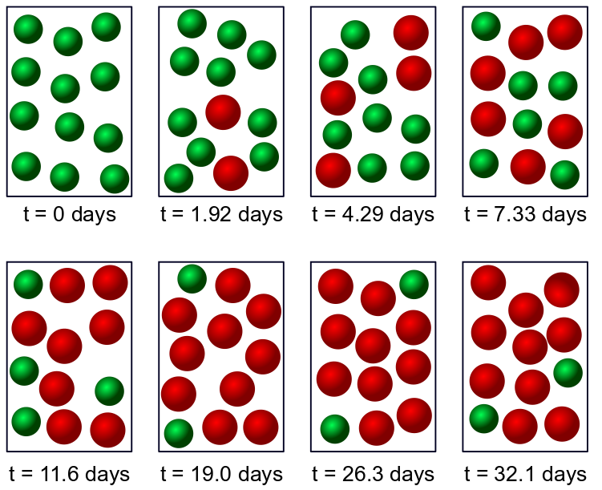
Half Life
- A student is investigating the reaction A ⇌ B. The data that they collected is shown below. Based on this information, answer the following questions.
- Determine the half-life at two different points in the reaction. In your answer, state that at time = x days, I had ___ amount of A and at time = y days, I had _______ amount of A.

- What should you be able to conclude from your answers to (a)?

- What is the value for the rate constant, k? Specify the units for the rate constant, k.

- Write the rate law for this reaction.

- At what time was equilibrium reached? How do you know that you have reached equilibrium?
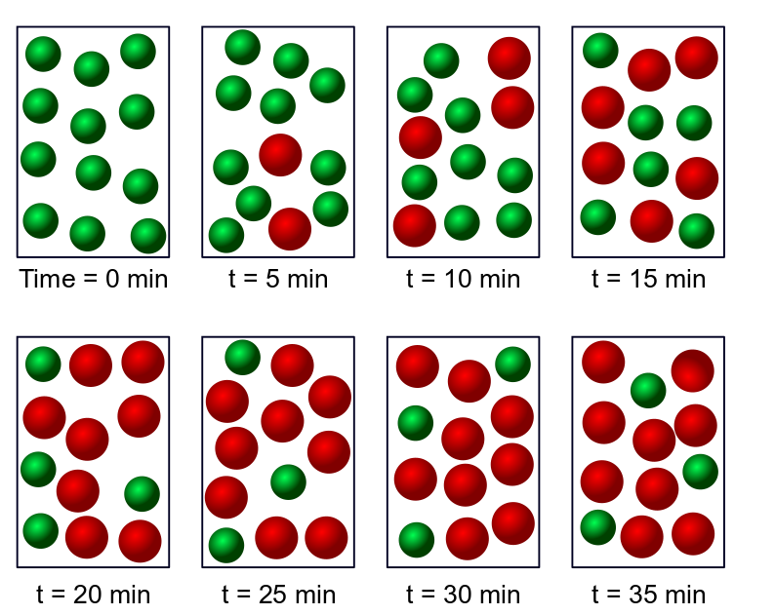
2. A student is investigating the reaction G ⇌ R. The data that they collected is shown below. Based on this information, answer the following questions.
- Determine the half-life at two different points in the reaction.

- What is the value for the rate constant, k? Specify the units for the rate constant, k.

- Write the rate law for this reaction.

- At what time was equilibrium reached? How do you know that you have reached equilibrium?

AP Problems
- The decomposition of compound X is an elementary process that proceeds as follows:
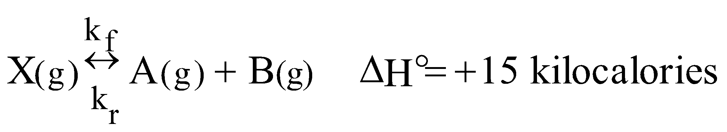
The forward reaction is slow at room temperature but becomes rapid when a catalyst is added.
(a)Draw a diagram of potential energy vs reaction coordinate for the uncatalyzed reaction. On this diagram label:
(1) the axes
(2) the energies of the reactants and the products
(3) the energy of the activated complex
(4) all significant energy differences

(b)On the same diagram indicate the change or changes that result from the addition of the catalyst. Explain the role of the catalyst in changing the rate of the reaction.

(c)If the temperature is increased, will the ratio ^{k}f/k_{r} increase, remain the same, or decrease? Justify your answer with a one or two sentence explanation. [k_{f} and k_{r} are the specific rate constants for the forward and the reverse reactions, respectively.]

2 ClO₂(g) + F₂(g) → 2 ClO₂F(g)
- The following results were obtained when the reaction represented above was studied at 25°C.
Experiment | Initial [ClO₂], (mol.L⁻¹) | Initial [F₂], (mol.L⁻¹) | Initial Rate of Increase of [ClO₂F],  (mol.L^{-1.}sec⁻¹)
1 | 0.010 | 0.10 | 2.4×10⁻³
2 | 0.010 | 0.40 | 9.6×10⁻³
3 | 0.020 | 0.20 | 9.6×10⁻³
(a) Write the rate law for the reaction above.

(b) Calculate the numerical value of the rate constant and specify the units.

(c) In experiment 2, what is the initial rate of decrease of [F₂]?

(d) Which of the following reaction mechanisms is consistent with the rate law developed in (a).
Justify your choice.
I. ClO₂ + F₂ ↔ ClO₂F₂ (fast)
ClO₂F₂ → ClO₂F + F (slow)
ClO₂ + F → ClO₂F (fast)
II. F₂ → 2 F (slow)
2 (ClO₂ + F → ClO₂F) (fast)

H₂(g) + I₂(g) → 2 HI(g)
- For the exothermic reaction represented above, carried out at 298K, the rate law is as follows.
Rate = k[H₂][I₂]
Predict the effect of each of the following changes on the initial rate of the reaction and explain your prediction.
(a) Addition of hydrogen gas at constant temperature and volume

(b) Increase in volume of the reaction vessel at constant temperature

(c) Addition of catalyst. In your explanation, include a diagram of potential energy versus reaction coordinate.

(d) Increase in temperature. In your explanation, include a diagram showing the number of molecules as a function of energy.

2 NO(g) +2 H₂(g) → N₂(g) + 2 H₂O(g)
- Experiments were conducted to study the rate of the reaction represented by the equation above. Initial concentrations and rates of reaction are given in the table below.
 | Initial Concentration (mol/L) |  | Initial Rate of Formation of N₂
Experiment | [NO] | [H₂] | (mol/L.min)
1 | 0.0060 | 0.0010 | 1.8 ×10⁻⁴
2 | 0.0060 | 0.0020 | 3.6 ×10⁻⁴
3 | 0.0010 | 0.0060 | 0.30 ×10⁻⁴
4 | 0.0020 | 0.0060 | 1.2 ×10⁻⁴
(a) (i) Determine the order for each of the reactants, NO and H₂, from the data given and show your reasoning.

(ii) Write the overall rate law for the reaction.

(b) Calculate the value of the rate constant, k, for the reaction. Include units.

(c) For experiment 2, calculate the concentration of NO remaining when exactly one-half of the original amount of H₂ had been consumed.

(d) The following sequence of elementary steps is a proposed mechanism for the reaction.
I. NO + NO ↔ N₂O₂
II. N₂O₂ + H₂ → H₂O + N₂O
III. N₂O + H₂ → N₂ + H₂O
Based on the data presented, which of the above is the rate-determining step? Show that the mechanism is consistent with
(i) the observed rate law for the reaction, and
(ii) the overall stoichiometry of the reaction.

Review 1st and 2nd Order Reactions
 | Equation | X | Y | Slope | k
First Order
Second Order
1. Find the final concentration of reactant A after 50 seconds when the initial concentration is 2.50M at 230C. k=5.60x10⁻⁶s⁻¹.

2. Find the initial concentration of reactant Cl₂ after 120 seconds when the final concentration is 0.350M at 400C. k=2.30x10⁻⁵s⁻¹.

3. Find the rate constant of a first order reaction when reactant M decreases from 5.0M to 3.0M in 125s.

4. Find the time it takes reactant B to decrease from 2.3M to 1.4M. k=1.23x10⁻²s⁻¹.

5. Find the final M of t NO₂ after 230 seconds when the initial concentration is 1.57M at 20C. k=3.75x10⁻⁸M⁻¹s⁻¹.

6. Find the initial M of X after 2.0 minutes when the final concentration is 2.150M at 580C. k=1.50x10⁻³ M⁻¹s ⁻¹.

7. Find the rate constant of a second order reaction when reactant O₂ decreases from 5.8M to 3.2M in 87s.

8. Find the time it takes reactant Cu(NO₃)₂ to decrease from 3.8M to 0.25M. k=3.50x10⁻⁴ M⁻¹s ⁻¹.

9. Find the half-life of a first order reaction if k=2.30x10⁻⁵s⁻¹

10. Find the half-life of a second order reaction if k=2.30x10⁻⁵ M⁻¹s ⁻¹

11. Find the rate constant of a first order reaction if the half-life is 65 seconds.
AP Chemistry: Kinetics Multiple Choice
Questions 25-26
H₃AsO₄ + 3I⁻+ 2 H₃O⁺ 🡪 H₃AsO₃ + I₃⁻ + H₂O
The oxidation of iodide ions by arsenic acid in acidic aqueous solution occurs according to the stoichiometry shown above. The experimental rate law of the reaction is: Rate = k [H₃AsO₄] [I⁻] [H₃O⁺]
25. What is the order of the reaction with respect to I⁻?
(A) 1 (B) 2 (C) 3 (D) 5 (E) 6
26. According to the rate law for the reaction, an increase in the concentration of hydronium ion has what effect on this reaction?
(A) The rate of reaction increases. (B) The rate of reaction decreases.
(C) The value of the equilibrium constant increases. (D) The value of the equilibrium constant decreases.
(E) Neither the rate nor the value of the equilibrium constant is changed.
28. 2 A_{(g)} + B_{(g)} ⇄ 2 C_{(g)}
When the concentration of substance B in the reaction above is doubled, all other factors being held constant, it is found that the rate of the reaction remains unchanged. The most probable explanation for this observation is that…
(A) the order of the reaction with respect to substance B is 1.
(B) substance B is not involved in any of the steps in the mechanism of the reaction.
(C) substance B is not involved in the rate-determining step of the mechanism, but is involved in subsequent steps.
(D) substance B is probably a catalyst, and as such, its effect on the rate of the reaction does not depend on its concentration.
(E) the reactant with the smallest coefficient in the balanced equation generally has little or no effect on the rate of the reaction.
Step 1) N₂H₂O₂ ⇄ N₂HO₂⁻ + H⁺ |  |  |  | fast equilibrium
Step 2) N₂HO₂⁻ 🡪 N₂O + OH⁻ |  |  |  | (slow)
Step 3) H⁺ + OH⁻ 🡪 H₂O |  |  |  | (fast)
82. Nitramide, N₂H₂O₂, decomposes slowly in aqueous solution. This decomposition is believed to occur according to the reaction mechanism above. The rate law for the decomposition of nitramide that is consistent with this mechanism is given by which of the following?
(A) Rate = k [N₂H₂O₂] (B) Rate = k [N₂H₂O₂] [H⁺] (C) Rate = (k [N₂H₂O₂]) / [H⁺]
(D) Rate = (k [N₂H₂O₂]) / [N₂HO₂⁻] (E) Rate = k [N₂H₂O₂] [OH⁻]
57. rate = k[X]
For the reaction whose rate law is given above, a plot of which of the following is a straight line?
(A) [X] versus time (B) ln [X] versus time (C) 1/[X] versus time
(D) [X] versus 1/time (E) ln [X] versus 1/time
58. (CH₃)₃CCl_{(aq)} + OH⁻ 🡪 (CH₃)₃COH_{(aq)} + Cl⁻
For the reaction represented above, the experimental rate law is given as follows:
Rate = k [(CH₃)₃CCl]
If some solid sodium solid hydroxide is added to a solution that is 0.010-molar in (CH₃)₃CCl and 0.10-molar in NaOH, which of the following is true? (Assume the temperature and volume remain constant.)
(A) Both the reaction rate and k increase. (B) Both the reaction rate and k decrease.
(C) Both the reaction rate and k remain the same. (D) The reaction rate increases but k remains the same.
(E) The reaction rate decreases but k remains the same.
17. Relatively slow rates of chemical reaction are associated with which of the following?
(A) The presence of a catalyst (B) High temperature (C) High concentration of reactants
(D) Strong bonds in reactant molecules (E) Low activation energy
Step 1: Ce⁴⁺ + Mn²⁺ 🡪 Ce³⁺ + Mn³⁺
Step 2: Ce⁴⁺ + Mn³⁺ 🡪 Ce³⁺ + Mn⁴⁺
Step 3: Mn⁴⁺ + Tl⁺ 🡪 Tl³⁺ + Mn²⁺
23. The proposed steps for a catalyzed reaction between Ce⁴⁺ and Tl⁺ are represented above. The products of the overall catalyzed reaction are…
(A) Ce⁴⁺ and Tl⁺
(B) Ce³⁺ and Tl³⁺
(C) Ce³⁺ and Mn³⁺
(D) Ce³⁺ and Mn⁴⁺
(E) Tl³⁺ and Mn²⁺
49. The isomerization of cyclopropane to propylene is a first-order process with a half-life of 19 minutes at 500 °C. The time it takes for the partial pressure of cyclopropane to decrease from 1.0 atmosphere to 0.125 atmospheres at 500 °C is closest to…
(A) 38 minutes (B) 57 minutes (C) 76 minutes (D) 152 minutes (E) 190 minutes
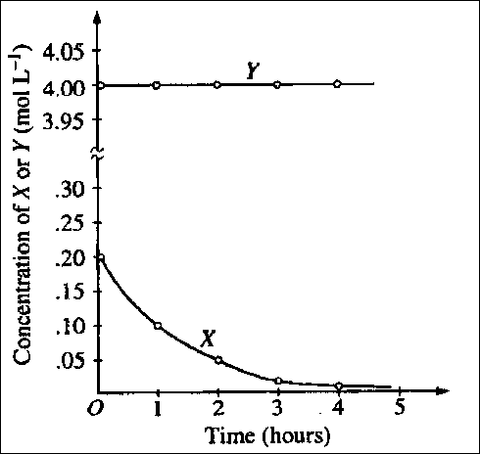
63. The graph to the right shows the results of a study of the reaction of X with a large excess of Y to yield Z. The concentrations of X and Y were measured over a period of time. According to the results, which of the following can be concluded about the rate of law for the reaction under the conditions studied?

(A) It is zero order in [X]. (B) It is first order in [X].

(C) It is second order in [X]. (D) It is the first order in [Y].

(E) The overall order of the reaction is 2.

Experiment |  | Initial [NO] | Initial [O₂] |  | Initial Rate of Formation of NO₂
 |  | (mol L⁻¹) | (mol L⁻¹) |  | (mol L⁻¹ s⁻¹)
1 |  | 0.1 | 0.1 |  | 2.5 x 10⁻⁴
2 |  | 0.2 | 0.1 |  | 5.0 x 10⁻⁴
3 |  | 0.2 | 0.4 |  | 8.0 x 10⁻³
36. The initial-rate data in the table above were obtained for the reaction represented below. What is the experimental rate law for the reaction?
(A) rate = k[NO] [O₂] (B) rate = k[NO] [O₂]² (C) rate = k[NO]² [O₂]
(D) rate = k[NO]² [O₂]² (E) rate = k[NO] / [O₂]
57. Rate = k[M][N]²
The rate of a certain chemical reaction between substances M and N obeys the rate law above. The reaction is first studied with [M] and [N] each 1 × 10⁻³ molar. If a new experiment is conducted with [M] and [N] each 2 × 10⁻³ molar, the reaction rate will increase by a factor of …
(A) 2 (B) 4 (C) 6 (D) 8 (E) 16

27. 2 NO(g) + O₂(g) → 2 NO₂(g)
A possible mechanism for the overall reaction represented above is the following:
(1) NO(g) + NO(g) → N₂O₂(g) slow
(2) N₂O₂(g) + O₂(g) → 2 NO₂(g) fast
Which of the following rate expressions agrees best with this possible mechanism?
(A) Rate = k[NO]² (D) Rate = k[NO]²[O₂]
(B) Rate = k[NO] (E) Rate = k[N₂O₂][O₂]
[O₂]
(C) Rate = k[NO]²
[O₂]
47. Which of the following is a correct statement about reaction order?
(A) Reaction order can only be a whole number
(B) Reaction order can be determined only from the coefficients of the balanced equation for the reaction
(C) Reaction order can be determined only by experiment
(D) Reaction order increases with increasing temperature
(E) A second-order reaction must involve at least two different compounds as reactants
54. Which of the following must be true for a reaction for which the activation energy is the same for both the forward and the reverse reactions?
(A) A catalyst is present.
(B) The reaction order can be obtained directly from the balanced equation.
(C) The reaction order is zero.
(D) ΔH° for the reaction is zero.
(E) ΔS° for the reaction is zero.
55. Time (days) 0 1 2 3 4 5 6 7 … 10 … 20
% Reactant Remaining 100 79 63 50 40 31 25 20 … 10 … 1
A reaction was observed for 20 days and the percentage of the reactant remaining after each day was recorded in the table above. Which of the following best describes the order and the half-life of the reaction?
Reaction Order Half-life(days)
(A) First 3
(B) First 10
(C) Second 3
(D) Second 6
(E) Second 10

AP FRQ 2015:

Na₂C₃₇H₃₄N₂S₃O₉ + OCl⁻ → products
blue colorless
Blue food coloring can be oxidized by household bleach (which contains OCl⁻ ) to form colorless products, as represented by the equation above. A student used a spectrophotometer set at a wavelength of 635 nm to study the absorbance of the food coloring over time during the bleaching process. In the study, bleach is present in large excess so that the concentration of OCl⁻ is essentially constant throughout the reaction. The student used data from the study to generate the graphs below.
- Based on the graphs above, what is the order of the reaction with respect to the blue food coloring?

- The reaction is known to be first order with respect to bleach. In a second experiment, the student prepares solutions of food coloring and bleach with concentrations that differ from those used in the first experiment. When the solutions are combined, the student observes that the reaction mixture reaches an absorbance near zero too rapidly. In order to correct the problem, the student proposes the following three possible modifications to the experiment.
• Increasing the temperature
• Increasing the concentration of the food coloring
• Increasing the concentration of the bleach
Circle the one proposed modification above that could correct the problem, and explain how that modification increases the time for the reaction mixture to reach an absorbance near zero.

- In another experiment, a student wishes to study the oxidation of red food coloring with bleach. How would the student need to modify the original experimental procedure to determine the order of the reaction with respect to the red food coloring?
AP Multiple Choice
1994
Concentrations of colored substances are commonly measured by means of a spectrophotometer. Which of the following would ensure that correct values are obtained for the measured absorbance?
I. There must be enough of the sample in the tube to cover the entire light path.
II. The instrument must be periodically reset using a standard.
III. The solution must be saturated.
(A) I only (B)II only (C) I and II only (D) II and III only (E) I, II, and III

1999
Appropriate uses of a visible-light spectrophotometer include which of the following?
I. Determining the concentration of a solution of Cu(NO₃)₂
II. Measuring the conductivity of a solution of KMnO₄
III. Determining which ions are present in a solution that may contain Na⁺, Mg²⁺, Al³⁺
(A) I only (B) II only (C) III only (D) I and II only (E) I and III only

2014

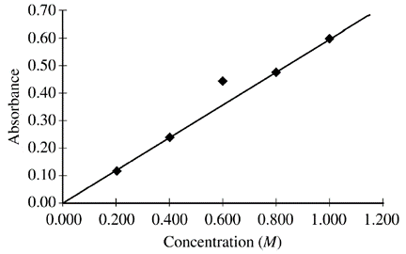
A student prepared five solutions of CuSO₄ with different concentrations, and then filled five cuvettes, each containing one of the solutions. The cuvettes were placed in a spectrophotometer set to the appropriate wavelength for maximum absorbance. The absorbance of each solution was measured and recorded. The student plotted absorbance versus concentration, as shown in the figure above. Which of the following is the most likely explanation for the variance of the data point for the 0.600 M CuSO₄ solution?
(A) The cuvette into which the 0.600 M solution was placed had some water droplets inside.
(B) The cuvette into which the 0.600 M solution was placed was filled slightly more than the other cuvettes.
(C) The wavelength setting was accidentally moved away from that of maximum absorbance.
(D)The cuvette used for the 0.600 M solution had not been wiped clean before being put in the
spectrophotometer.

2016
C₂₅H₃₀N₃⁺(aq) + OH–(aq) → C₂₅H₃₀N₃OH(aq)
violet colorless
The reaction between C₂₅H₃₀N₃⁺(aq) and OH–(aq), as represented above, is first order with respect to
C₂₅H₃₀N₃⁺(aq) in the presence of excess OH–(aq). A 10.0 mL sample of 0.10 M NaOH(aq) is mixed with a 10.0 mL sample of 2.5 × 10^{–5} M C₂₅H₃₀N₃⁺(aq). A 5.0 mL sample of the mixture is quickly transferred to a clean cuvette and placed in a spectrophotometer, and the progress of the reaction is measured. The data are given in the table below.
Time (s) | 0 | 30 | 60 | 90 | 120 | 150 | 180 | 210 | 240 | 270 | 300
Absorbance | 0.62 | 0.54 | 0.47 | 0.41 | 0.36 | 0.31 | 0.27 | 0.23 | 0.20 | 0.17 | 0.15
To choose a wavelength to analyze the progress of the reaction, a student records the absorbance spectra of both C₂₅H₃₀N₃⁺(aq) and C₂₅H₃₀N₃OH(aq) in the range of 200-800 nm. The two spectra are presented in the graph below.
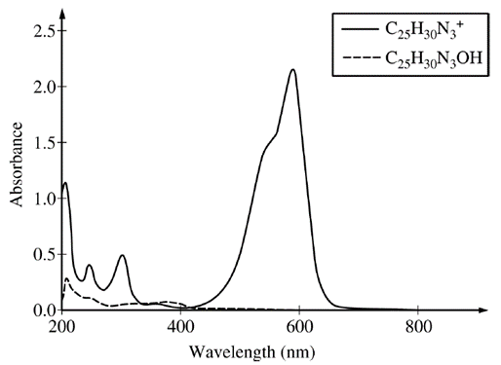
The student wants to use the spectrophotometer to measure [C₂₅H₃₀N₃⁺] with the greatest sensitivity as the reaction progresses. Which of the following indicates the best wavelength setting and explains why it is best?
(A) 205 nm, because the colorless form of the molecule will absorb significantly at this wavelength
(B) 205 nm, because both forms of the molecule will absorb significantly at this wavelength
(C) 590 nm, because only the violet form of the molecule will absorb significantly at this wavelength
(D) 590 nm, because this wavelength falls in the violet region of the visible light spectrum

2018
2 NO₂(g) ⇄ N₂O₄(g)
dark brown colorless
The dimerization of NO₂(g), an exothermic process, is represented by the equation above.
Which of the following experimental techniques will allow the most accurate determination of the concentration of NO₂(g) at equilibrium?
(A) Paper chromatography (C) Titration
(B) Gravimetric analysis (D) Spectrophotometry
2021
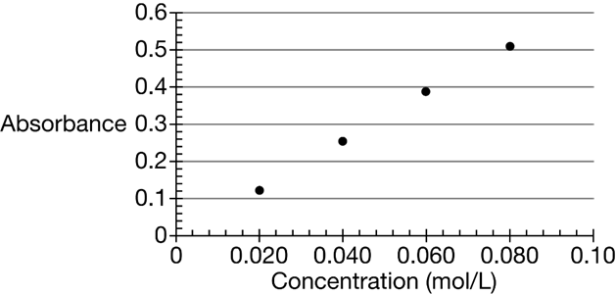
An experiment was performed to investigate the reaction between Zn metal and Ni²⁺(aq) at different concentrations. Because the Ni²⁺(aq) ion is green, the extent of the reaction was determined using spectrophotometric analysis. Four 20.0 mL standard solutions of Ni²⁺(aq) were prepared by dissolving NiCl₂•6H₂O (molar mass 240 g/mol) in water. The absorbance of each solution was measured; the results are shown both in the table below and in the following plot of the absorbance data.
Solution | [Ni²⁺] | Absorbance
1 | 0.020 | 0.12
2 | 0.040 | 0.25
3 | 0.060 | 0.39
4 | 0.080 | 0.51

The concentration of Cl–(aq) ions in solution 2 was
(A) 0.020 M
(B) 0.040 M
(C) 0.060 M
(D) 0.080 M

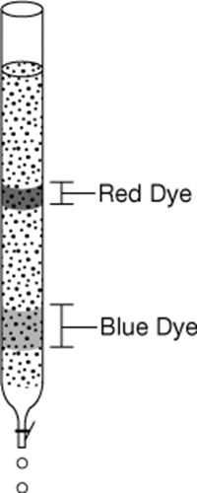
What is the expected absorbance of a standard solution made by dissolving 0.0070 mol of NiCl₂•6H₂O in water to make 100. mL of solution?
(A) 0.0039
(B) 0.0080
(C) 0.045
(D) 0.45

A student placed a sample of a food coloring that contains a mixture of a blue dye and a red dye at the top of a chromatography column filled with a nonpolar stationary phase. When water is poured through the column, two bands of colors are seen in the column, as shown in the diagram above.
A student collects a sample of the blue dye from the column in a cuvette. Which of the following is least useful to determine the concentration of the sample using a spectrophotometer set at 640 nm?
(A) The volume of the sample
(B) The path length of the cuvette
(C) The absorbance of the dye at 640 nm
(D) The molar absorptivity of the dye at 640 nm
How to Graph in Sheets

- To Input data: Type numbers into the chart cells (preferably independent x values in column A with axes name at the top and dependent y values with axes name at the top- but this can be modified later).
  - If you want to manipulate your data (for example take the natural log of each number and make a new column) in the next column of the sheet, enter the “=+ select the function (such as natural log) from the function button (Σ) and type which previous cell you are modifying (example =LN(B2) would take the natural log of B2).
  - Drag the bottom left corner of that box down to allow morse boxes to perform that calculation.
- To create a Graph: Highlight the data you wish to plot. Select “Insert” and “chart” from the top menu. The chart editor should appear on the left of the screen. You can select the line graph at the top. If you input the data with labels as instructed above, the axes may already be labeled and the x and y should be correct.
- To modify your graph: Select “customize” on the top of the chart editor. The use drop down features:
  - Chart style: You can change the color of the background of the graph, font and border colors….
  - Chart & Axes title: Change the name of the graph and font options. Use the drop down feature to change the axis names and fonts.
  - Series:Change plot line color and thickness, points shapes, etc. You may include error bars, data labels and trend lines if needed. If you select “trendline” an option will appear to “show equation” and “add R²” values to determine how straight your linear graph is and its slope and y intercept values (appears in the legend).
  - Legend: change the position and contents of the legend
  - Horizontal axis: Change the x axis fonts. Reverse axes order will plot the x axis from big to small instead of small to big numbers.You may choose min and max axes numbers.
  - Vertical axis: same as horizontal but for y axis.
  - Gridlines and Ticks:allows you to add more gridlines to the page.
- To evaluate your graph:
  - Symbols:
    - Cells: The cells of your data are labeled with the column letter and row number (coordinate), for example A1
    - Colon: The colon symbol used between Cell coordinates uses data from all cells between the coordinates (for example B1:B3 will use data from B1, B2,a and B3)
  - To find slope: In any empty cell type =SLOPE and cell options will appear. Type in the cell coordinates of the first data point (like A1) followed by a colon : and then the last data point cell coordinate after the colon (example B2:B9 would use B2-B9 data). Then add a comma to separate the y axis data and the x axes data. Select the cell coordinate for the first data point for x, followed by a colon : and the last data point cell coordinate. (example: =SLOPE (B2:B9, A2:A9) would plot B2-B9 as my y axes and A2-A9 as my y axes). ‘
- Extras: You can add multiple graphs all in one plot by selecting all the data and then selecting “insert” and “chart.” Screen grab your chart to add it to other files.

