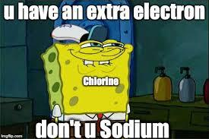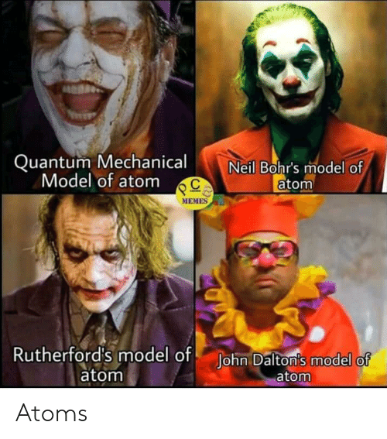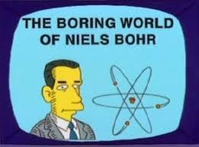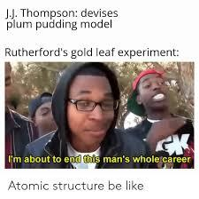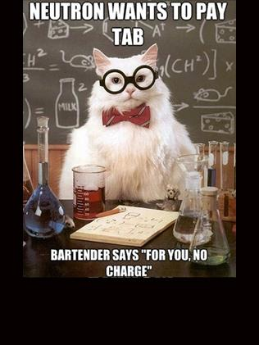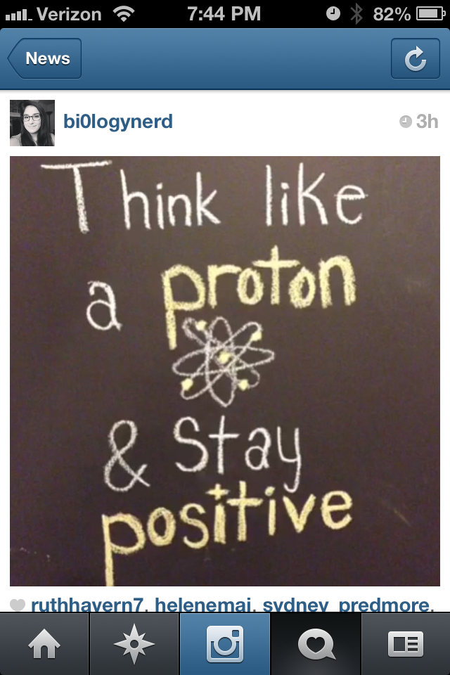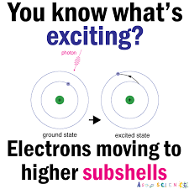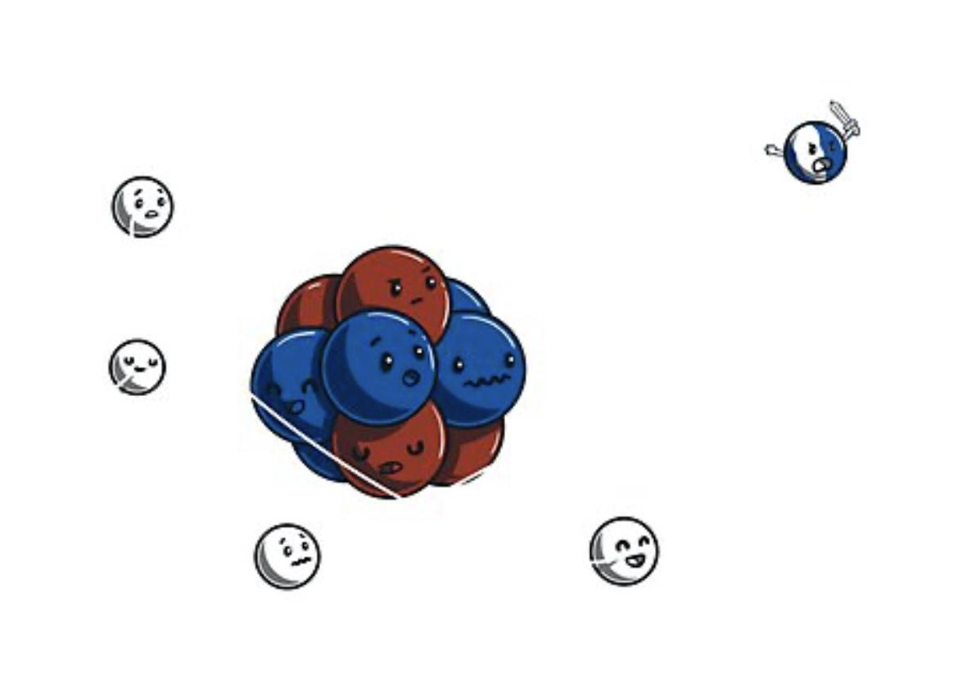

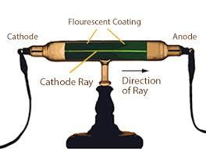 **Rutherford** Think Tank Problems

A scientist, John Dalton presumed atoms were the smallest particle in the universe and stated that they were small hard spheres. Years later J.J. Thomson was experimenting with an apparatus known as the cathode ray tube (used in old TVs!). He evacuated the chamber of any known substances and passed electricity through it. He was shocked to see a glowing green light. He noticed the green light was flowing towards the positive electrode of his tube. He discovered the first particle inside “the smallest particle” and it was later called an electron. Watch this: <https://www.youtube.com/watch?v=XBqHkraf8iE> 

1. What is the charge of an electron, according to the saying “opposites attract?”

The student of Thomson, Ernest Rutherford, sets up an experiment to determine if the atom is in fact the smallest particle. He decided to shoot lasers at gold foil. Read about it below: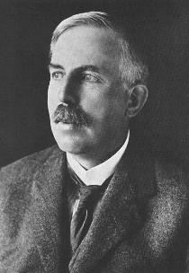

Ernest Rutherford performed the “Gold Foil'' experiment in 1911 which helped him develop the “solar system’” or “nuclear” model of the atom. He used alpha particles (small but dense **positively charged** particles emitted like x-rays) and shot them at gold foil. He assumed that either the particles would go straight through the foil like an x-ray through a person’s skin, or they would be deflected back like x-rays on the lead suit you wear at the dentist. So he placed a detection chamber around his experiment to detect the alpha particles (and to shield himself from the radiation).

1. 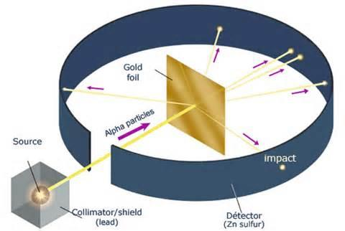If you threw a stream of tennis balls at a brick wall what would happen?
2. If you threw a stream of tennis balls at smoke what would happen?
3. If Dalton’s model is correct and the atom is a solid sphere; when alpha particles (tennis balls) were shot at the gold foil (wall), what should happen?
4. If Thomson’s model is correct and the atom is a positive cloud (smoke) with electrons scattered throughout; when alpha particles (tennis balls) were shot at the cloud (smoke), what should happen?
5. When Rutherford performed his experiment, for every 100 alpha particles, only one particle was deflected. All other 99 particles traveled straight through the foil.
   1. What does deflected mean?
   2. Was the probability of hitting the nucleus high or low?
   3. Does that mean the nucleus is small or large?*
   4. Is that atom mostly solid or mostly empty?*
   5. Rutherford knew the alpha particles are positive and they were deflected by the nucleus, rather than attracted to it. What is the charge of the nucleus?*
   6. If the nucleus deflected the alpha particles, was it massive or not?*
   7. Where could the negatively charged electrons be?
   8. Are the electrons massive? How can you tell?
6. Put all the questions with an asterisk (*) next to them together to explain Rutherford’s results.
7. Watch the demonstration performed by your teacher about centripetal force.
   1. Negative electrons attract positive protons. So why don’t electrons collapse into the nucleus?
   2. Draw the Rutherford model labeling the protons, neutrons, electrons, nucleus and how alpha particles may be deflected or go straight through.



**JJ Thomson and Rutherford** Check Your Understanding

1. J.J. Thomson’s Cathode Ray Tube experiment led to the discovery of

1. the positively charged subatomic particle called the electron

2. the positively charged subatomic particle called the proton

3. the positively charged subatomic particle called the proton

4. the negatively charged subatomic particle called the electron

1. In Thomson’s cathode-ray experiment, what evidence led him to believe that the ray consisted of particles, and why did he conclude that the ray was negatively charged?
2. One model of the atom states that atoms are tiny particles composed of a uniform mixture of positive and negative charges. Scientists conducted an experiment where alpha particles were aimed at a thin layer of gold atoms. Most of the alpha particles passed directly through the gold atoms. A few alpha particles were deflected from their straight-line paths. An illustration of the experiment is shown below.
   1. Most of the alpha particles passed directly through the gold atoms undisturbed. What does this evidence suggest about the structure of the gold atoms?
   2. A few of the alpha particles were deflected. What does this evidence suggest about the structure of the gold atoms?

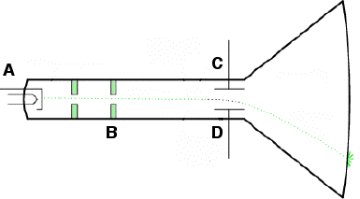

1. **A** is the anode. **B** are the alignment rods to control the path of the subatomic particle that Thomson discovered. **C** is a negative plate and **D** is a positive plate. Based on your knowledge of chemistry, label **C** and **D** as positive or negative on the diagram. Then label the subatomic particle that is coming from the source, **A**. Finally, based on the charges you drew, and the charge of the subatomic particle, draw an arrow that represents the path of that subatomic particle through the cathode ray tube.
2. On the diagram to the left, draw beams of alpha particles from the emitter to the foil with possible outcomes of the Rutherford Experiment.

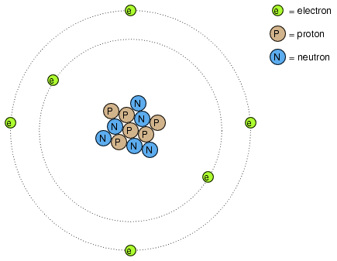 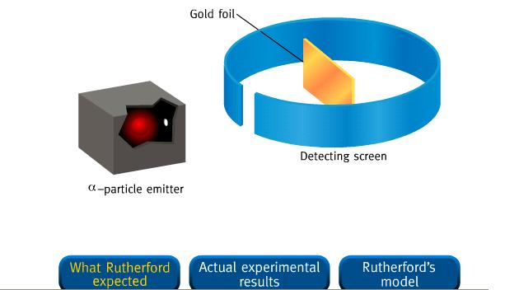

1. On the diagram to the right, draw those alpha rays on a pico-scopic scale to show the outcome(s) of the Rutherford Experiment. Label the alpha particle beam, the nucleus and the electrons with their appropriate charges.
2. Explain why the alpha particle was not attracted to the nucleus in terms of charges.
3. Last, explain the interaction, or lack of interaction, between the alpha particles and the electrons.

1. If all of the mass of an atom is in the nucleus, which subatomic particles have mass?
2. The **mass number** is the number of particles in an atom with mass. If an atom has 3 protons, 4 neutrons and 3 electrons what is its mass number?
3. If an atom has a mass number of 11 and also has 5 protons and 5 electrons how many neutrons does it have?
4. Which element is described above and what is its atomic number?
5. What does **atomic number** represent for an atom?
6. Complete the table below.

|  | Proton p+ | Neutron n0 | Electron e- |
| --- | --- | --- | --- |
| inside the nucleus or outside? |  |  |  |
| massive or not? |  |  |  |
| charge |  |  |  |

1. If atoms are neutral, what does this mean for the ratio of protons and electrons inside an atom?

**Subatomic Particles** Check Your Understanding

**Directions:** Under the headings, explain how to obtain each piece of data. Then based on the information given in the row, determine the element and its contents, thus filling out the entire chart.

| **Name** | **Symbol** | **Protons** | **Neutrons** | **Electrons** | **Atomic #** | **Mass #** |
| --- | --- | --- | --- | --- | --- | --- |
| Hydrogen |  |  | 0 | 1 |  | 1 |
|  | He | 2 |  |  |  | 4 |
| Carbon | C |  | 6 |  |  | 12 |
| Nitrogen |  |  | 7 | 7 | 7 |  |
| Oxygen | O | 8 | 8 |  | 8 |  |
| Aluminum |  |  | 14 | 13 |  | 27 |
| Iron |  | 26 | 30 |  |  |  |
|  | Co | 27 |  |  |  | 59 |
| Lithium |  |  | 4 |  |  |  |
| Beryllium | Be |  |  | 4 | 4 | 9 |
| Boron |  | 5 |  |  |  | 11 |
|  | Ne |  | 10 |  |  |  |
| Sodium |  | 11 | 12 |  |  |  |
| Fluorine |  | 9 | 10 |  |  |  |
| Nickel | Ni |  |  |  |  | 59 |
|  | Ca |  |  |  |  | 40 |

**Ions** Think Tank Questions

**Cations are _____________ charged because they _______________ _______________ when bonding.**

***(positively/negatively) (gain/lose) (electrons/protons)***

**Anions are _____________ charged because they _______________ _______________ when bonding.**

***(positively/negatively) (gain/lose) (electrons/protons)***

* If a particle has 9 protons and 10 electrons, what is the symbol and charge? ___________
* If a particle has 11 protons and 10 electrons, what is the symbol and charge? ___________
* If a particle has 12 protons and 10 electrons, what is the symbol and charge? ___________

Give a mathematical rule for determining the charge of a particle: ____________________________________

**Ions** Check Your Understanding

| **Name** | **Symbol** | **Protons** | **Neutrons** | **Electrons** | **Atomic #** | **Mass #** |
| --- | --- | --- | --- | --- | --- | --- |
| Copper ion | Cu+2 | 29 | 35 |  |  | 64 |
| Barium ion | Ba+2 |  |  |  | 56 | 137 |
|  | K+ |  |  |  |  | 39 |
| Gold ion | Au+3 |  | 118 |  | 79 |  |
| Chloride ion |  |  | 18 | 18 | 17 |  |
| Fluoride ion | F- |  | 10 |  |  |  |
| Sulfide ion | S-2 |  | 16 |  |  |  |
|  | O-2 |  |  |  |  | 16 |
| Aluminum ion |  | 13 |  | 10 |  | 27 |

**Subatomic Particles** Check Your Understanding

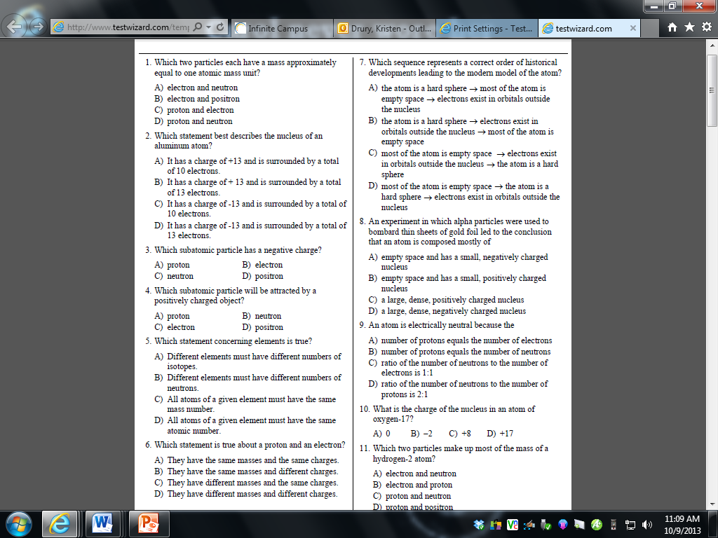

**Nuclear Charge** Think Tank Problems

1. Draw a model of Carbon with a mass number of 12.
2. How many protons, neutrons and electrons does carbon have?
3. What is the charge inside the nucleus?
4. The term **nuclear charge** represents the number and sign of the charge inside the nucleus. Protons which are __________________ charged and neutrons which are __________________ charged, are in the nucleus. This means the nucleus is always ______________ charged.

**Nuclear Charge** Check Your Understanding

| **Name** | **Symbol** | **Protons** | **Neutrons** | **Electrons** | **Atomic #** | **Mass #** | **Nuclear charge** |
| --- | --- | --- | --- | --- | --- | --- | --- |
| Oxygen |  |  | 8 | 8 | 8 | 16 | 8+ |
|  |  | 7 | 7 |  | 7 |  |  |
|  | S |  |  |  |  | 34 |  |
| Hydrogen (deuterium) |  | 1 | 1 |  | 1 |  |  |
|  |  | 9 |  |  |  | 19 |  |
| Beryllium |  |  |  |  |  | 9 |  |
|  |  | 12 |  |  |  | 24 |  |
|  |  |  |  | 92 |  | 238 | 92+ |
| Chlorine |  |  |  |  |  | 35 |  |
|  | Kr |  |  | 36 |  | 84 |  |
|  |  | 26 |  |  |  | 56 |  |
| Silver |  |  | 60 |  |  |  |  |

**Mass Spectrometry**

Model 1 shows a mass spectrometer which measures the mass of multiple atoms of an element at a time. In this example, magnesium is vaporized and the magnesium metal atoms are added to the device on the left and travel towards a magnetic field in the stage labeled “ionization.”

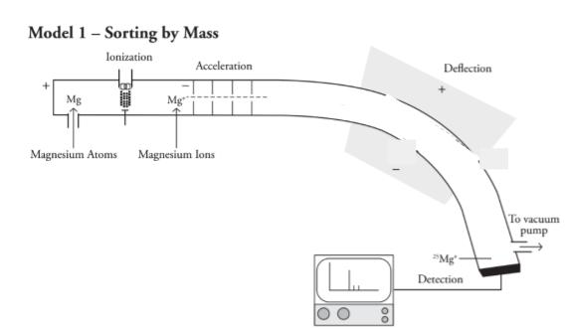

1. In terms of subatomic particles, what is an ion and how do ions form?
2. What is the charge of the magnesium ions in the spectrometer? Look closely.
3. The ions are passed through a magnetic field during “acceleration.” Imagine the magnesium ions are small magnetic marbles traveling through a tube. If the lines in the tube near the acceleration period are also magnets how could they influence the magnesium ions to travel faster (and accelerate) through the tube?
4. As the ions travel they approach a stronger magnetic field in the “deflection” section of Model 1. Sketch a dotted line that represents the path of the ions as they travel through the tube. Explain why you sketched the path you chose.
5. There is a “detection” section of model 1 which is where the ions finally collide with a metal plate and signals to the computer how many ions collided and at what angle they collided. What is the mass of a magnesium atom that you expect to collide at the detector?

Model 2 represents the mass spectra that is generated by the mass spectrometer when the magnesium is detected.

**Model 2: Mass Spectrum of Magnesium**

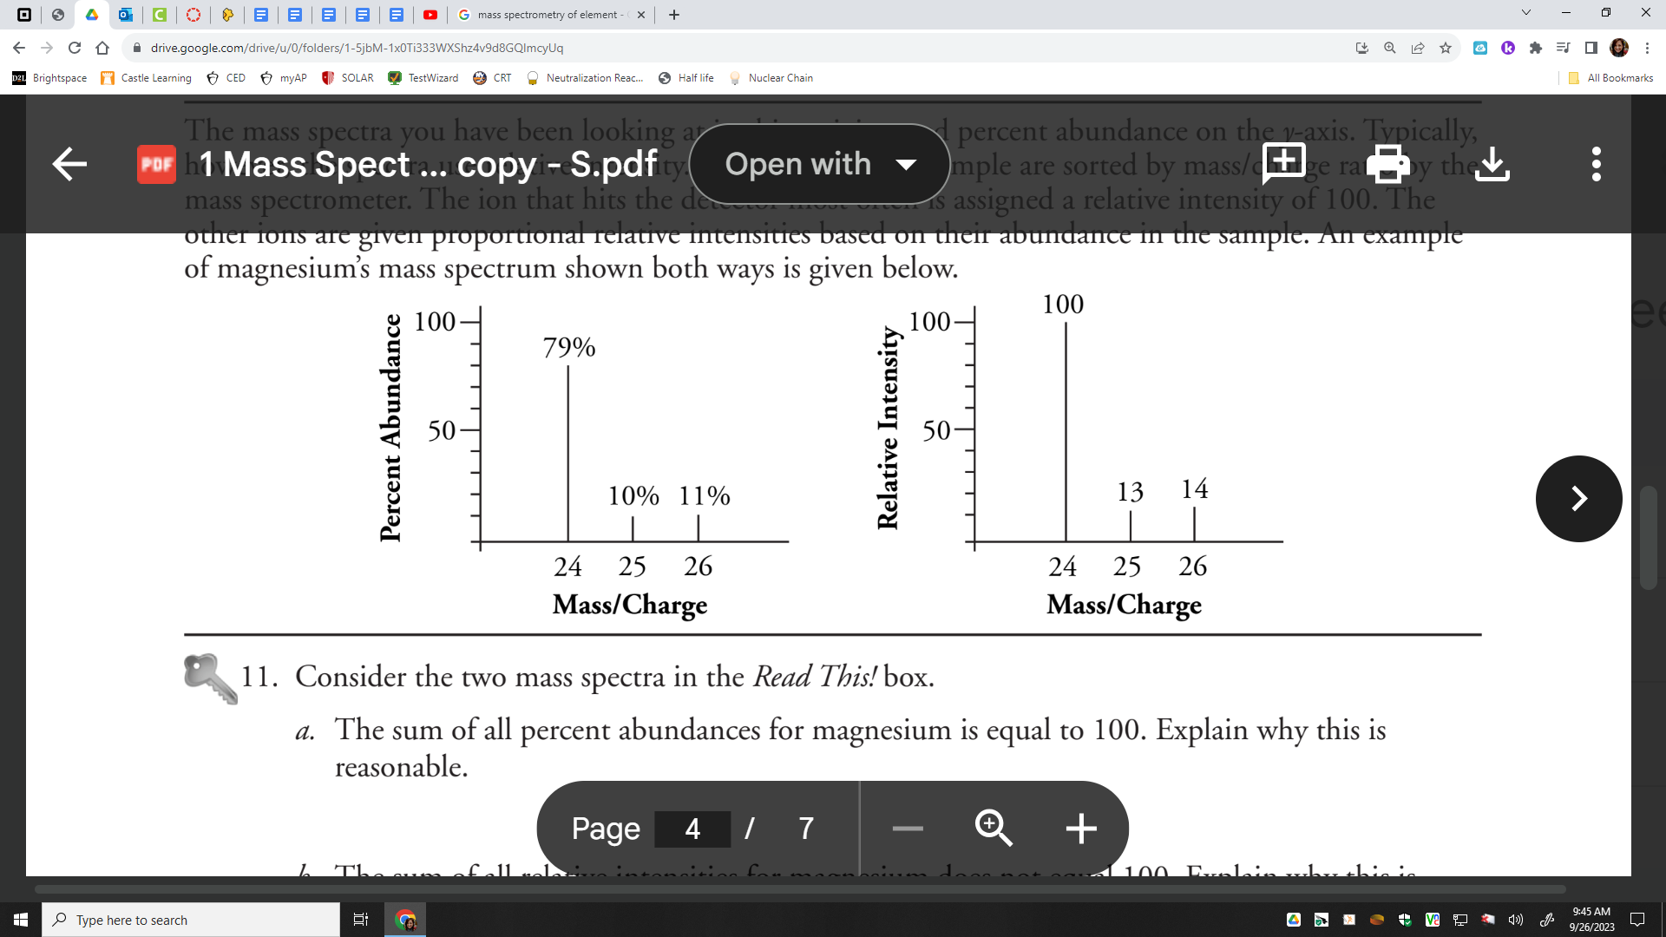

1. What masses of magnesium were detected by the mass spectrometer?
2. What mass of magnesium was most abundant in the detector?
3. Could the more massive magnesium atoms be caused by additional protons? Explain your answer.
4. Could the more massive magnesium atoms be caused by additional electrons? Explain your answer.
5. Could the more massive magnesium atoms be caused by additional neutrons? Explain your answer.

An **isotope** is an atom that has a different proton:neutron ratio than the most abundant atom of the element. Isotopes are natural and each element has different amounts of isotopes in nature. Scientists can also manufacture artificial isotopes by colliding high speed neutrons with atoms.

1. How many protons, neutrons, and electrons are in the the following isotopes of magnesium:
   1. Mg-24
   2. Mg-25
   3. Mg-26

**Model 3: Unknown Mass Spectrum**

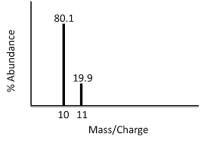

1. Identify the masses indicated on Model 3.
2. Which element could possibly have isotopes with those masses?
3. The Periodic Table of Elements provides the **Atomic Mass** of each element. Where is that located on each element’s box?
4. Is the atomic mass the mass of one atom or one isotope? Explain your answer.
5. The atomic mass is the average mass of the naturally occurring isotopes of an element. Using models 2 and 3, find the average mass of the following. (Hint: you cannot just sum the masses and divide by the number of isotopes)
   1. Magnesium
   2. Unknown
6. Compare your answers to the previous question with those provided on the periodic table.
7. The table below provides mass numbers and percent abundance information for the element lead. Draw a mass spectrum of lead.

| Pb-204 | 1.4% |
| --- | --- |
| Pb-206 | 24.1% |
| Pb-207 | 22.1% |
| Pb-208 | 52.4% |

1. Calculate the atomic mass of lead based on the data provided.
2. Compare your answers to the previous question with those provided on the periodic table.

The process of ionization inside of a mass spectrometer is quite violent. There are several methods of ionization used in industry, but many of them remove electrons from the atoms or molecules by high energy particle bombardment. In other words, the electrons are knocked off the atoms or molecules by high speed particles colliding with them. Occasionally this process will break apart a molecule. This is called fragmentation. The pieces are analyzed by the mass spectrometer along with the whole molecules.

1. The following information was gathered by mass spectroscopy for the element fluorine. Fluorine has only one natural isotope, but it does form diatomic molecules naturally. Propose an explanation for the two lines on fluorine’s mass spectrum.

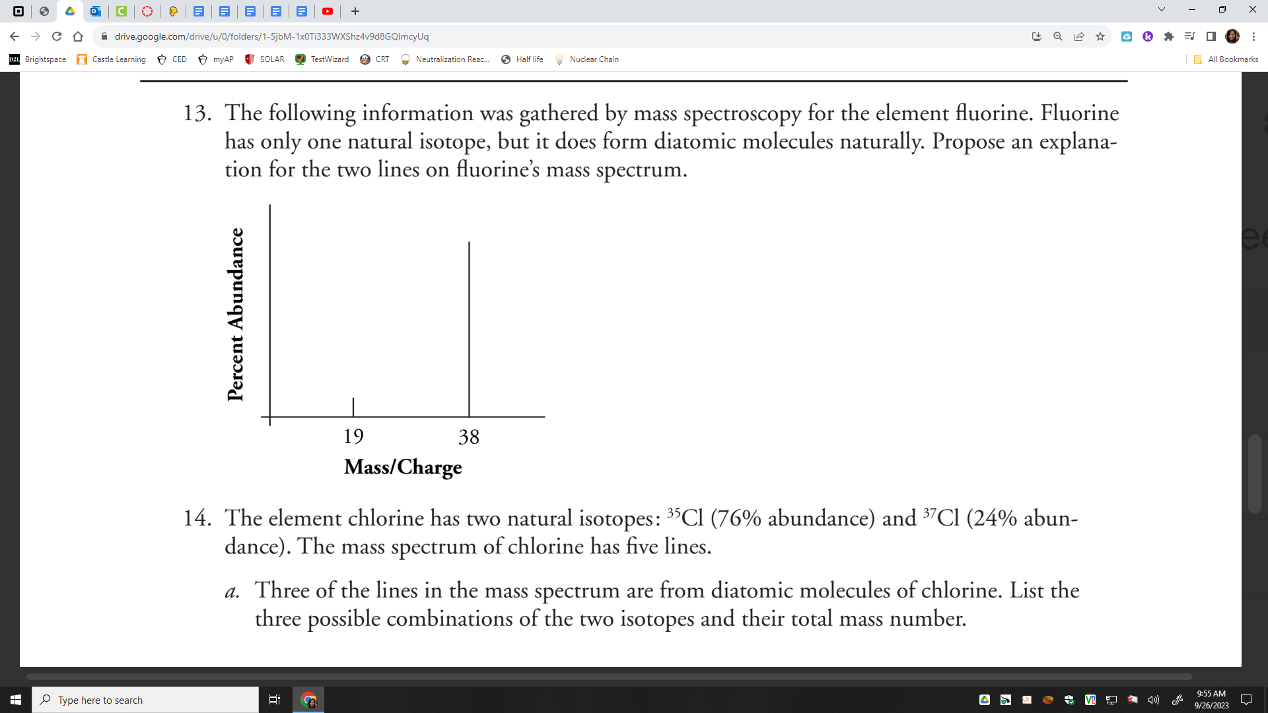

1. The element chlorine has two natural isotopes: Cl-35 (76% abundance) and Cl-37 (24% abundance). The mass spectrum of chlorine has five lines.
   1. Label the Cl-35 and Cl-37 peaks on the plot below.
   2. Three of the lines in the mass spectrum are from diatomic molecules of chlorine. List the three possible combinations of the two isotopes and their total mass number.

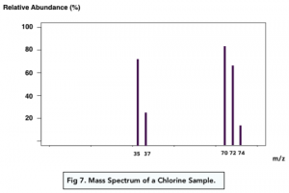

1. Calculate the atomic mass of chlorine atoms.
2. Summarize what mass spectra can be used for.
3. Mass spectra can also be used to analyze and identify larger molecules like carbon dioxide. Label each peak with the atom or molecule it may represent based on the mass.

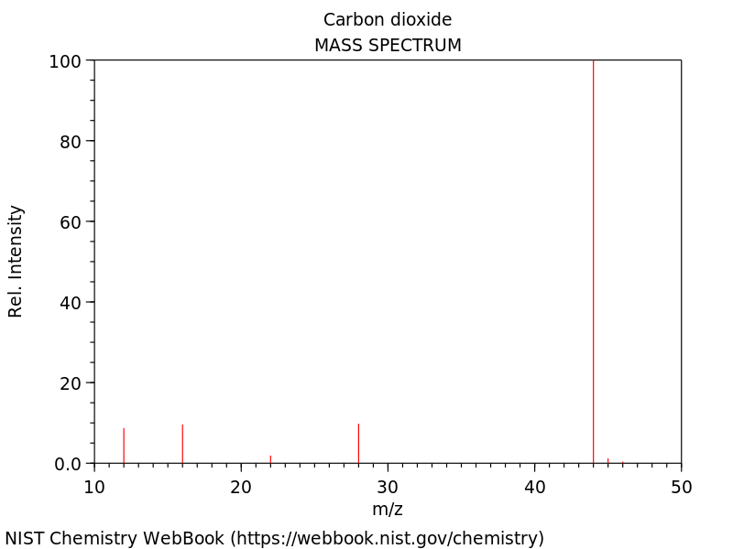

1. The mass spectrum can also be used to determine components of a mixture of compounds. Match the molecular ion and fragment ions below to each of the lettered peak clusters in the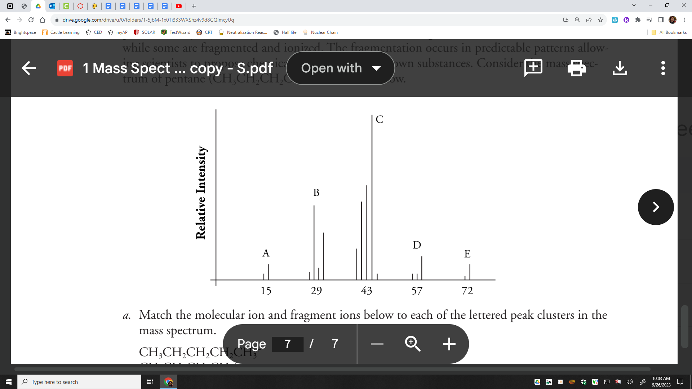

mass spectrum.

CH3CH2CH2CH2CH3+

CH3CH2CH2CH2+

CH3CH2CH2+

CH3CH2+

CH3+

1. What are some applications for the use of mass spectra? In other words, why do we need to know the isotopes and compounds in a mixture?

**Isotopes** Check Your Understanding

| **Name-Mass Number** | **Isotope Symbol** | **Mass Number** | **Atomic Number** | **Neutrons** | **Protons** | **Electrons** | **Nuclear Charge** |
| --- | --- | --- | --- | --- | --- | --- | --- |
| Lithium-6 |  |  |  |  |  |  |  |
| Lithium-7 |  |  |  |  |  |  |  |
| Boron-10 |  |  |  |  |  |  |  |
| Boron-11 |  |  |  |  |  |  |  |
| Sodium-22 |  |  |  |  |  |  |  |
| Sodium-24 |  |  |  |  |  |  |  |
| Aluminum-26 |  |  |  |  |  |  |  |
| Aluminum-27 |  |  |  |  |  |  |  |
| Iron-55 |  |  |  |  |  |  |  |
| Iron-56 |  |  |  |  |  |  |  |
| Zinc-65 |  |  |  |  |  |  |  |
| Zinc-66 |  |  |  |  |  |  |  |

For each pair above, look up the element’s atomic mass from the reference table and decide which isotope is more abundant. Circle the more abundant isotope’s name.

**Atomic Mass** Think Tank Problems

1. In class the following grades were reported; calculate the class average and show your work.

| **Grade out of 50** | **% of students** |
| --- | --- |
| 50 | 10 |
| 45 | 25 |
| 40 | 40 |
| 35 | 20 |
| 30 | 5 |

1. The teacher uses the following calculation:

**50(.10) + 45(.25) + 40(.40) + 35(.20) + 30(.05) = Class Average out of 50**

* 1. Finish her calculation in your calculator. Class average:
  2. Explain how she completed the calculation and why it works.

The atomic mass is the weighted average mass of the naturally occurring isotopes of an element. It can be found by multiplying the mass number of the atom by the percent abundances (in decimal form) and adding the results. For each example, draw a 10 particle model of the percent of each isotope (with a key) and calculate the atomic mass.

**Example:** Copper-63 and Copper-65 are 69.17% and 30.83% respectively. What is the atomic mass?











**Atomic Mass** Check Your Understanding

Find the atomic masses of the following:

1. Silver: 55.0% Ag-107, 45.0% Ag-109
2. Indium: 40.0% In-113, 60.0% In-115
3. Rhendium: 30.0% Re-185, 70% Re-187
4. Copper: 75.0% Cu-63, 25.0% Cu-65
5. Chlorine: 75.5% Cl-35, the rest Cl-37
6. Lithium: 7.4% Li-6, the rest Li-7
7. Boron: 19.6 % B-10, the rest B-11
8. Oxygen: 99.76% O-16, 0.046% O-17, and 0.20% O-18
9. Naturally occurring chlorine that is put in pools is 75.53% Cl-34.969 and 24.47% Cl-36.9666. Calculate the atomic mass.
10. Copper is used in electric wires and comes as two isotopes, Cu-63 and Cu-65. Cu-63 has an actual mass of 62.9298amu and Cu-65 has an actual mass of 64.9233 amu. If they are 69.09% and 30.91% abundant respectively, what is the atomic mass?

**Isotopes and Atomic Mass** More Practice

1. Using the model of the atom at the time of Rutherford, explain how boron can have atoms of two different masses. Draw a diagram of each atom to support your explanation.
2. Explain why it would be incorrect to state that the average mass of boron atoms is .



1. What is the average mass of these 15 items?

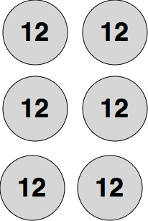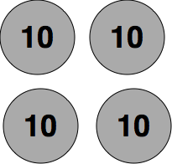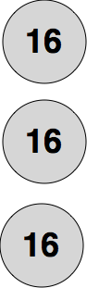

1. From the spectrum below, determine the average molar mass of the element.

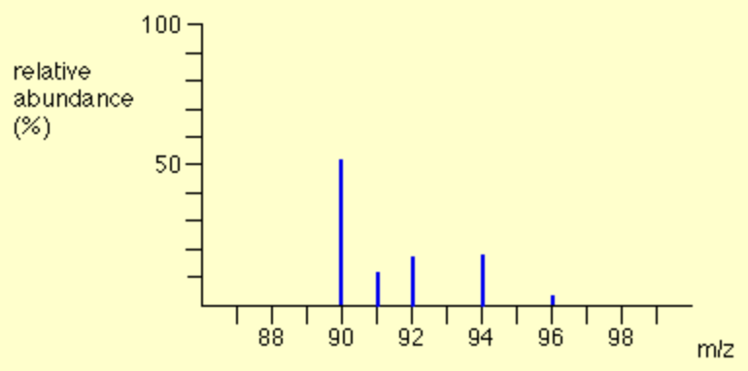

1. From the average mass, identify the element, then write the symbol (including atomic number and mass number) of the most abundant isotope of this element.
2. For each of the following mass spectra, determine the average molar mass of the element and write the symbol for each of the isotopes.

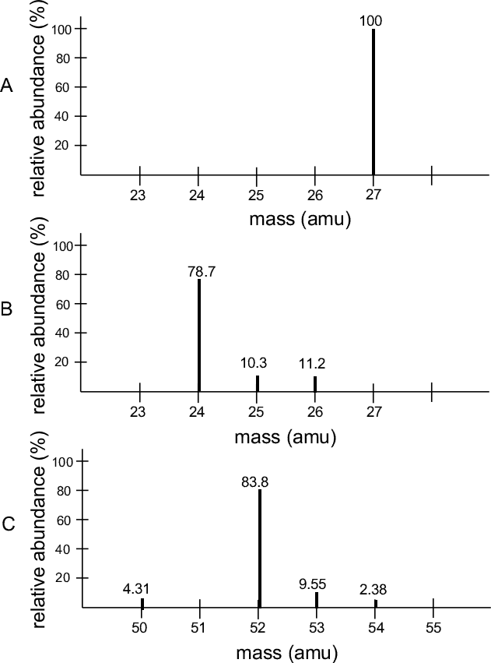

1. Suppose the discovery of a new element with two isotopes is announced. The reporter on Fox News says that the isotopes are and . What mistake was made in the report?



1. Element X has two natural isotopes. The isotope with a mass number of 6 has a relative abundance of 7.5%. The isotope with a mass number of 7 has a relative abundance of 92.5%. Determine the average molar mass for the element from these figures. What is the true identity and atomic number of element X?
2. The element copper is found to contain the naturally occurring isotopes and . The relative abundances are 69.1% and 30.9% respectively. Calculate the average molar mass of copper.



1. Uranium has three isotopes with the following percent abundances:   
    (0.0058%), (0.71%), (99.23%). What do you expect the molar mass of uranium to be in whole numbers? Why?



1. A sample of silver as it occurs in nature is 52.0% of isotope and 48.0% of isotope . What is the average molar mass of silver? (Compare your result with the value given in the periodic table).



1. Ninety-two percent of the atoms of an element have a mass of 28.0 amu, 5.0% of the atoms have a mass of 29.0 amu, and the remaining atoms have a mass of 30.0 amu. Calculate the average molar mass and identify the element.
2. Use the following isotope data for lead to show that its molar mass is 207 amu,

(1.37%)



(26.26%)



(20.82%)



(51.55%)



1. Boron exists in the form to two stable isotopes, boron-10 and boron-11. These occur in the abundance of 19.6 percent and 80.4 percent respectively. Calculate the average molar mass of boron.
2. Precise molar masses of each isotope of magnesium are given below along with the percent abundance of each isotope:

magnesium-24 23.98504 78.70%

magnesium-25 24.98584 10.13%

magnesium-26 25.98259 11.17%

Calculate the average molar mass of magnesium.

**Bohr Diagrams**

**Bohr diagrams** show the number of protons and neutrons in the nucleus and the number of electrons in their energy levels. The electron configuration shows how many electrons are in each level in the ground state, or under normal conditions. An example of a Bohr diagram is given below:

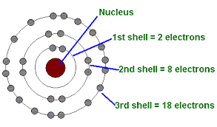

**Draw the Bohr diagrams of the following:**

| **H-1** | **K-40** | **Li-7** | **Be-9** |
| --- | --- | --- | --- |
| **B-11** | **C-14** | **Ne-20** | **O-16** |
| **F-19** | **Cl-35** | **Al-27** | **S-28** |
| **S-32** | **N-14** | **Mg-24** | **P-31** |

Valence electrons are the electrons in the outermost shell. They are the furthest from the nucleus, escaping the protons pulling on them. Therefore, they have the __________ energy out of all the electrons. Do any of the elements above have the same number of valence electrons? List the pairs:

**Spectra** Check Your Understanding

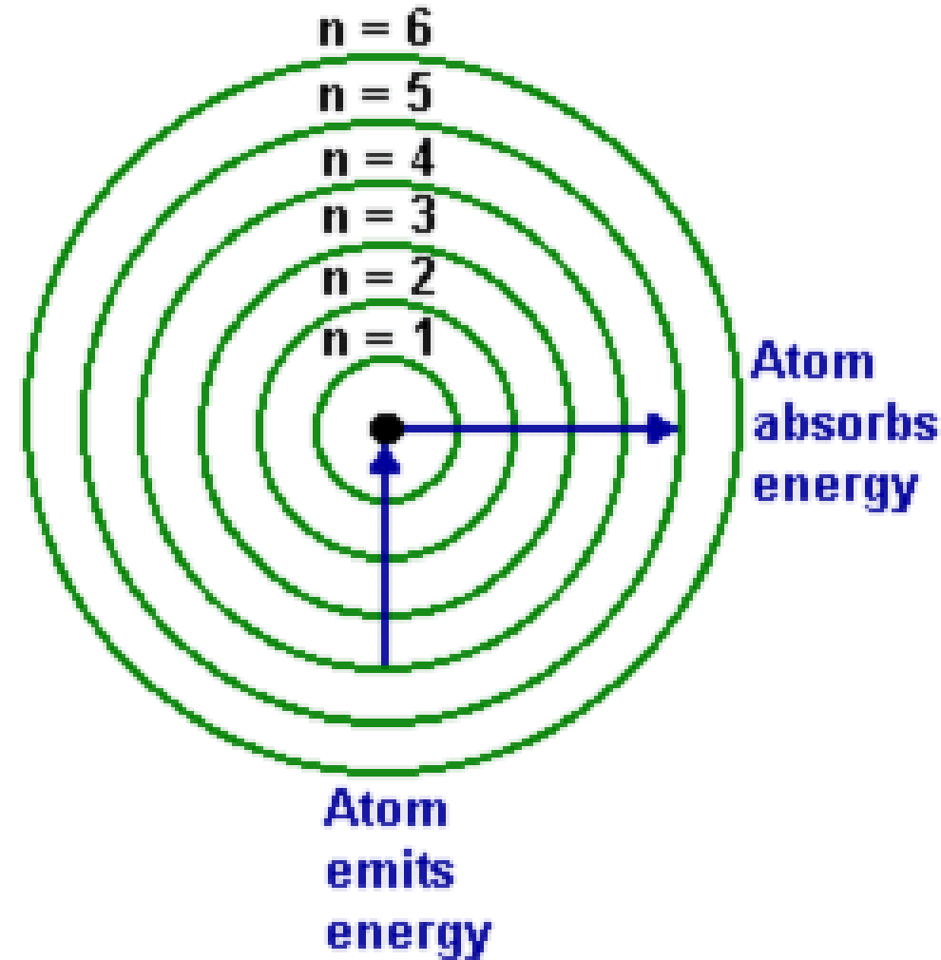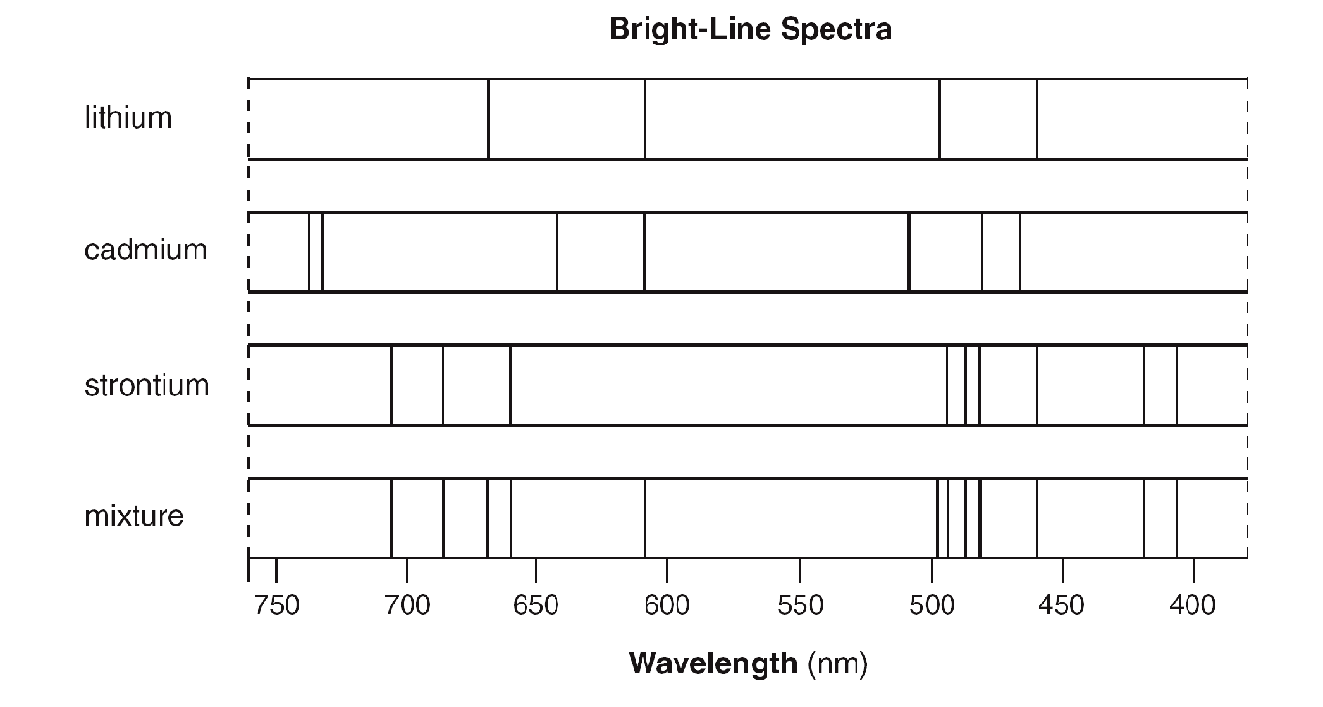

1. State the total number of valence electrons in a cadmium atom in the ground state.

2. Identify *all the elements in the mixture shown above.*

The Balmer series refers to the visible bright lines in the spectrum produced by hydrogen atoms. The

color and wavelength of each line in this series are given in the table below.

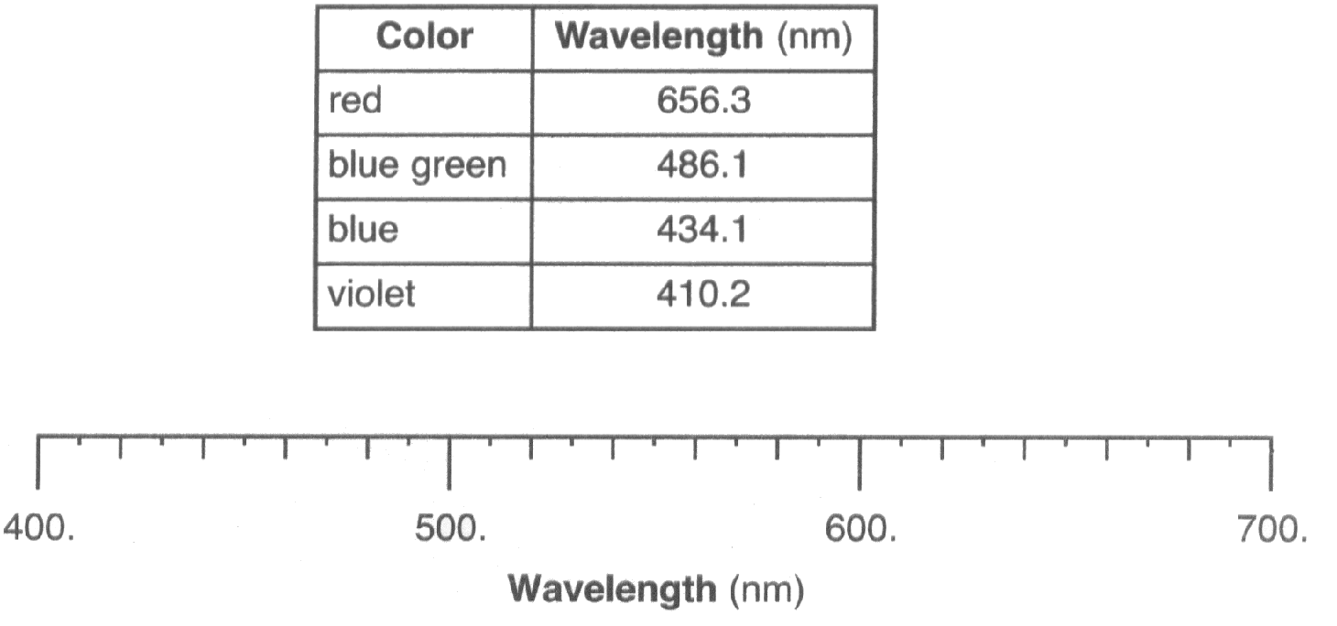

3. Explain, in terms of both subatomic particles and energy states, how the Balmer series is produced.

4. Recreate diagram above and draw four vertical lines to represent the Balmer series.

5. Write an appropriate number of electrons in *each* shell 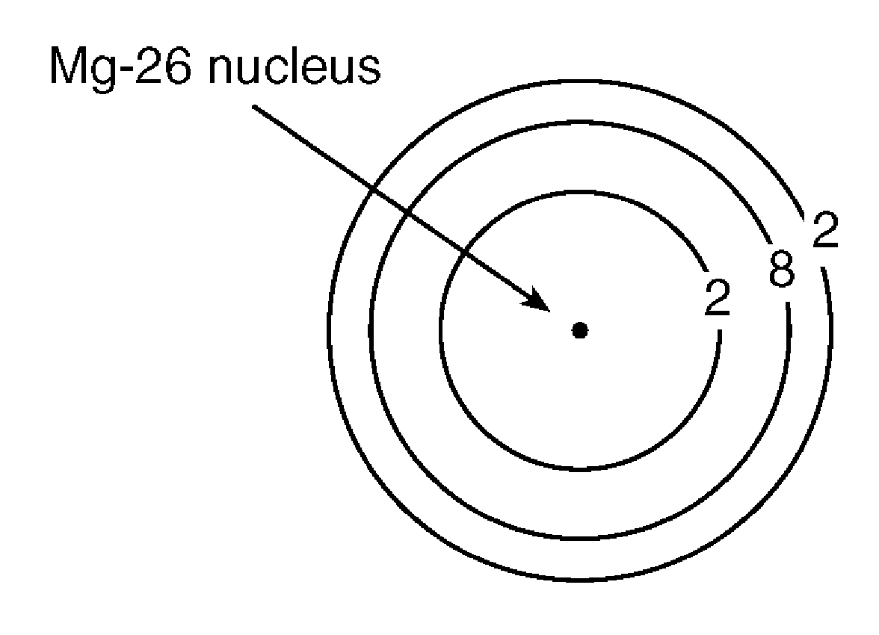

to represent a Mg-26 atom in an excited state.

6. What is the total number of valence electrons in an atom

of Mg-26 in the ground state?_________

Many advertising signs depend on the production of light emissions from gas-filled glass tubes that are

subjected to a high-voltage source. When light emissions are passed through a spectroscope, bright-line

spectra are produced.

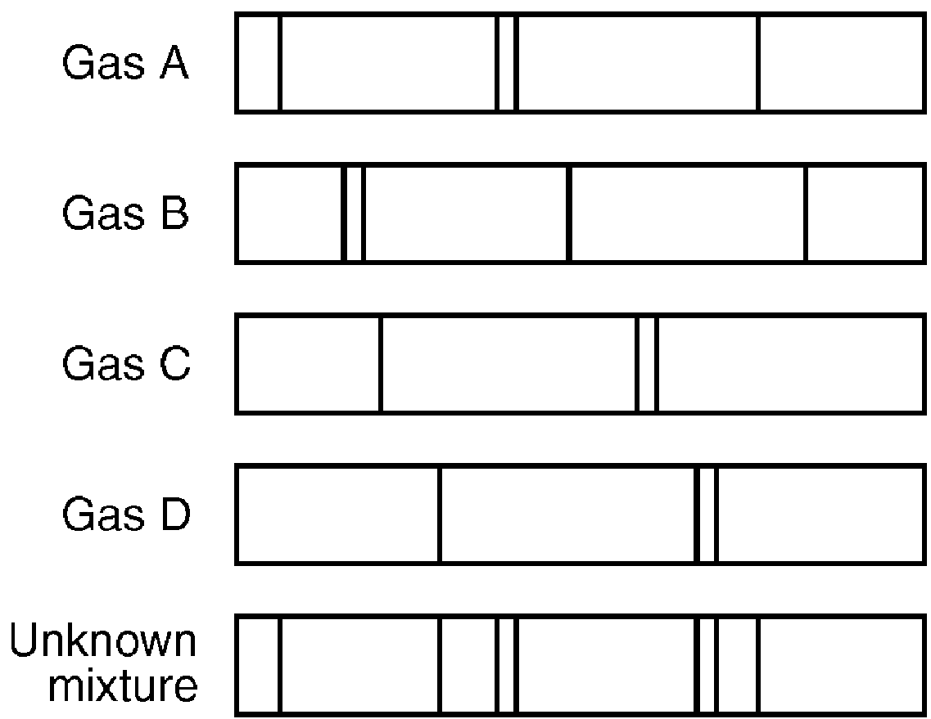

7. Explain the production of an emission spectrum in terms of the *energy states of an electron*.

8. Identify the *two* gases in the unknown mixture.

9. Electron transitions from one shell to another are given for four different atoms below:

**Atom G:** 3rd shell to 2nd shell **Atom I:** 4th shell to 6th shell

**Atom H:** 1st shell to 4th shell **Atom J:** 5th shell to 3rd shell

1. In which atom(s) is energy absorbed during the e- transition?
2. In which atom(s) is energy released during the e- transition?
3. In which atom(s) would spectral lines be observed?
4. In which atom is the greatest amount of energy absorbed?
5. In which atom is the greatest amount of energy released?
6. In atom G, compare the energy of the electron in the 3rd shell to that of the electron in the 2nd shell.

**Valence electrons and Lewis Diagrams** Check Your Understanding

**Lewis diagrams** show only the atom’s symbol and dots representing the valence electrons. The most valence electrons an atom can have is ____ so the most dots you will draw is ____. Please make dots very visible! **Examples**: 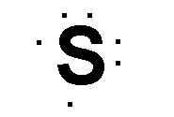

| **Name** | **Protons** | **Neutrons** | **Electrons** | **Electron Configuration** | **Valence Electrons** | **Lewis Diagram** |
| --- | --- | --- | --- | --- | --- | --- |
| Rubidium-85 |  |  |  |  |  |  |
| Cesium-133 |  |  |  |  |  |  |
| Strontium-88 |  |  |  |  |  |  |
| Thallium-204 |  |  |  |  |  |  |
| Tin-119 |  |  |  |  |  |  |
| Arsenic-75 |  |  |  |  |  |  |
| Antimony-121 |  |  |  |  |  |  |
| Sellenium-79 |  |  |  |  |  |  |
| Tellurium-127 |  |  |  |  |  |  |
| Bromine-80 |  |  |  |  |  |  |
| Iodine-127 |  |  |  |  |  |  |
| Xenon-131 |  |  |  |  |  |  |

1. Why are the valence electrons the most important electrons?
2. What do elements with the same valence electrons have in common?
3. Draw the Lewis dot diagram of Li+, Ca+2, S-2 and F-
4. All cations have _________ dots and all anions have _______ dots.

**Honors Electron Configurations**

|  | **Full e- Configuration** | **Valence e-** | **Valence orbital notation** | **Lewis Diagram** |
| --- | --- | --- | --- | --- |
| **H** |  |  |  |  |
| **He** |  |  |  |  |
| **Li** |  |  |  |  |
| **Be** |  |  |  |  |
| **B** |  |  |  |  |
| **C** |  |  |  |  |
| **N** |  |  |  |  |
| **O** |  |  |  |  |
| **F** |  |  |  |  |
| **Ne** |  |  |  |  |
| **Mg** |  |  |  |  |
| **Si** |  |  |  |  |
| **S** |  |  |  |  |
| **Ar** |  |  |  |  |
| **K** |  |  |  |  |
| **Fe** |  |  |  |  |
| **Zn** |  |  |  |  |
| **As** |  |  |  |  |
| **Br** |  |  |  |  |
| **Sr** |  |  |  |  |
| **Zr** |  |  |  |  |
| **Te** |  |  |  |  |
| **Xe** |  |  |  |  |

**Honors Ion Configurations and Practice**

|  | **Atom’s e- Configuration**  **(Noble Gases Short Cut Allowed)** | **Valence e-** | **Ion’s e- Configuration**  **(Noble Gases Short Cut Allowed)** | **Ion’s Lewis Diagram** |
| --- | --- | --- | --- | --- |
| **Li+** |  |  |  |  |
| **Cu+2** |  |  |  |  |
| **Co+3** |  |  |  |  |
| **Mg+2** |  |  |  |  |
| **Sc+2** |  |  |  |  |
| **Na+** |  |  |  |  |
| **Ag+** |  |  |  |  |
| **Ca+2** |  |  |  |  |
| **O-2** |  |  |  |  |
| **Zn+2** |  |  |  |  |

1. Explain why arsenic can form three different ions in terms of valence electrons and stability.
2. Explain why more transition metals have two valence electrons with the exception of groups 6 and 11.
3. The electron configuration 1s2 2s2 2p6 3s2 3p6 4s2 3d10 4p6 5s2 has _____ unpaired electrons and represents element _________________.
4. The electron configuration 1s2 2s2 2p6 3s2 3p6 4s2 3d10 4p2 has _____ unpaired electrons and represents element ______________________.
5. Which electron configuration(s) are in the excited state? Circle all that apply:

1s2 2p6 3s2 3p6 4s2 3d10 4p2 1s2 2s2 2p6 3s2 3p1

1s2 2s2 2p6 3s2 3p6 4s2 3d10 4p2 1s2 2p6 3s2 3p6 4s2 3d10 4p2

1s2 2s2 2p6 3s2 4s2 3d10 4p2 1s2 2s2 2p6 3s1

1s2 2s2 2p6 3s2 3p5 4s2 3d10 4p2 1s2 2s2 2p6 3s3

1s2 2s2 2p6 3s2 3p6 4s2 3d8 1s2 2s2 2p6 3s2 3p8

1. Were any of the above configurations not allowed? Box them and explain their errors.

**Common Sense Chemistry Review**

*Don’t trust atoms, they make up everything.*

1. Calcium ions are in your white solid bones and in your white liquid milk, but calcium atoms are lustrous metallic solids.
   1. Provide the number of each subatomic particle in the calcium atom and the calcium ion.
   2. Compare the subatomic particles in Ca and Ca+2 to explain why they have different properties.
   3. Draw a Lewis dot diagram for the calcium atom and the calcium ion.
2. Fluoride ions are present but invisible in your drinking water as well as your toothpaste. Fluoride is present in solid Teflon. However pure fluorine is a yellow gas.
   1. Provide the number of each subatomic particle in the fluorine atom and the fluoride ion.
   2. Compare the subatomic particles in F and F- to explain why they have different properties.
   3. Draw a Lewis dot diagram for the fluoride atom and the fluoride ion.
3. Fireworks provide colorful sparks of light in the sky. The various colors emitted correspond to specific elements. After each statement write the ground state electron configuration and circle the valence electrons.
   1. Aluminum contributes to the white color in fireworks
   2. Barium contributes the green color.

1. After each statement, provide a possible excited state electron configuration.
   1. Calcium contributes to the orange color.
   2. Copper contributes the blue color.
2. Sodium contributes to the yellow color. When you **see** the yellow color, are the electrons releasing or absorbing energy?
3. Strontium contributes the red color. **Before** the color is seen, do the electrons release or absorb energy?
4. Titanium contributes the silver color. Explain how the electrons provide that color in terms of excited and ground states.