AP Learning Objectives
- Explain the relationship between experimental observations and energy changes associated with a chemical or physical transformation. (6.1)
- Represent a chemical or physical transformation with an energy diagram. (6.2)
- Explain the relationship between the transfer of thermal energy and molecular collisions.(6.3)
- Calculate the heat q absorbed or released by a system undergoing heating/ cooling based on the amount of the substance, the heat capacity, and the change in temperature.(6.4)
- Explain changes in the heat q absorbed or released by a system undergoing a phase transition based on the amount of the substance in moles and the molar enthalpy of the phase transition. (6.5)
- Calculate the heat q absorbed or released by a system undergoing a chemical reaction in relationship to the amount of the reacting substance in moles and the molar enthalpy of reaction.(6.6)
- Calculate the enthalpy change of a reaction based on the average bond energies of bonds broken and formed in the reaction. (6.7)
- Calculate the enthalpy change for a chemical or physical process based on the standard enthalpies of formation. (6.8)
- Represent a chemical or physical process as a sequence of steps.(6.9)
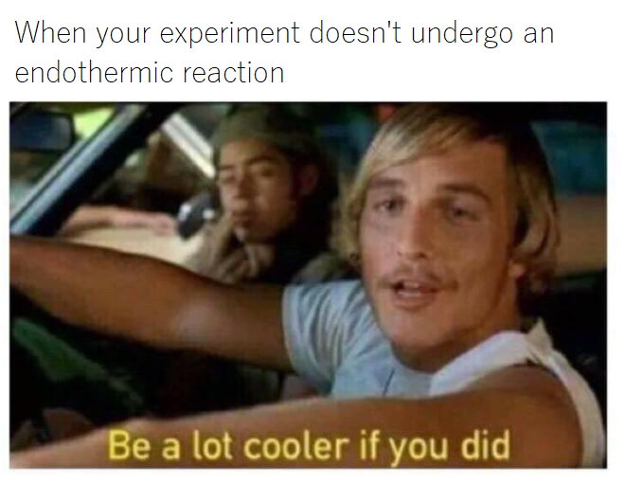
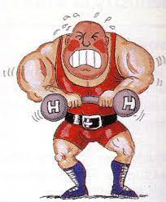

Thermodynamics Review
Answer the following questions using the heat formula. Show work with units and significant figures.
- How many Joules of energy are needed to change the temperature of 100.0 grams of water from 20.0C to 40.0C?

- How many kilojoules of energy are needed to change the temperature of 15.0 grams of water from 35.0C to 75.0C?

- If the temperature of water is changed from 10.0C to 35.0C by the addition of 350.0J, how many grams were heated?

- If the temperature of water is changed from 100.0C to 250.0C by the addition of 5000.0J, how many grams were heated?

- If 3500.0J of energy are applied to 150.0 grams of water at 50.0C, what is the final temperature?

- If 425J of energy are released from 25.0 grams of water at 25.0C, what is the final temperature?

- Look at the rearranged equation for heat, solved for specific heat. What are the units of specific heat based on this rearranged equation?
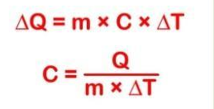

- What is the specific heat of silver if an 80.0 gram sample is heated from 24.0C to 49.0C by adding 468.2J?

- What is the specific heat of copper if a 75.0 gram sample of copper is heated from 20.0C to 24.0C by adding 117J?

- The specific heat of aluminum is 0.88J/gC. How many joules of heat does it take to heat 50.0 grams of aluminum from 20.0 to 70.0C?

- What is the change in temperature when 3.00 grams of Iron (specific heat = 0.45J/gC) is subjected to 350.0.J of energy?

- What mass of Aluminum (specific heat = 0.902 J/gC) can be heated from 25.0C to 90.0C with the addition of 100.0J of heat?

- How many joules of heat must be released in order to change the temperature of 50.0 grams of air (specific heat 1.01 J/gC) from 35.0C to 25.0C?

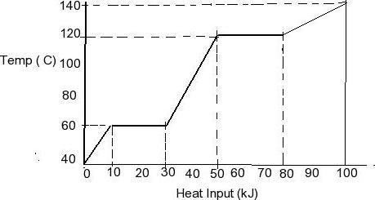
Base answers to questions 14-17 on the diagram:
- How much heat is added to change the
substance from the coldest to the warmest
pure liquid state?

- If the specific heat of this substances in the liquid
phase is 3.56 J/gC calculate how many grams were
heated in question 14?

- If the same sample is heated as a solid at 40C to 60C will it have the same specific heat? Show work to support your answer.

- How much heat will need to be added to the same sample in order to raise the temperature from 20.0C to 40.0C? (Notice this is not on the graph, you must calculate it based on your answers above.)

AP Calorimetric Calculations

The first law of thermodynamics: Energy can never be created nor destroyed. Therefore, the energy of the universe is constant.

- It takes 585J of energy to raise the temperature of 125.6g of Hg from 20.0 to 53.5C. Calculate the specific heat of Hg.

- A 46.2g sample of Cu is heated to 95.4C and placed in a calorimeter containing 75.0g of water at 19.6C. The final temperature inside the calorimeter equals 21.8C. Calculate the specific heat of copper.

- The specific heat of aluminum is 0.9000J/gC and the density is 2.71g/cm³.
  - Calculate the energy needed to raise the temperature of 4.36x10⁵cm³ block from 22.8 to 94.6C.

  - Calculate the molar heat capacity of aluminum.

- A piece of iron with a mass of 56.0g and specific heat of 0.45J/gC is placed in 155g of water at 21.0C. The final temperature is 33.5C. Calculate the original temperature of the iron.

Enthalpy

- Consider the reaction: 2Mg + O₂ 🡪 2MgO ΔH=-1204kJ/mol
  - Is this reaction endothermic or exothermic?

  - Calculate the heat transferred when 3.60g of Mg reacts with excess oxygen.

  - How many grams of MgO are produced during the enthalpy change of -96.0kJ?

- Consider the reaction: 2AgBr + Cl₂ 🡪 2AgCl + Br₂ ΔH=-55.2kJ/mol
  - Calculate the heat transferred by 37.56g of silver bromide reacting with excess chlorine.

  - How many grams of liquid bromine are produced when the enthalpy change equals -106kJ?

  - Calculate the heat of reaction when 60.0g of solid silver chloride are produced.

- Given the following information: C₂H₆ + 7/2 O₂ 🡪 2CO₂ + 3H₂O ΔH = -91 kJ/mol
  - What is the enthalpy change for the reverse reaction?

  - Which reaction (forward or reverse) is more favorable?

Enthalpy of Formation

- The thermite reaction is highly exothermic and is used for welding :
2Al(s) + Fe₂O₃(s) 🡪 2Fe(s) + Al₂O₃(s)
Calculate the heat of this reaction using enthalpies of formation.

- Calculate the enthalpy of these reactions using enthalpies of formation:
  - 4FeO(s) + O₂(g) 🡪 2Fe₂O₃(s)

  - SiCl₄(l) + 2H₂O(l) 🡪 SiO₂(s) + 4HCl(aq)

  - NH₃(g) + HCl(g) 🡪 NH₄Cl(s)

  - MgO(s) + H₂O(l) 🡪 Mg(OH) ₂ (s)

  - C₂H₅OH(g) + 3O₂ (g) 🡪 2CO₂ (g) + 3H₂O(g)

Reminder of an old Enthalpy Question:

- Calculate the change in energy that accompanies the following reaction given the data below.
H₂(g) + F₂(g) → 2 HF(g) Bond Type Bond Energy H−H 432 kJ/mol F−F 154 kJ/mol H−F 565 kJ/mol

Hess’s Law
- Given the following data, calculate the heat of S(s) + O₂(g) 🡪 SO₂(g)
S(s) + 3/2 O₂(g) 🡪 SO₃(g) ΔH= -395.2kJ/mol
2SO₂(g) + O₂(g) 🡪 2SO₃(g) ΔH= -198.2kJ/mol

- Given the following data, calculate the heat of C₆H₄(OH)₂(aq) + H₂O₂ (aq) 🡪 C₆H₄O₂ (aq) + 2H₂O(l)
C₆H₄(OH)₂(aq) 🡪 C₆H₄O₂ (aq) + H₂(g) ΔH= 177.4kJ/mol
H₂ (g) + O₂ (g) 🡪 H₂O₂ (aq) ΔH= -191.2kJ/mol
H₂ (g) + ½ O₂ (g) 🡪 H₂O(g) ΔH= -241.8kJ/mol
H₂O(g) 🡪 H₂O(l) ΔH= -43.8kJ/mol

- Given the following data, calculate the heat of 2CO₂ (g) + H₂O(g) 🡪 C₂H₂ (g) + 5/2 O₂ (g)
C₂H₆(g) 🡪 C₂H₂ (g) + 2H₂ (g) ΔH= 850.5kJ/mol
H₂ (g) + ½ O₂ (g) 🡪 H₂O(g) ΔH= -641.2kJ/mol
C₂H₆(g) + 7/2 O₂ (g) 🡪 2CO₂ (g) + 3H₂O(g) ΔH= -2547kJ/mol

- Given the following data, calculate the heat of NO(g) + O(g) 🡪 NO₂(g)
2O₃ (g) 🡪 3O₂(g) ΔH= -427kJ/mol
O₂ (g) 🡪 2O(g) ΔH= 495kJ/mol
NO(g) + O₃(g) 🡪 NO₂ (g) + O₂ (g) ΔH= -199kJ/mol
Thermodynamics Practice

1. Propane, C₃H₈, is a hydrocarbon that is commonly used as fuel for cooking.
(a) Write a balanced equation for the complete combustion of propane gas, which yields CO₂(g) and H₂O(l).

(b) Calculate the volume of air at 30C and 1.00 atmosphere that is needed to burn completely 10.0 grams of propane. Assume that air is 21.0 percent O₂ by volume.

(c) The heat of combustion of propane is -2,220.1 kJ/mol. Calculate the heat of formation, ΔH_{f}, of propane given that ΔH_{f} of H₂O(l) = -285.3 kJ/mol and ΔH_{f} of CO₂(g) = -393.5 kJ/mol.

(d) Assuming that all of the heat evolved in burning 30.0 grams of propane is transferred to 8.00 kilograms of water (specific heat = 4.18 J/g.K), calculate the increase in temperature of water.

2. Pentane, C₅H₁₂, is a hydrocarbon used in the production of Styrofoam and is present in certain fuels.
(a) Write a balanced equation for the complete combustion of pentane gas, which yields CO₂(g) and H₂O(l).

(b) Calculate the volume of air at 25C and 1.00 atmosphere that is needed to burn completely 50.5 grams of pentane. Assume that air is 21.0 percent O₂ by volume.

(c) The heat of combustion of pentane is -3,285.3 kJ/mol. Calculate the heat of formation, ΔH_{f}, of pentane given that ΔH_{f} of H₂O(l) = -285.3 kJ/mol and ΔH_{f} of CO₂(g) = -393.5 kJ/mol.

(d) Assuming that all of the heat evolved in burning 50.5 grams of pentane is transferred to 10.0 kilograms of water (specific heat = 4.18 J/g.K), calculate the increase in temperature of water.

3. (a) The specific heat of fluorine gas is 0.037 J/g∙K. Calculate the molar heat capacity (in J/mol∙K) of fluorine gas.

(b) The molar heat capacity of a compound with the formula C₄H₁₀SO is 43.6 J/mol∙K. Calculate the specific heat, c, of this substance.

4. Given the following data: S(s) + 3/2 O₂(g) 🡪 SO₃(g) ∆H_{f}º =-395.2 kJ
2 SO₂(g) + O₂ 🡪 2 SO₃(g) ∆H_{f}º=-198.2 kJ
Calculate ∆Hº_{rxn} for the reaction: S(s) + O₂(g) 🡪 SO₂(g)
AP Chemistry: Heat Multiple Choice

47. CH_{4(g)} + 2 O_{2(g)} 🡪 CO_{2(g)} + 2 H₂O_{(l)}; ∆H_{rxn} = −889.1 kJ
∆H_{f}° H₂O_{(l)} = − 285.8 kJ / mole ∆H_{f}° CO_{2(g)} = − 393.3 kJ / mole
What is the standard heat of formation of methane, ∆H_{f}° CH_{4(g)}, as calculated from the data above?
(A) −210.0 kJ/mole (B) −107.5 kJ/mole (C) −75.8 kJ/mole (D) 75.8 kJ/mole (E) 210.0 kJ/mole
48. Which of the following is a graph that describes the pathway of reaction that is endothermic and has high activation energy?
(A | 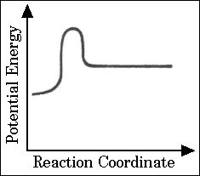 | (B | 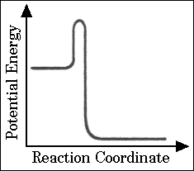 |  |  | (C) | 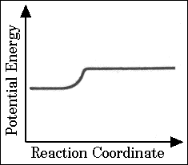
(D | 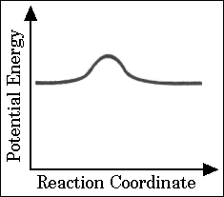 | (E | 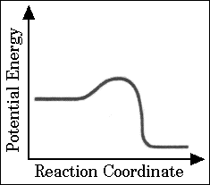
25.
H_{2(g)} + 1/2 O_{2(g)} 🡪 H₂O_{(l)} |  |  |  | ∆H° = x
2 Na_{(s)} + 1/2 O_{2(g)} 🡪 Na₂O_{(s)} |  |  |  | ∆H° = y
Na_{(s)} + 1/2 O_{2(g)} + 1/2 H_{2(g)} 🡪 NaOH_{(s)} |  |  |  | ∆H° = z
Based on the information above, what is the standard enthalpy change for the following reaction?
Na₂O_{(s)} + H₂O_{(l)} 🡪 2 NaOH_{(s)}
(A) x + y + z (B) x + y − z (C) x + y − 2z (D) 2z − x −y (E) z − x −y
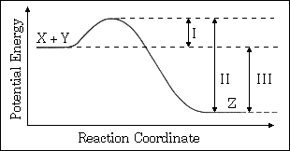
30. The energy diagram for the reaction X + Y 🡪 Z is shown. The addition of a catalyst to this reaction would cause a change in which of the indicated energy differences?
(A) I only (D) I and II only
(B) II only (E) I, II, and III
(C) III only
19. Which of the following best describes the role of the spark from the spark plug in an automobile engine?
(A) The spark decreases the energy of activation for the slow step.
(B) The spark increases the concentration of the volatile reactant.
(C) The spark supplies some of the energy of activation for the combustion reaction.
(D) The spark provides a more favorable activated complex for the combustion reaction.
(E) The spark provides the heat of vaporization for the volatile hydrocarbon.
61. C₂H_{4(g)} + 3 O_{2(g)} 🡪 2 CO_{2(g)} + 2 H₂O_{(g)}
For the reaction of ethylene represented above, ∆H is −1,323 kJ. What is the value of ∆H if the combustion produced liquid water H₂O_{(l)}, rather than water vapor H₂O_{(g)}?

(∆H for the phase change H₂O_{(g)} 🡪 H₂O_{(l)} is −44 kJ mol⁻¹.)
(A) −1,235 kJ (B) −1,279 kJ (C) −1,323 kJ (D) −1,367 kJ (E) −1,411 kJ
25. 3 C₂H_{2(g)} 🡪 C₆H_{6(g)}
What is the standard enthalpy change, ΔH° , for the reaction represented above?
(ΔH°_{f} of C₂H_{2(g)} is 230 kJ mol⁻¹ ; ΔH°_{f} of C₆H_{6(g)} is 83 kJ mol⁻¹)
(A) −607 kJ (B) −147 kJ (C) −19 kJ (D) + 19 kJ (E) +773 kJ

