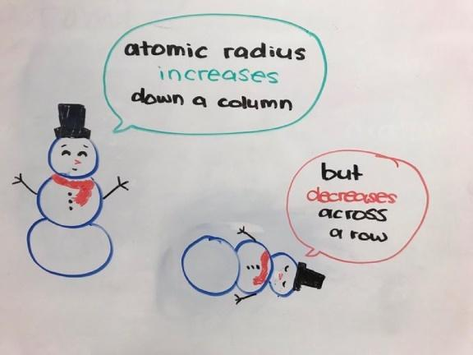
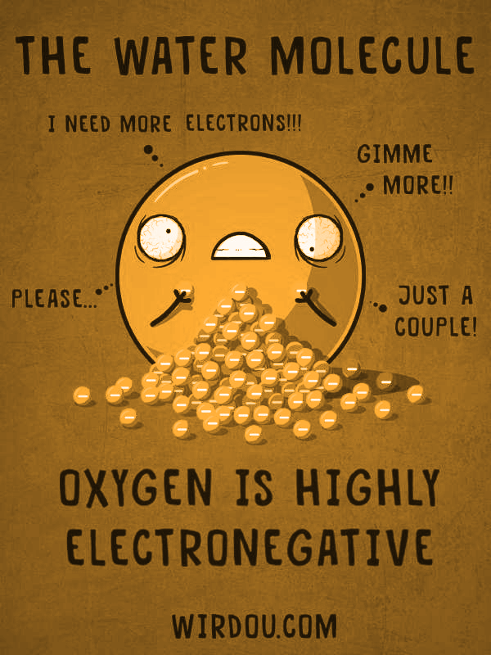
Comparison of Periodic Tables Think Tank Problems
Do Now:
- Define the word periodic with an example from your everyday life. What do you do periodically?

- Explain why the element tables are known as periodic tables. What is happening periodically?

Observe Your Table
How are the elements arranged on your table? What properties were used to organize the elements? | How is your table different than the standard periodic table? Give specific examples.
How is your table similar to the standard periodic table? Give specific examples. | What makes your table unique? Give specific examples.

Patterns Found in All Tables
What properties are most often used by the tables? Provide examples. | Are similar elements grouped? How so? Provide examples.
How can these alternative tables help students learn the periodic properties of elements better than the standard tables? | Why do you think the standard tables are preferred by most scientists and educational faculty?
Periods and Groups Think Tank Problems
- Periods represent the (vertical/horizontal) rows on the table.
- Draw Bohr diagrams for Carbon, Boron and Oxygen, all in period 2.

- Elements in the same period have the same number of ______________________.
- Groups represent the (vertical/horizontal) columns on the table.
- Draw Bohr diagrams for Lithium, Sodium, and Potassium, all in group 1.

- Elements in the same group have the same number of ______________________.

Periods and Groups Check Your Understanding
RULES: Group 1 are known as Alkali Metals. Group 2 are Alkaline earth metals. Groups 3-12 are Transition metals. Group 17 are Halogens. Group 18 are Noble gases. All other groups do not have names.
Name | Symbol | Period | # Energy Levels | Group | # Valence Electrons | Group Name | Lewis Diagram
Sodium

 | S
 | Ne
 |  | 1 |  |  |  | Noble Gases
 |  | 2 |  | 2
 |  | 2 |  |  |  | Alkali Metals
 |  |  | 4 | 1
 |  |  | 4 |  | 7
 |  |  | 4 |  |  | Alkaline Earth

Periods and Groups Summary

- How many periods are on the periodic table of elements?

- Write out electron configurations for any three elements in period 3.

- What do elements in the same period have in common?

- How many groups are on the periodic table of elements?

- Write out Lewis dot diagrams for any three elements in group 18.

- Write out the most probable charges of elements in group:

  - One___ b. Two___ c. Seventeen____ d. Eighteen___

- What do elements in the same group have in common?

- Do elements in the same period have more or less in common than elements in the same group?

- Complete the summary chart for the groups below:

Group Name | Group Number | Valence Electrons | Common Charge(s) | Interesting Properties and Define Terms
Alkali Metals

Alkaline Earth Metals
Transition Metals
Halogens |  |  |  | Diatomic:
Noble Gases |  |  |  | Inert:  Monatomic:

Metals, Nonmetals, and Metalloids Think Tank Problems

- Draw the Bohr diagrams for Neon and Helium and explain why they do not bond:

________________________________________________________________________________________________________

- Draw the Bohr diagrams for Sodium and Calcium and explain why metals lose electrons:

________________________________________________________________________________________________________
- Draw the Bohr diagrams for Fluorine and Sulfur and explain why nonmetals gain electrons:

________________________________________________________________________________________________________
- Draw the Bohr diagrams for Silicon and germanium and explain why they are metalloids:

________________________________________________________________________________________________________

Ionization Energy and Atomic Radius Trends

The data shown below is from the NYS Regents Reference Table S. For each question below use well diagrams to help explain why this trend is consistent with our understanding of the structure of the atom.
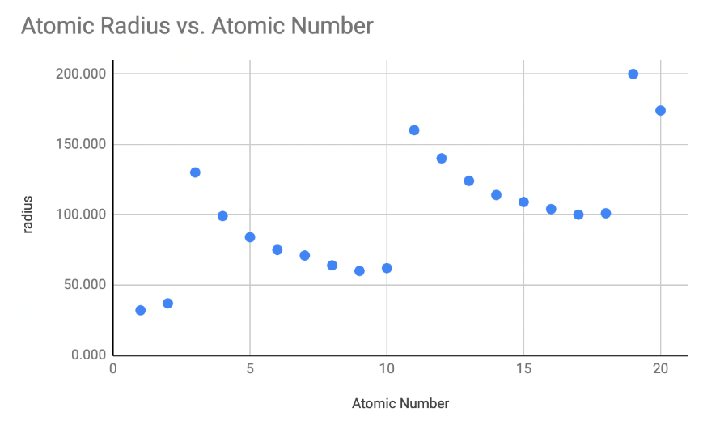
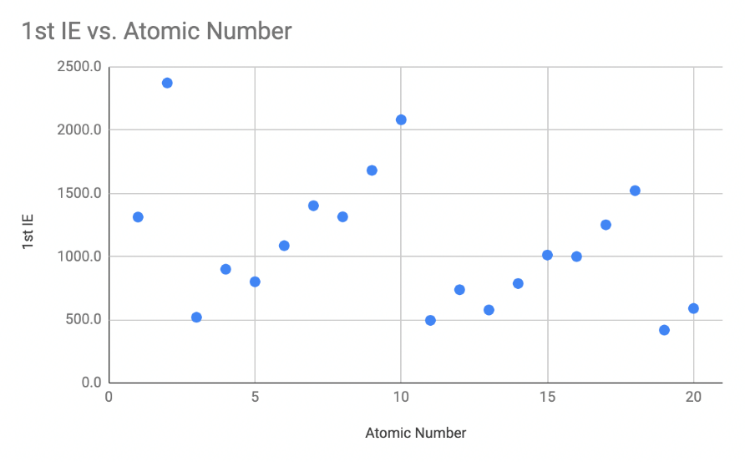
 | Atomic Number | 1st Ionization Energy (kJ/mol) | Atomic Radius (pm)
H | 1 | 1312 | 32
He | 2 | 2372 | 37
Li | 3 | 520 | 130
Be | 4 | 900 | 99
B | 5 | 801 | 84
C | 6 | 1086 | 75
N | 7 | 1402 | 71
O | 8 | 1314 | 64
F | 9 | 1681 | 60
Ne | 10 | 2081 | 62
Na | 11 | 496 | 160
Mg | 12 | 738 | 140
Al | 13 | 578 | 124
Si | 14 | 787 | 114
P | 15 | 1012 | 109
S | 16 | 1000 | 104
Cl | 17 | 1251 | 100
Ar | 18 | 1521 | 101
K | 19 | 419 | 200
Ca | 20 | 590 | 174

- Define the term 1st Ionization energy.

- Identify and explain the trend in 1st ionization energy versus atomic number for any period. Draw well diagrams for Li and F to help explain the trend.

- Which group on the periodic table tends to have the highest 1st ionization energy values? Draw well diagrams for two atoms with the highest values to help explain the trend.

- Which group on the periodic table tends to have the lowest 1st ionization energy values? Draw well diagrams for two atoms with the lowest values to help explain the trend.

- Using your math vocabulary, what does atomic radius of an atom mean?

- Identify and explain the trend in atomic radius versus atomic number for any period. Draw well diagrams for Na and Cl to help explain the trend.

- Which group on the periodic table tends to have the largest atomic radii values? Draw well diagrams for the two largest atoms to help explain the trend.

- Summarize your results using the words increases or decreases in the first blank, along with an explanation that includes an explanation of the proton’s pull on electrons in the second blank.
  - Across a period, the ionization energy of each successive atom ___________________ due to ____________________________________________________________________________.
  - Down a group, the ionization energy of each successive atom ___________________ due to ____________________________________________________________________________.
  - Across a period, the atomic radius of each successive atom ___________________ due to ____________________________________________________________________________.
  - Down a group, the atomic radius of each successive atom ___________________ due to ____________________________________________________________________________.

Atomic Radius Think Tank Problems
Hypothesis:
- Consider elements in period 2. Do you think all atoms of the elements in period 2 will have the same radius? If they are different, what do you expect the trend to be across the period? Explain your answer.

- Consider elements in period 2. Do you think all atoms of the elements in Group 1 will have the same radius? If they are different, what do you expect the trend to be down the group? Explain your answer.

Period Trend:
- Draw the Bohr diagrams for Lithium and Fluorine. Create a nucleus with a diameter of 2.0 cm. Create a first energy level with a radius of 2.0 cm (measure from center of nucleus). Recall, positive charges attract negative charges. Therefore, protons will attract the electrons in the energy levels. The more protons an atom has, the stronger the pull on electrons. Draw the second energy level in considering these statements. The second energy level will have a radius close to 4.0cm.
Li
F

- Using table S, record the radius of Lithium and Fluorine: _______________ and _______________.

- Provide a rule that explains the trend of Atomic Radius in a period with respect to the number of protons, electrons, and energy levels in the atom.

Group Trend:
- Draw the Bohr diagram for Beryllium and Magnesium. Create a nucleus with a diameter of 2.0 cm. Create a first energy level with a radius of 2.0 cm (measure from center of nucleus). Each additional energy level will add 1.0cm to the radius.
Be

Mg

- Using table S, record the radius of Beryllium and Magnesium: _______________ and _______________.

- Provide a rule to explain the trend of Atomic radius in a group with respect to the number of protons, electrons, and energy levels in the atom.

Atomic Radius Check Your Understanding

- An atom of which element has the largest radius?
  - Fe b. Mg c. Si d. Zn

- As atomic number increases within Group 15 on the Periodic Table, atomic radius
- decreases, only
- decreases, then increases
- increases, only
- increases, then decreases

- How do the atomic radius and metallic properties of Na compare to the atomic radius and metallic properties of P?
- Sodium has a larger atomic radius and is more metallic.
- Sodium has a larger atomic radius and is less metallic.
- Sodium has a smaller atomic radius and is more metallic.
- Sodium has a smaller atomic radius and is less metallic.

- Which list of elements from Group 2 is arranged in order of increasing radius?
a. Be, Mg, Ca b. Ca, Mg, Be
c. Ba, Ra, Sr d. Sr, Ra, Ba

- The data table below shows elements Xx, Yy, and Zz from the same group on the Periodic Table.
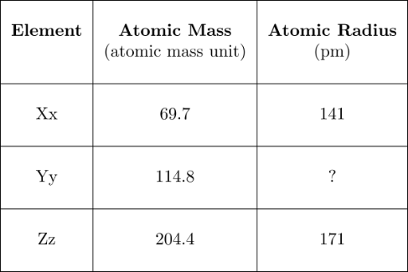

What is the atomic radius of element Yy?
a. 103 pm b. 127 pm c. 166 pm d. 185 pm

- As the elements in Period 2 are considered in succession from left to right, there is a decrease in atomic radius with increasing atomic number. This may best be explained by the fact that the

- number of protons increases, the number of shells of electrons remains the same
- number of protons increases, and the number of shells of electrons increases
- number of protons decreases, the number of shells of electrons remains the same
- number of protons decreases, and the number of shells of electrons increases

- Which of the following electron configurations represents the element with the smallest radius?
- 2-4 b. 2-5 c. 2-6 d. 2-7

- Which electron configuration represents the atom with the largest atomic radius?
- 1 b. 2-1 c. 2-2 d. 2-3

- As the elements of Group 16 are considered in order from top to bottom, the covalent radius of each successive element increases. This increase is primarily due to an increase in
- atomic number
- mass number
- the number of protons occupying the nucleus
- the number of occupied electron shells

- An ion of which element has a larger radius than an atom of the same element?
- aluminum c. chlorine
- Magnesium d. sodium

- An atom with the electron configuration 2-8-2 would most likely
- decrease in size as it forms a positive ion
- increase in size as it forms a positive ion
- decrease in size as it forms a negative ion
- increase in size as it forms a negative ion

- The radius of a calcium ion is smaller than the radius of a calcium atom because the calcium ion contains the same nuclear charge and
- fewer protons c. more protons
- fewer electrons d. more electrons

- A chloride ion differs from a chlorine atom in that the chloride ion has
- more protons c. fewer protons
- a larger radius d. a smaller radius

- How does the size of a barium ion compare to the size of a barium atom?
- The ion is smaller because it has fewer electrons.
- The ion is smaller because it has more electrons.
- The ion is larger because it has fewer electrons.
- The ion is larger because it has more electrons.

Ionization Energy Think Tank Problems
Ionization Energy: The minimum energy needed to remove an electron from the valence shell of an atom in the ground state.

Period Trend:
- Draw the Bohr diagrams of Lithium and Fluorine using the key:
Protons
Neutrons
Electrons

- On your diagrams above, use an arrow to show the attraction of protons to electrons in the structure. For example:

- Which atom, lithium or fluorine, feels the most pull on its valence shell? Explain your answer.

- For which atom, Lithium or fluorine, is it harder to remove its most loosely bound valence electron? Explain your answer.

- Using table S, record the Ionization energies of Lithium and Fluorine: ___________ and _____________.
- Describe the trend of ionization energies within a period in terms of protons, electrons, and energy levels.

Group Trend:
- Draw the Bohr diagrams of Beryllium and Magnesium using the key above.

- On your diagrams above, use an arrow to show the attraction of protons to electrons in the structure. Use the same size arrows to denote that the pull of each proton is the same amount of energy. For example:

- Which atom, beryllium or magnesium, feels the most pull on its valence shell? Explain your answer.

- For which atom, beryllium or magnesium, is it harder to remove its most loosely bound valence electron? Explain your answer.

- Using table S, record the Ionization Energies of Beryllium and Magnesium: ________ and __________.
- Describe the trend of ionization energies within a group in terms of protons, electrons, and energy levels.

Ionization Energy Check Your Understanding

- Which general trend is found in Period 2 on the Periodic Table as the elements are considered in order of increasing atomic number?

  - Decreasing atomic mass
  - increasing ionization energy
  - increasing atomic radius

- As the elements of Group 1 on the Periodic Table are considered in order of increasing atomic radius, the ionization energy of each successive element generally
  - decreases c. increases
  - remains the same

- The amount of energy required to remove the outermost electron from a gaseous atom in the ground state is known as
  - first ionization energy c. activation energy
  - conductivity d. electronegativity

- Which atom in the ground state requires the least amount of energy to remove its valence electron?
  - lithium atom c. rubidium atom
  - potassium atom d. sodium atom

- Which element requires the least amount of energy to remove the most loosely held electron from its atom?
  - bromine c. sodium
  - calcium d. silver

- Samples of four Group 15 elements, antimony, arsenic, bismuth, and phosphorus, are in the gaseous phase. An atom in the ground state of which element requires the least amount of energy to remove its most loosely held electron?
  - As b. Bi c. P d. Sb

- In the ground state, each atom of an element has two valence electrons. This element has a lower first ionization energy than calcium. Where is this element located on the Periodic Table?
  - Group 1, Period 4 c. Group 2, Period 5
  - Group 2, Period 3 d. Group 3, Period4

- Which electron configuration represents an element with the highest first ionization energy?
  - 2-1 b. 2-2 c. 2-8-1 d. 2-8-2

- What does the second ionization energy refer to?
  - Removing two electrons at once
  - Removing the second electron from the valence
  - Adding an electron back to the ion

- Which element can have the following ionization energies:

First | Second | Third | Fourth
250 | 500 | 2500 | 2800
  - K b. Mg c. O d. F

- Which element can have the following ionization energies:

First | Second | Third | Fourth
100 | 700 | 900 | 1000
  - K b. Mg c. O d. F

- Low ionization energies are most characteristic of atoms that are
  - metals c. nonmetals
  - metalloids d. noble gases

Electronegativity Think Tank Problems
1.
Period Trend:
- What particle in the nucleus is responsible for attracting the electrons of another atom as described above?

- Finish the statement: Fluorine has (more/less) protons than lithium and a (larger/smaller) electronegativity value because fluorine’s nucleus has a (stronger/weaker) pull on new electrons than lithium.

- Using table S, record the electronegativity values of Lithium and Fluorine: _____________ and _____________.
- Describe the trend of electronegativity within a period in terms of protons, electrons and energy levels.

Group Trend:
- Magnesium has more protons than beryllium but a weaker pull on electrons. Draw Be and Mg Bohr diagrams with arrows to denote the pull of protons and electrons of a new atom. Use the diagrams to determine what other factors might make Magnesium’s nucleus not pull as strong.

- Using table S, record the electronegativity values of Be and Mg: _________ and ________
- Describe the trend of electronegativity within a group in terms of protons, electrons and energy levels.

- Describe why fluorine would have the highest electronegativity of all elements in terms of protons, electrons and energy levels.

- Explain a possible reason why noble gases have no published electronegativity values based on your knowledge of noble gas properties.
Electronegativity Check Your Understanding

- Which general trend is found in Period 3 as the elements are considered in order of increasing atomic number?
A) increasing atomic radius
B) increasing electronegativity
C) decreasing atomic mass
D) decreasing first ionization energy

- Which statement describes the general trends in electronegativity and metallic properties as the elements in Period 2 are considered in order of increasing atomic number?
  - Both electronegativity and metallic properties decrease.
  - Electronegativity decreases and metallic properties increase.
  - Electronegativity increases and metallic properties decrease.

- Which atom has the weakest attraction for electrons in a chemical bond?
A) boron B) calcium C) fluorine D) nitrogen

- Which general trend is demonstrated by the Group 17 elements as they are considered in order from top to bottom on the Periodic Table?
  - a decrease in atomic radius
  - an increase in first ionization energy
  - a decrease in electronegativity
  - an increase in nonmetallic behavior

- Which properties are most common in nonmetals?
  - low ionization energy and low electronegativity
  - low ionization energy and high electronegativity
  - high ionization energy and low electronegativity
  - high ionization energy and high electronegativity

- Which element in Period 2 has the greatest tendency to form a negative ion?
a. Lithium b. carbon c. neon d. fluorine

- Elements that readily gain electrons tend to have
  - high ionization energy and high electronegativity
  - high ionization energy and low electronegativity
  - low ionization energy and low electronegativity
  - low ionization energy and high electronegativity

- Element M has an electronegativity of less than 1.2 and reacts with bromine to form the compound MBr2. Element M could be
  - Al b. Na c. Ca d. K

- The Group 17 element with the highest electronegativity is
  - Fluorine b. chlorine c. bromine d. iodine

- The ability of carbon to attract electrons is
  - greater than nitrogen, but less than oxygen
  - less than nitrogen, but greater than oxygen
  - greater than that of nitrogen and oxygen
  - less than that of nitrogen and oxygen

Trends review
- Complete the table below. Some examples have been completed for you to reference.
 | # Valence e- | 1st IE (kJ/mol) | Attraction to nucleus: Weak<750  Strong<1000  Intermediate | Can it lose e- easily? | How many can it lose? | EN value | Can it strongly attract e-? | How many e- can it attract? | What ion will form? | Metal, nonmetal, or semimetal
Li | 1 | 520 | W | Y | 1 | 1.0 | N | 0 | +1 | m
Na |  | 496 |  |  |  | 0.9
K |  | 419 |  |  |  | 0.8
Mg |  | 738 |  |  |  | 1.3
Ca |  | 590 |  |  |  | 1.0
Sr |  | 549 |  |  |  | 1.0
He |  | 2372 |  |  |  | 0
Ne |  | 2081 |  |  |  | 0
Ar |  | 1521 |  |  |  | 0
Kr |  | 1351 |  |  |  | 0
F | 7 | 1681 | S | N | 0 | 4 | Y | 1 | -1 | nm
Cl |  | 1251 |  |  |  | 3.2
Br |  | 1140 |  |  |  | 3.0
I |  | 1008 |  |  |  | 2.7
O |  | 1314 |  |  |  | 3.4
S |  | 1000 |  |  |  | 2.6
Se |  | 941 |  |  |  | 2.6
Te |  | 869 |  |  |  | 2.1
N |  | 1402 |  |  |  | 3.0
P |  | 1012 |  |  |  | 2.2
Be |  | 900 |  |  |  | 1.6
B |  | 801 |  |  |  | 2.0
Al |  | 578 |  |  |  | 1.6
C |  | 1086 |  |  |  | 2.6
 | # Valence e- | 1st IE (kJ/mol) | Attraction to nucleus: Weak<750  Strong<1000  Intermediate | Can it lose e- easily? | How many can it lose? | EN value | Can it strongly attract e-? | How many e- can it attract? | What ion will form? | Metal, nonmetal, or semimetal
Si | 4 | 787 | I | N | 0 | 1.9 | N | 0 | - | sm
Ge |  | 762 |  |  |  | 2.0
Sn |  | 709 |  |  |  | 2.0
Pb |  | 716 |  |  |  | 1.8
Ga |  | 579 |  |  |  | 1.8
As |  | 944 |  |  |  | 2.2
Sb |  | 831 |  |  |  | 2.1
Bi |  | 703 |  |  |  | 1.9
- Create a color key to shade the elements examined above as a metal, nonmetal, or semimetal. Leave elements without information blank. Add the most common ion charge.
1 H |  |  |  |  |  |  |  | 2 He
3 Li | 4 Be |  | 5 B | 6 C | 7 N | 8 O | 9 F | 10 Ne
11 Na | 12 Mg |  | 13 Al | 14 Si | 15 P | 16 S | 17 Cl | 18 Ar
19 K | 20 Ca |  | 31 Ga | 32 Ge | 33 As | 34 Se | 35 Br | 36 Kr
37 Rb | 38 Sr |  | 49 In | 50 Sn | 51 Sb | 52 Te | 53 I | 54 Xe
55 Cs | 56 Ba |  | 81 Tl | 82 Pb | 83 Bi | 84 Po | 85 At | 86 Rn
- Draw some similarities about the placement, attraction for electrons, and charges of ions of each of the following: metals, metalloids, and nonmetals.
Common Sense Chemistry Review
You might need to know this stuff periodically.

- A teacher wants to use KCl for a lab that requires chloride ions in solution, but goes to the stock room and sees that there is no KCl available. What other chemicals could the teacher potentially use for the lab that may have similar properties?

- The term alkaline is often used to denote substances that are basic. Most bases are a metallic hydroxide or metallic oxide chemical. What metals make up the alkaline chemicals?

- Since the late 1800s, halogen lights have been used because the bulb can withstand higher temperatures without shattering. What gas(es) could be used in the halogen light bulbs?

- Iron rusts red (nails), nickel rusts green (nickel coins), copper rusts blue-green (pennies and the statue of liberty) gold rusts green (bad gold rings), however, magnesium rusts white (white fireworks) and aluminum rusts colorless/white (glossy side of aluminum foil).
  - What is the major chemical difference in the colored rusts versus the white rusts?

  - When they rust they are forming oxide layers. Why is oxygen so reactive with metals?

- A use for argon is in historical preservation. The gas is pumped around important documents such as a map of the world dating back to 1507 in the Library of Congress, and a copy of the Magna Carta held by the U.S. National Archives. The argon doesn't degrade the paper or ink on delicate documents. Why doesn’t argon react?

- Krypton isn’t just a fictional planet that birthed Superman. Researchers dubbed this discovery "krypton," from the Greek word for "hidden," kryptos. Why was it “hidden”?

- Most electronic circuits require the use of semiconductors including silicon, germanium and arsenic.
  - What similarities do these elements have that gives them the semiconducting property?

  - What other chemicals may be used as semiconductors?

