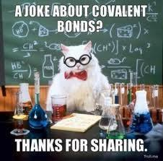
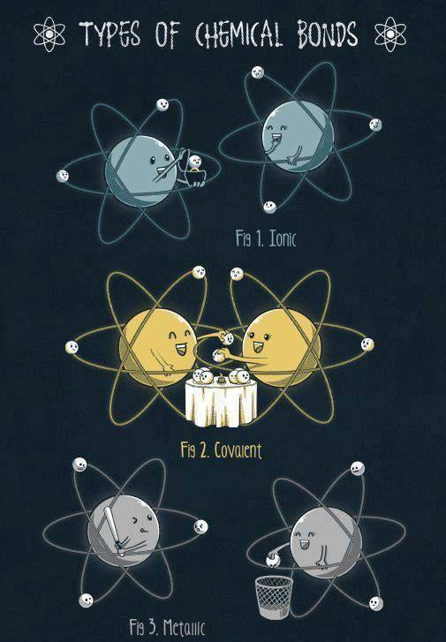
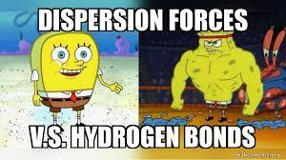
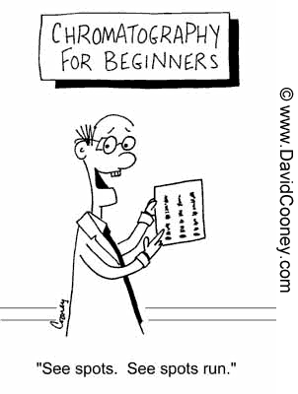
Ionic Bond Formation Think Tank Problems

- Draw well diagrams to represent neutral Na and Cl atoms.

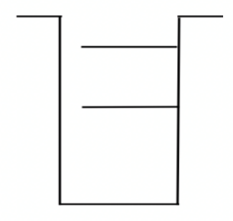
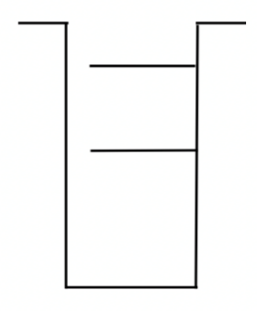

- Explain why the well of Cl is deeper and has more shelves than Na.

- Predict what would happen if energy were applied to both the Na and Cl atoms. Based on the strength of their attractive forces, which atom would it be easier to remove the electron from using that applied energy? Explain your answer using the well diagrams and ionization energy values.

- When the electron is removed from the atom predicted above, to which atom will it most likely return to? Explain your answer using the well diagrams and ionization energy values.

- Draw new well diagrams to represent the Na and Cl after the energy is applied to remove the electron and the electron settles back into the system.
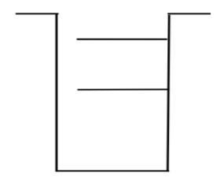

- Draw well diagrams to represent neutral Mg and Cl atoms.
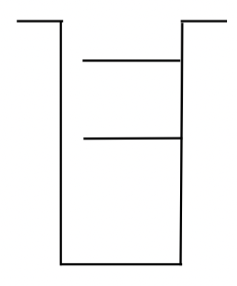

- Predict what would happen if energy were applied to both the Mg and Cl atoms. Based on the strength of their attractive forces, which atom would it be easier to remove the electron from using that applied energy? Explain your answer using the well diagrams and ionization energy values.

- When the electron is removed from the atom predicted above, to which atom will it most likely return to? Explain your answer using the well diagrams and ionization energy values.

- In your diagram above, show the migration of electrons as Mg reacts with Cl.
- Explain why more Cl atoms were needed to react with Mg than to react with Na. In other words, why does NaCl form and not NaCl₂ and why does MgCl₂ from and not MgCl?

- In summary, what happens subatomically when a metallic atom and a nonmetallic atom react to forma compound?

- What determines the ratio (chemical formula) in which the ions are used to form a compound?

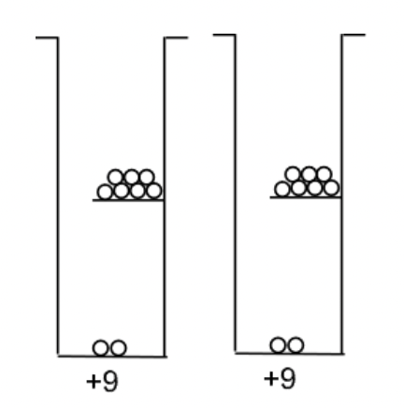
Consider the well diagrams for two fluorine atoms. Diatomic fluorine, F₂(g) is a naturally occurring, highly toxic, pale yellow gas.

- Could the process you described for the formation of NaCl and MgCl₂ account for the formation of F₂? Explain your answer.

- Try to come up with a way to manipulate the well diagrams above to account for the bond that naturally occurs between two fluorine atoms.

- Does your model account for the fact that F₂ occurs naturally but F₃, F₄ and other combinations of F atoms do not occur naturally?
IONIC Lewis Structures Introduction

Element | Metal or Nonmetal | Lewis Dot Structure  as an ATOM | Gain or lose electrons | How many e⁻ | Lewis Dot Structure  of Stable ION | Becomes like which noble gas?
Fluorine
Lithium
Aluminum
Sulfur
Radium
Phosphorous

Check Your Understanding: Using your chart, draw Lewis structures for the following compounds:
Lithium Phosphide

Lithium Fluoride
Lithium Sulfide
Aluminum Fluoride
Aluminum Sulfide
Radium Fluoride
Radium Sulfide
Aluminum Phosphide
Radium Phosphide
Summarize:
-Why do metals bond with nonmetals?

-What determines how many atoms of the metal and nonmetal will combine to form the compound?
IONIC Lewis Dot Structures Practice
Lewis Diagram | Formula | Lewis Diagram | Name
Sodium fluoride |  | CsCl
Potassium oxide |  | MgO
Rubidium nitride |  | SrI₂
Calcium bromide |  | BaS
Strontium sulfide |  | Fe₂O₃
Magnesium phosphide |  | Ag₂S
Aluminum iodide |  | CuO
Copper (I) sulfide |  | NiCl₃
Chromium (III) nitride |  | TiO₂
Manganese (IV) oxide |  | PtCl₂

Honors: Lattice Energy

Ionic bonds contain cations and anions that have _________________ electrons and attract each other due to their __________ charges. The strength of the ionic bond is largely due to the lattice energy. Lattice Energy is the energy released when gaseous ions create a solid ionic compound. Lattice energy depends on the charge and radii of the ions. The lattice energy will be a large value if the charges are _____________ and the radii are ___________, making the ionic compound stronger.

- Why will ionic compounds formed with large positive and large negative ions be stronger than those formed with +1 and -1 ions?

- Why will ionic compounds formed with smaller cations and anions be stronger than those formed with large ions?

- Which is more important: the ionic charge or the radii? Why?

- Draw a particle view (ions attracting) to describe your answers to questions 1-3.

- Circle the compound in each set that has a stronger ionic bond. Explain your answer.
  - LiF versus KF
  - CaO versus MgO
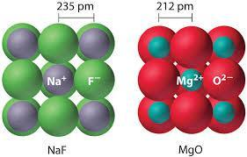
  - Li₂O versus LiCl
  - AlCl₃ versus LiF

- Describe which lattice will have a higher lattice energy
in the picture on the right.

COVALENT Lewis Dot Diagrams Think Tank Problems

1. All nonmetals (with the exception of H and He) will have between ______ and _____ valence electrons. Nonmetals tend to ________ valence electrons to obtain a stable octet. When two nonmetals react they form _________________ bonds. Draw Lewis dot diagrams for the following species:
F Cl Br I O S

Se Te N P C

2. Can these atoms create ionic bonds with one another? Will they transfer electrons to one another? Why or why not?

3. If these nonmetals need 8 valence electrons to become stable, how can they obtain electrons other than transferring electrons to one another? (Think about what you would do in your life if you needed a pencil for a lab but only one member of the lab group had a pencil.)

4. Show how a fluorine atom might bond with a chlorine atom in order for them both to obtain an octet.

5. Show how a fluorine atom might bond with an iodine atom in order for them both to obtain an octet. How is this similar to fluorine bonding with chlorine?

6. Show how a fluorine atom might bond with an oxygen atom in order for them both to obtain an octet. Compare this bond with the previous bonds.

Covalent Lewis Dot Diagrams Check Your Understanding

Compound | Total valence electrons | Lewis Diagram | Shape | Shared pairs | Unshared pairs | Bond Angle
H₂
F₂
O₂
H₂O
OF₂
NH₃
PCl₃
CH₄
SiF₄
SCl₂
CCl₄
AsF₃
Compound | Total valence electrons | Lewis Diagram | Shape | Shared Pairs | Unshared Pairs | Molecular Polarity
HF
H₂S
SiBr₄
PH₃
Cl₂
N₂
CO₂

Covalent Lewis Diagrams Summary
- Compounds with 2 atoms are always ___________________shaped.
- Compounds with 3 atoms are either _____________ or ________ shaped.
- What determines which shape the molecule will take? ______________________________________
- Compounds with 4 atoms are ______________________ shaped.
- Compounds with 5 atoms are ____________________ shaped.
- Single bonds share _____ electrons and are the ______________ bonds.
- Double bonds share _____ electrons.
- Triple bonds share _____ electrons and are the ______________ bonds.
- Halogens always bond _______ time(s) because they have _____ valence and need ____ electrons to fill the valence.
- Chalcogens (oxygen’s group) always bond _______ time(s) because they have _____ valence and need ____ electrons to fill the valence.
- Nitrogen’s group always bond _______ time(s) because they have _____ valence and need ____ electrons to fill the valence.
- Carbon’s group always bond _______ time(s) because they have _____ valence and need ____ electrons to fill the valence.
- Hydrogen always bonds _______ time(s) because they have _____ valence and need ____ electrons to fill the valence.

Bond Polarity Think Tank Problems
1 2 13 14 15 16 17 18
In the empty spaces of the chart above, fill in the element symbols and electronegativity values.
- Electronegativity values generally _______________ down a group and ____________ across a period.
- Metals tend to have ____________ electronegativity values and nonmetals are _____________ values.
- When lithium bonds with fluorine they form an ________________ bond.
  - What is the electronegativity difference of lithium and fluorine that might help characterize the properties they have? _____
  - List some of the properties:

- When fluorine bonds with another fluorine atom they form a ________________ bond.
  - What is the electronegativity difference of the two fluorine atoms that might help characterize the properties they have? _____
  - List some of the properties:

- When hydrogen bonds with fluorine atom they form a ________________ bond.
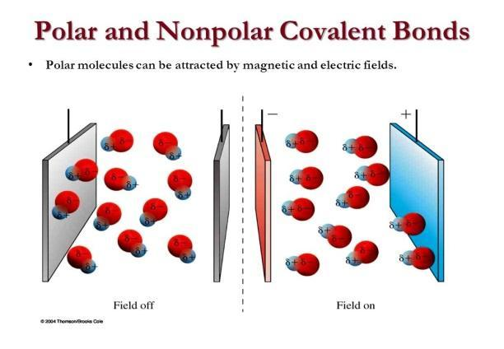
  - What is the electronegativity difference of the hydrogen and fluorine atoms that might help characterize the properties they have? _____
  - List some of the properties:

- HF and F₂ are both ________ compounds, but they actually have some slightly different properties. F₂ is not attracted to an electromagnetic field, where HF is. HF has a high boiling point, but F₂ is very low. Based on the information you obtained so far, what characteristics might cause these differences?
Bonding Rules:
- All diatomic elements such as ____, will have an electronegativity difference of ____ and have low boiling points and weak attractions with one another. These will be considered nonpolar covalent compounds. Since both atoms have the same electronegativity value, they share the electrons equally.
- Compounds created using nonmetals that have the same electronegativity value such as ____ and ____ will also be nonpolar covalent compounds. Since both atoms have the same electronegativity values, they share the electrons equally.
- Compounds created using nonmetals with similar electronegativity values in which the difference rounds to zero, (0-0.4) such as elements ____ and ____ will also be nonpolar covalent compounds. Since both atoms have similar electronegativity values, they share the electrons equally.
- Compounds created using nonmetals with different electronegativity values in which the difference rounds to one, (0.5-1.4) such as elements ____ and ____ will have higher boiling points and attract to each other more. These will be known as polar covalent compounds. Since the atoms have different electronegativity values, they share the electrons unequally; the ____(more/less) electronegative element will have the electrons more of the time and obtain a slightly ____ charge.
- Compounds created using metals and nonmetals will have large electronegativity differences in which the difference rounds to two, such as elements ____ and ____. These will be known as ionic compounds.

- Fill in the chart below:
Electronegativity Difference | Type of Bond
0.0-0.4
0.5-1.4
1.5-4.0

Bond Polarity Check Your Understanding

Using your table above, find the electronegativity difference for each substance. If more than one bond is formed, find all differences. Then, check which bonds are present.

Substance | Electronegativity difference(s) | Ionic | Covalent | Polar | Nonpolar
I₂
PCl₃
SiO₂
Br₂
CO₂
NaCl
CH₄
N₂O₅
NH₃
KCl
NaNO₃
KClO₃
Ca(ClO₃)₂

Bonding Polarity Practice

- Indicate which atom will have the positive charge and which will have the negative charge in the following polar bonds:
H-Cl H-F S-F N-O
- Organize the following in order from least to most polar bonds: HCl, HF, H₂O, NH₃, HI

- Identify and explain each bond drawn below:
 | Type of Bond | Explanation
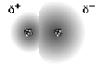

- For each statement check if it describes ionic, polar covalent, nonpolar covalent, or metallic bonds:
 | Ionic | Polar Covalent | Nonpolar Covalent | Metallic
A transfer of electrons between two atoms
Positive nuclei dispersed in a sea of mobile electrons
Metals and nonmetals bonding
One atom loses, and another atom gains electrons
Two atoms share electrons equally
Metals bonding only
Electronegativity differences under 0.4
A bond resulting from electrostatic charges between oppositely charged particles
Two atoms share electrons unequally
Nonmetals bonding only
Electronegativity differences over 1.7
In terms of lone pairs of electrons, how can you determine if a molecule is polar?

How can a molecule be nonpolar if it contains polar bonds?

Can a shape have nonpolar bonds and be polar?

Go back to Covalent Lewis Diagrams you drew on pages 13 and 14. Determine if the molecules were polar or nonpolar in the margin next to the name.

Molecular Polarity
 | Bond Polarity  (polar or nonpolar covalent due to E.N.D.) | Distribution of charge? (symmetrical or asymmetrical) | Molecular Polarity  (polar or nonpolar molecule) | Molecular Shape (linear, pyramidal, tetrahedral, or bent)
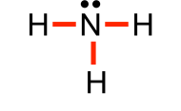

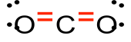

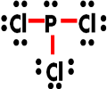

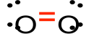

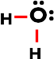

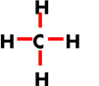

Summarize the similarities and differences between bond and molecular polarity:

Bond Energy Summary

- When bonds are formed, the new substance is ____(more/less) stable and therefore the reaction will _______(absorb/release) energy.
- When bonds are broken, the new substances are ____(more/less) stable and therefore the reaction will _______(absorb/release) energy.
- When energy is released the value is ___(+/-) and labeled _________________(endo/exo)thermic.
- When energy is absorbed the value is ___(+/-) and labeled _________________(endo/exo)thermic.

Bond Energy Practice

For each of the reactions, draw the structure of the compounds and then find the change in enthalpy of reaction (ΔHrxn). Assume all elements and compounds are in the gas phase unless noted otherwise.
- H₂ + Cl₂ 🡪 2HCl

- N₂ + 3H₂ 🡪 2NH₃

- N₂H₄ + 2F₂ 🡪 N₂ + 4HF

Polarity Activity

Directions: For each molecule, draw the Lewis structure and fill in the chart.
1 | Is the bond polar or nonpolar?  Justify your answer:  Is the molecule polar or nonpolar?  Justify your answer:
2 | Is the bond polar or nonpolar?  Justify your answer:  Is the molecule polar or nonpolar?  Justify your answer:
3 | Is the bond polar or nonpolar?  Justify your answer:  Is the molecule polar or nonpolar?  Justify your answer:
4 | Is the bond polar or nonpolar?  Justify your answer:  Is the molecule polar or nonpolar?  Justify your answer:
5 | Is the bond polar or nonpolar?  Justify your answer:  Is the molecule polar or nonpolar?  Justify your answer:
6 | Is the bond polar or nonpolar?  Justify your answer:  Is the molecule polar or nonpolar?  Justify your answer:
7 | Is the bond polar or nonpolar?  Justify your answer:  Is the molecule polar or nonpolar?  Justify your answer:

- Can bonds be polar and the molecule nonpolar? Explain.

- Why were some bonds shorter than others?

- Which bond was the most polar?

Conductivity of Substances and Mixtures Summary
Use particle diagrams to represent why each case either conducts or does not conduct. For each situation, an example of that substance or mixture is given. In each case, consider the relative size and shape of the particles, charges of the particles, phase (spacing the particles), and mobility (vibrational or zoom lines). Use green lines to represent electricity trying to move from the left side of the substance to the right.
Solid Metals (K_{(s)})
Liquid Metals (Mg_{(l)})

Liquid Covalent Compounds (H₂O_{(l)})
Solid Covalent Compounds (CO_{2(s)})

Gaseous Covalent Compounds (CO_{(g)})
Solid Ionic Compounds (NaBr_{(s)})

Molten Ionic Compounds (KI_{(l)})
Aqueous Ionic Compounds (NaBr_{(aq)})

Boiling Point Trends Think Tank Problems
The boiling point, atomic mass, and total electrons of nonmetallic diatomic elements are shown below.
Element | Boiling Point (K) | Number of e-
H₂ | 20 | 2
N₂ | 77 | 14
O₂ | 90 | 16
F₂ | 85 | 18
Cl₂ | 239 | 34
Br₂ | 332 | 70
I₂ | 457 | 106

- Based on the evidence provided in the table, identify the factor that accounts for the differences in boiling point between hydrogen and fluorine.

- Draw the Lewis diagram for H₂ molecules:

  - In your diagram, are the electrons evenly or unevenly distributed among the atoms?

  - In previous lessons we discussed how the uneven distribution of electrons can explain why the aluminum foil was attracted to the sticky tape. Based on this information, would you expect hydrogen molecules to attract charged particles? Explain your choice.

  - Is the hydrogen molecule polar or nonpolar?

- Examine the possible electron density diagrams for hydrogen. The shaded regions indicate probable locations of e- at a snapshot in time.
  - Draw in 2e- per molecule to show where they may be positioned at each time.
  - Are the electrons always evenly distributed within the molecule? Explain your answer.
Time 1 Time 2
- Chemists use the small delta sign (δ+ and δ-) to show slight differences in charge within a molecule.
  - Label the diagrams above with those symbols to show where there may be small concentrations of + and – charges.
  - How could slight or temporary uneven distribution of electrons affect the attraction between molecules, like those in H₂? What does this mean for the polarity of H₂?

- Below are two molecule diagrams. The left diagram is shaded to show electrons in an uneven distribution, known as a dipole.
  - How could this distribution of electrons affect the distribution of electrons in the molecule on the right? Shade the molecule on the right to show its electron distribution when it is close to the left molecule. Mark the δ + and δ – regions.
  - Would this uneven distribution of electrons be temporary or permanent? Explain your answer.

- The temporary dipoles described above result in attractions known as London Dispersion Forces (LDF). Explain why these forces are stronger in fluorine than hydrogen.

- As we have discovered, charged objects exert forces on one another. Describe the distinction between attractions we have observed here and bonds.

- Examine the electron density map of F₂ and CH₄.

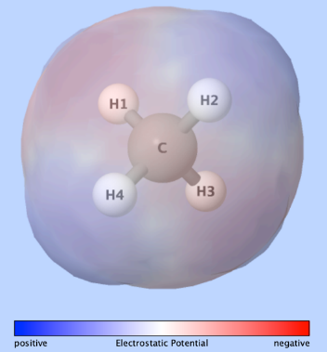
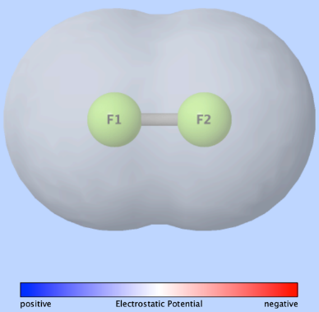
a. Describe similarities and differences between the two structures.

b. Are these molecules polar or nonpolar? Explain.

c. Can they exert a strong permanent force on other molecules?

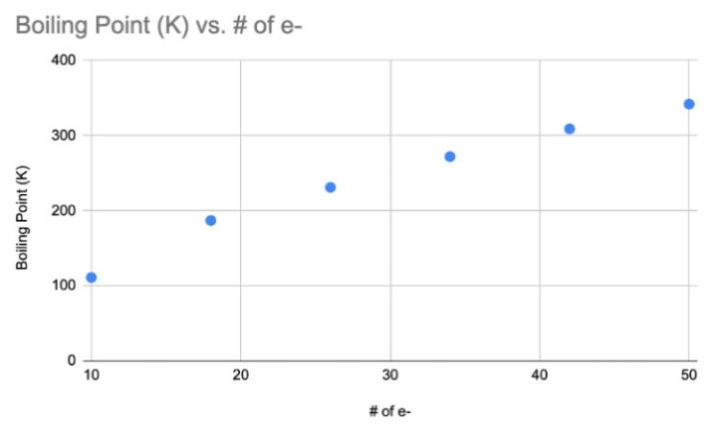
- Describe the trend between the boiling point of the following compounds and the number of electrons. Explain the trend.

 | Boiling Point (K) | Number of e-
CH₄ | 111 | 10
C₂H₆ | 187 | 18
C₃H₈ | 231 | 26
C₄H₁₀ | 272 | 34
C₅H₁₂ | 309 | 42
C₆H₁₄ | 342 | 50
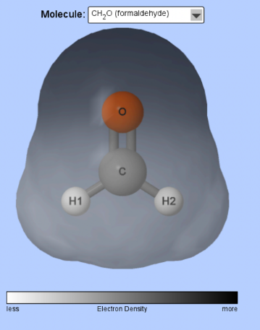
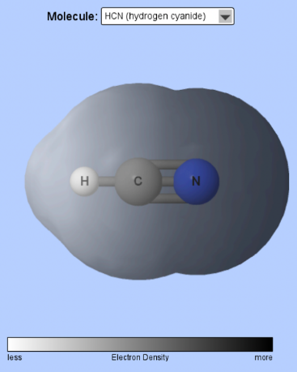
Observe the electron density diagrams for HCN and CH₂O below. These both have significantly high boiling points than H₂, F₂ and CH₄.
- Let’s compare HCN and CH₂O to see how they differ from H₂, F₂ and CH₄ in terms of electron distribution: Draw on the diagrams above where the molecules are δ + and δ – charged. Are HCN and CH₂O molecules symmetrical or asymmetrical?

- Use table S to find the electronegativities of the various elements used in these structures.

  - Do the differences in electronegativity values help account for the differences in boiling points in the two types of molecules?

  - Draw two HCN molecules with their charges and show their attractive forces between the two molecules using a dashed line.

  - Molecules composed of elements with significantly different electronegativity values are known as dipolar molecules. Which set of molecules have stronger attractive forces: London Dispersion Forces in H₂, F₂ and CH₄ or Dipole Forces in HCN and CH₂O?

- Identify the trend in boiling points for group 14 compounds.
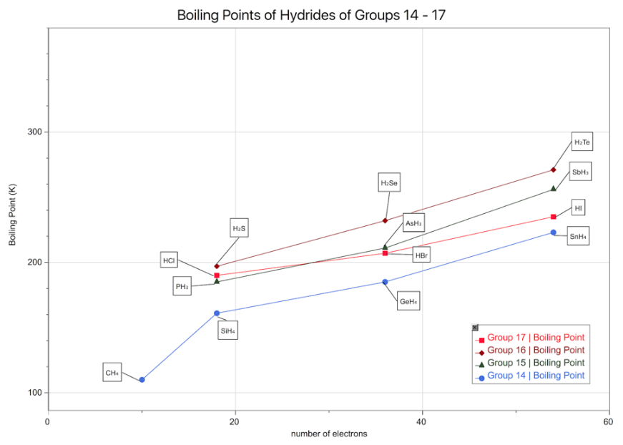
- Estimate the boiling points of NH₃, H₂O and HF if these compounds followed the same trend as CH₄ does in group 14. Label the graph with your predicted boiling points for these three molecules.

- The actual boiling points of the three molecules are listed below. Do these values follow the trend?
NH₃: 240K H₂O: 373K HF: 293K

Molecules that have extreme differences in electronegativity values, specifically molecules created with bonds between H and either F, O, or N, have a strong intermolecular force known as hydrogen bonding.
- How is a “hydrogen bond” different than a covalent bond?

- If it weren’t for hydrogen bonds, in what phase would water exist on our planet?

- Why are hydrogen bonds called bonds rather than attractions?

- Describe the role hydrogen bonding plays in the structure of ice. Why is ice less dense than liquid water? Draw water molecules in the liquid phase and then in the solid phase to support your explanation.

- Both ethanol, CH₃CH₂OH and dimethyl ether, CH₃OCH₃ have the same molecular formula, but one of these substances has a much higher boiling point than the other. Predict which has the higher boiling point and explain. Draw diagrams of each molecule to support your explanation.

- Summary of intermolecular forces of attraction:
 | London Dispersion Forces | Dipole-Dipole Forces | Hydrogen Bonds
Electronegativity Difference
Polarity
Relative Strength
Other details

Intermolecular Forces Summary
Define the words to complete the following chart:
Compound:

Intermolecular Forces:
Intramolecular Forces:

IMF | Type of Molecules Involved | Model | Properties | Strength Depends On
London Dispersion Forces

Dipole Dipole

Hydrogen Bonds

Ion Dipole

Intermolecular Forces and Bonds Check Your Understanding

- For each example identify the electronegativity values of each element in the compound. Shade the region of the molecule that is most electronegative red and the most electropositive blue or use δ. Then determine the type of bond, polarity, and force the molecules of the substance have.
Electronegativity Values  O: ___ H: ___  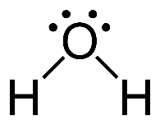  Type of Bond: ___________________  Molecular Polarity: _____________  Type of Force: ___________________ | Electronegativity Values  C: ___ H: ___  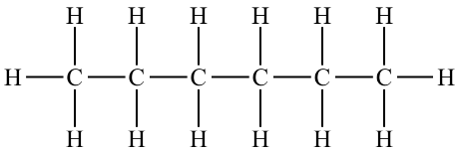  Type of Bond: ___________________  Molecular Polarity: _____________  Type of Force: ___________________ | Electronegativity Values  H: ___ F: ___  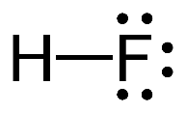  Type of Bond: ___________________  Molecular Polarity: _____________  Type of Force: ___________________
Electronegativity Values  C: ___ Cl: ___  Type of Bond: ___________________  Molecular Polarity: _____________  Type of Force: ___________________ | Electronegativity Values  C: ___ Cl: ___ F: ___  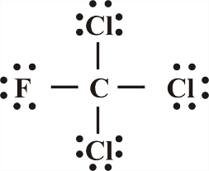  Type of Bond: ___________________  Molecular Polarity: _____________  Type of Force: ___________________ | Electronegativity Values  C: ___ O: ___ H: ___  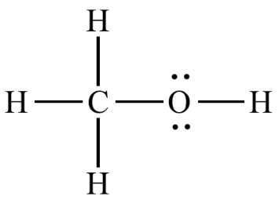  Type of Bond: ___________________  Molecular Polarity: _____________  Type of Force: ___________________

- Generally, all physical changes involve changes ____________________ and chemical changes involve changes in _____________________________.

- List the noble gases with their boiling points in order. They all do not bond, so why are they not all the same value?

- Why does gasoline (C₈H₁₈) remain in the liquid phase but our Bunsen burner gas made out of the same elements (CH₄) remains in the gas phase?

- Why does dry ice, CO₂, sublime at room temperature but sugar, C₆H₁₂O_{6,} and salt, NaCl, don’t even melt?

- Why is sodium chloride’s melting point much higher than sugar’s?

- Explain why this data makes sense for the last three compounds, but not the first?
 | Atomic mass | Boiling Point (˚C)
H₂O | 18.0 | 100
H₂S | 34.1 | -62
H₂Se | 81.0 | -42
H₂Te | 129.6 | -2

- What is the exception for the first compound?

- Explain why this data makes sense for the last three compounds, but not the first?
 | Atomic mass | Boiling Point (˚C)
HF | 20.0 | 19
HCl | 36.5 | -84
HBr | 80.9 | -67
HI | 129 | -35

- What is the exception for the first compound?

- Surface tension is a result of strong intermolecular forces allowing the lizard to run on water. Which of the compounds in question 10 has the strongest surface tension and why?

- Some perfumes only last a short time while others have lasting odors.

- Why does dye dissolve in water and not oil?

- Why does I₂ dissolve in oil and not water?

Liquid Demo

Before | After
Sketch the 3 layers of liquids in the first cylinder before shaking. Label each layer and sketch structures for each of the molecules in the layers. Identify the liquids as polar or nonpolar based on your structures. | Sketch the appearance of the contents of the cylinder after shaking. In which layer (hexane or water) did the methanol appear to dissolve? From the class discussion, what generalization was made about polarity and solubility?
Sketch the 3 layers of liquids in the second cylinder before shaking. Label each layer and sketch the structures for the 1,1-dichloroethane. Predict whether this liquid would dissolve in the organic or aqueous phase; explain your prediction. | Sketch the appearance of the contents of the cylinder after shaking. In which layer (pentane or water) did the dichloroethane appear to dissolve? Explain what modification should be made to the generalization about solubility.
Sketch the 3 layers of liquids in the third cylinder before shaking. Label each layer and sketch the structures for the acetone. Predict whether this liquid would dissolve in the organic or aqueous phase; explain your prediction. | Sketch the appearance of the contents of the cylinder after shaking. In which layer(s) - hexane or water - did the acetone appear to dissolve? Explain what is problematic about the generalization "like dissolves like".

Structures of Molecules and IMF Check Your Understanding

Use your knowledge of intermolecular forces (IMFs) to determine whether each molecule is polar or nonpolar. For polar molecules, determine if they are capable of forming hydrogen bonds with another molecule like it. Circle the atoms in the molecule that give it that capability.

H₂O CH₃CH₂CH₂CH₂CH₃ CH₃OH

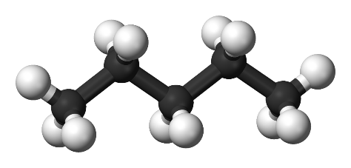
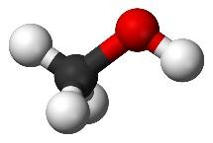
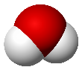

Water Pentane Methanol

CHCl₂CH₃ CH₃COCH₃
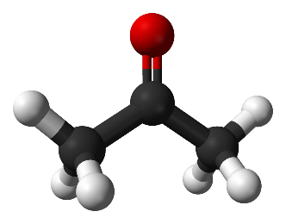
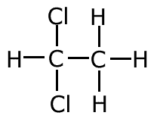

1,1-dichloroethane Acetone

Alcohol Solubility
Examine the solubility information for methanol and pentanol below. Explain the difference in the solubility of each alcohol. Draw particle diagrams of the interactions between each alcohol and water molecules to support your explanation.
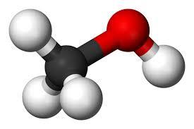

Methanol CH₃OH miscible

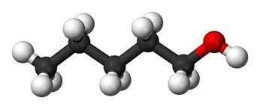

Pentanol C₅H₁₁OH 2.7g/100g solubility

Solubility Table F Check Your Understanding

Use Table F to determine if the following compounds are soluble or insoluble.
a. NaCl | e. K₃PO₄ | i. calcium hydroxide
b. PbBr₂ | f. MgCO₃ | j. copper (II) hydroxide
c. CaSO₄ | g. NH₄NO₃ | k. lead(II) sulfate
d. K₂CrO₄ | h. sodium hydrogen  carbonate | l. ammonium sulfide

Key:  I – Insoluble  S – Soluble | nitrate | acetate | H carbonate | chlorate | chlor  ide | fluoride | iodide | sulfate | carbonate | chromate | phosphate | sulfide | hydroxide
lithium
sodium
potassium
rubidium
cesium
ammonium
silver
lead
mercury
calcium
strontium
barium
magnesium

Solubility Table G Check Your Understanding

- Check the conditions under which each of the following solutes will be most soluble.

Solute Name | Solute Formula | Temperature |  | Pressure |  |  | Best Solvent
 |  | Low | High | Low | High | No Effect | H₂O | CCl₄
potassium nitrate | KNO₃(s)
hydrogen chloride | HCl(g)
nitrogen trihydride | NH₃(g)
ammonium chloride | NH₄Cl(s)
carbon dioxide | CO₂(g)
potassium iodide | KI(s)
potassium chlorate | KClO₃(s)

- Observe the demonstration of unsaturated, saturated, and supersaturated solutions.

Observations: | Diagram:
Graphical: | Narrative:
- State whether each of the following solutions is saturated, unsaturated, or supersaturated.
(a) 80 g NaNO₃ in 100 g H₂O at 10ºC ___________________________
(b) 75 g NaNO₃ in 100 g H₂O at 10ºC ___________________________
(c) 90 g NaNO₃ in 100 g H₂O at 10ºC ___________________________
(d) 90 g KNO₃ in 100 g H₂O at 50ºC ___________________________
(e) 90 g KI in 100 g H₂O at 50ºC ___________________________
(f) 5 g KClO₃ in 100 g H₂O at 5ºC ___________________________
(g) 40 g KCl in 50 g H₂O at 60ºC ___________________________
(h) 35 g NaNO₃ in 50 g H₂O at 10ºC ___________________________
(i) 5 g KClO₃ in 50 g H₂O at 5ºC ___________________________
(j) 5 g KClO₃ in 200 g H₂O at 5ºC ___________________________
(k) 30 g NH₄Cl in 200 g H₂O at 10ºC ___________________________
(l) 40 g SO₂ in 200 g H₂O at 5ºC ___________________________

- Tell how many MORE grams of each solute must be added to 100 g of water to form a saturated solution at that temperature.
Grams Solute per  100 g H₂O | Solute Added to make Saturated |  | Grams Solute per  100 g H₂O | Solute Added to make Saturated |  | Grams Solute per  100 g H₂O | Solute Added to make Saturated
a. 35 g KNO₃ at 40ºC |  |  | d. 35 g NaCl at 90ºC |  |  | g. 25 g NH₃ at 5ºC
b. 50 g NH₃ at 10ºC |  |  | e. 5 g NH₃ at 90ºC |  |  | h. 30 g NaNO₃ at 50ºC
c. 15 g KCl at 75ºC |  |  | f. 10 g KClO₃ at 40ºC |  |  | i. 15 g KClO₃ at 75ºC

- Tell how many grams of each solute will crystallize/precipitate/settle. Assume all solutions are saturated and in 100 grams of H₂O.
Amount cooled | Amount Precipitated |  | Amount cooled | Amount Precipitated
a. KNO₃ (aq) is cooled  from 70ºC to 40ºC |  |  | d. NaCl (aq) is cooled  from 100ºC to 40ºC
b. NH₄Cl (aq) is cooled  from 90ºC to 20ºC |  |  | e. KNO₃ (aq) is cooled  from 65ºC to 25ºC
c. KCl (aq) is cooled  from 55ºC to 30ºC |  |  | f. KClO₃ (aq) is cooled  from 100ºC to 40ºC
Naming with Transition Metals Check Your Understanding

Transition metals refer to the metals in groups 3-12 of the period table (elements Sc through Zn and down). These metals form various positive ions. It is important to identify which ion is used when naming the compound. We will work backwards to do this, meaning, we will look at the charge for the second ion in the formula to find that charge of the first. We will report the charge of the first ion in roman numerals (the numerals you need to memorize are listed to the right) in parenthesis after that ion. For example:
One I Five V
Two II Six VI
Three III Seven VII
Four IV

CuO O is -2 so Cu needs to be +2 Copper (II) oxide
Cu₂O O is -2 so each Cu must be +1 Copper (I) oxide
These two compounds have different structures and properties and must have different names. Try to name the following compounds with transition metals:
1. FeBr₂ ________________________ 6. NiF₃ ________________________
2. FeBr₃ ________________________ 7. CuCl ________________________
3. PbS ________________________ 8. CuCl₂ ________________________
4. PbS₂ ________________________ 9. CuS ________________________
5. NiO ________________________ 10. Cu₂S ________________________
Formula writing may seem easier. You can still use the drop and swap rule. Remember the number in roman numerals refers to the charge of the first ion. Try to give the formula of the following compounds:
1. Chromium (VI) oxide _____________ 6. Zinc (II) oxide _____________
2. Manganese (VII) chloride____________ 7. Iron (II) oxide _____________
3. Lead (IV) iodide _____________ 8. Iron(III) oxide _____________
4. Silver (I)sulfide _____________ 9. Gold (III) phosphide _____________
5. Nickel (II) fluoride _____________ 10. Titanium (IV) sulfide _____________
Naming with Polyatomic Ions Check Your Understanding
Binary compounds have only two elements in their formula, as we saw in exercises above. Tertiary compounds have three or more elements in their formula and have a new system of naming. These compounds have a polyatomic ion, which is an ion that has a few elements grouped together with only one charge between them. A common example is OH⁻ which shows two elements with an overall charge of -1. As before, name the first element completely and then look up the rest of the compound on table E of the reference tables. Make sure you copy the right one, some are very similar! For example: NaOH is called sodium hydroxide. Also, beware of NH₄⁺ which is the only polyatomic cation (that comes in front). Try naming the following examples:

1. KHCO₃ _________________________ 4. LiNO₂ ______________________________

2. CaSO₄ _________________________ 5. Cu(ClO₄)₂ ______________________________

3. NaNO₃ __________________________ 6. Al₂(SO₃)₂ ______________________________

To write the formula of a tertiary compound you can still use the drop and swap rule, however, you must be sure to only drop the superscripts and leave the subscripts alone. For example, aluminum carbonate:

Al⁺³ and CO₃⁻² Leave the ₃ alone! Swap the ³ and ² Al₂(CO₃)₃

Remember, formulas don’t show any charges. You can see that we use parenthesis around the polyatomic ion because the entire ion charge was -2 and must swap with aluminum so the entire ion gets aluminum’s 3. Try to write the formula for the following compounds (write the formulas of the ions next to the name first):

 | Hydroxide | Nitrate | Carbonate | Phosphate | Acetate
Sodium
Calcium
Ammonium
Iron (II)
Aluminum

Try a few more:

1. Zinc Hydroxide: ________________________ 4. Magnesium oxalate:______________________

2. Calcium chlorate: ________________________ 5. Lead (IV) chromate:_______________________

3. Hydrogen acetate: ________________________ 6. Strontium cyanide:________________________

Common Sense Chemistry Review
I am transferring my knowledge to you. Isn’t it ionic?

- Charlie knows that melting sugar can create delicious caramel. Charlie also loves salty foods. He has an idea: melt salt and use it as a drizzle as well!
  - Explain to Charlie- in terms of bond strength, melting points, and electrons- why melting the salt isn’t feasible.

  - Charlie doesn’t believe you. He tries to melt salt in another pot anyway and thinks adding water will help. And then drops an electric mixer into the pot. Is it safe to pull out? Why or why not?

  - If he dropped the mixer in the sugar melting, would he be more or less safe than the salt solution?

- Explain why all salts are not compressible, hard structures whereas sugar can be powdery.

- Nitrogen gas is a major component in the air. The amount of water vapor varies. Explain in terms of bond strength, why nitrogen gas is always present in the air and mainly non-reactive, while water vapor varies. Draw diagrams to elaborate.

- Sometimes it takes forever to dry off from a shower or pool, but nail polish remover dries instantly. Explain this phenomenon.

- Why won’t my oil and vinegar just mix already?

- Explain in terms of bonds and forces, why methane (CH₄, cow farts) is gaseous, but a compound made of the same elements, octane (C₈H₁₈, gasoline) is a liquid.

- Explain why water is attracted to itself creating strong surface tension allowing lizards to run across the surface of lakes. Would water be as strong if oxygen has no lone pairs?

- Many houses are supplied with “hard” water, water containing calcium ions that when mixed with carbonate ions create “lime buildup” in your showers, sinks, and cooking appliances. What phase is the calcium carbonate? Why doesn’t it just wash down with the water when you shower?

- Soda cans are considered to be supersaturated solutions of carbon dioxide in sugar water. How will more CO₂ dissolve than the water solution can hold?

