AP Learning Objectives
- Identify the sign and relative magnitude of the entropy change associated with chemical or physical processes.(9.1)
- Calculate the entropy change for a chemical or physical process based on the absolute entropies of the species involved in the process.(9.2)
- Explain whether a physical or chemical process is thermodynamically favored based on an evaluation of ∆Go . (9.3)
- Explain, in terms of kinetics, why a thermodynamically favored reaction might not occur at a measurable rate.(9.4)
- Explain whether a process is thermodynamically favored using the relationships between K, ΔGo , and T.(9.5)
- Explain the relationship between external sources of energy or coupled reactions and their ability to drive thermodynamically unfavorable processes. (9.6)
- Explain the relationship between the physical components of an electrochemical cell and the overall operational principles of the cell. (9.7)
- Explain whether an electrochemical cell is thermodynamically favored, based on its standard cell potential and the constituent half-reactions within the cell. (9.8)
- Explain the relationship between deviations from standard cell conditions and changes in the cell potential.(9.9)
- Calculate the amount of charge flow based on changes in the amounts of reactants and products in an electrochemical cell.(9.10)
- Identify a reaction as acid base, oxidation-reduction, or precipitation.(4.7)
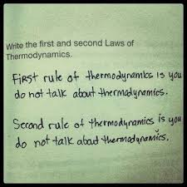
- Represent a balanced redox reaction equation using half-reactions.(4.9)

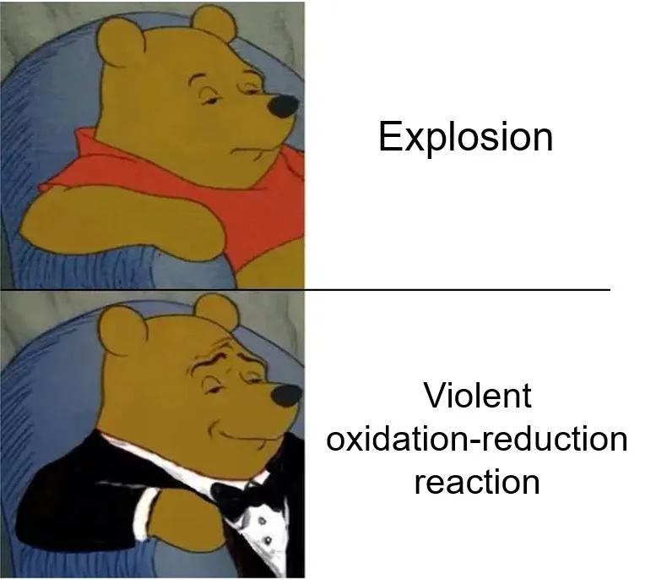
Enthalpy Review

The first law of thermodynamics: Energy can never be created nor destroyed. Therefore, the energy of the universe is constant.

- It takes 585J of energy to raise the temperature of 125.6g of Hg from 20.0 to 53.5C. Calculate the specific heat of Hg.

- A 46.2g sample of Cu is heated to 95.4C and placed in a calorimeter containing 75.0g of water at 19.6C. The final temperature inside the calorimeter equals 21.8C. Calculate the specific heat of copper.

- Consider the reaction:
2Mg + O₂ 🡪 2MgO ΔH=-1204kJ/mol
  - Is this reaction endothermic or exothermic?

  - Calculate the heat transferred when 3.60g of Mg reacts with excess oxygen.

  - How many grams of MgO are produced during the enthalpy change of -96.0kJ?

- The thermite reaction is highly exothermic and is used for welding: ΔHf Fe₂O₃(s) = -822.2kJ/mol
2Al(s) + Fe₂O₃(s) 🡪 2Fe(s) + Al₂O₃(s) ΔHf Al₂O₃(s) = -1669.8kJ/mol
Calculate the heat of this reaction using enthalpies of formation.

- Calculate the change in energy that accompanies the following reaction given the data below.
H₂(g) + F₂(g) → 2 HF(g) Bond Type Bond Energy H−H 432 kJ/mol F−F 154 kJ/mol H−F 565 kJ/mol

Entropy
Entropy is the degree of disorder or randomness in a substance. The symbol for change in entropy is ΔS.Solids are very ordered and have low entropy. Liquids and aqueous ions have more entropy because they move about more freely, and gases have an even larger amount of entropy. According to the Second Law of Thermodynamics, nature is always proceeding to a state of higher entropy. Determine whether the following reactions show an increase or decrease in entropy.

- 2KClO_{3(s)} → 2KCl_{(s)} + 3O_{2(g)}

- H₂O_{(l)} → H₂O_{(s)}

- N_{2(g)} + 3H_{2(g)} → 2NH_{3(g)}

- 2NaCl_{(s)} → 2Na_{(s)} + Cl_{2 (g)}

- KCl_{(s)} → KCl_{(l)}

- CO_{2(s)} → CO_{2(g)}

- H⁺_{(aq)} + C₂H₃O₂⁻_{(aq)} → HC₂H₃O_{3(l)}

- C_{(s)} + O_{2(g)} → CO_{2(g)}

- H_{2(g)} + Cl_{2(g)} → 2HCl_{(g)}

- Ag⁺_{(aq)} + Cl⁻_{(aq)} → AgCl_{(s)}

- 2N₂O_{5(g)} → 4NO_{2(g)} + O_{2(g)}

- 2Al_{(s)} + 3I_{2(s)} → 2AlI_{3(s)}

- H⁺_{(aq)} + OH⁻_{(aq)} → H₂O_{(l)}

- 2NO_{(g)} → N_{2(g)} + O_{2(g)}

- H₂O_{(g)} → H₂O_{(l)}

Entropy Calculations

The second law of thermodynamics: the universe is constantly increasing the dispersal of matter and energy.
The third law of thermodynamics: the entropy of a perfect crystal at 0 K is zero. [Not a lot of perfect crystals out there so, entropy values are RARELY ever zero—even elements] So what? This means the absolute entropy of a substance can then be determined at any temp. higher than zero K. (Handy to know if you ever need to defend why G & H for elements = 0. . . . BUT S does not!)
ΔS is + when dispersal/disorder increases (favored)
ΔS is – when dispersal/disorder decreases
NOTE: Units are usually J/(molrxn • K) (not kJ!)

- Calculate the entropy change at 25°C, in J/(molrxn • K) for: 2 SO₂(g) + O₂(g) → 2 SO₃(g) Given the
following data: SO₂(g) 248.1 J/(mol• K) O₂(g) 205.3 J/(mol• K) SO₃(g) 256.6 J/(mol • K)

Gibbs Free Energy Introduction
Imagine making plans to hang out with friends. A number of different factors may come into play when deciding what you will do when you meet up. Do you have money to spend? Do you have a means of transportation? What are your available options? These day to day decisions will be used as an analogy for the study of thermodynamics.

- Using your prior knowledge of chemistry, specifically, enthalpy (heat, ΔH), temperature (kinetic energy, T), and entropy (number of microstates/ randomness, ΔS): For each factor below, explain why each of the corresponding chemical terms and signs (+/-) are analogous.
Factor | Term | Explanation
Money available to spend | -ΔH
Money need to save for bills | +ΔH
Transportation long distances is available | High T
Transportation is unavailable or only short distances | Low T
Endless opportunities, businesses open | +ΔS
Sunday,  businesses are closed | -ΔS
- You really need some friend time! Which is more favorable, money available to spend or money needed to save for bills? How is that related to endothermic and exothermic reaction favorability?

- Similarly, which is more favorable, endless opportunities for entertainment or businesses being closed? How is that related to entropic favorability?

- Using full sentences:
  - Explain the best scenario for making plans with your friends including the money, transportation availability, and opportunities.
  - Explain the analogous scenario using thermodynamic terms including enthalpy, temperature, and entropy. Also include the correct sign of each term (+/-).
- The Gibbs free energy is defined as the energy available to do work. If a system is thermodynamically favorable, each factor (enthalpy, temperature, and entropy) play a role. In this analogy, Gibbs free energy may be described as the energy you release to go out with your friends (dependent on money, transportation, and opportunities). What algebraic sign would best describe a favorable Gibbs free energy?
- For each scenario, explain how it relates to our analogy for enthalpy, entropy, and thermodynamic favorability. Use signs (+/-) in the small columns. Recall, it would be favorable to go out of the house with your friends.
 | Scenario | ΔH° | ΔS° | When will this scenario be favorable?  (Always, never, sometimes)
a | You have $200 to spend. You are visiting NYC on a fun Saturday night.
b | You have $200 to spend.  You are grounded.
c | You are saving money for a school trip. There’s a free fair with games, rides, and snacks; but it isn’t nearby.
d | You are saving money for a school trip.  You are grounded.

- For each scenario is question 6, explain if the availability of free transportation would influence the favorability of the scenario. If so, explain how it would be affected (more or less favorable than before).
  - Scenario a

  - Scenario b

  - Scenario c

  - Scenario d

- For each scenario in question 6, fill in the “Thermodynamic Favorability” column of the table below with + or – for Gibbs free energy. If your answer was “sometimes” based on your answers to question 7 and the analogy of transportation made in question 1, determine if the scenario is more favorable at high or low temperatures.
 | Enthalpy, ΔH° (KJ) | Entropy, ΔS° (J) | Thermodynamic Favorability, ΔG (KJ) | Temperature (K)  (all T, high T, low T, no T)
a | - | +
b | - | -
c | + | +
d | + | -

- Use complete sentences to explain how changes in enthalpy, temperature, and entropy would create each type of reaction.
  - A reaction that is always favorable

  - A reaction that is always unfavorable

  - A reaction that is sometimes favorable

- For each chemical scenario, determine if the reaction is endothermic or exothermic (enthalpy), and whether the reaction is increasing in overall entropy or decreasing. Then decide if the reaction is thermodynamically favorable. If the reaction is temperature dependent, state under which conditions the reaction will be favorable. Use the table created above to guide you.
 | Reaction | Enthalpy (+/-) | Entropy (+/-) | Gibbs (+/-)
a | CH₃OH(l) + 3/2 O₂(g) 🡪 CO₂(g) + 2H₂O(g) + heat
b | CO(g) + 2H₂(g) 🡪 CH₃OH(l) + 128.13 kJ/mol
c | 177kJ/mol + CaCO₃(s)🡪 CaO(s) + CO₂(g)
d | 49kJ/mol + 6C(s) + 3H₂(g) 🡪 C₆H₆(l)
Gibbs Free Energy is calculated using the formula below. The ° symbol means the calculation is for systems at 298K and 1 atmosphere. For each question, calculate the Gibbs free energy to determine if the reaction is thermodynamically favorable.
ΔG° = ΔH° – TΔS°

- The hydrogenation of ethene gas at 298. K shows a decrease in disorder (ΔS˚ = -120.7 J/(mol•K)) during an exothermic reaction (ΔH˚ = -136.9 kJ/mol).
  - Compare the units of enthalpy and entropy and record them below. Before calculating any variable, what must you do to ensure you will have all the units correct?

  - Notice the units of entropy include Kelvin. Why is entropy temperature dependent and multiplied by the temperature of the reaction?

  - Determine whether the reaction is thermodynamically favorable or nonspontaneous by calculating ΔG˚. C₂H₄ (g) + H₂ (g) → C₂H₆ (g)

- Copper (I) sulfide reacts with sulfur to produce copper (II) sulfide at 25°C. The process is exothermic (ΔH˚ = -26.7 kJ/mol) with a decrease in disorder (ΔS˚ = -19.7 J/(mol•K)). Determine the thermodynamic favorability of the reaction by calculating ΔG˚. Cu₂S (s) + S (s) → 2 CuS (s)

Much like enthalpy and entropy, Gibbs free energy is a state function because they describe quantitatively an equilibrium state of a thermodynamic system, irrespective of how the system arrived in that state. Additionally, like enthalpy and entropy, Gibbs free energy can be calculated independently using the equation below.

∆G_{r}˚ = ∑G_{f}˚ products - ∑G_{f}˚ reactants

- What is the standard free energy change, ∆G˚, in kJ, for the following reaction at 298K?
C₂H₅OH(l) + 3O₂(g)🡪 2CO₂(g) + 3H₂O(g)

Compound | ∆G_{f}˚ kJ.mol⁻¹
C₂H₅OH(l) | -175
O₂(g) | 0
CO₂(g) | -394
H₂O(g) | -229

- Just because a system is thermodynamically favorable, does not mean a reaction will be observable. What other factor(s) should be considered when observing reactions and explaining if they have a measurable reaction rate?
Reaction thermodynamic favorability can be tied to equilibrium conditions. Considering the analogy made in the first part of this activity, where you are trying to spend time with your friends. This was dependent on funding, opportunity, and transportation. The “equation” for this could be as described below, where Y stands for You and F stands for Friends.
Y + 2F ↔ YF₂

- Explain the difference between the “reactants” and the “products” of this equation. When are you alone and when are you with your friends?

- Write the equilibrium constant expression for this scenario assuming all factors affect equilibrium conditions.

- If the scenario is favorable, will the K value be larger than 1, smaller than 1, or equal to 1?

- If the scenario is unfavorable, will the K value be larger than 1, smaller than 1, or equal to 1?

- Using your answers above, and your new understanding of Gibbs free energy, fill in the summary of how Gibbs free energy, equilibrium constant values, and thermodynamic favorability are related.
∆G˚ | K (<,>, or = to 1) | Favorability (yes/no)
+
-
0

Calculations Summary: For each factor, provide the ways to find their values and describe how you will know to use the calculation. One example is provided for you. Use your reference table and your packet!

ΔH/q Enthalpy/heat (kJ/mol) | ΔS Entropy/disorder (J/mol K) | ΔG Gibbs Free Energy (kJ/mol)
 |  | ΔG=-nFE

Gibbs Free Energy Calculations

- Identify if each of the following represent an exo or endothermic enthalpy, an increasing or decreasing entropy and a favorable or unfavorable Gibbs free energy. If indeterminate, identify if it is favorable at high or low temperatures.
 | ΔH | ΔS | ΔG | temperature
melting
freezing
evaporating
condensing
subliming

- 2 H₂O + O₂(g) → 2 H₂O₂ Calculate the free energy of formation for the oxidation of water to produce
hydrogen peroxide given the following information ∆G values: H₂O ‒56.7 kcal/mol H₂O₂ ‒27.2 kcal/mol

- C_{diamond}(s) + O₂(g) → CO₂(g) ∆G°= ‒397 kJ/mol
C_{graphite}(s) + O₂(g) → CO₂(g) ∆G°= ‒394 kJ/mol
Calculate ∆G° for the reaction C_{diamond}(s)→C_{graphite}(s)

- 2 SO₂(g) + O₂(g) → 2 SO₃(g) The reaction above was carried out at 25°C and 1 atm. Calculate ∆H°, ∆S°, and
∆G° using the following data:
Substance ΔHf (kJ/mol) S (J/molK)
SO₂(g) -297 248
SO₃(g) -396 257
O₂(g) 0 205

- The overall reaction for the corrosion (rusting) of iron by oxygen is 4 Fe(s) + 3 O₂(g) → 2 Fe₂O₃(s) Using the following data, calculate the Gibbs Free Energy for this reaction at 25°C
Substance ΔHf (Kj/mol) S (J/molK)
Fe₂O₃(s) -826 90
Fe(s) 0 27
O₂(g) 0 205
Gibbs Free Energy

For a physical or chemical reaction to be favorable, the sign of ΔG (Gibbs Free Energy) must be negative. The mathematical formula for this value is:
ΔG = ΔH – TΔS
where ΔH = change in enthalpy or heat of reaction
ΔS = change in entropy or randomness
T = temperature in Kelvin
ΔH | ΔS | ΔG
- | +
+ | -
- | -
+ | +
Complete the table for the sign of ΔG; +, - or undetermined. When conditions allow for an undetermined sign of ΔG, temperature will decide favorability. (temp. dependent)

- The conditions in which ΔG is always negative is when ΔH is _________________ and ΔS is _________________.
- The conditions in which ΔG is always positive is when ΔH is _________________ and ΔS is _________________.
- When the situation is indeterminate, a low temperature favors the ( entropy / enthalpy ) factor, and a high temperature favors the ( entropy / enthalpy ) factor.

Answer Problems 4-6 with high, low, or all temperatures.

- The reaction: 2KClO_{3(s)} + heat → 2KCl_{(s)} + 3O_{2(g)} will be favorable at ______ T’s.

- The reaction: 2H_{2(g)} + O_{2(g)} → 2H₂O_{(l)} + heat will be favorable at ____ temps.

- The reaction: heat + H₂O_{(s)} → H₂O_{(l)} will be favorable at ____ temperatures.

- What is the value of ΔG if ΔH = -32.0 kJ/mol, ΔS = +25 J/molK and T = 293 K? _________________

- Is the reaction in Problem 7 favorable? ______ Explain ______________

- What is the value of ΔG if ΔH = +12.0 kJ/mol, ΔS = - 5 J/molK and T = 290 K? _________________

- Is the reaction in Problem 9 favorable? _________________

AP FRQ
1. CO(g) + ½ O₂(g) → CO₂(g)
The combustion of carbon monoxide is represented by the equation above.
(a) Determine the value of the standard enthalpy change, ∆H˚_{rxn} for the combustion of CO(g) at 298 K using the following information.
C(s) + ½ O₂(g) → CO(g) ∆H˚₂₉₈ = –110.5 kJ mol⁻¹
C(s) + O₂(g) → CO₂(g) ∆H˚₂₉₈ = –393.5 kJ mol⁻¹

(b) Determine the value of the standard entropy change, ∆S˚_{rxn}, for the combustion of CO(g) at 298 K using the information in the following table.
Substance | S˚₂₉₈ (J mol⁻¹ K⁻¹)
CO(g) | 197.7
CO₂(g) | 213.7
O₂(g) | 205.1

(c) Determine the standard free energy change, ∆G˚_{rxn}, for the reaction at 298 K. Include units.

(d) Is the reaction spontaneous under standard conditions at 298 K? Justify your answer.

(e) Calculate the value of the equilibrium constant, K_{eq}, for the reaction at 298 K.

2. Answer the following questions that relate to the chemistry of nitrogen.
(a) Two nitrogen atoms combine to form a nitrogen molecule, as represented by the following equation. Using the table of average bond energies below, determine the enthalpy change, ∆H, for the reaction.
2 N(g) → N₂(g)

Bond | Average Bond Energy (kJ mol^{–1})
N–N | 160
N=N | 420
N≡N | 950
(b) The reaction between nitrogen and hydrogen to form ammonia is represented below.
N₂(g) + 3 H₂(g) → 2 NH₃(g) ∆H˚ = –92.2 kJ
Predict the sign of the standard entropy change, ∆S˚, for the reaction. Justify your answer.

(c) The value of ∆G˚ for the reaction represented in part (b) is negative at low temperatures but positive at high temperatures. Explain.

(d) When N₂(g) and H₂(g) are placed in a sealed container at a low temperature, no measurable amount of NH₃(g) is produced. Explain.

4. Cl₂(g) + 3 F₂(g) → 2 ClF₃(g)
ClF₃ can be prepared by the reaction represented by the equation above. For ClF₃ the standard enthalpy of formation, ΔH_{f}°, is -163.2 kilojoules/mole and the ΔG_{f}°, is -123.0 kJ/mole.
- Calculate the value of the equilibrium constant for the reaction at 298K.

- Calculate the standard entropy change, ΔS°, for the reaction at 298K.

- If ClF₃ were produced as a liquid rather than as a gas, how would the sign and the magnitude of ΔS for the reaction be affected? Explain.

- At 298K the absolute entropies of Cl₂(g) and ClF₃(g) are 222.96 J/mol K and 281.50 J/mol K
  - Account for the larger entropy of ClF₃(g) relative to that of Cl₂(g).

  - Calculate the value of the absolute entropy of F₂(g) at 298K.

5. 2 C₄H₁₀(g) + 13 O₂(g) → 8 CO₂(g) + 10 H₂O(l)
The reaction represented above is spontaneous at 25°C. Assume that all reactants and products are in their standard state.
(a) Predict the sign of ΔS° for the reaction and justify your prediction.

(b) What is the sign of ΔG° for the reaction? How would the sign and magnitude of ΔG° be affected by an increase in temperature to 50°C? Explain your answer.

(c) What must be the sign of ΔH° for the reaction at 25°C? How does the total bond energy of the reactants compare to that of the products?

(d) When the reactants are place together in a container, no change is observed even though the reaction is known to be spontaneous. Explain this observation.
6. 2H₂S(g) + SO₂(g) → 3 S(s) + 2 H₂O(g)
At 298 K, the standard enthalpy change, ΔH° for the reaction represented above is -145 kilojoules.
(a) Predict the sign of the standard entropy change, ΔS°, for the reaction. Explain the basis for your prediction.

(b) At 298 K, the forward reaction (i.e., toward the right) is spontaneous. What change, if any, would occur in the value of ΔG° for this reaction as the temperature is increased? Explain your reasoning using thermodynamic principles.

(c) What change, if any, would occur in the value of the equilibrium constant, K_{eq}, for the situation described in (b)? Explain your reasoning.

(d) The absolute temperature at which the forward reaction becomes nonspontaneous can be predicted. Write the equation that is used to make the prediction. Why does this equation predict only an approximate value for the temperature?

7.
N₂(g) + 3 F₂(g) → 2 NF₃(g) 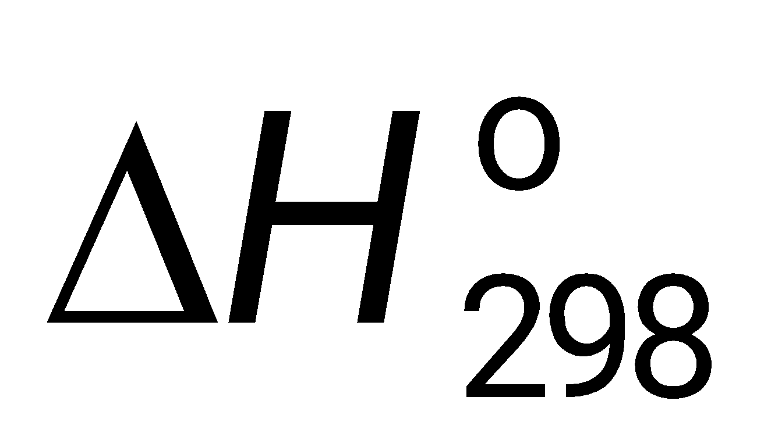 = – 264 kJ mol^{–1}; 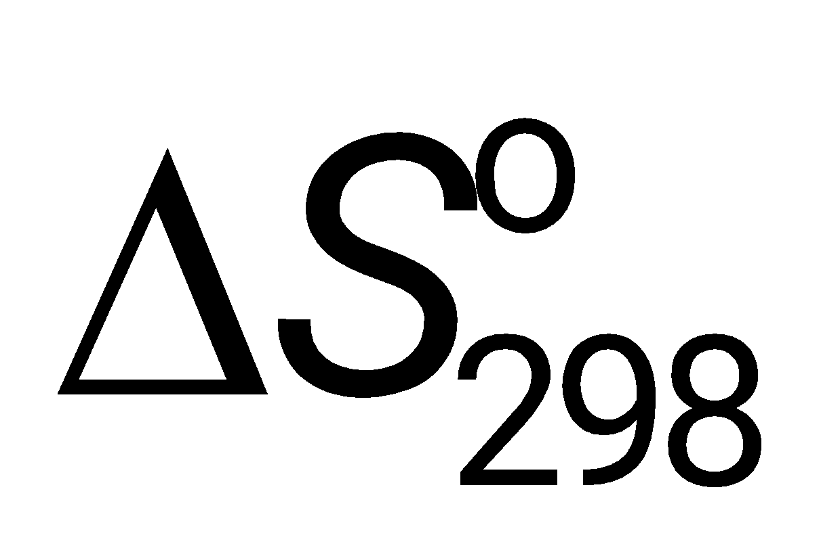 = – 278 J K^{–1} mol^{–1}
The following questions relate to the synthesis reaction represented by the chemical equation in the box above.
(a) Calculate the value of the standard free energy change, 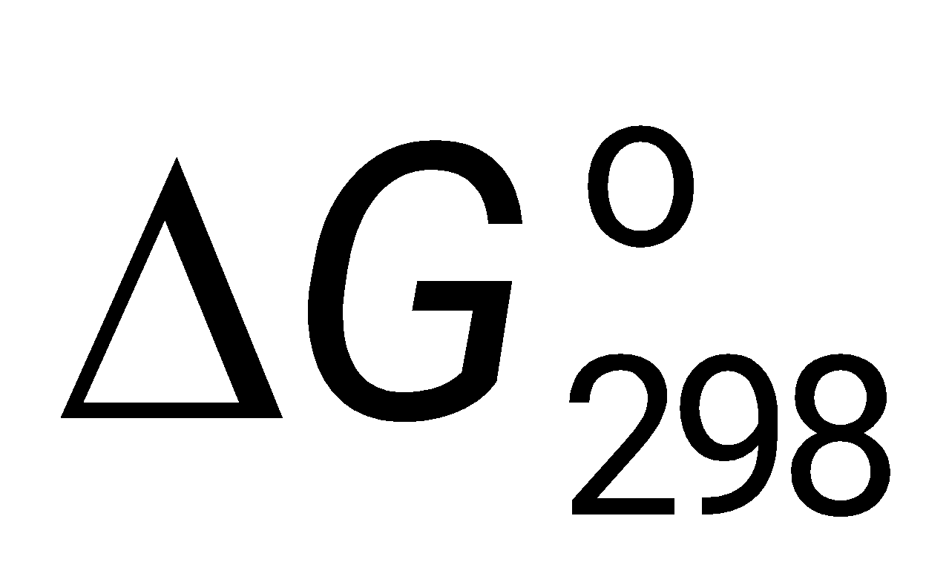 for the reaction.

(b) Determine the temperature at which the equilibrium constant, K_{eq}, for the reaction is equal to 1.00. (Assume that ∆H˚ and ∆S˚ are independent of temperature.)

(c) Calculate the standard enthalpy change, ∆H˚, that occurs when a 0.256 mol sample of NF₃(g) is formed from N₂(g) and F₂(g) at 1.00 atm and 298 K.

The enthalpy change in a chemical reaction is the difference between energy absorbed in breaking bonds in the reactants and energy released by bond formation in the products.
(d) How many bonds are formed when two molecules of NF₃ are produced according to the equation in the box above?

(e) Use both the information in the box above and the table of average bond enthalpies below to calculate the average enthalpy of the F–F bond.

Bond | Average Bond Enthalpy  (kJ mol⁻¹)
NN | 946
N–F | 272
F–F | ?

8. Lead iodide is a dense, golden yellow, slightly soluble solid. At 25°C, lead iodide dissolves in water forming a system represented by the following equation. PbI₂(s) → Pb²⁺ + 2 I⁻ ΔH = +46.5 kilojoules
(a) How does the entropy of the system PbI₂(s) + H₂O(l) change as PbI₂(s) dissolves in water at 25°C? Explain

(b) If the temperature of the system were lowered from 25°C to 15°C, what would be the effect on the value of K_{sp}? Explain.

(c) If additional solid PbI₂ were added to the system at equilibrium, what would be the effect on the concentration of I⁻ in the solution? Explain.

(d) At equilibrium, ΔG = 0. What is the initial effect on the value of ΔG of adding a small amount of Pb(NO₃)₂ to the system at equilibrium? Explain.

9. For the gaseous equilibrium represented below, it is observed that greater amounts of PCl₃ and Cl₂ are produced as the temperature is increased. PCl₅(g) → PCl₃(g) + Cl₂(g)
(a) What is the sign of ΔS° for the reaction? Explain.

(b) What change, if any, will occur in ΔG° for the reaction as the temperature is increased? Explain your reasoning in terms of thermodynamic principles.

(c) If He gas is added to the original reaction mixture at constant volume and temperature, what will happen to the partial pressure of Cl₂? Explain.

(d) If the volume of the reaction mixture is decreased at constant temperature to half the original volume, what will happen to the number of moles of Cl₂ in the reaction vessel? Explain.

10. C₂H₂(g) + 2 H₂(g) → C₂H₆(g)
Information about the substances involved in the reaction represented above is summarized in the following tables.

Substance | S° (J/mol⋅K) | ΔH°f (kJ/mol)
C₂H₂(g) | 200.9 | 226.7
H₂(g) | 130.7 | 0
C₂H₆(g) | - - - - | -84.7
Bond | Bond Energy (kJ/mol)
C-C | 347
C=C | 611
C-H | 414
H-H | 436
(a) If the value of the standard entropy change, ΔS°, for the reaction is -232.7 joules per mole⋅Kelvin, calculate the standard molar entropy, S°, of C₂H₆ gas.

(b) Calculate the value of the standard free-energy change, ΔG°, for the reaction. What does the sign of ΔG° indicate about the reaction above?

(c) Calculate the value of the equilibrium constant, K, for the reaction at 298 K.

(d) Calculate the value of the C≡C bond energy in C₂H₂ in kilojoules per mole.
11. Standard Heat of Formation, ΔH_{f}° AbsoluteEntropy, S°,
Substance kJ mol⁻¹ J mol⁻¹ K⁻¹
C(s) 0.00 5.69
CO₂(g) -393.5 213.6
H₂(g) 0.00 130.6
H₂O(l) -285.85 69.91
O₂(g) 0.00 205.0
C₃H₇COOH(l) ? 226.3
The enthalpy change for the combustion of butyric acid at 25°C, ΔH°_{comb}, is -2,183.5 kilojoules per mole. The combustion reaction is C₃H₇COOH(l) + 5 O₂(g) → 4 CO₂(g) + 4 H₂O(l)
(a) From the above data, calculate the standard heat of formation, ΔH_{f}°, for butyric acid.

(b) Write a correctly balanced equation for the formation of butyric acid from its elements.

(c) Calculate the standard entropy change, ΔS_{f}°, for the formation of butyric acid from its elements at 25°C.

(d) Calculate the standard free energy of formation, ΔG°_{f}, for butyric acid from its elements at 25°C.

12. Br₂(l) → Br₂(g) At 25°C the equilibrium constant, K_{p}, for the reaction above is 0.281 atmosphere.
- What is the ΔG°₂₉₈ for this reaction?

- It takes 193 joules to vaporize 1.00 gram of Br₂(l) at 25°C and 1.00 atmosphere pressure. What are the values of ΔH°₂₉₈ and ΔS°₂₉₈ for this reaction?

- Calculate the normal boiling point of bromine. Assume that ΔH° and ΔS° remain constant as the temperature is changed.

- What is the equilibrium vapor pressure of bromine at 25°C?

13. BCl₃(g) + NH₃(g) ↔ Cl₃BNH₃(s)
(a) Predict the sign of the entropy change, ΔS, as the reaction proceeds to the right. Explain your prediction.

(b) If the reaction spontaneously proceeds to the right, predict the sign of the enthalpy change, ΔH. Explain your prediction.

(c) The direction in which the reaction spontaneously proceeds changes as the temperature is increased above a specific temperature. Explain.

(d) What is the value of the equilibrium constant at the temperature referred to in (c); that is, the specific temperature at which the direction of the spontaneous reaction changes? Explain.

(e) Calculate the value of the C≡C bond energy in C₂H₂ in kilojoules per mole.

14. C₆H₅OH(s) + 7 O₂(g) → 6 CO₂(g) + 3 H₂O(l)
When a 2.000-gram sample of pure phenol, C₆H₅OH(s), is completely burned according to the equation above, 64.98 kilojoules of heat is released. Use the information in the table below to answer the questions that follow.
Substance | Standard Heat of Formation, ΔH°_{â}; at 25°C (kJ/mol) | Absolute Entropy, S°, at 25°C (J/molòK)
C(graphite) | 0.00 | 5.69
CO₂(g) | -393.5 | 213.6
H₂(g) | 0.00 | 130.6
H₂O(l) | -285.85 | 69.91
O₂(g) | 0.00 | 205.0
C₆H₅OH(s) | ? | 144.0

(a) Calculate the molar heat of combustion of phenol in kilojoules per mole at 25°C.

(b) Calculate the standard heat of formation, ΔH°_{f}, of phenol in kilojoules per mole at 25°C.

(c) Calculate the value of the standard free-energy change, ΔG°, for the combustion of phenol at 25°C.
(d) If the volume of the combustion container is 10.0 liters, calculate the final pressure in the container when the temperature is changed to 110.°C. (Assume no oxygen remains unreacted.)
AP Chemistry: Thermodynamics Multiple Choice

47. CH_{4(g)} + 2 O_{2(g)} 🡪 CO_{2(g)} + 2 H₂O_{(l)}; ∆H_{rxn} = −889.1 kJ
∆H_{f}° H₂O_{(l)} = − 285.8 kJ / mole ∆H_{f}° CO_{2(g)} = − 393.3 kJ / mole
What is the standard heat of formation of methane, ∆H_{f}° CH_{4(g)}, as calculated from the data above?
(A) −210.0 kJ/mole (B) −107.5 kJ/mole (C) −75.8 kJ/mole (D) 75.8 kJ/mole (E) 210.0 kJ/mole
48. Which of the following is a graph that describes the pathway of reaction that is endothermic and has high activation energy?
(A | 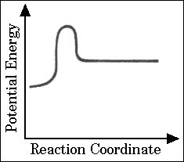 | (B | 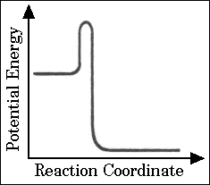 |  |  | (C) | 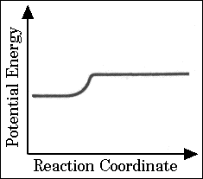
(D | 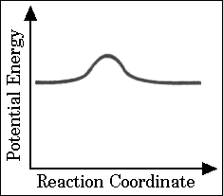 | (E | 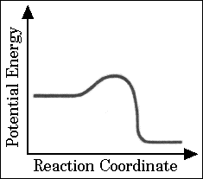
25.
H_{2(g)} + 1/2 O_{2(g)} 🡪 H₂O_{(l)} |  |  |  | ∆H° = x
2 Na_{(s)} + 1/2 O_{2(g)} 🡪 Na₂O_{(s)} |  |  |  | ∆H° = y
Na_{(s)} + 1/2 O_{2(g)} + 1/2 H_{2(g)} 🡪 NaOH_{(s)} |  |  |  | ∆H° = z
Based on the information above, what is the standard enthalpy change for the following reaction?
Na₂O_{(s)} + H₂O_{(l)} 🡪 2 NaOH_{(s)}
(A) x + y + z (B) x + y − z (C) x + y − 2z (D) 2z − x −y (E) z − x −y
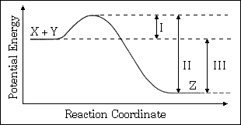
30. The energy diagram for the reaction X + Y 🡪 Z is shown. The addition of a catalyst to this reaction would cause a change in which of the indicated energy differences?
(A) I only
(B) II only
(C) III only
(D) I and II only
(E) I, II, and III
19. Which of the following best describes the role of the spark from the spark plug in an automobile engine?
(A) The spark decreases the energy of activation for the slow step.
(B) The spark increases the concentration of the volatile reactant.
(C) The spark supplies some of the energy of activation for the combustion reaction.
(D) The spark provides a more favorable activated complex for the combustion reaction.
(E) The spark provides the heat of vaporization for the volatile hydrocarbon.
61. C₂H_{4(g)} + 3 O_{2(g)} 🡪 2 CO_{2(g)} + 2 H₂O_{(g)}
For the reaction of ethylene represented above, ∆H is −1,323 kJ. What is the value of ∆H if the combustion produced liquid water H₂O_{(l)}, rather than water vapor H₂O_{(g)}?
(∆H for the phase change H₂O_{(g)} 🡪 H₂O_{(l)} is −44 kJ mol⁻¹.)
(A) −1,235 kJ (B) −1,279 kJ (C) −1,323 kJ (D) −1,367 kJ (E) −1,411 kJ
25. 3 C₂H_{2(g)} 🡪 C₆H_{6(g)}
What is the standard enthalpy change, ΔH° , for the reaction represented above?
(ΔH°_{f} of C₂H_{2(g)} is 230 kJ mol⁻¹ ; ΔH°_{f} of C₆H_{6(g)} is 83 kJ mol⁻¹)
(A) −607 kJ (B) −147 kJ (C) −19 kJ (D) + 19 kJ (E) +773 kJ

 | Energy |  | Entropy
A | Remains constant |  | Remains constant
B | Remains constant |  | Decreases
C | Remains constant |  | Increases
D | Decreases |  | Increases
E | Increases |  | Decreases
56. A cube of ice is added to some hot water in a rigid, insulated container, which is then sealed. There is no heat exchange with the surroundings. What has happened to the total energy and the total entropy when the system reaches equilibrium?
41. Which of the following reactions has the largest positive value of ∆S per mole of Cl₂ ?
(A) H_{2(g)} + Cl_{2(g)} 🡪 2 HCl_{(g)} (B) Cl_{2(g)} + 1/2 O_{2(g)} 🡪 Cl₂O_{(g)} (C) Mg_{(s)} + Cl_{2(g)} 🡪 MgCl_{2(s)}
(D) 2 NH₄Cl_{(s)} 🡪 N_{2(g)} + 4 H_{2(g)} + Cl_{2(g)} (E) Cl₂(_{g)} 🡪 2 Cl_{(g)}
53. Which of the following must be true for a reaction that proceeds spontaneously from initial standard state conditions?
(A) ∆G° > 0 and K_{eq} > 1 (B) ∆G° > 0 and K_{eq} < 1 (C) ∆G° < 0 and K_{eq} > 1
(D) ∆G° < 0 and K_{eq} < 1 (E) ∆G° = 0 and K_{eq} = 1
70. H₂O_{(s)} 🡪 H₂O_{(l)}
When ice melts at its normal melting point, 273.16 K and 1 atmosphere, which of the following is true for the process shown above?
(A) ∆H < 0, ∆S > 0, ∆G > 0 (B) ∆H < 0, ∆S < 0, ∆G > 0 (C) ∆H > 0, ∆S < 0, ∆G < 0
(D) ∆H > 0, ∆S > 0, ∆G > 0 (E) ∆H > 0, ∆S > 0, ∆G < 0
35. For which of the following processes would ∆S have a negative value?
I. 2 Fe₂O_{3(s)} 🡪 4 Fe_{(s)} + 3 O_{2(g)}
II. Mg²⁺ + 2 OH⁻ 🡪 Mg(OH)_{2(s)}
III. H_{2(g)} + C₂H_{4(g)} 🡪 3 C2H6_{(g)}
(A) I only (B) I and II only (C) I and III only (D) II only (E) I, II, and III
58. N₂(g) + 3 H_{2(g)} 🡪 2 NH_{3(g)}
The reaction indicated above is thermodynamically spontaneous at 298 K, but becomes nonspontaneous at higher temperatures. Which of the following is true at 298 K?
(A) ∆G, ∆H, and ∆S are all positive. (B) ∆G, ∆H, and ∆S are all negative.
(C) ∆G and ∆H are negative, but ∆S is positive. (D) ∆G and ∆S are negative, but ∆H is positive.
(E) ∆G and ∆H are positive, but ∆S is negative.
 | ∆H | ∆S
A | Positive | Positive
B | Positive | Negative
C | Positive | Equal to zero
D | Negative | Positive
E | Negative | Negative
66. When solid ammonium chloride, NH₄Cl_{(s)} is added to water at 25 °C, it dissolves and the temperature of the solution decreases. Which of the following is true for the values of ∆H and ∆S for the dissolving process?
22. Of the following reactions, which involves the largest decrease in entropy?
(A) CaCO_{3(s)} 🡪 CaO_{(s)} + CO_{2(g)} (B) 2 CO_{(g)} + O_{2(g)} 🡪 2 CO_{2(g)}
(C) Pb(NO₃)_{3(aq)} + 2 KI_{(aq)} 🡪 PbI_{2(s)} + 2 KNO_{3(aq)} (D) C₃H_{8(g)} + O_{2(g)} 🡪 3 CO_{2(g)} + 4 H₂O_{(g)}
(E) 4 La_{(s)} + 3 O_{2(g)} 🡪 2 La₂O_{3(s)}
41. When solid NH₄SCN is mixed with solid Ba(OH)₂ in a closed container, the temperature drops and a gas is produced. Which of the following indicates the correct signs for ΔG, ΔH, and ΔS for the process?
ΔG ΔH ΔS
(A) − − −
(B) − + −
(C) − + +
(D) + − +
(E) + − −
73. X_{(s)} ⇄ X_{(l)}
Which of the following is true for any substance undergoing the process represented above at its normal melting point?
(A) ΔS <0 (B) ΔH = 0 (C) ΔH = TΔG (D) TΔS = 0 (E) ΔH = TΔS

Balancing Redox Reactions

Balance in an acidic solution:
1. Cr₂O₇²⁻ + I⁻ 🡪 Cr³⁺ + IO₃⁻

2. MnO₄⁻ + CH₃OH 🡪 Mn²⁺ + HCO₂H

3. I₂ + OCl⁻ 🡪 IO₃⁻ + Cl⁻

4. As₂O₃ + NO₃⁻ 🡪 H₃AsO₄ + N₂O₃

Balance in a basic solution:

5. MnO₄⁻ + Br- 🡪 MnO₂ + BrO₃–

6. Pb(OH)₄²⁻ + ClO⁻ 🡪 PbO₂ + Cl⁻

7. Al + MnO₄ ⁻ 🡪 MnO₂ + Al(OH)₄–

8. Cl₂ 🡪 Cl⁻ + OCl–

9. NO₂- + Al 🡪 NH₃ + AlO₂⁻
Electrochemical Cells

Directions: In each of the following, determine which element oxidized easier. Then label the anode, cathode, direction of e- flow, and the half reactions. Then find the voltage.
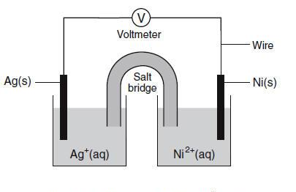
- 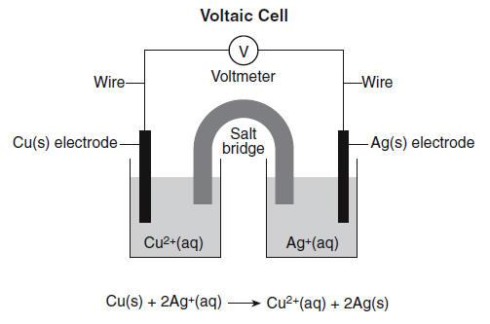 2. 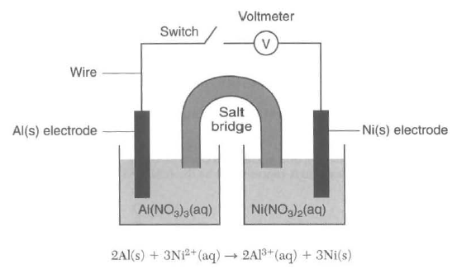3. 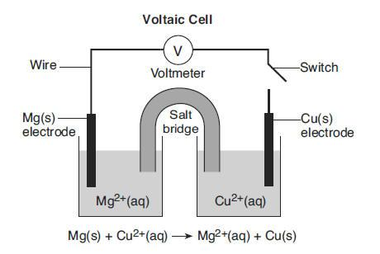 4.

Additional Questions:
- On diagram 1, which way will anions travel through the salt bridge? ____________
- On diagram 2, towards which electrode will cations travel through the salt bridge? ____________
- On diagram 3, how many e- are exchanged per mole of Mg? ____________
- On diagram 4, how many e- are transferred between Ag and Ni? ____________
- On all diagrams, at which electrode does oxidation occur? ____________
- On all diagrams, at which electrode does reduction occur? ____________
- On all diagrams, from which electrode will electrons travel? ____________
- What is the purpose of the salt bridge? ____________________________________________________
- Describe the change in energy that occurs in voltaic cells in terms of electric and chemical energies:

EKG

- Given a battery using Cu(s) in 1.0M Cu⁺² and Zn(s) in = 1.0M Zn⁺², calculate the E, K, and ΔG at 298K.

- Given Fe(s) in 1.0M Fe⁺² andCo(s) in 1.0M Co⁺², calculate the E, K, and ΔG at 298K.

- If a cell is formed with the reaction Zn + Al⁺³ 🡪 Al + Zn⁺² is it favorable? Calculate the E, K and G at 298K.

- If a cell is formed with the reaction Ag + Ca⁺² 🡪 Ca + Ag⁺ is it favorable? Calculate the E, K and G at 298K.

Redox Titrations

Like acids and bases, redox reactions can represent titrated substances. When an oxidizing agent or reducing agent is added to a solution the oxidation numbers will change and often color changes can be seen. For example, when copper changes from Cu⁺² to Cu⁺³ the color changes from blue to colorless. A list of color changes are below. Either dimensional anaylysis or titration equations can be used to determine the concentration of species in the reaction.
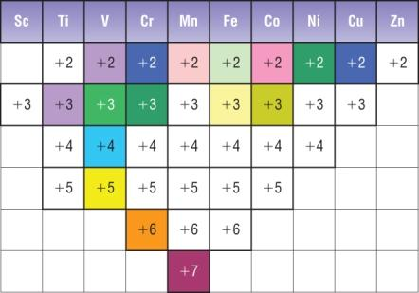
Ti⁺³ and V⁺² are purple
V⁺³ Cr⁺³, Fe⁺², Co⁺³, and Ni⁺² are bright, dark,
aqua, olive, and blue-green
V⁺⁴, Cr⁺², Cu⁺² are bright, dark, and navy blue
V⁺⁵ and Fe⁺³ are bright and light yellow
Mn⁺⁷ is magenta
Mn⁺² and Co⁺² are light and dark pink
Cr⁺⁶ is orange

1. (a) CrCl₂ solution is oxidized by AgNO₃. Write a reaction between the two solutions.

(b) How did the student know to end the titration?

(c) When 300.0 milliliters of a solution of 0.200 molar AgNO₃ is mixed with 100.0 milliliters of CrCl₂ solution, the student ends the titration. What is the molarity of the CrCl₂ solution?

(d) Write the net cell reaction for a cell formed by placing a silver electrode in the solution remaining from the reaction above and connecting it to a standard hydrogen electrode.

(e) Calculate the voltage of a cell of this type in which the concentration of silver ion is 4×10⁻² M.

(f) Calculate the value of the standard free energy change ΔG° for the following half reaction:
Ag⁺ (1M) + e- → Ag°
2. Answer parts (a) through (e) below, which relate to reactions involving silver ion, Ag⁺.
The reaction between silver ion and solid zinc is represented by the following equation.
2 Ag⁺(aq) + Zn(s) → Zn²⁺(aq) + 2 Ag(s)
(a) A 1.50 g sample of Zn is combined with 250. mL of 0.110 M AgNO3 at 25˚C.
(i) Identify the limiting reactant. Show calculations to support your answer.

(ii) On the basis of the limiting reactant that you identified in part (i), determine the value of [Zn²⁺] after the reaction is complete. Assume that volume change is negligible.

(iii) What color change will be seen as this cell operates?

(b) Determine the value of the standard potential, E˚, for a galvanic cell based on the reaction between AgNO3(aq) and solid Zn at 25˚C.

Another galvanic cell is based on the reaction between Ag⁺(aq) and Cu(s), represented by the equation below. At 25˚C, the standard potential, E˚, for the cell is 0.46 V.
2 Ag⁺(aq) + Cu(s) → Cu²⁺(aq) + 2 Ag(s)
(c) Determine the value of the standard free-energy change, ∆G˚, for the reaction between Ag⁺(aq) and Cu(s) at 25˚C.

(d) The cell is constructed so that [Cu²⁺] is 0.045 M and [Ag⁺] is 0.010 M. Calculate the value of the potential, E, for the cell.

(e) Under the conditions specified in part (d), is the reaction in the cell spontaneous? Justify your answer.

Electrolysis Review

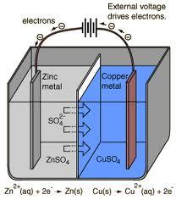
1. Which element is oxidizing in the diagram to the left?
2. According to E Tables, should that element oxidize?
3. Is this reaction spontaneous?
4. What type of cell is it?
5. Label the anode and the cathode with charges on the diagram to the left.
6. Write the overall reaction for this cell.

7. Water is being decomposed using a battery in the diagram to the right. Write the equation for the decomposition of water.

8. Which element is being oxidized?
9. How many e- are lost?
10. Should that element oxidize?
11. Is this reaction spontaneous?
12. What type of cell is it?
13. Label where oxidation and reduction on the diagram.
14. Why is more H₂ gas being formed that O₂ gas?
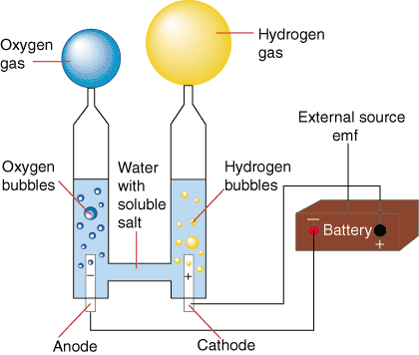

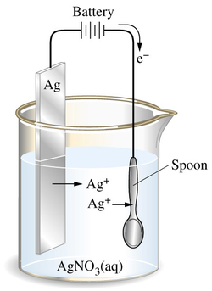
15. Only one element is being used in the diagram to the left. The silver plate ionizes and the ions attach to the spoon. Show a half reaction for silver oxidizing.

16. Label the anode and cathode with charges on the diagram.
17. Explain the direction of e- flow through the wire.

18. Is this reaction spontaneous? _____ How can you tell?

AP Electrolysis
1. All of the equations on your reference table are written as (oxidations/reductions).
2. The chemicals at the upper left (Cl₂ and O₂) are the most likely to be (oxidized/reduced) and therefore the best (oxidizing agents/reducing agents).
3. The chemicals at the lower right (Na and K) are the most likely to be (oxidized/reduced) and therefore the best (oxidizing agents/reducing agents).
4. In an electrolytic cell, the (−) electrode is negative because it has (too many/too few) electrons. Chemicals that come into contact with the (−) electrode will (gain/lose) electrons and be (oxidized/reduced). The (−) electrode in electrolysis is called the (cathode/anode).
5. Write the change that water goes through at the (−) electrode.

6. In an electrochemical cell, the (+) electrode is positive because it has (too many/too few) electrons. Chemicals that come into contact with the (+) electrode will (gain/lose) electrons and be (oxidized/reduced). The (+) electrode in electrolysis is called the (cathode/anode).
7. Write the change that water goes through at the (+) electrode.

8. Add these two reactions together and write the overall reaction for the electrolysis of water.

9. We will perform this electrolysis using an aqueous solution of sodium sulfate.
Both the Na⁺ and H₂O will be near the (−) electrode. Which chemical is more likely to be reduced?

10. Both the SO₄²⁻ and H₂O will be near the (+) electrode. Which chemical will be oxidized?

11. In the electrolysis of KI(aq)
Both the K⁺ and H₂O will be near the (−) electrode. Which chemical is more likely to be reduced?
Both the I⁻ and H₂O will be near the (+) electrode. Which chemical is more likely to be oxidized?
Write the reactions at each electrode and the overall reaction:

Cathode:

Anode:

Overall:

12. In the electrolysis of CuSO₄(aq)
Both the Cu²⁺ and H₂O will be near the (−) electrode. Which chemical will be reduced?
Both the SO₄²⁻ and H₂O will be near the (+) electrode. Which chemical will be oxidized?
Write the reactions at each electrode and the overall reaction:

Cathode:

Anode:

Overall:

13. Silver plating occurs when electrolysis of a Ag₂SO₄ solution is used because silver metal is formed at the (cathode/anode). This is the ( + / − )electrode. The reaction at this electrode is:

Recall that 1 amp·sec = 1 Coulomb and 96,485 Coulombs = 1 mole e⁻‘s (Faraday’s constant).
If a cell is run for 200. seconds with a current of 0.250 amps, how many grams of Ag° will be deposited?

14. A current of 10.0 amperes flows for 2.00 hours through an electrolytic cell containing a molten salt of metal X. This results in the decomposition of 0.250 mole of metal X at the cathode. The oxidation state of X in the molten salt is (X⁺, X²⁺, X³⁺, X⁴⁺)

15. Solutions of Ag⁺, Cu²⁺, Fe³⁺ and Ti⁴⁺ are electrolyzed with a constant current until 0.10 mol of metal is deposited. Which will require the greatest length of time?
AP Questions
1. (a) Calculate the value of ΔG° for the standard cell reaction Zn + Cu²⁺(1M) → Zn²⁺(1M) + Cu

- One half cell of an electrochemical cell is made by placing a strip of pure zinc in 500 milliliters of 0.10 molar ZnCl₂ solution. The other half cell is made by placing a strip of pure copper in 500 milliliters of 0.010 molar Cu(NO₃)₂ solution. Calculate the initial voltage of this cell when the two half cells are joined by a salt bridge and the two metal strips are joined by a wire.

(c) Calculate the final concentration of copper ion, Cu²⁺, in the cell described in part (b) if the cell were allowed to produce an average current of 1.0 ampere for 3 minutes 13 seconds.

2. When a dilute solution of H₂SO₄ is electrolyzed, O₂(g) is produced at the anode and H₂(g) is produced at the cathode.
(a) Write the balanced equations for the anode, cathode, and overall reactions that occur in this cell.

- Compute the coulombs of charge passed through the cell in 100. minutes at 10.0 amperes.

- What number of moles of O₂ is produced by the cell when it is operated for 100. minutes at 10.0 amperes?

- The standard enthalpy of formation of H₂O(g) is -242 kilojoules per mole. How much heat is liberated by the complete combustion, at 298K and 1.00 atmospheres, of the hydrogen produced by the cell operated as in (c)?

3. Ti³⁺ + HOBr → TiO²⁺ + Br⁻ (in acid solution)
(a) Write the correctly balanced half-reactions and net ionic equation for the skeletal equation shown above.

(b) Identify the oxidizing agent and the reducing agent in this reaction.

- A galvanic cell is constructed that utilizes the reaction above. The concentration of each species is 0.10 molar. Compare the cell voltage that will be observed with the standard cell potential. Explain your reasoning.

- Give one example of a property of this reaction, other than the cell voltage, that can be calculated from the standard cell potential, E°. State the relationship between E° and the property you have specified.

4. (a) Titanium can be reduced in an acid solution from TiO²⁺ to Ti³⁺ with zinc metal. Write a balanced equation for the reaction of TiO²⁺ with zinc in acid solution.

(b) What mass of zinc metal is required for the reduction of a 50.00 millilitre sample of a 0.115 molar solution of TiO²⁺?

(c) Alternatively, the reduction of TiO²⁺ to Ti³⁺ can be carried out electrochemically. What is the minimum time, in seconds, required to reduce another 50.000 millilitre sample of the 0.115 molar TiO²⁺ solution with a direct current of 1.06 amperes?

(d) The standard reduction potential, E°, for TiO²⁺ to Ti³⁺ is +0.060 volt. The standard reduction potential, E°, for Zn²⁺ to Zn_{(s)} is -0.763 volt. Calculate the standard cell potential, E°, and the standard free energy change, ΔG°, for the reaction described in part (a).
5. A direct current of 0.125 ampere was passed through 200 millilitres of a 0.25 molar solution of Fe₂(SO₄)₃ between platinum electrodes for a period of 1.100 hours. Oxygen gas was produced at the anode. The only change at the cathode was a slight change in the color of the solution.
At the end of the electrolysis, the electrolyte was acidified with sulfuric acid and was titrated with an aqueous solution of potassium permanganate. The volume of the KMnO₄ solution required to reach the end point was 24.65 millilitres.
- How many faradays were passed through the solution?

- Write a balanced half-reaction for the process that occurred at the cathode during the electrolysis.

- Write a balanced net ionic equation for the reaction that occurred during the titration with potassium permanganate.

(d) Calculate the molarity of the KMnO₄ solution.

6. An electrochemical cell consists of a tin electrode in an acidic solution of 1.00 molar Sn²⁺ connected by a salt bridge to a second compartment with a silver electrode in an acidic solution of 1.00 molar Ag⁺.
(a) Write the equation for the half–cell reaction occurring at each electrode. Indicate which half–reaction occurs at the anode.

(b) Write the balanced chemical equation for the overall spontaneous cell reaction that occurs when the circuit is complete. Calculate the standard voltage, E°, for this cell reaction.

(c) Calculate the equilibrium constant for this cell reaction at 298K.
7. Explain each of the following.
(a) When an aqueous solution of NaCl is electrolyzed, Cl₂(g) is produced at the anode, but no Na(s) is produced at the cathode.

(b) The mass of Fe(s) produced when 1 faraday is used to reduce a solution of FeSO₄ is 1.5 times the mass of Fe(s) produced when 1 faraday is used to reduce a solution of FeCl₃.

(c) Zn + Pb²⁺ (1–molar) → Zn²⁺ (1–molar) + Pb
The cell that utilizes the reaction above has a higher potential when [Zn²⁺] is decreased and [Pb²⁺] is held constant, but a lower potential when [Pb²⁺] is decreased and [Zn²⁺] is held constant.

- The cell that utilizes the reaction given in (c) has the same cell potential as another cell in which [Zn²⁺] and [Pb²⁺] are each 0.1–molar.

8. An unknown metal M forms a soluble compound, M(NO₃)₂.
(a) A solution of M(NO₃)₂ is electrolyzed. When a constant current of 2.50 amperes is applied for 35.0 minutes, 3.06 grams of the metal M is deposited. Calculate the molar mass of M and identify the metal.

(b) The metal identified in (a) is used with zinc to construct a galvanic cell, as shown below. Write the net ionic equation for the cell reaction and calculate the cell potential, E°.
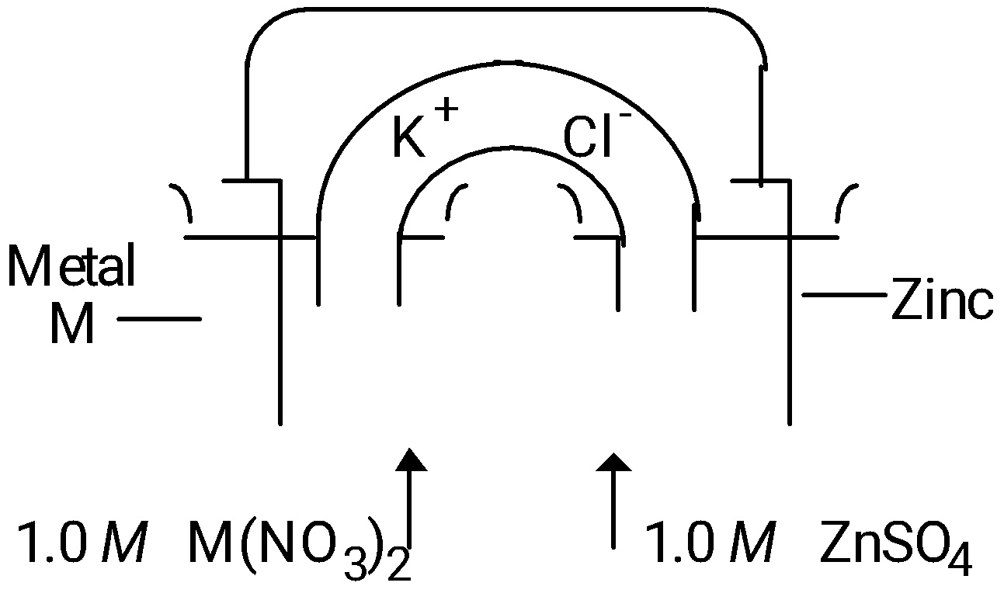
- Calculate the value of the standard free energy change, ΔG°, at 25°C for the reaction in (b).

(d) Calculate the potential, E, for the cell shown in (b) if the initial concentration of ZnSO₄ is 0.10-molar, but the concentration of the M(NO₃)₂ solution remains unchanged.
9. Sr(s) + Mg²⁺ → Sr²⁺ + Mg(s) Consider the reaction represented above that occurs at 25°C. All reactants and products are in their standard states. The value of the equilibrium constant, K_{eq}, is 4.2×10¹⁷ at 25°C.
- Predict the sign of the standard cell potential, E°, for a cell based on the reaction. Explain

- Identify the oxidizing agent for the spontaneous reaction.

- If the reaction were carried out at 60°C instead of 25°C, how would the cell potential change? Justify your answer.

(d) How would the cell potential change if the reaction were carried out at 25°C with a 1.0-molar solution of Mg(NO₃)₂ and a 0.10-molar solution of Sr(NO₃)₂ ? Explain.

(e) When the cell reaction in (d) reaches equilibrium, what is the cell potential?

10. In an electrolytic cell, a current of 0.250 ampere is passed through a solution of a chloride of iron, producing Fe(s) and Cl₂(g).
(a) Write the equation for the half-reaction that occurs at the anode.

(b) When the cell operates for 2.00 hours, 0.521 gram of iron is deposited at one electrode. Determine the formula of the chloride of iron in the original solution.

(c) Write the balanced equation for the overall reaction that occurs in the cell.

- How many liters of Cl₂(g), measured at 25°C and 750 mm Hg, are produced when the cell operates as described in part (b) ?

(e) Calculate the current that would produce chlorine gas from the solution at a rate of 3.00 grams per hour.
11. 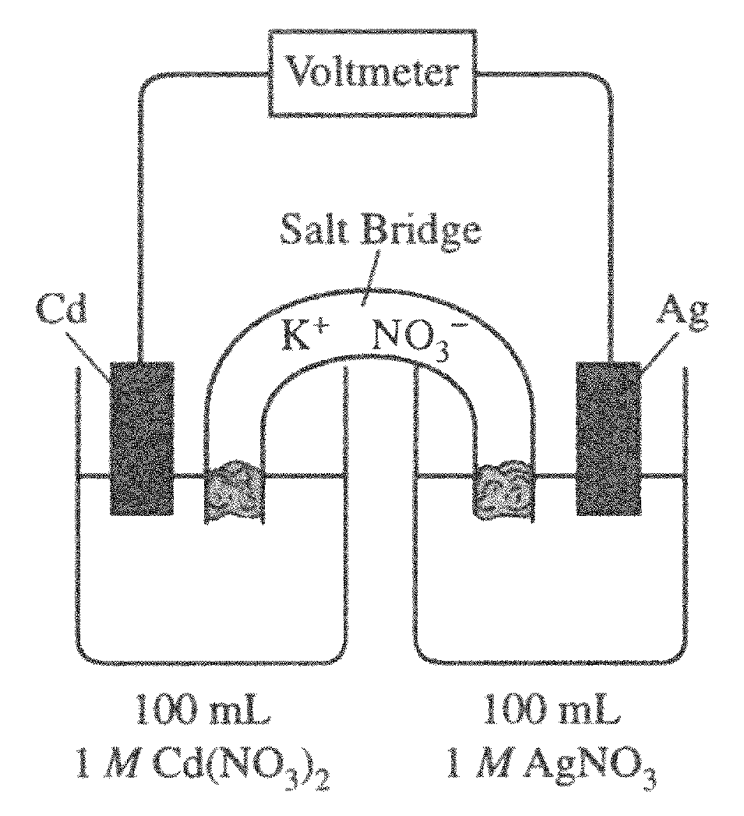
Answer the following questions regarding the electrochemical cell shown.
- Write the balanced net-ionic equation for the spontaneous reaction that occurs as the cell operates, and determine the cell voltage.

(b) In which direction do anions flow in the salt bridge as the cell operates? Justify your answer.

(c) If 10.0 mL of 3.0-molar AgNO₃ solution is added to the half-cell on the right, what will happen to the cell voltage? Explain.

(d) If 1.0 gram of solid NaCl is added to each half-cell, what will happen to the cell voltage? Explain.

(e) If 20.0 mL of distilled water is added to both half-cells, the cell voltage decreases. Explain.

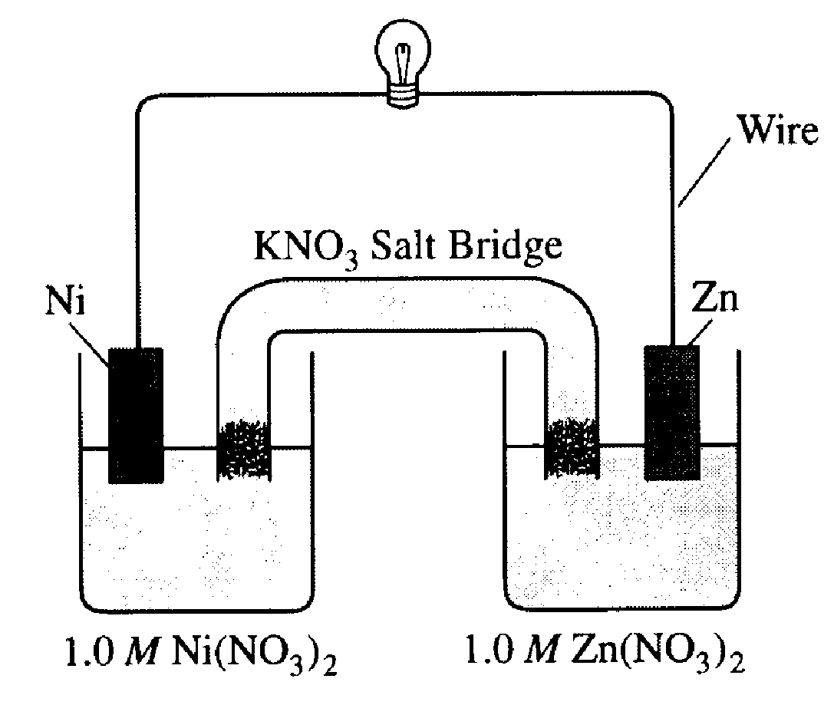
12. Answer the following questions that refer to the galvanic cell shown in the diagram above.
(a) Identify the anode of the cell and write the half reaction that occurs there.

- Write the net ionic equation for the overall reaction that occurs as the cell operates and calculate the value of the standard cell potential, E°_{cell} .

- Indicate how the value of E_{cell} would be affected if the concentration of Ni(NO₃)₂(aq) was changed from 1.0 M to 0.10 M and the concentration of Zn(NO₃)₂(aq) remained at 1.0 M. Justify your answer.

- Specify whether the value of K_{eq} for the cell reaction is less than 1, greater than 1, or equal to 1. Justify your answer.

13. AgNO3(s) → Ag⁺(aq) + NO3–(aq)
The dissolving of AgNO3(s) in pure water is represented by the equation above..
- Is ∆G for the dissolving of AgNO3(s) positive, negative, or zero? Justify your answer.

- Is ∆S for the dissolving of AgNO3(s) positive, negative, or zero? Justify your answer.

(c) The solubility of AgNO3(s) increases with increasing temperature.
(i) What is the sign of ∆H for the dissolving process? Justify your answer.

(ii) Is the answer you gave in part (a) consistent with your answers to parts (b) and (c) (i)? Explain.

The compound NaI dissolves in pure water according to the equation NaI(s) → Na⁺(aq) + I–(aq). Some of the information in the table of standard reduction potentials given below may be useful
Half-reaction | E˚ (V)
O2(g) + 4 H⁺ + 4 e- → 2 H2O(l) | 1.23
I2(s) + 2 e- → 2 I– | 0.53
2 H2O(l) + 2 e- → H2(g) + 2 OH– | -0.83
Na⁺ + e- → Na(s) | -2.71
(d) An electric current is applied to a 1.0 M NaI solution.
(i) Write the balanced oxidation half reaction for the reaction that takes place.

(ii) Write the balanced reduction half-reaction for the reaction that takes place.

(iii) Which reaction takes place at the anode, the oxidation reaction or the reduction reaction?

(iv) All electrolysis reactions have the same sign for ∆G˚. Is the sign positive or negative? Justify your answer.
14. 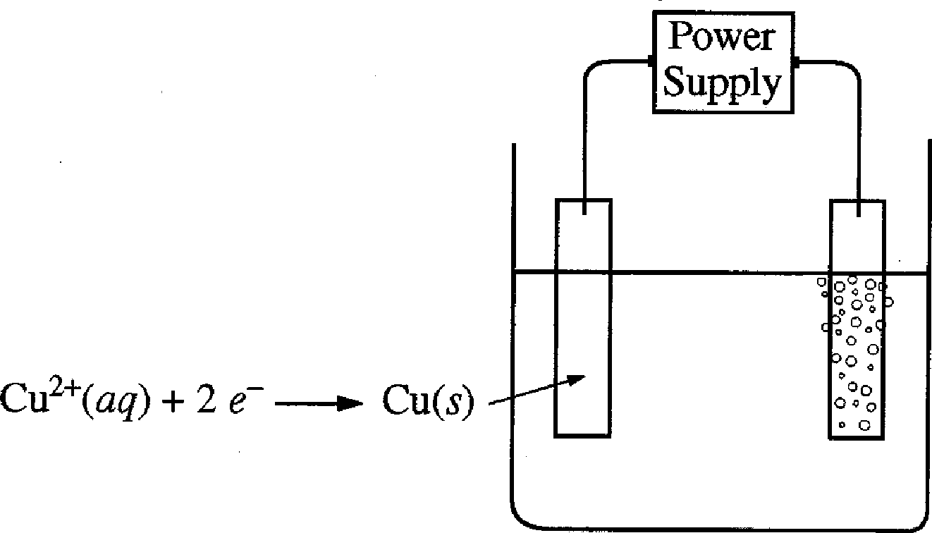
An external direct-current power supply is connected to two platinum electrodes immersed in a beaker containing 1.0 M CuSO₄(aq) at 25˚C, as shown in the diagram above. As the cell operates, copper metal is deposited onto one electrode and O₂(g) is produced at the other electrode. The two reduction half-reactions for the overall reaction that occurs in the cell are shown in the table below.
Half-Reaction | E⁰(V)
O₂(g) + 4 H⁺(aq) + 4 e⁻ → 2 H₂O(l) | +1.23
Cu²⁺(aq) + 2 e⁻ → Cu(s) | +0.34

- On the diagram, indicate the direction of electron flow in the wire.

- Write a balanced net ionic equation for the electrolysis reaction that occurs in the cell.

- Predict the algebraic sign of ∆G˚ for the reaction. Justify your prediction.

- Calculate the value of ∆G˚ for the reaction.

An electric current of 1.50 amps passes through the cell for 40.0 minutes.
- Calculate the mass, in grams, of the Cu(s) that is deposited on the electrode.

(f) Calculate the dry volume, in liters measured at 25˚C and 1.16 atm, of the O₂(g) that is produced.

15. 2 H₂(g) + O₂(g) → 2 H₂O(l)
In a hydrogen-oxygen fuel cell, energy is produced by the overall reaction represented above.
- When the fuel cell operates at 25˚C and 1.00 atm for 78.0 minutes, 0.0746 mol of O₂(g) is consumed. Calculate the volume of H₂(g) consumed during the same time period. Express your answer in liters measured at 25˚C and 1.00 atm.

(b) Given that the fuel cell reaction takes place in an acidic medium,
(i) write the two half reactions that occur as the cell operates,

(ii) identify the half reaction that takes place at the cathode, and

(iii) determine the value of the standard potential, E˚, of the cell.

(c) Calculate the charge, in coulombs, that passes through the cell during the 78.0 minutes of operation as described in part (a).

AP Chemistry: Electrochemistry Multiple Choice
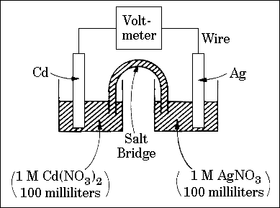
14. Questions 14-17
The spontaneous reaction that occurs when the cell in the picture operates is as follows:
2Ag⁺ + Cd_{(s)} 🡪 2 Ag_{(s)} + Cd²⁺
(A) Voltage increases.
(B) Voltage decreases but remains > zero.
(C) Voltage becomes zero and remains at zero.
(D) No change in voltage occurs.
(E) Direction of voltage change cannot be predicted without additional information.
Which of the above occurs for each of the following circumstances?
14. A 50-milliliter sample of a 2-molar Cd(NO₃)₂ solution is added to the left beaker.
15. The silver electrode is made larger.
16. The salt bridge is replaced by a platinum wire.
17. Current is allowed to flow for 5 minutes.
29. Cu_{(s)} + 2 Ag⁺ 🡪 Cu²⁺ + 2 Ag_{(s)}
If the equilibrium constant for the reaction above is 3.7 x 10¹⁵, which of the following correctly describes the standard voltage, E°, and the standard free energy change, ∆G°, for this reaction?
(A) E° is positive and ∆G° is negative. (B) E° is negative and ∆G° is positive.
(C) E° and ∆G° are both positive. (D) E° and ∆G° are both negative.
(E) E° and ∆G° are both zero
75. If a copper sample containing some zinc impurity is to be purified by electrolysis, the anode and the cathode must be which of the following?
 | Anode |  |  | Cathode
(A) | Pure copper |  |  | Pure zinc
(B) | Pure zinc |  |  | Pure copper
(C) | Pure copper |  |  | Impure copper sample
(D) | Impure copper sample |  |  | Pure copper
(E) | Impure copper sample |  |  | Pure zinc
Fe²⁺ + 2e⁻ 🡪 Fe_{(s)} |  | E° = − 0.44 volt
Ni²⁺ + 2e⁻ 🡪 Ni_{(s)} |  | E° = − 0.23 volt
60. The standard reduction potentials for two half reactions are given above.
What is the equilibrium constant for the reaction? Fe_{(s)} + Ni²⁺ 🡪 Fe²⁺ + Ni_{(s)}
(A) 1.9 x 10⁻²³ (B) 7.6 x 10⁻⁸ (C) 3.6 x 10⁺³ (D) 1.3 x 10⁺⁷ (E) 5.2 x 10⁺²²
36. Zn_{(s)} + Cu²⁺ 🡪 Zn²⁺ + Cu_{(s)}
An electrolytic cell based on the reaction represented above was constructed from zinc and copper half-cells. The observed voltage was found to be 1.00 volt instead of the standard cell potential, E°, of 1.10 volts. Which of the following could correctly account for this observation?
(A) The copper electrode was larger than the zinc electrode.
(B) The Zn²⁺ electrolyte was Zn(NO₃)₂, while the Cu²⁺ electrolyte was CuSO₄.
(C) The Zn²⁺ solution was more concentrated than the Cu²⁺ solution.
(D) The solutions in the half-cells had different volumes.
(E) The salt bridge contained KCl as the electrolyte.
63. Which of the following expressions is correct for the maximum mass of copper, in grams, that cou1d be plated out by electrolyzing aqueous CuCl₂ for 16 hours at a constant current of 3.0 amperes?
(A) [(16)(3,600)(3.0)(63.55)(2)] / (96,500)
(B) [(16)(3,600)(3.0)(63.55)] / [(96,500)(2)]
(C) [(16)(3,600)(3.0)(63.55)] / (96,500)
(D) [(16)(60)(3.0)(96,500)(2)] / (63.55)
(E) [(16)(60)(3.0)(96,500)] / [(63.55)(2)]
75. A direct-current power supply of low voltage (less than 10 volts) has lost the markings that indicate which output terminal is positive and which is negative. A chemist suggests that the power supply terminals be connected to a pair of platinum electrodes that dip into 0.1-molar KI solution. Which of the following correctly identifies the polarities of the power supply terminals?
(A) A gas will be evolved only at the positive electrode.
(B) A gas will be evolved only at the negative electrode.
(C) A brown color will appear in the solution near the negative electrode.
(D) A metal will be deposited on the positive electrode.
(E) None of the methods above will identify the polarities of the power supply terminals.
Questions 34-35 refer to an electrolytic cell that involves the following half-reaction:
AlF₆³⁻ + 3 e⁻ 🡪 Al + 6F⁻
34. Which of the following occurs in the reaction?
(A) AlF ₆³⁻ is reduced at the cathode.
(B) Al is oxidized at the anode.
(C) Aluminum is converted from the −3 oxidation state to the 0 oxidation state.
(D) F⁻ acts as a reducing agent.
(E) F⁻ is reduced at the cathode.
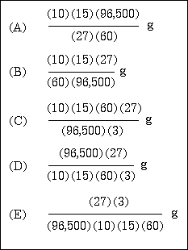
35. As steady current of 10 amperes in passed though an aluminum-production cell for 15 minutes. Which of the following is the correct expression for calculating the number of grams of aluminum produced? (1 faraday = 96,500 coulombs)
M_{(s)} + 3 Ag⁺_{(aq)} 🡪 3 Ag_{(s)} + M³⁺_{(aq)} |  |  | E = +2.46 V
Ag⁺⁽_{aq)} + e⁻ 🡪 Ag_{(s)} |  |  | E = +0.80 V
57. According to the information above, what is the standard reduction potential for the half-reaction M³⁺_{(aq)} + 3 e⁻ 🡪 M_{(s)}?
(A) −1.66 V (B) −0.06 V (C) 0.06 V (D) 1.66 V (E) 3.26 V

20. .....Mg_{(s)} + .....NO₃⁻ _{(aq)} +.....H⁺_{(aq)} 🡪......Mg²⁺_{(aq)} + ....NH₄⁺_{(aq)} + ....H₂O_{(l)}
When the skeleton equation above is balanced and all coefficients reduced to their lowest whole-number terms, what is the coefficient for H⁺ ?
(A) 4 (B) 6 (C) 8 (D) 9 (E) 10
34. ...CrO₂⁻ + ...OH⁻ 🡪 ... CrO₄²⁻ + ... H₂O + ... e⁻
When the equation for the half-reaction above is balanced, what is the ratio of the coefficients OH⁻ / CrO₂⁻ ?
(A) 1:1 (B) 2:1 (C) 3:1 (D) 4:1 (E) 5:1
61. When a solution of potassium dichromate is added to an acidified solution of iron (II) sulfate, the products of the reaction are…
(A) FeCr₂O_{7(s)} and H₂O (B) FeCrO_{4(s)} and H₂O (C) Fe³⁺, CrO₄²⁻, and H₂O
(D) Fe³⁺, Cr³⁺, and H₂O (E) Fe₂(SO₄)_{3(s)}, Cr³⁺ and H₂O
79. 5 Fe²⁺ + MnO₄⁻ + 8 H⁺ ⇄ 5 Fe³⁺ + Mn²⁺ + 4 H₂O
In a titration experiment based on the equation above, 25.0 milliliters of an acidified Fe²⁺ solution requires 14.0 milliliters of standard 0.050-molar MnO₄⁻ solution to reach the equivalence point. The concentration of Fe²⁺ in the original solution is…
(A) 0.0010 M (B) 0.0056 M (C) 0.028 M (D) 0.090 M (E) 0.14 M
20. 6 I⁻ + 2 MnO₄⁻ + 4 H₂O_{(l)} 🡪 3 I_{2(s)} + 2 MnO_{2(s)} + OH⁻
Which of the following statements regarding the reaction represented by the equation above is correct?
(A) Iodide ion is oxidized by hydroxide ion.
(B) MnO₄⁻ is oxidized by iodide ion.
(C) The oxidation number of manganese changes from +7 to +2.
(D) The oxidation number of manganese remains the same.
(E) The oxidation number of iodine changes from −1 to 0.
22. __ Cr₂O₇²⁻ + __ e⁻ + __ H⁺ 🡪 __ Cr³⁺ + __ H₂O_{(l)}
When the equation for the half reaction above is balanced with the lowest whole-number coefficients, the coefficient for H₂O is…
(A) 2 (B) 4 (C) 6 (D) 7 (E) 14
18. 2 H₂O + 4 MnO₄⁻ + 3 ClO₂⁻ 🡪 4 MnO₂ + 3 ClO₄⁻ + 4 OH⁻
Which species is oxidizing in the reaction represented above?
(A) H₂O (B) ClO₄⁻ (C) ClO₂⁻ (D) MnO₂ (E) MnO₄⁻
20. . . . Ag⁺ + . . . AsH_{3(g)} + . . . OH⁻ 🡪 . . . Ag_{(s)} + . . . H₃AsO_{3(aq)} + . . . H₂O
When the equation above is balanced with lowest whole-number coefficients, the coefficient for OH⁻ is…
(A) 2 (B) 4 (C) 5 (D) 6 (E) 7
71 ... Fe(OH)₂ + ... O₂ + ... H₂O 🡪 ... Fe(OH)₃
If 1 mole of O₂ oxidizes Fe(OH)₂ according to the reaction represented above, how many moles of Fe(OH)₃ can be formed?
(A) 2 (B) 3 (C) 4 (D) 5 (E) 6
20. What mass of Au is produced when 0.0500 mol of Au₂S₃ is reduced completely with excess H₂?
(A) 9.85 g (B) 19.7 g (C) 24.5 g (D) 39.4 g (E) 48.9 g
42. . . . Li₃N_{(s)} + . . . H₂O_{(l)} 🡪 . . . Li⁺_{(aq)} + . . . OH⁻ _{(aq)} + . . . NH_{3(g)}
When the equation above is balanced and all coefficients reduced to lowest whole number terms, the coefficient for OH⁻_{(aq)} is…
(A) 1 (B) 2 (C) 3 (D) 4 (E) 6
H₂Se(g) + 4 O₂F₂(g) 🡪 SeF₆(g) + 2 HF(g) + 4 O₂(g)
30. Which of the following is true regarding the reaction represented above?
(A) The oxidation number of O does not change.
(B) The oxidation number of H changes from −1 to +1.
(C) The oxidation number of F changes from +1 to −1.
(D) The oxidation number of Se changes from −2 to +6.
(E) It is a disproportionation reaction for F.
- In the electroplating of nickel, 0.200 faraday of electrical charge is passed through a solution of NiSO₄. What mass of nickel is deposited?
(A) 2.94 g (B) 5.86 g (C) 11.7 g (D) 58.7 g (E) 294 g
- In which of the following species does sulfur have the same oxidation number as it does in H₂SO₄?
(A) H₂SO₃ (B) S₂O₃²⁻ (C) S²⁻ (D) S₈ (E) SO₂Cl₂

